Supplementary

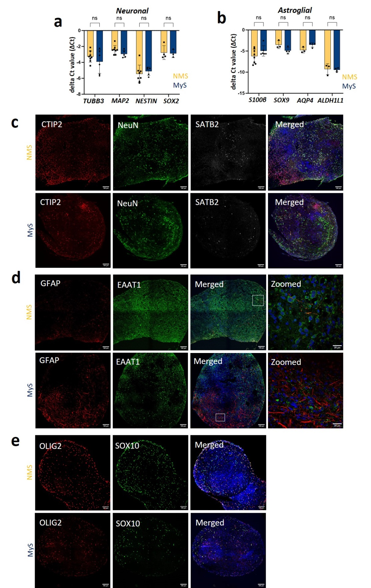
Figure S1: Cellular characterization of Sigma-iPSC0028 iPSCs derived MyS and NMS. a-b RT-qPCR of gene markers for neuronal (TUBB3, MAP2, NESTIN, SOX2) and astroglial (S100β, SOX9, AQP4 and ALDH1L1) cells in week 10 MyS and NMS. c-e Immunostaining for neuronal (CTIP2, NeuN, SATB2), astroglia (GFAP, EAAT1) and oligodendroglia (OLIG2, SOX10) markers in week 10 MyS and NMS (scale bar = 100 μm and 25 μm for zoomed images (d)). Statistical analyses were performed by unpaired two tailed t-tests (a-b). Data shown are mean ± SD, N=3 (n=3-8, each data point represents two spheroids, a-b), representative immunostaining images from N=3 (c-e). ns = statistically not significant.
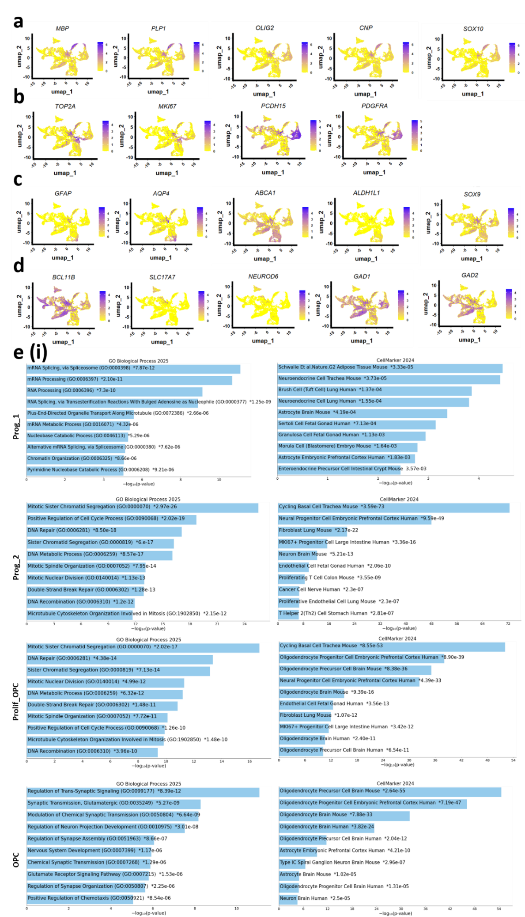
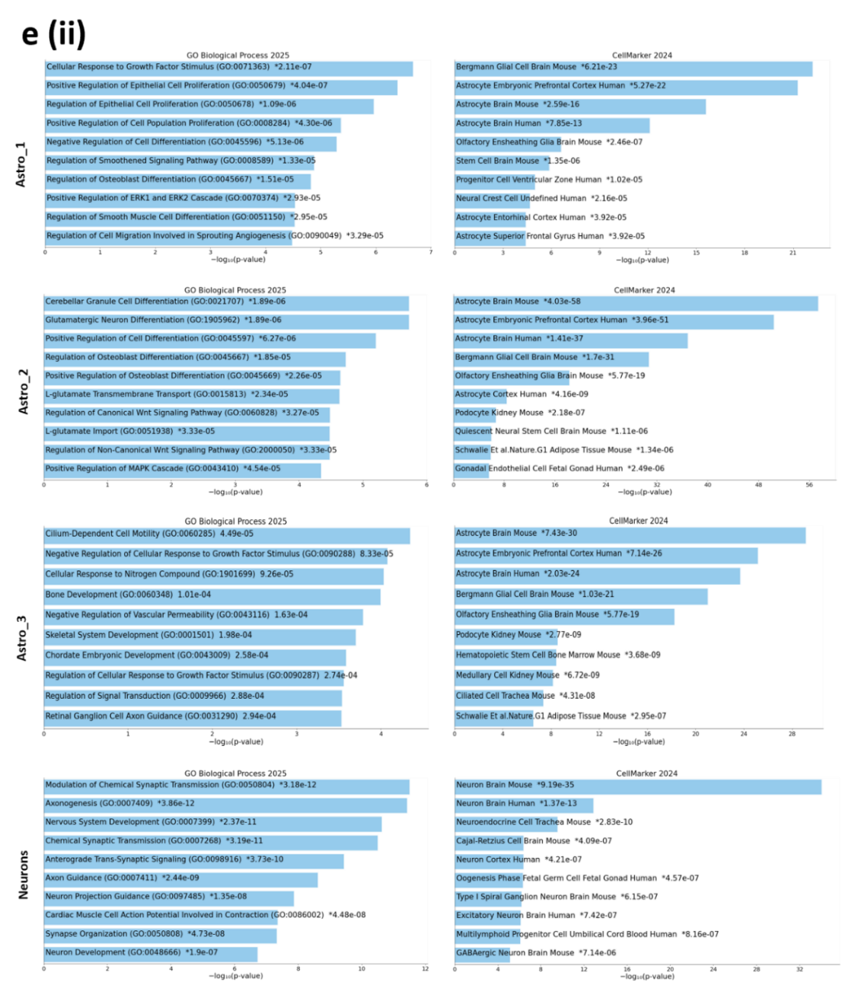
Figure S2. Characterization of the identities of cellular clusters in Sigma-iPSC0028 iPSCs derived MyS and NMS. a-d Feature plots illustrating marker gene expression for: (a) oligodendrocytes, (b) proliferating OPCs/OPCs, (c) astrocytes, and (d) neurons. e (i and ii) GO enrichment analysis for biological process terms and cell type enrichment analysis were conducted using the GO Biological Process 2025 and CellMarker 2024 databases. These analyses were performed using (at least) the top 500 DEGs from each cluster, with p-values adjusted for multiple testing using the Bonferroni method (< 0.05) and an average log fold change > 0.20 for each cellular cluster.

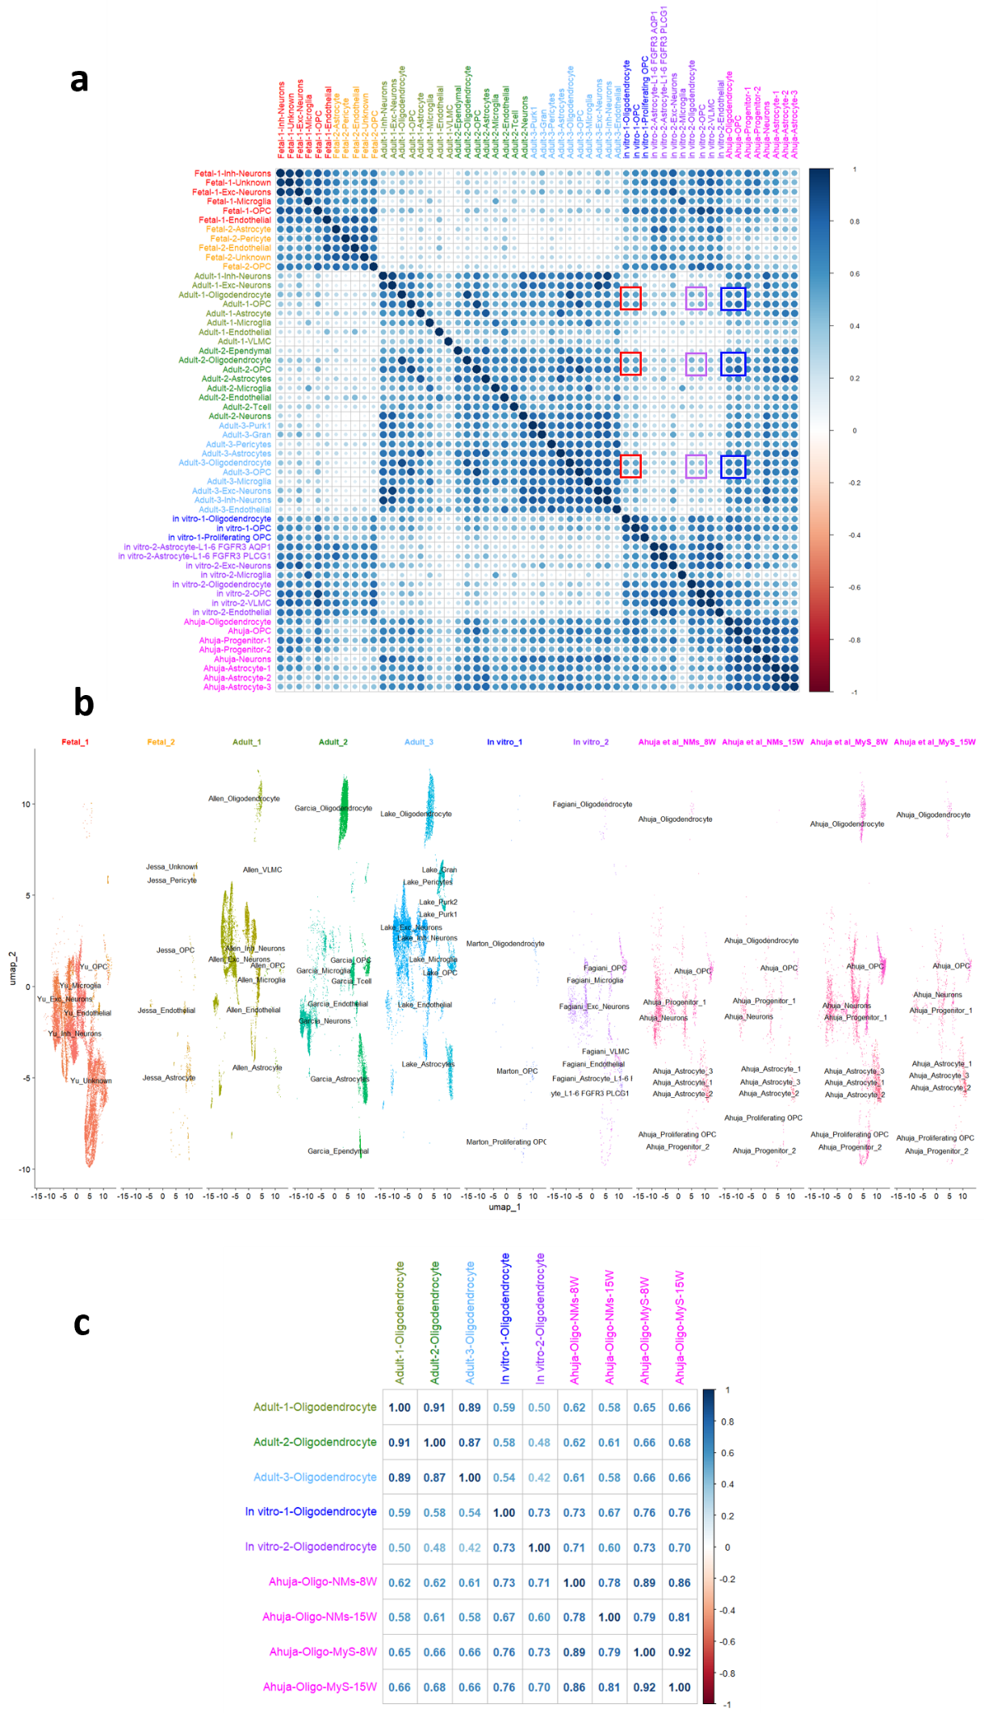
Figure S3. Transcriptional similarity analysis between Sigma-iPSC0028–derived MyS and NMS and reference sn/scRNA-seq datasets. Comparative analyses were performed between snRNA-seq datasets from Sigma-iPSC0028 iPSC-derived MyS and NMS at weeks 8 and 15 and published sn/scRNA-seq datasets from in vivo adult^{37–39} and developing^{35,36} human brain as well as two in vitro brain models^{16,19}. a Correlation matrix illustrating transcriptional relationships among all major cell clusters across the merged sn/scRNA-seq datasets from adult^{37–39}, fetal^{35,36}, and in vitro brain models^{16,19}. Correlations between adult brain datasets and In vitro_1 (Marton et al.)¹⁹, In vitro_2 (Fagiani et al.)¹⁶, and the present dataset (combined NMS and MyS at weeks 8 and 15) are highlighted by red, violet, and blue boxes, respectively. b UMAP representation of the integrated sn/scRNA-seq datasets, including MyS and NMS samples at weeks 8 and 15, in vivo adult^{37–39} and developing brain cells^{35,36}, and the two in vitro brain models^{16,19}. c Correlation analysis showing that oligodendrocytes present in MyS and NMS at both week 8 and week 15 are more transcriptionally similar to adult oligodendrocytes from three independent in vivo datasets^{37–39} than to oligodendrocytes generated in two in vitro models^{16,19}.
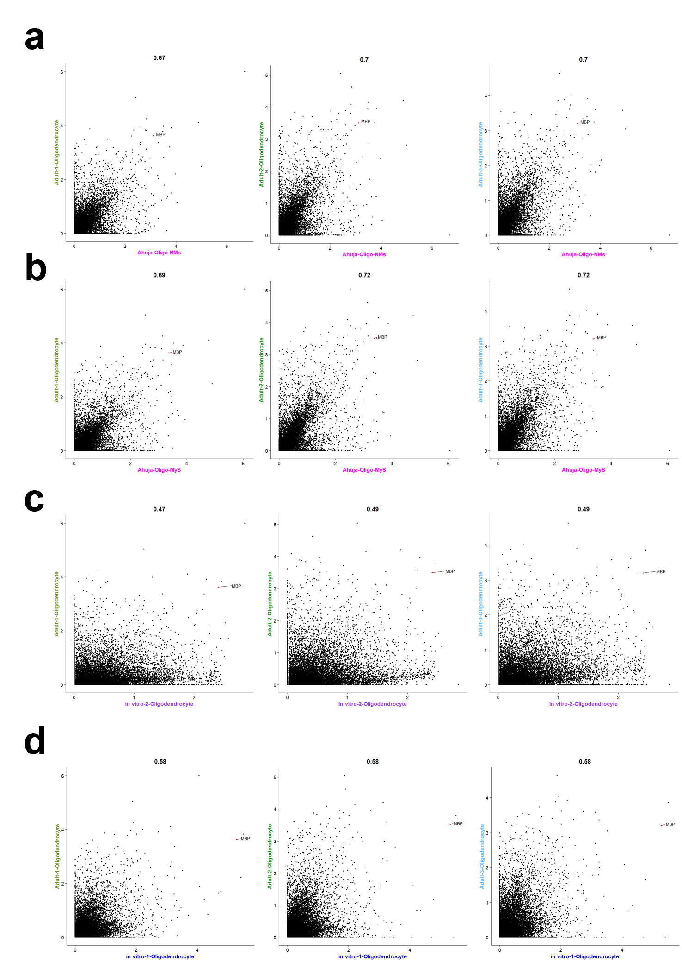
Figure S4. Comparative analysis of pseudobulk profiles of oligodendrocytes from Sigma-iPSC0028 iPSCs derived MyS and NMS and in vitro models with the adult oligodendrocytes. a-d The gene expression profiles of oligodendrocytes from (a) NMS, (b) MyS, (c) the Fagiani et al. model¹⁶, and (d) the Marton et al. model¹⁹ are compared to those of adult oligodendrocytes^{37–39}.
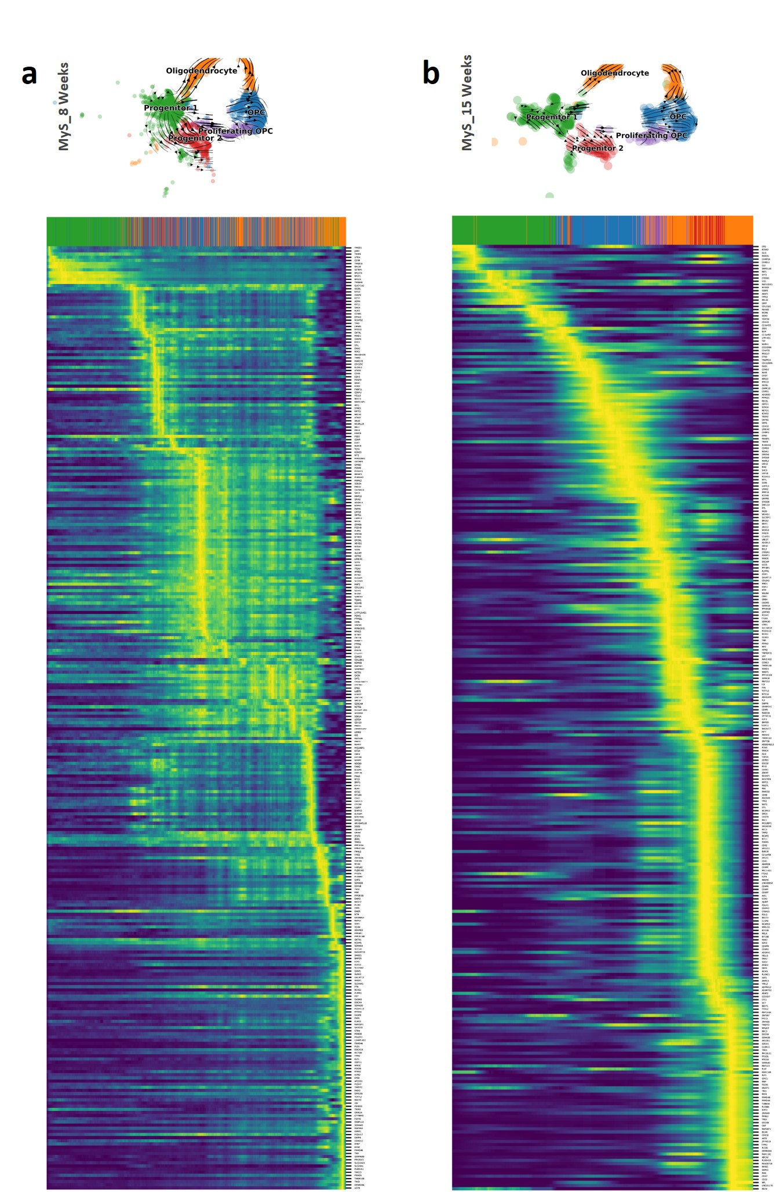
Figure S5. RNA velocity analysis demonstrated temporal dynamic of oligodendrocyte development in 8 and 15 weeks Sigma-iPSC0028 derived MyS. a-b The heatmaps revealed the dynamics of gene expression across latent-time of the underlying cellular processes, for the top 300 genes ranked by likelihood, in progenitors, OPCs, and oligodendrocyte clusters during (a) 8 weeks and (b) 15 weeks of culture.

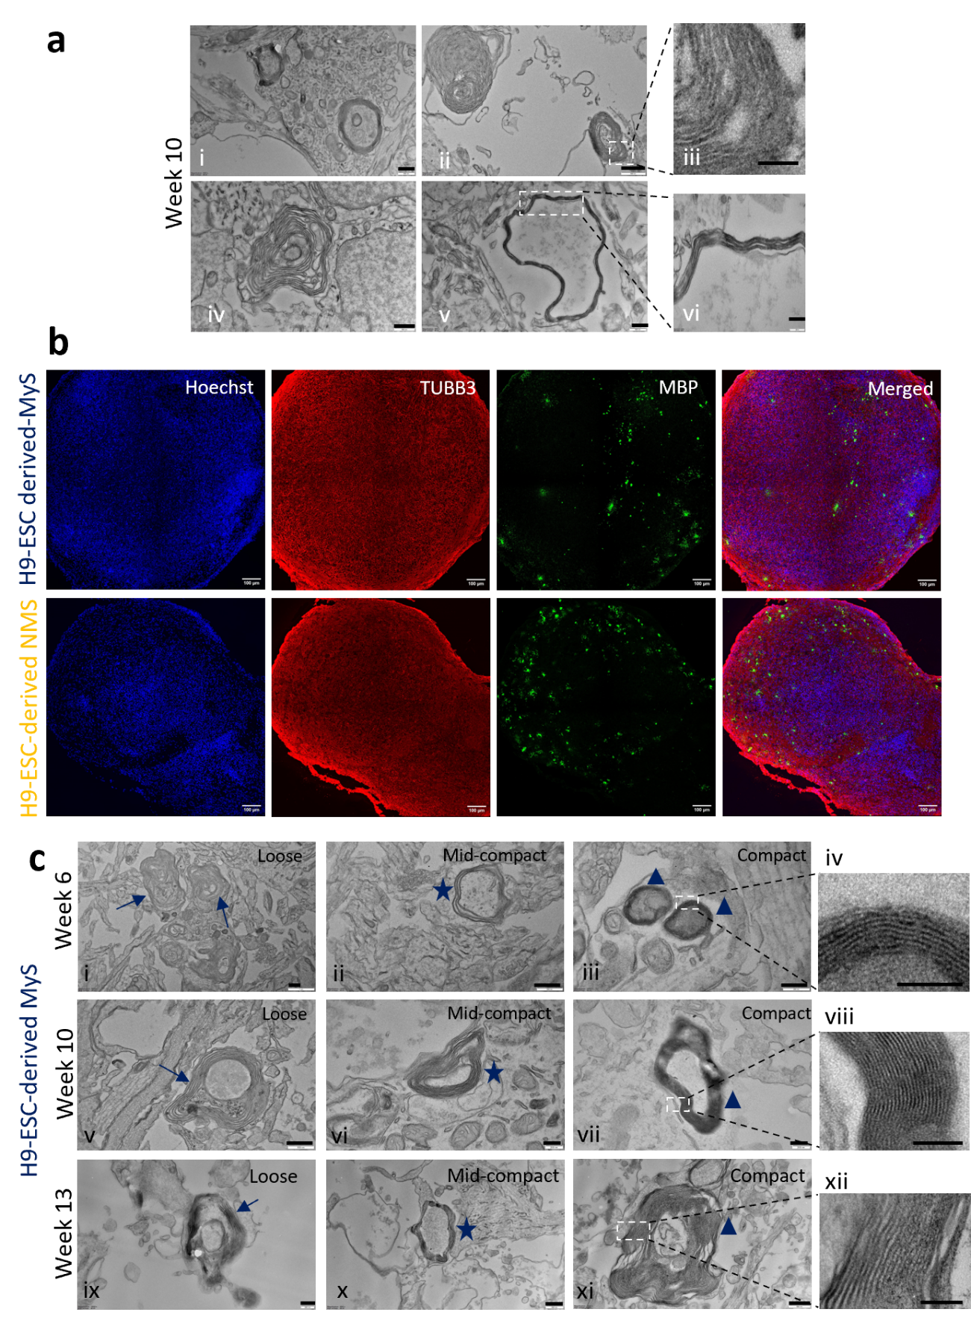
Figure S6: In vitro myelination in NMS generated from Sigma-iPSC0028 iPSCs; and MyS and NMS-derived from human H9-ESCs. a TEM images showing formation of fewer myelin sheaths in week 10 Sigma-iPSC0028 iPSCs derived NMS (scale bar = 500 nm (i, ii, iv, v) 100 nm (iii) and 200 nm (vi)). b Immunostaining for neuronal (TUBB3) and oligodendrocyte (MBP) markers in week 10 NMS and MyS-derived from H9-ESC cells (scale bar = 100 μm). Nuclei were counterstained with Hoechst. c TEM images showing formation of different subtypes of myelin sheaths (loose (arrow) i, v, ix), mid-compact ((star) ii, vi, x) and compact ((triangle) iii, iv, vii, viii, xi, xii) in week 6, 10 and 13 H9-ESC derived MyS (scale bar = 500 nm (i, ii, v, x, xi) , 200 nm (iii, vi, vii, ix), 100 nm (iv, viii), 250 nm (xii)). Representative images from N=3, n=3 (a), N=2, n=3 (b-c).

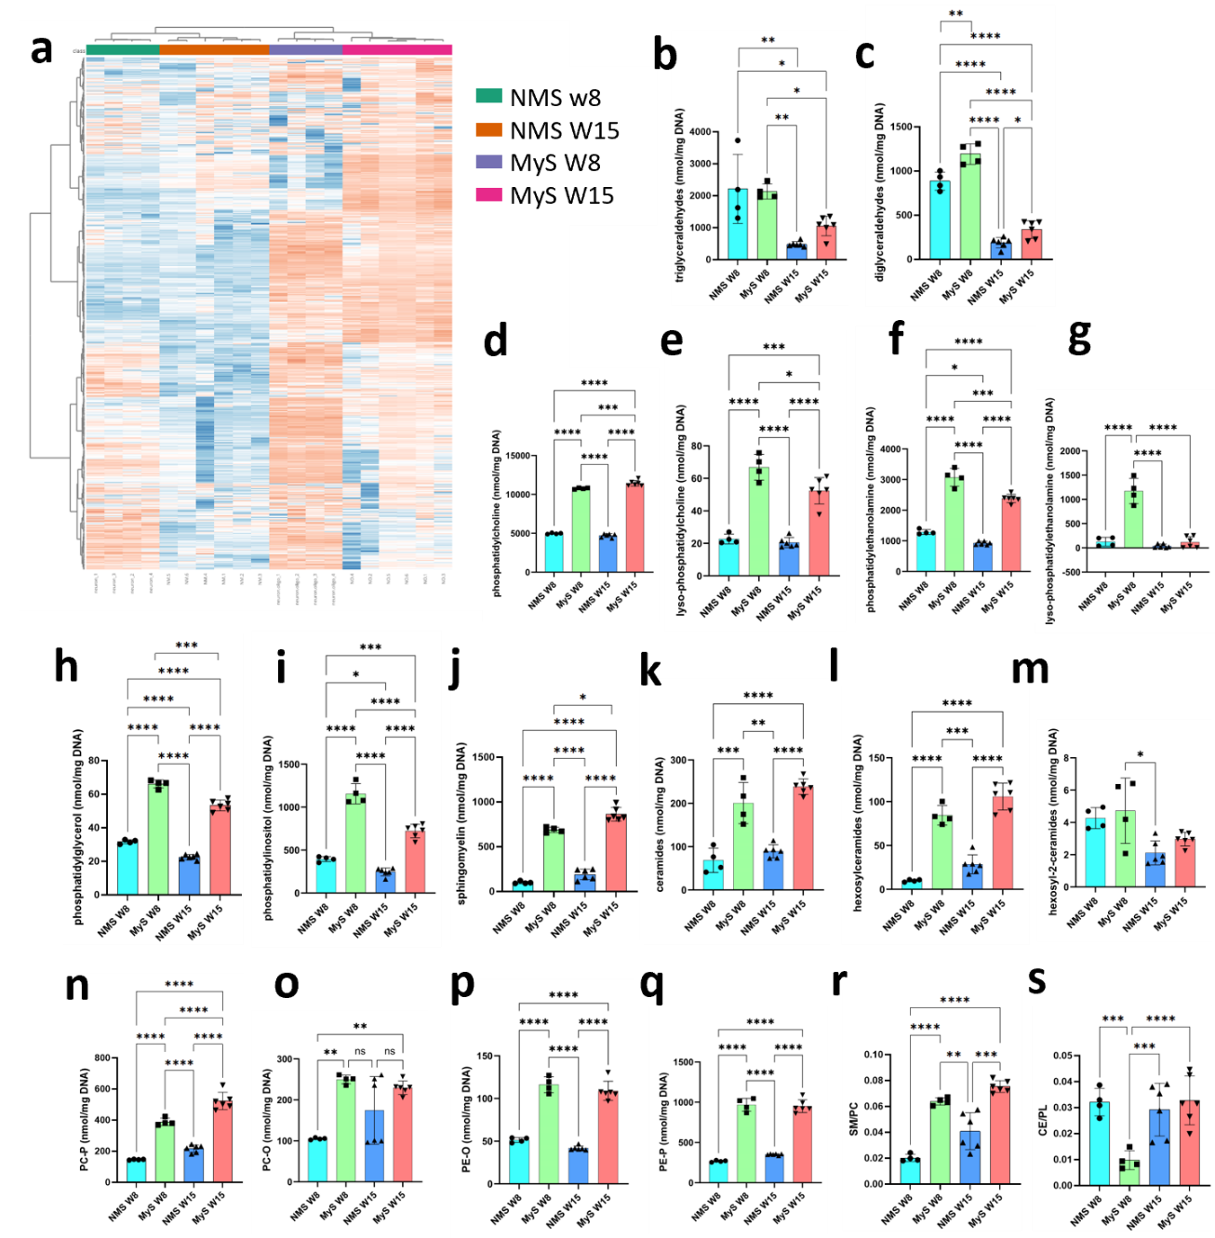
Figure S7: Global lipidome analysis revealed the presence of higher myelin lipids in Sigma-iPSC0028 iPSCs derived MyS than NMS. a Heatmap showing separate clustering of MyS and NMS samples at week 8 and 15. b-q Absolute amounts of different subclasses of major lipid classes: triglycerides, diglycerides (glycerolipids, b, c), phosphatidylcholine (PC), lyso-PC, phosphatidylethanolamine (PE), lyso-PE, phosphatidylglycerol, phosphatidylinositol (phospholipids, d-i), sphingomyelin, ceramides, hexosylceramides, hexosyl-2-ceramides (sphingolipids, j-m), PC-P, PC-O, PE-O and PE-P (esther linked phospholipids , n-q) in MyS and NMS samples at week 8 and 15. r-s Ratio of sphingomyelin/ phosphatidylcholine (r) and cholesteryl esters (CE)/phospholipids (PL) (s) indicate MyS lipid profile dominated by structural phospholipids and minimal cholesterol esterification. Statistical analyses were performed by Two-way ANOVA with Sidak’s comparison test (b-q). Data shown are mean ± SD, N=4-6 (b-q). *p<0.05, **p<0.01, ***p<0.001, ****p<0.0001.
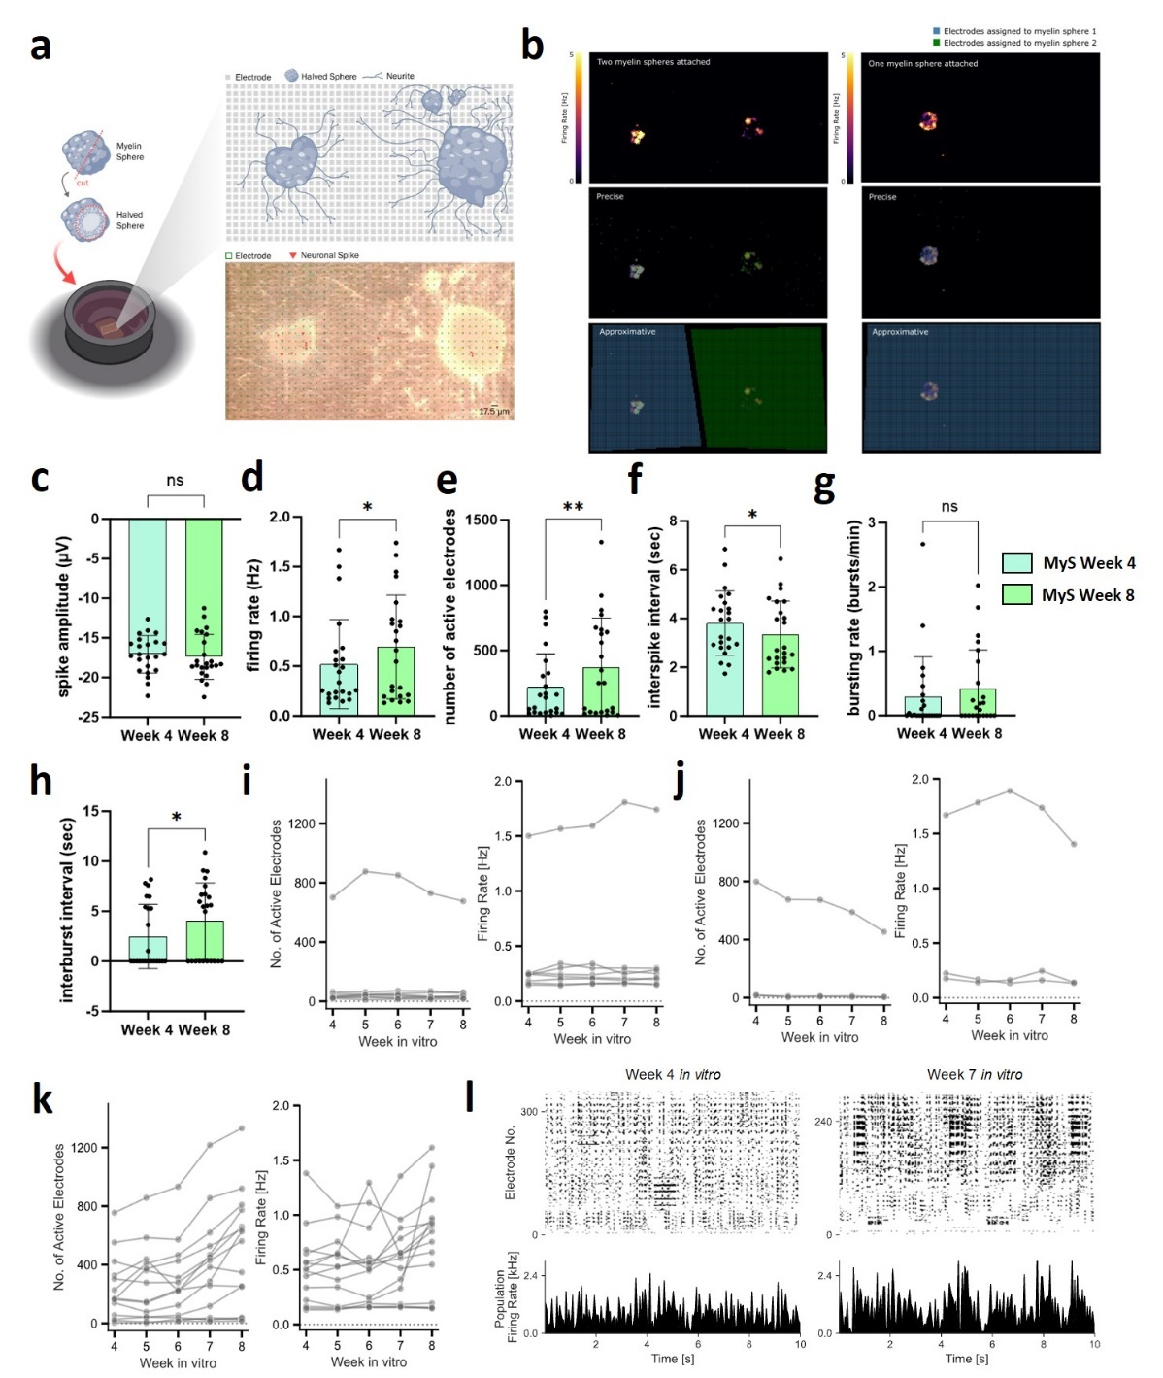
Figure S8: Electrophysiological characterization reveals functional activity in Sigma-iPSC0028 iPSCs derived MyS. a Schematic illustration of MyS sliced spheres plated on a high density CMOS multi-electrode array for electrophysiological recordings. b Visualization of firing rate in separated electrode regions corresponding to individual MyS sliced spheres plated within a single well. c-e Quantification of neuronal spiking properties at week 4 and week 8, including spike amplitude (c), firing rate (d), number of active electrodes (e) and interspike interval (f) per well. g-h Assessment of neuronal bursting activity at week 4 and week 8, showing bursting rate (g) and interburst interval (h) per well. i-k Longitudinal analysis of individual MyS sliced spheres indicated by each graph lines, showing the number of active electrodes and the different firing rates over time: constant (i), decreasing (j), or increasing (k) activity patterns during weeks in vitro. l Representative raster plot illustrating increased spike activity in a MyS slice from week 4 to week 7 in vitro. Statistical analyses were performed by paired two tailed t-tests (c-h). Data shown are mean ± SD for N = 4 independent experiments, n = 23 MyS sliced spheres, *p< 0.05, **p< 0.01. ns = not significant.

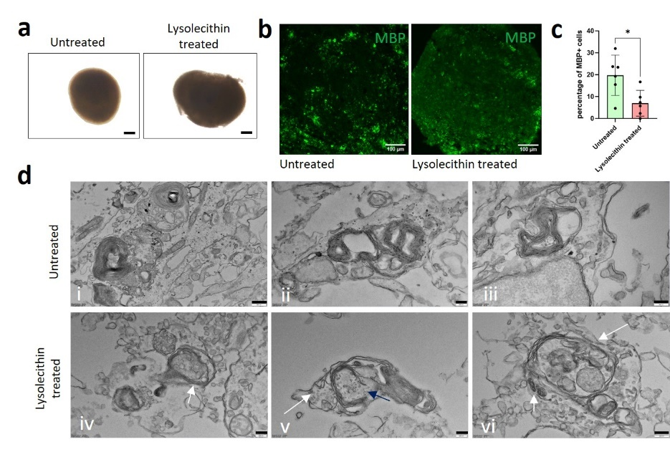
Figure S9: Lysolecitin induced demyelination in Sigma-iPSC0028 iPSCs derived MyS. a Brightfield image of untreated and lysolecithin-treated week 10 MyS (scale bar = 200 μm). b Immunostaining of mature oligodendrocyte marker (MBP) in untreated and lysolecithin-treated week 10 MyS (scale bar = 100 μm). c Quantification of immunostained MBP⁺ cells in untreated and lysolecithin-treated week 10 MyS. d TEM images showing lysed myelin sheaths (arrows) in lysolecithin-treated week 10 MyS as compared to untreated week 10 MyS (scale bar = 500 nm-i; 200nm- ii-vi). Statistical analyses were performed by unpaired two tailed t-tests (c). Data shown are ± SD, representative images and quantification from N = 3 (n = 5-6, each data point indicates 3 slices) (a-d). *p<0.05.

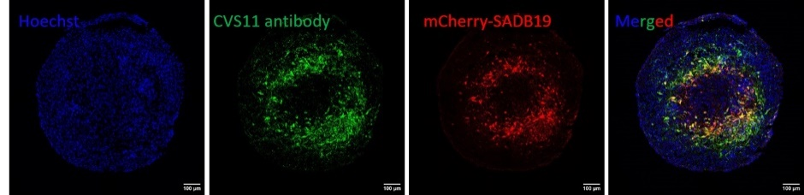
Figure S10: mCherry-SAD-B19 signal corresponds to RABV particles in Sigma-iPSC0028 iPSCs derived MyS. Week 10 MyS infected with mCherry-SAD-B19 stained with an anti-RABV N protein antibody against the RABV Nucleoprotein shows colocalization of mCherry signal with RABV infected cells (scale bar = 100 μm).
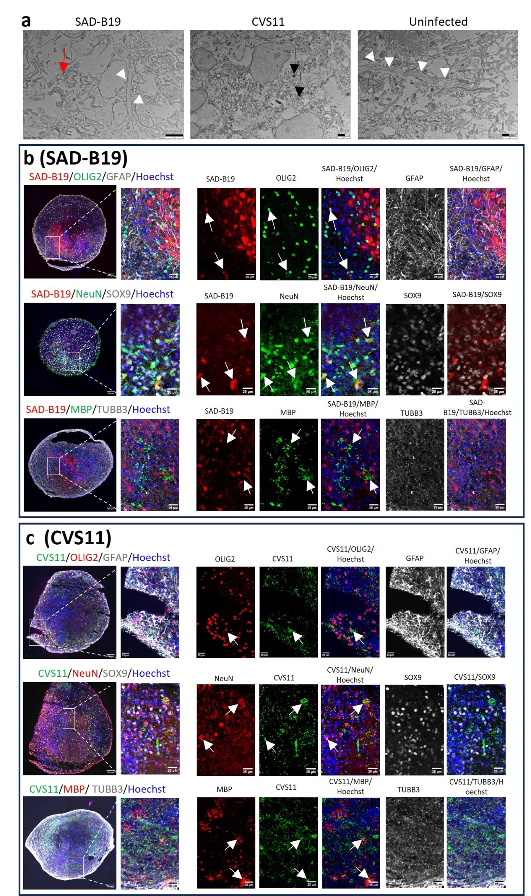
Figure S11: Differences in Rabies virus pathology and tropism observed across strains in Sigma-iPSC0028 iPSCs derived MyS. a Transmission electron microscopic images showing severe damage to microtubule networks (white arrow heads) by the CVS-11 (black arrow) but not mCherry-SAD-B19 (red arrow) virus as compared to uninfected week 10 MyS (scale bar = 1μm). b Immunostaining imaging for markers of neuron (NeuN, TUBB3), astroglia (GFAP, SOX9), oligodendrocyte progenitors (OLIG2) and mature oligodendrocytes (MBP) along with mCherry expression from mCherry-SAD-B19 virus demonstrating tropism towards neurons, and oligodendrocyte progenitors but not astroglia and mature oligodendrocytes. c Immunostaining imaging for neurons (NeuN, TUBB3), astroglia (GFAP/SOX9), oligodendrocyte progenitors (OLIG2) and mature oligodendrocytes (MBP) combined with anti-RABV Nucleoprotein antibody demonstrating tropism of the CVS-11 virus towards neurons, oligodendrocyte progenitors and mature oligodendrocytes but not to astrocytes (scale bar = 100 μm and 25μm for the zoomed panels). Zoomed panels are cropped manually from their corresponding images for better visualization. Representative images from N=3 (a-c).

