Supplementary Material

Supplementary Table 1: Flow cytometry antibodies of the infiltration panel

Antigen | Fluorochrome | Clone | Manufacturer
MHC II | FITC | M5/114.15.2 | eBioscience
TCRγδ | PerCP-Cy5.5 | GL-3 | Biolegend
Ly6G | PE | 1A8 | BD Biosciences
CD11b | PE-Cy7 | M 1/70 | Biolegend
CD11c | APC | N 418 | eBioscience
CD45 | APC-eFluor780 | 30-F11 | eBioscience
CD3 | BV 421 | 17A2 | Biolegend
B220 | BV 570 | RA3-6B2 | Biolegend
F4/80 | BV 605 | BM8 | Biolegend
CD8 | BV 650 | 53-6.7 | Biolegend
NK1.1 | BV 710 | PK 136 | Biolegend
CD4 | BV 785 | RM4-5 | Biolegend

Supplementary Table 2: Flow cytometry antibodies of the T cell panel

Antigen | Fluorochrome | Clone | Manufacturer
Interferon-g | Alexa Fluor 488 | XMG 1.2 | Biolegend
TCRγδ | PerCP-Cy5.5 | GL-3 | Biolegend
ROR-γT | PE | Q31-378 | BD Biosciences
IL-17 | APC | eBio17B1 | Invitrogen
CD45 | APC-eFluor780 | 30-F11 | eBioscience
CD3 | BV 421 | 17A2 | Biolegend
B220 | BV 570 | RA3-6B2 | Biolegend
CD8 | BV 650 | 53-6.7 | Biolegend
NK1.1 | BV 710 | PK 136 | Biolegend
CD4 | BV 785 | RM4-5 | Biolegend

Supplementary Table 3: Antibodies for astrocyte sorting

Antigen | Fluorochrome | Clone | Manufacturer
CD11b | PE-CF594 | M 1/70 | BD Horizon
CD45 | APC-eFluor780 | 30-F11 | eBioscience
ESAM | PE | 168/ESAM | Biolegend
EMCN | PE | eBioV.7C7 | Invitrogen
O4 | APC | O4 | Miltenyi
CD140a | PE-Cy7 | APA5 | Biolegend
ACSA-2 | Vio® Bright B515 (FITC) | REA969 | Miltenyi

Supplementary Table 4: qRT-PCR primers
Gene | Assay ID
Sdha | Mm01352366_m1
B2m | Mm00437762_m1
Gapdh | Mm99999915_g1
Actb | Mm00607939_s1
Pgk1 | Mm00435617_m1
Gusb | Mm01197698_m1
Cyc1 | Mm00470540_m1
Tbp | Mm01277042_m1
Cxcl1 | Mm04207460_m1
Cxcl2 | Mm00436450_m1
Ccl2 | Mm00441242_m1
Aqp4 | Mm00802131_m1
Slc1a3 | Mm00600697_m1
Mog | Mm01279062_m1
Tubb3 | Mm00727586_s1
Cldn5 | Mm00727012_s1
Tie1 | Mm00441786_m1
P2ry12 | Mm00446026_m1
Lcn2 | Mm01324470_m1
Timp1 | Mm01341361_m1
Cebpb | Mm00843434_s1
Ptx3 | Mm00477268_m1

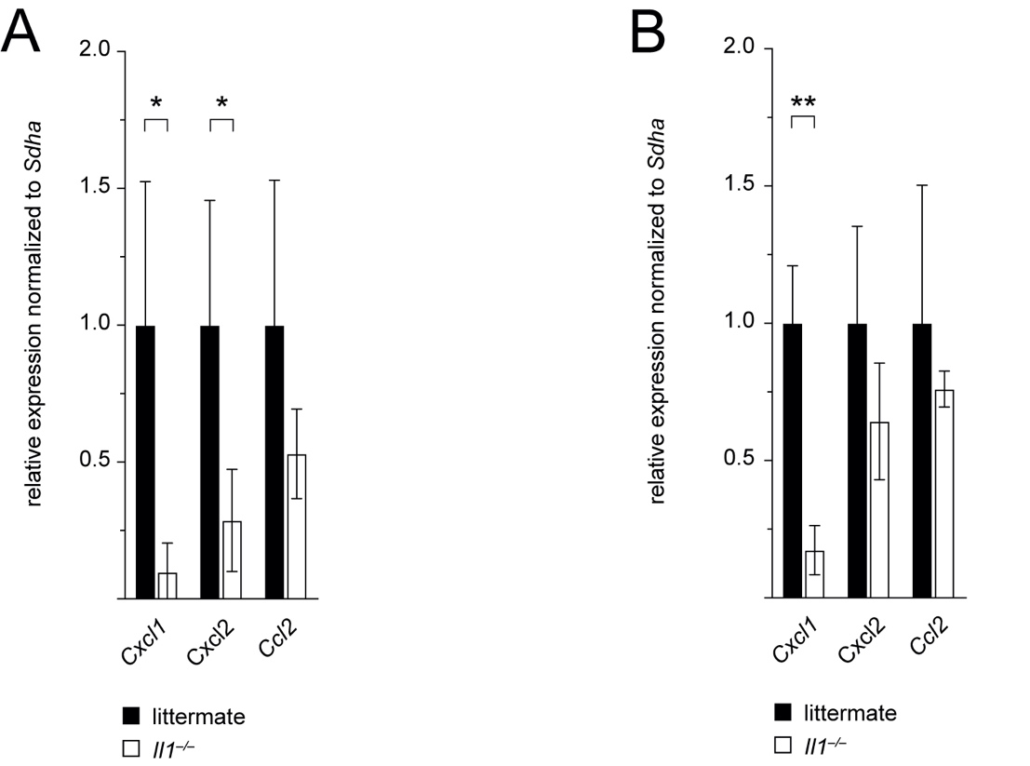

Supplemental Figure 1: Cxcl1 expression is reduced 24 h and 72 h after pMCAO in Il1–/– mice.
(A) Expression levels of Cxcl1, Cxcl2, and Ccl2 in FACS sorting input single-cell suspensions from the ischemic hemisphere of Il1–/– mice relative to WT littermates (normalized to 1) 24 h and (B) 72 h after pMCAO. Data are presented as mean ± SEM, n = 3-4 pooled samples from n = 7-8 mice/group, unpaired Student’s t-test, * p ≤ 0.05, ** p ≤ 0.01.

