A Slower-Progressing TDP-43 rNLS8 Mouse Model for ALS: Implications for Preclinical and Mechanistic Studies

Cyril Jones Jagaraj¹, Prachi Mehta¹, Julie Hunter¹, Julie D Atkin^{1,2}
Author affiliations:
¹ MND Research Centre, Macquarie Medical School, Faculty of Medicine, Health and Human Sciences, Macquarie University, Sydney, NSW 2109, Australia.
² La Trobe University, Bundoora, Melbourne, VIC 3086, Australia.

Correspondence to
Prof. Julie D Atkin
Macquarie University
75 Talavera Road NSW 2109
Phone: 02 9850 2772
Email ID: julie.atkin@mq.edu.au
Running title: Extending disease in TDP-43 rNLS8 ALS mice
Keywords: ALS/MND, TDP-43 pathology, Longer disease course

Supplementary Figure 1
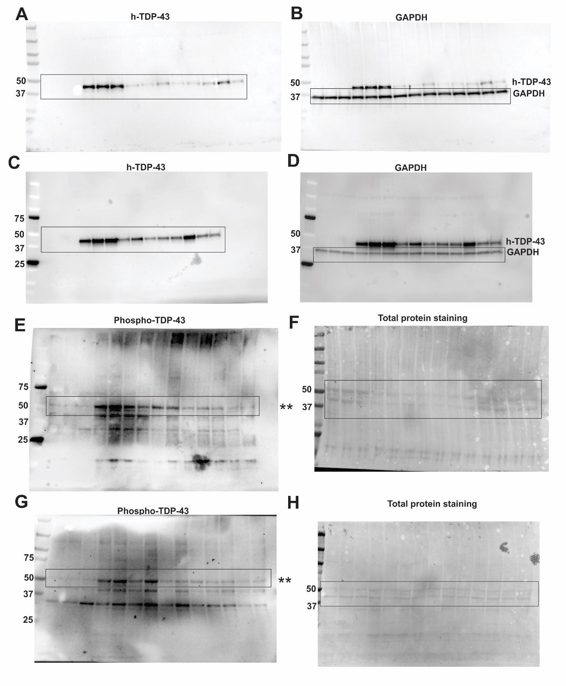
(A and B) Full-length Western blots shown in Figure 1A
(C and D) Full-length Western blots shown in Figure 1C
(E and F) Full-length Western blots shown in Figure 1G
(G and H) Full-length Western blots shown in Figure 1I

(A-H) boxes indicate region of gel shown in each figure.
Supplementary Figure 2
Combined analysis of disease onset of 10mg/kg and 20mg/kg Dox mice and controls (Dox off and Diet gel).
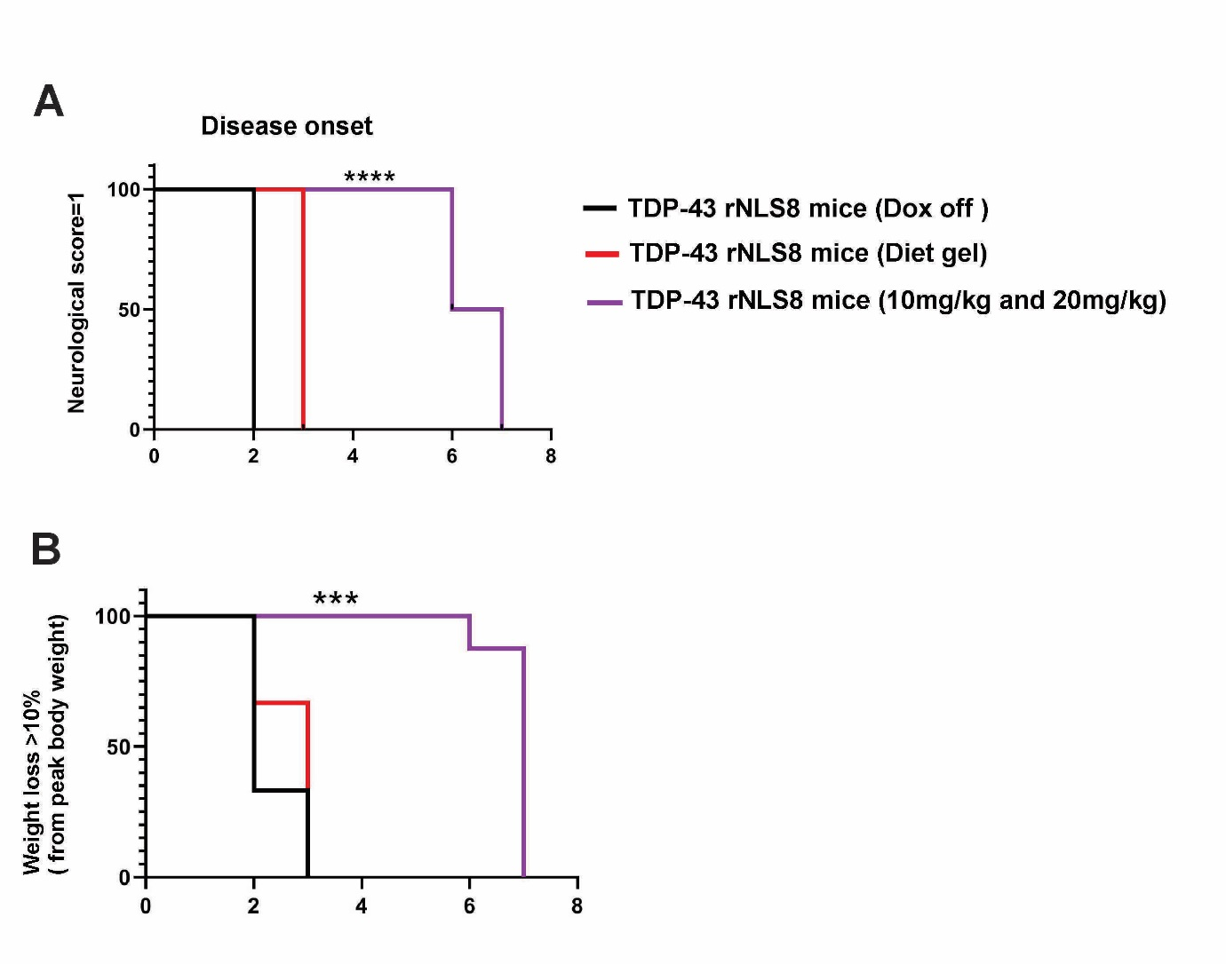
(A) Kaplan Meier curves representing age of disease onset in weeks, defined as an individual mouse achieving a neurological score =1 (NS=1). Log-rank (Mantel-Cox) test, ****p<0.0001. Disease onset is delayed in mice supplemented with 10-20mg/kg Dox: mean = 7 weeks for combined 10mg/kg and 20mg/kg Dox group (n=8), compared to 2 weeks for Dox off (n=3), and 3 weeks for Diet gel groups (n=3). (B) Kaplan Meier curves representing age of disease onset in weeks, defined as an individual mouse achieving a weight loss of >10% from peak body weight. Log-rank (Mantel-Cox) test, ***p<0.001. Disease onset is delayed in mice supplemented with 10-20mg/kg Dox: mean = 7 weeks for combined 10mg/kg and 20mg/kg Dox group (n=8), compared to 2 weeks for Dox off (n=3), and 3 weeks for Diet gel groups (n=3).

Supplementary Figure 3
Combined analysis of disease progression of 10mg/kg and 20mg/kg Dox mice and controls (Dox off and Diet gel).
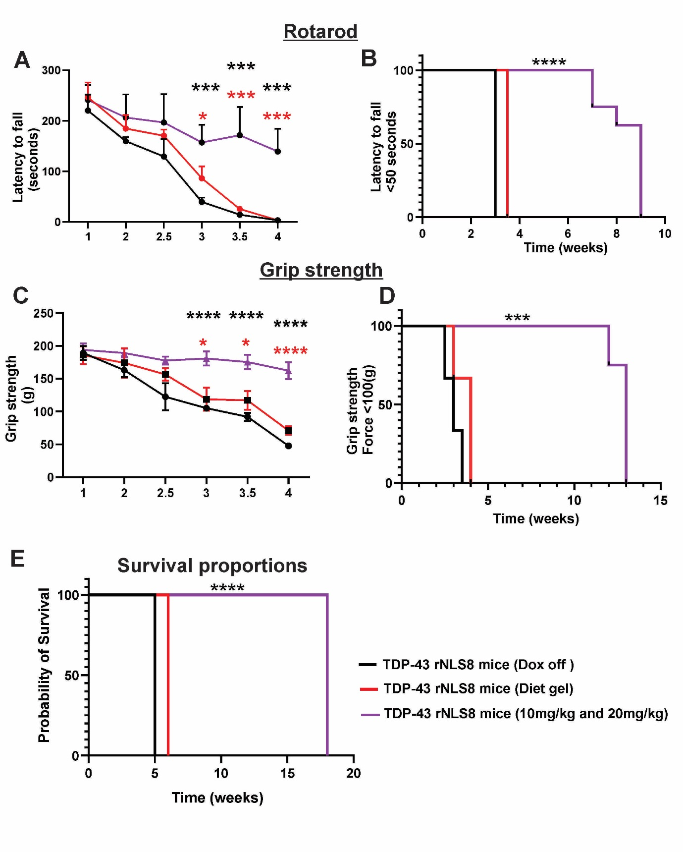

(A) Rotarod performance (latency to fall in seconds) is significantly improved at 3, 3.5 and 4 weeks in combined 10mg/kg and 20mg/kg Dox mice compared to Dox off and Diet gel animals, indicating improvement in motor function. Mixed effect analysis mean ± SD, two-way Anova, Tukey’s multiple test comparison, ***p<0.001, *p<0.05, n=3 (Dox off and Diet gel), n=8. (10mg/kg and 20mg/kg Dox). Black (*) and red (*) asterisks refer to comparisons to Dox off or Diet gel mice respectively. (B) Kaplan Meier curves representing Rotarod latency to fall, defined as an individual mouse latency to fall less than 50s. Log-rank (Mantel-Cox) test, ****p<0.0001. With a median rotarod of 3 and 3.5 weeks for Dox off and Diet gel supplemented group (n=3) respectively, 9 weeks for 10mg/kg and 20mg/kg Dox plus Diet gel group (n=8). (C) Muscle function, indicated by grip strength, is significantly improved at 3, 3.5 and 4 weeks in combined 10mg/kg and 20mg/kg Dox mice compared to Dox off and Diet gel mice. Mixed effect analysis mean ± SD, two-way Anova, Tukey’s multiple test comparison, ****p<0.0001, *p<0.05, n=3 (Dox off and Diet gel group), n=8 (10mg/kg and 20mg/kg Dox group). Black (*) and red (*) asterisks refer to comparisons to Dox off or Diet gel mice respectively. (D) Kaplan Meier curves representing grip strength, defined as an individual mouse achieving less than 100(g) force. Log-rank (Mantel-Cox) test, ***p<0.001. With a median grip strength of 3 and 4 weeks for both dox off and Diet gel supplemented group (n=3), 13 weeks for 10mg/kg and 20mg/kg Dox plus Diet gel group(n=8). (E) Kaplan Meier curves representing probability of survival, defined as an individual mouse achieving a neurological score =3 (NS=3). Log-rank (Mantel-Cox) test, ****p<0.0001. Combined 10mg/kg and 20mg/kg Dox mice reach NS=3 at median = 18 weeks compared to 5 or 6 weeks for Dox off or Diet gel group respectively.

