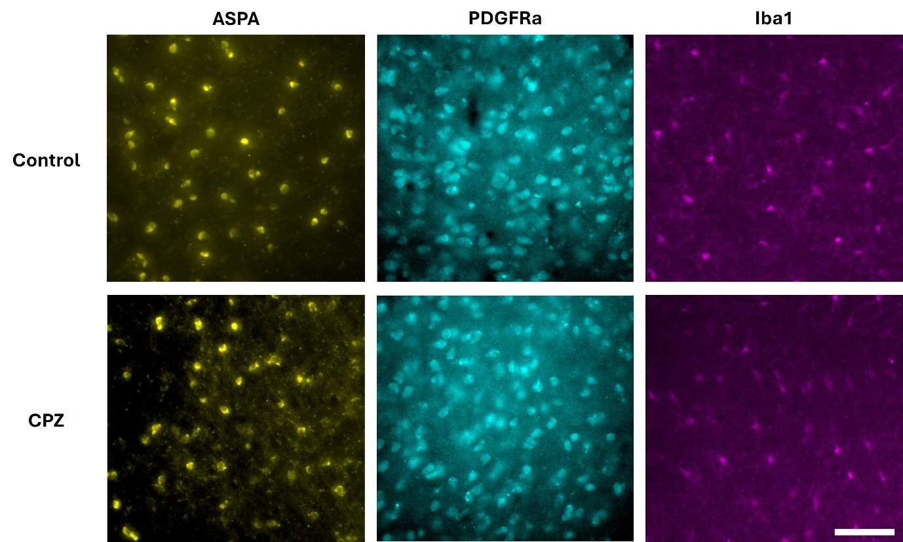
Supplementary figure 1. Representative Immunofluorescence images of staining for ASPA (mOLs marker, yellow), PDGFRa (OPCs marker, cyen) and Iba1 (microglia marker, magenta) in the cortex of control (top) and CPZ-exposed mice (lower).

