Supplementary Material
Table 1: Results of the groupwise comparison between SELMA and the originally published results²³.
 | Original | SELMA
N_{detected} | 24 ± 6 | 28 ± 6
v_{mean} | 3.9 ± 0.6 | 4.0 ± 0.5
PI | 0.28 ± 0.08 | 0.27 ± 0.07
Values are given as mean ± SD. N_{detected} = amount of detected arteries; v_{mean} = mean blood flow velocity of the perforating arteries given in cm/s; PI = pulsatility index

Table 2: Results of the linear mixed model between velocity pulsatility index and N_{detected}, corrected for scanner vendor.
 | Velocity PI​
​n = 60 | β [95% CI]​ | p-value​
N_{detected} | -0.013 [-0.026 – -0.0013]​ | 0.04
. N_{detected} = amount of detected arteries; PI = pulsatility index
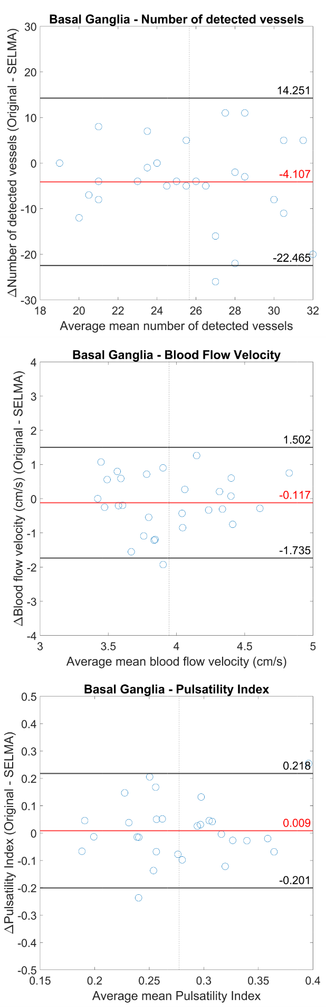
Figure 1 Bland–Altman plots for comparison between the original measurements and SELMA for all outcome measurements in the basal ganglia on previously published data²⁴. The red line shows the mean in every figure and the black lines show the limits of agreement.

