Supplemental Figure 1: RNA sequencing data showing increased expression of SATB2 in ATC compared to other thyroid malignancies. (NT= Normal thyroid tissue, PTC=Papillary thyroid carcinoma, FTC=Follicular thyroid carcinoma, ATC=Anaplastic thyroid carcinoma). (*, **, *** P < 0.05)

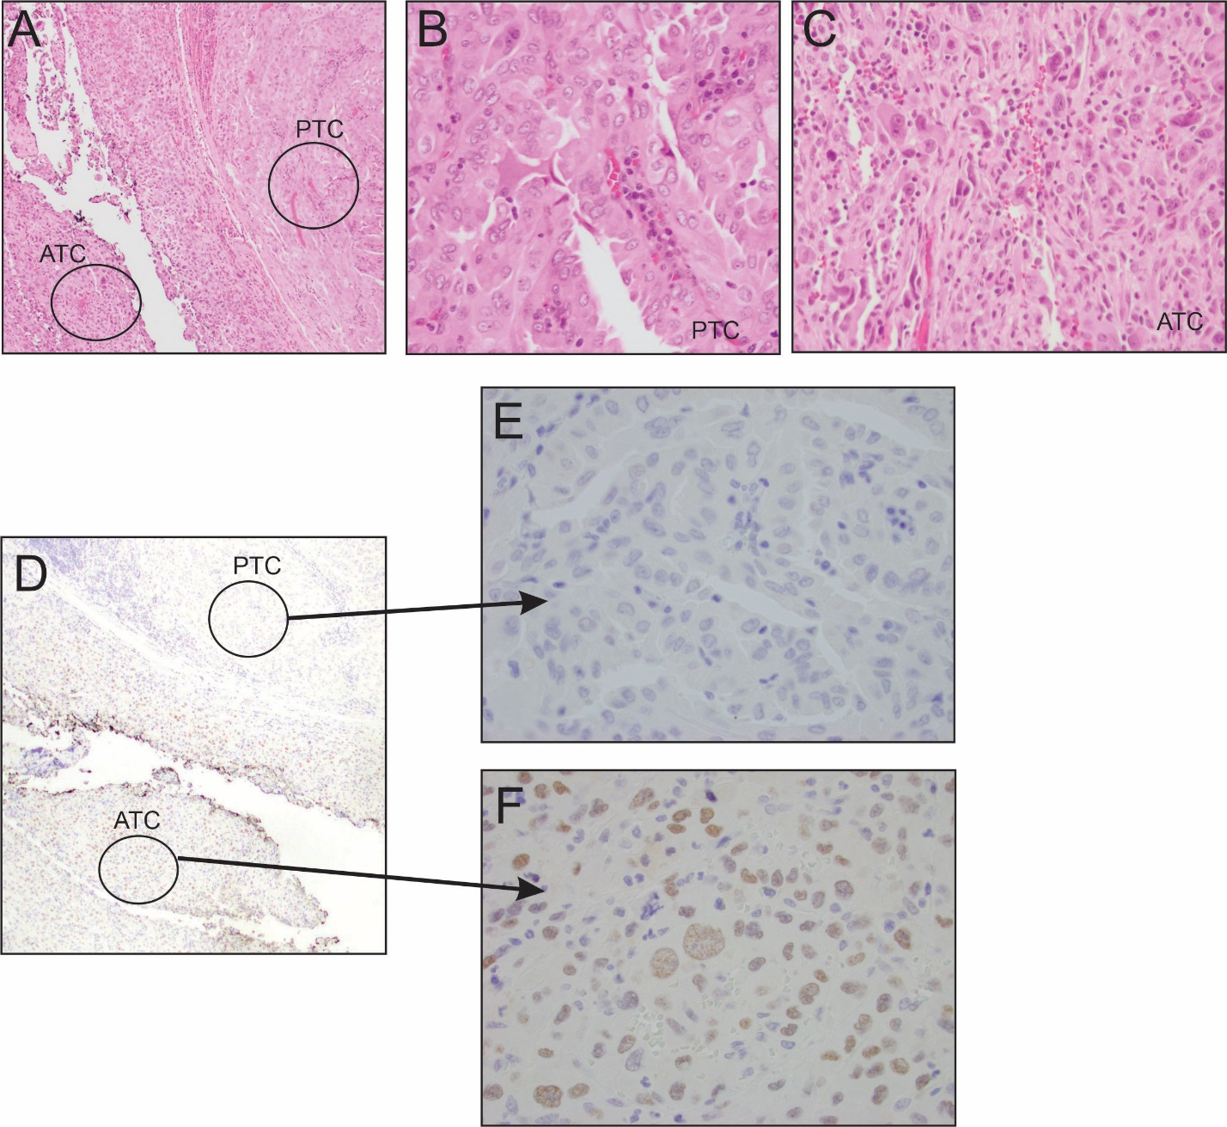

Supplemental Figure.2: (A-C) Representative case with anaplastic thyroid carcinoma and papillary thyroid carcinoma. (D-F) SATB2 IHC showing positive staining in the anaplastic component and negative immune-reactivity in the PTC component

