Supplemental Table 1. Genomic Profiles of Patients Diagnosed with Adrenocortical Carcinoma (N = 20)

Patient | Subtype of ACC | System criteria | Tumor mutational burden, mut/Mb* | MSI | Somatic findings | Germline findings
1 | Oncocytic | LWB | NA | NA | NA | NA
2 | Conventional | Weiss | Low (1.00) | Stable | MLH3 (N674fs)  TP53 (H214R) | NA
3 | Conventional | Weiss | Low (1.00) | Stable | KLF4 (c.127-1G>A) | NA
4 | Oncocytic | LWB | High (15.00) | Stable | ATRX (K1357fs)  CHEK2 (K373E)  MSH2 (deletion)  NBN (c.1124+2T>C)  RNF43 (G659fs)  SMARCA4 (Q194fs)  TP53 (R273H)  WRN (K168fs)  WRN (c.654+2T>C)  ZNRF3 (S613fs); | NA
5 | Conventional | Weiss | Low (1.00) | Stable | NA | NA
6 | Conventional | Weiss | Low (2.00) | Stable | RB1 (Q685fs)  CYLD (Q595fs) | NA
7 | Conventional | Weiss | Low (1.00) | Stable | CTNNB1 (S33F)  RB1 (M484fs)  TP53 (L14fs) | NA
8 | Conventional | Weiss | Low (4.34) | Stable | MDM2 (amplification)  FRS2 (amplification)  HMGA2 (HMGA2-LOC728084 rearrangement) | Negative for pathogenic variants
9 | Conventional | Weiss | NA | NA | NA | NA
10 | Conventional | Weiss | Low (2.00) | Stable | CDKN2A (deletion)  CDKN2B (deletion)  MTAP (deletion)  PALB2 (E907fs)  TP53 (A138V)  TERT (c.-124C>T) | PALB2 (c.2719del, p.Glu907Lysfs*16)  POLE (c.4145G>A, p.Arg1382His)
11 | Conventional | Weiss | NA | Stable | CTNNB1 (S45P) | Negative for pathogenic variants
12 | Conventional | Weiss | NA | NA | NA | Negative for pathogenic variants
13 | Conventional | Weiss | NA | NA | NA | Negative for pathogenic variants
14 | Conventional | Weiss | Low | NA | CTNNB1 (p.533A)c.97T>G  RB1 ([p.5318fs]c951_954delTCT)  SDHAF2 (deletion) | Negative for pathogenic variants
15 | Oncocytic | LWB | NA | NA | NA | NA
16 | Oncocytic | LWB | Low (1.43) | Stable | APC (T1556Nfs*3 loss of function) | APC (rs137854568, c.904C>T [p.R302*])
17 | Oncocytic | LWB | Low (3.00) | Stable | NA | NA
18 | Oncocytic | LWB | Low (1.03) | Stable | TP53 (T211P loss of function) | Negative for pathogenic variants
19 | Oncocytic | LWB | Low (0.91) | Stable | PTEN (L325P loss of function) | FLCN (c.346C>T, p.Q116*)
20 | Conventional | Weiss | Low (1.54) | Stable | TP53 (L130V loss of function)  RB1 (loss of function) | NA
ACC, adrenocortical carcinoma; LWB, Lin-Weiss-Bisceglia system; MSI, microsatellite instability; mut/Mb, mutations per megabase; NA, not available.
*Tumor mutational burden was classified as low (<10 mutations/megabase) or high (≥10mutations/megabase) [43].

Supplemental Table 2. Pathologic Classification Criteria for Adrenocortical Carcinoma (N = 20)

ID | Subtype of ACC | System criteria | Definition of Malignancy
1 | Oncocytic ACC | LWB | Two major criteria: mitoses >5 per 50 HPF, and atypical mitosis.
2 | Conventional ACC | Weiss | Weiss score is 6 (mitosis >5 per 50 HPF, atypical mitoses, necrosis, diffuse architecture >30% of tumor volume, clear cells <= 25% of the tumor volume, capsular invasion).
3 | Conventional ACC | Weiss | Weiss score is 5 (high Fuhrman nuclear grade, necrosis, diffuse architecture >30% of tumor volume, clear cells <= 25% of the tumor volume, venous invasion).
4 | Oncocytic ACC | LWB | Two major criteria: mitoses >5 per 50 HPF, and atypical mitosis.
5 | Conventional ACC | Weiss | Weiss score is 6 (high Fuhrman nuclear grade, mitosis >5 per 50 HPF, necrosis, diffuse architecture >30% of tumor volume, venous invasion, sinusoidal invasion).
6 | Conventional ACC | Weiss | Weiss score is 9 (high Fuhrman nuclear grade, mitosis >5 per 50 HPF, atypical mitoses, necrosis, diffuse architecture >30% of tumor volume, clear cells <= 25% of the tumor volume, capsular invasion, venous invasion, sinusoidal invasion).
7 | Conventional ACC | Weiss | Weiss score is 6 (high Fuhrman nuclear grade, mitosis >5 per 50 HPF, atypical mitoses, necrosis, clear cells <= 25% of the tumor volume, venous invasion).
8 | Conventional ACC | Weiss | Weiss score is 7 (high Fuhrman nuclear grade, mitosis >5 per 50 HPF, atypical mitoses, necrosis, capsular invasion, venous invasion, sinusoidal invasion).
9 | Conventional ACC | Weiss | NA *
10 | Conventional ACC | Weiss | Weiss score is 6 (high Fuhrman nuclear grade, mitosis >5 per 50 HPF, necrosis, diffuse architecture >30% of tumor volume, clear cells <= 25% of the tumor volume, capsular invasion).
11 | Conventional ACC | Weiss | NA *
12 | Conventional ACC | Weiss | NA *
13 | Conventional ACC | Weiss | NA *
14 | Conventional ACC | Weiss | Weiss score is 7 (mitosis >5 per 50 HPF, atypical mitoses, necrosis, diffuse architecture >30% of tumor volume, clear cells <= 25% of the tumor volume, capsular invasion, venous invasion).
15 | Oncocytic ACC | LWB | Three major criteria: mitoses >5 per 50HPF, atypical mitosis, and venous invasion.
16 | Oncocytic ACC | LWB | Two major criteria: mitoses >5 per 50HPF, and venous invasion.
17 | Oncocytic ACC | LWB | NA *
18 | Oncocytic ACC | LWB | Two major criteria: mitoses >5 per 50HPF, and atypical mitosis.
19 | Oncocytic ACC | LWB | One major criterion: mitoses >5 per 50HPF.
20 | Conventional ACC | Weiss | Weiss score is 4 (high Fuhrman nuclear grade, capsular invasion, venous invasion, sinusoidal invasion).
ACC, Adrenocortical carcinoma; LWB, Lin-Weiss-Bisceglia system; NA, not available.
*Five patients underwent tumor resection at an outside institution, and the corresponding tumor blocks were unavailable for research purposes.
Supplemental Figure 1. Correlation Between Circulating Tumor DNA (ctDNA) and Tumor Burden for Each Patient. Points are colored according to the number of days between the blood draw for ctDNA assessment and the radiologic study.

Patient ID: 16
Patient ID: 17
Patient ID: 18
Patient ID: 19
Patient ID: 20
Patient ID: 11
Patient ID: 12
Patient ID: 13
Patient ID: 14
Patient ID: 15
Patient ID: 6
Patient ID: 7
Patient ID: 8
Patient ID: 9
Patient ID: 10
Patient ID: 1
Patient ID: 2
Patient ID: 3
Patient ID: 4
Patient ID: 5
0
5
10
15
20
0
5
10
15
20
0
5
10
15
20
0
5
10
15
20
0
5
10
15
20
1
10
100
1000
1
10
100
1000
1
10
100
1000
1
10
100
1000
Sum of diameters of target lesions (cm)
ctDNA MTM/mL + 1
0
10
20
30
40
50
Days Between ctDNA
and Radiological Study

Supplemental Table 3. Characterization of the total cohort (n=20)

Pt. | Age^ | Sex | ACC side* | Size on CT (mm)* | Stage@* | R status* | Ki67* | Helsinki Score* | Risk of Recurrence* | Hormonal Activity^ | ctDNA (MTM/mL)^ | TB (cm)^ | Sites of mets^ | Previous therapies^
1 | 76 | M | Right | 78 | II | R0 | 24.9% | 32.9 | Standard Risk | Cortisol-producing | 2.93 | 7.2 | None | None
2 | 70 | M | Right | 22 | III | R0 | 26.7% | 34.7 | Standard Risk | NA | 22.28 | 6.6 | ST | Mitotane, Metastasectomy
3 | 66 | M | Right | 81 | II | R0 | 15.0% | 20.0 | Standard Risk | NA | 0 | 1.5 | Liver | EDP
4 | 45 | M | Left | 17 | I | R0 | 32.0% | 35.0 | Very high Risk | Non-cortisol-producing | 54.85 | 3.3 | ST | None
5 | 57 | M | Right | 214 | II | R0 | 17.0% | 25.0 | Standard Risk | Non-producing | 0.43 | 15.5 | Liver, lung, peritoneum, ST | Mitotane, EP, Cryoablation, Pembrolizumab, Lenvatinib
6 | 69 | F | Right | 130 | IV | R0 | NA | NA | NA | Non-producing | 0.6 | 3.2 | LN, ST | EDP, Mitotane, Pembrolizumab, Anti-LILRB2+Pembrolizumab, Cryoablation, Metastasectomy
7 | 53 | F | Left | 38 | II | R1 | 50.0% | 58.0 | Very high Risk | Non-producing | 7.8 | 3.2 | Liver | Radiation therapy, Mitotane
8 | 23 | F | Right | 122 | III | R0 | 33.4% | 41.4 | Very high Risk | Non-producing | 0.49 | 4.2 | Liver, lung, ST | EP, Mitotane, Radiation therapy, Metastasectomy
9 | 52 | F | Left | 18 | I | R0 | NA | NA | NA | Cortisol-producing | 29.38 | 7.1 | Liver | None
10 | 53 | M | Right | 122 | II | R1 | NA | NA | NA | Non-producing | 192.94 | NA | NA | None
11 | 39 | M | Right | 75 | III | R0 | 70.0% | NA | Very high Risk | Non-producing | 0.07 | 0.8 | Lung | None
12 | 72 | F | Left | 56 | III | R0 | 50.0% | NA | Very high Risk | Non-producing | 0.1 | 0 | None | None
13 | 31 | F | Left | 85 | IV | NA | NA | NA | NA | Non-producing | 336.1 | 20.6 | Liver, LN, lung | EDP, Mitotane
14 | 69 | M | Right | 159 | III | NA | 25.8% | 33.8 | NA | Non-cortisol-producing | 143.13 | 7.5 | Bone, liver, LN, lung | EDP, Mitotane, Pembrolizumab
15 | 60 | F | Left | 107 | III | R0 | 20.0% | 28.0 | Standard Risk | Non-cortisol-producing | 14.66 | 11.5 | Bone, LN, lung, ST | Mitotane, HIPEC, Radiation, Lenvatinib, Pembrolizumab
16 | 38 | M | Right | 119 | IV | R1 | 48.4% | 56.4 | Very high Risk | Non-producing | 0.32 | 2.6 | Liver, LN | None
17 | 63 | M | Left | 31 | I | R1 | 10.0% | NA | Very high Risk | Cortisol-producing | 15.53 | 12.9 | Lung, ST | EDP, Mitotane, Cabozantinib, Osilodrostat, Radiation, Pembrolizumab
18 | 30 | F | Left | 180 | IV | R0 | 39.8% | 47.8 | Very high Risk | Cortisol-producing | 654.18 | 23.1 | LN | None
19 | 81 | M | Left | 54 | II | NA | 45.0% | 53.0 | Very high Risk | Non-producing | 0.26 | 2 | ST | Radiation therapy, Mitotane, Metastasectomy
20 | 61 | F | Right | 78 | IV | R1 | 60.0% | 63.0 | Very high Risk | Non-producing | 4.28 | 4.2 | LN, Lung, ST | EDP
R Status, resection status; Anti-LILRB2, monoclonal antibody targeting leukocyte immunoglobulin-like receptor B2; CT, computed tomography; EDP, etoposide, doxorubicin, and cisplatin; EP, etoposide and cisplatin; F, female; HIPEC, hyperthermic intraperitoneal chemotherapy; ICI, immune checkpoint inhibitor; LN, lymph node; M, male; MTM/mL, mean tumor molecules per mL; NA: not available; ST, soft tissue; TB, tumor burden; TKI, tyrosine kinase inhibitor.
Helsinki Score was calculated as (3 x mitotic rate)+(5 x necrosis) +(proliferation index%) [72].
Risk of recurrence was classified as follows: low risk for ENSAT stage I or II with Ki-67 ≤10%; standard risk for ENSAT stage I or II with Ki-67 between 11% and 30%, or ENSAT stage III with Ki-67 <30%; and very high risk for any of the following criteria: Ki-67 ≥30%, presence of a large tumor thrombus in the vena cava, stage IV disease, or R1 resection [2].
@Cancer stage classified according to European Network for the Study of Adrenal Tumors (ENSAT).
* At ACC diagnosis. ^At first ctDNA assessment.

Supplemental Figure 2. Temporal relationship between ctDNA fluctuations, treatment response and tumor burden. Panel A: Patient 1; Panel B: Patient 3; Panel C: Patient 4; Panel D: Patient 5.
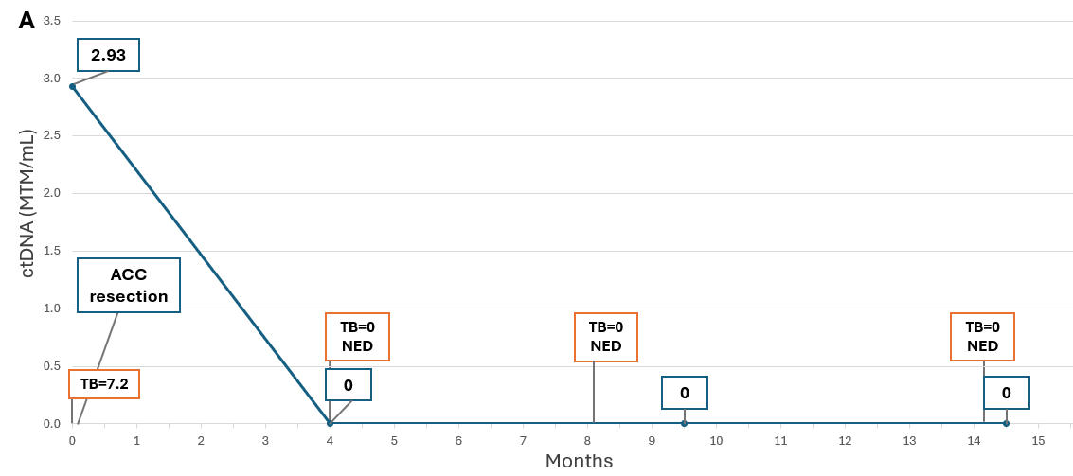

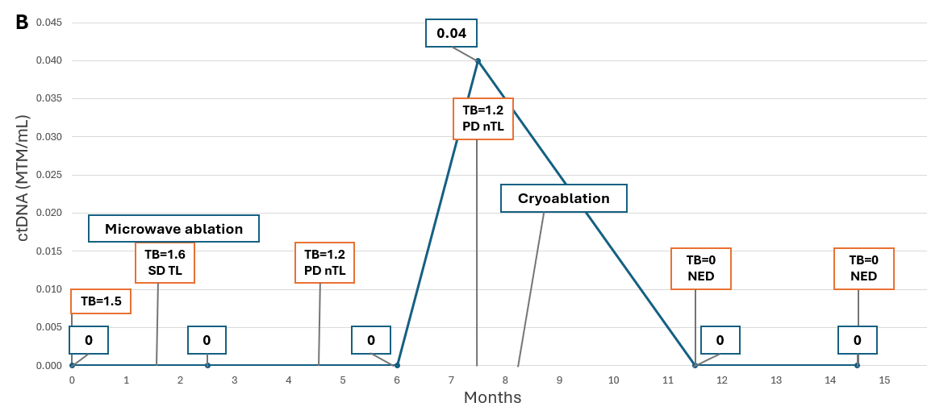
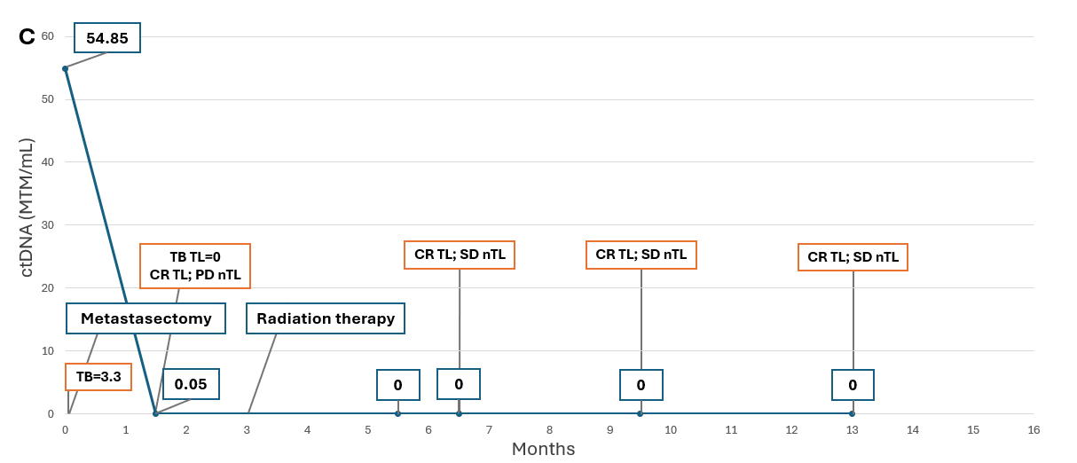
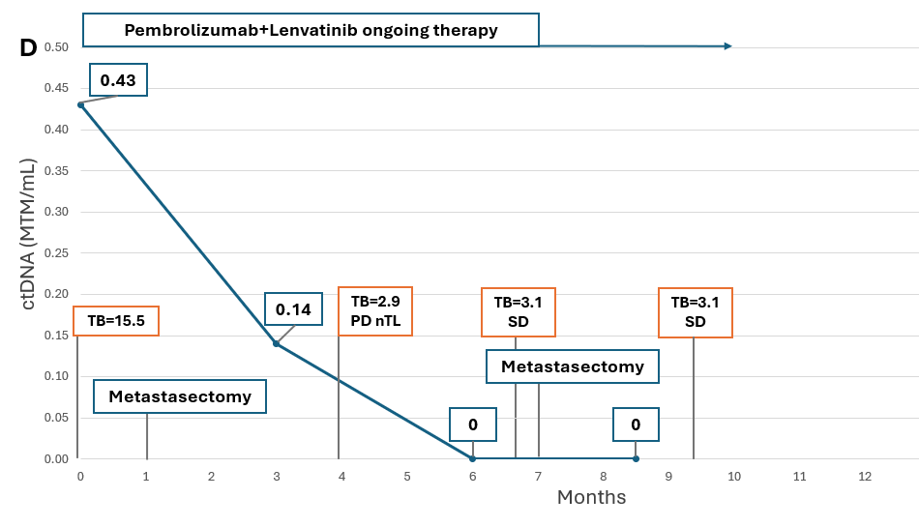
ACC: adrenocortical carcinoma; TB: tumor burden (cm); NED: no evidence of disease; SD: stable disease; TL: target lesion; PD: progression of disease; nTL: non-target lesion; CR: complete response.

Supplemental Figure 3. Timing of positive ctDNA detection in relation to radiographic assessment of structural disease​
​
Panel A shows the distribution of positive ctDNA tests (ctDNA > 0 MTM/mL; n = 61) in relation to the timing of corresponding imaging studies demonstrating structural disease. The x-axis represents days relative to the imaging study (negative values indicate days before imaging, and positive values indicate days after imaging), with the vertical line at day 0 denoting the date of imaging. The y-axis displays ctDNA levels (MTM/mL), with an axis break to accommodate the wide range of values.​
Panel B illustrates the distribution of ctDNA levels across three time intervals (before the scan, on the same day, and after the scan). The data highlight substantial variability in ctDNA values, particularly among samples collected after imaging, where a broader range and higher outliers are observed.​
