Activation of Autophagy Reverses Gemcitabine-induced Immune Inhibition of RAW264.7 Macrophages by promoting TNF-α, IL-6 and MHC-II expression

Shanshan Jiang¹*·Rong Wang¹*·Lu Han^{1*}·Kudelaidi Kuerban²·Li Ye²·Shu Pan¹·Shengnan Li¹·Yongfang Yuan¹

¹ Department of Pharmacy, Shanghai Ninth People’s Hospital, Shanghai JiaoTong University School of Medicine, Shanghai 200011, China
² Department of Microbiological and Biochemical Pharmacy & The Key Laboratory of Smart Drug Delivery, Ministry of Education, School of Pharmacy, Fudan University, Shanghai 201203, China
*These authors contributed equally to this work.

Yongfang Yuan:
Phone: +86 21 5678 6907
Fax: +86 21 5678 6907
E-mail: nmxyyf@126.com

Supplementary Figures
Fig.S1 Cytotoxic effect of LPS, IFN-γ and GEM on RAW264.7 cells. A. RAW 264.7 cells were treated with different concentrations of GEM (0-1000 ng/ml) for 24 h. Cell viability was detected by MTT assay. B. RAW264.7 cells were incubated with 300 IU/ml of IFN-γ or 100 ng/ml of LPS, with or without 100 ng/ml of GEM for 24 h. The cell viability was detected by MTT assay. **P < 0.01 versus control, *P < 0.05 versus control.
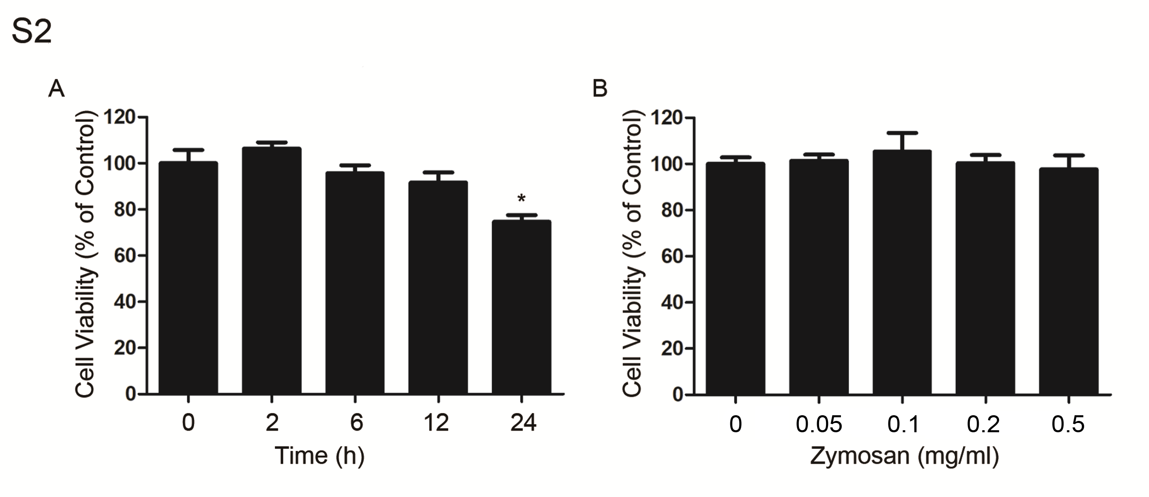
Fig.S2 The cytotoxic of zymosan on RAW264.7 cells. A. RAW264.7 cells were treated with 100 μg/ml of zymosan for different times. The cell viability was detected by MTT assay. B. RAW264.7 cells were treated with different concentrations of zymosan for 2 h. The cell viability was detected by MTT assay. *P < 0.05 versus control.
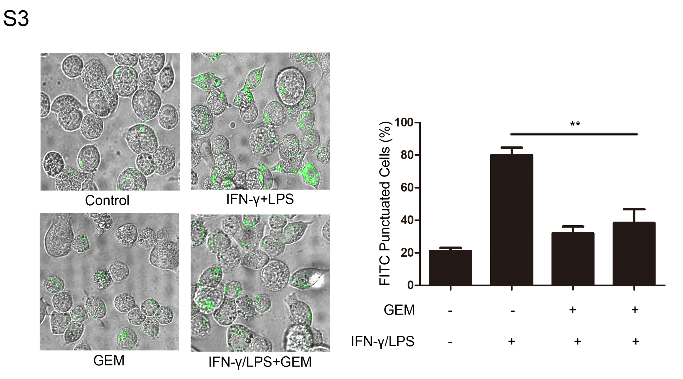
Fig.S3 Phagocytosis is inhibited by GEM in RAW264.7 cells. Cells were treated with 300 IU/ml of IFN-γ and 100 ng/ml of LPS, either alone or in combination with 100 ng/ml of GEM for 24 h. RAW264.7 cells were treated with FITC-labeled E.coli DH 5α for another 2 h and the fluorescent punctuation was observed through confocal microscopy. **P < 0.01.
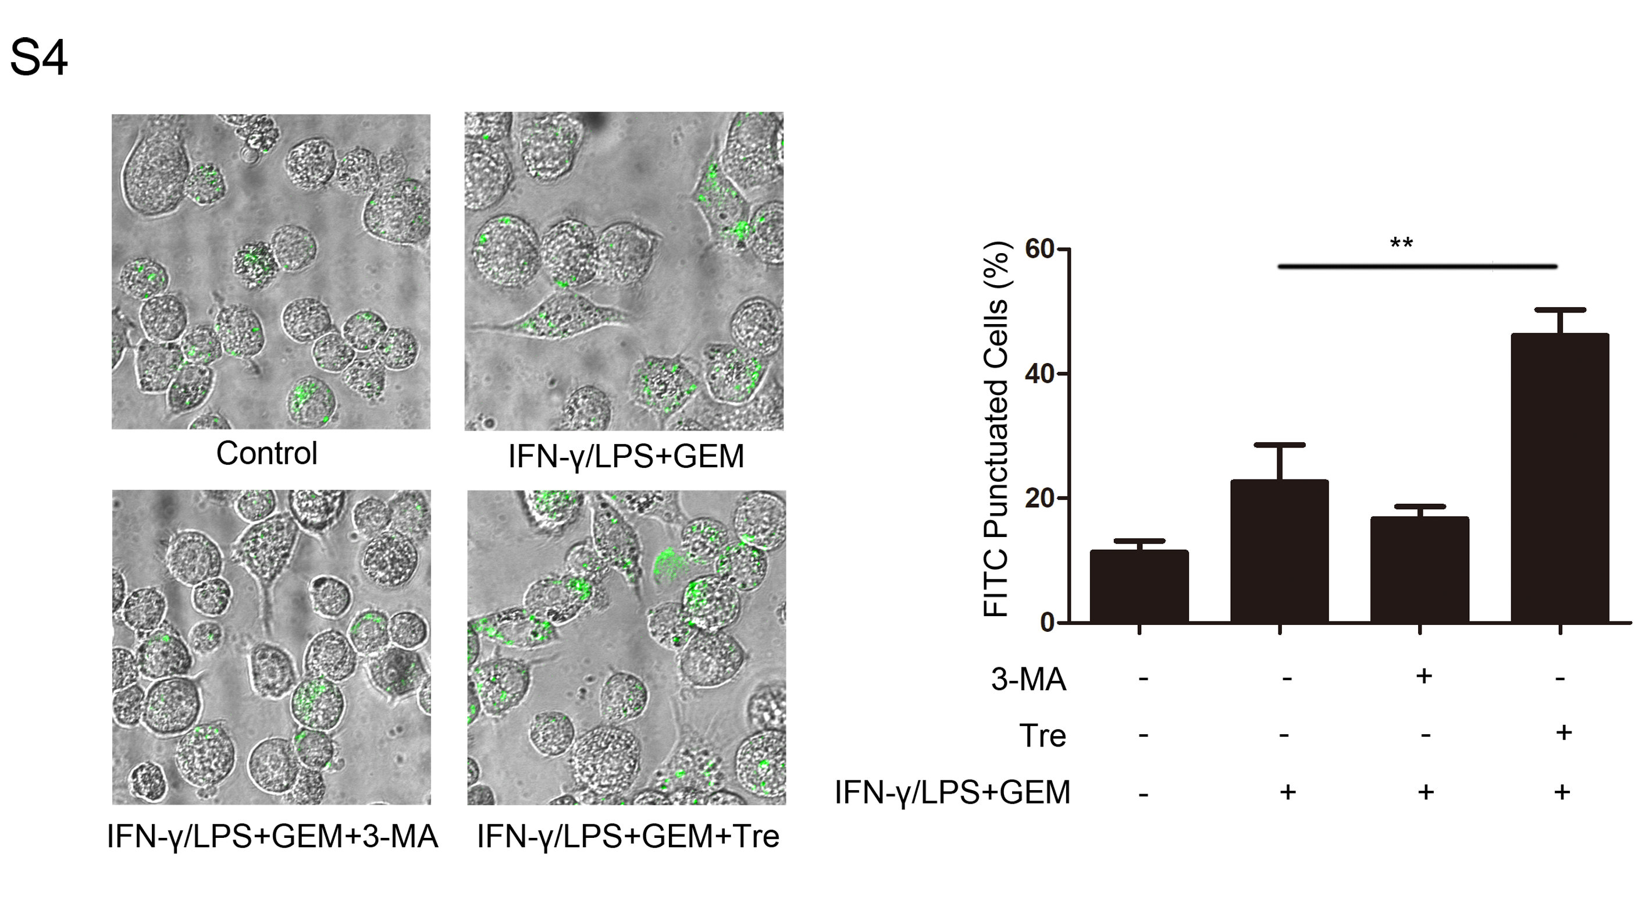
Fig.S4 The role of autophagy in GEM-induced phagocytosis inhibition in RAW264.7 cells. Cells were treated with 300 IU/ml of IFN-γ, 100 ng/ml of LPS and 100 ng/ml of GEM, either alone or in combination with 2mM of 3MA or 25 μM of Tre for 24 h. And then, RAW264.7 cells were treated with FITC-labeled E.coli DH 5α for another 2 h and the fluorescent punctuation was observed through confocal microscopy. **P < 0.01.

