Inactivation of ATG13 Stimulates Chronic Demyelinating Pathologies in Muscle-serving Nerves and Spinal Cord
Molly E Drosen^{1,2}, Sarojini Bulbule², Gunnar Gottschalk^{2,3}, Daniel Peterson^{2,4}, Linda Adrienne Allen¹, Leggy A Arnold¹, Avik Roy^{1,2,3}

¹University of Wisconsin-Milwaukee, Department of Chemistry & Biochemistry, Milwaukee, WI 53211, USA; ²Simmaron R&D lab, 3210 N Cramer Street, Milwaukee, WI 53211, USA; ³Simmaron Research Institute, 948 Incline Way, Incline Village, NV 89451, USA;⁴ Sierra Internal Medicine, Incline village, NV 89451, USA.

Running title: mTOR-ATG13 crosstalk in ME/CFS

To whom correspondence should be addressed:
Avik Roy, Ph.D.
Chief Scientific Officer
Simmaron Research Institute
&
Adjunct Professor of Biochemistry
University of Wisconsin-Milwaukee
3210 N Cramer Street
Suite # CHM 214, 216, and 639
Milwaukee, WI 53211
Email: aroy@simmaron.com
Ph: (773) 263 8182

Legends to Supplementary Figures.

Supplementary Fig. 1. MHY1485 feeding alters health vitals in B6 mice. (A) A schema for the treatment with MHY1485. Alternate grey lines indicate the treatment days. (B) Kaplan-Meier curve demonstrated the probability of survival for 0 (control or vehicle), 5, and 10 mg/kg MHY1485-treated B6 female mice (n=8). Starting age 3-4 weeks. (C) Body temperature in the vehicle (orange), MHY 2mg/Kg (red), and MHY 5mg/Kg (grey) during the study up to 30 days after the first and 15 days after the last treatments. (D) Heart rate was recorded in Mouse Stat Jr (Kent scientific) recorder and plotted as beats per minute or BPM scale in a scatter diagram. (E) Scatter plot of body weights of three different groups ( n=8 per group). ***p<0.001, **p<0.01, and ns =not significant when comparing with 0-day body weight of the respective groups.

Supplementary Fig. 2. Tyrosine hydroxylase expression in striatal tissue of vehicle and MHY1485-fed B6 mice. Briefly, 3-4 weeks-old female B6 mice were fed with vehicle (0.05% methylcellulose) and MHY1485 ( 5 mg/Kg) for 2 weeks, waited for one week after the last dose, and then striatal tissue was dissected as described elsewhere ¹ followed by the lysis with RIPA buffer supplemented with Protease and phosphatase inhibitor cocktail. Immunoblot analysis of Tyrosine Hydroxylase or TH (primary antibody, Cat# 3870479 ; Millipore Sigma; 1:500 dilution), TUJ1 (primary antibody, Cat# YB367568; Thermofisher Scientific; 1:500 dilution), and beta-actin (primary antibody; Thermofisher Scientific; 1:500 dilution) were analyzed. (B) Relative densitometry was assessed by ImageJ software. Results are mean ± SD of three experiments. An unpaired t-test was conducted to test the significance of the mean between two groups that generated T_{1,4} =2.812: *p<0.05 (0.0482).

Supplementary Fig. 3. MHY1485 inhibits autophagy via mTOR-dependent inactivation of ATG13. (A) HEK293T cells were co-transfected ² with FLAG-ATG13 and HA-ULK1 for 24 hrs followed by serum starvation for another 24 hrs. After 24 hrs of starvation, 2 and 5 µM MHY1485 (MHY) were treated for another 5 hours and analyzed for immunoprecipitation (IP) followed by immunoblot (IB) analyses. (B) HEK293T cells were transfected with GFP-tagged LC3 (autophagy marker) after 24 hrs of serum-starvation and then after another 24 hrs, cells were treated with 5 µM MHY for 5 hrs and then stained with Red DND-99 LysoTracker (lysosomal marker). Cells were imaged under FITC (GFP-LC3) and TRITC (LysoTracker) filters of a fluorescence microscope. Similar reactions were set up in a 96-well plate with increasing doses of MHY followed by quantitative fluorescence readings for (C) eGFP-LC3 and (D) lysosomes. (E) Three-to-four weeks’ old female mice were food-deprived for 24 hrs and then treated with vehicle ( n=3) and MHY1485 (n=3) followed by LC3 immunoblot analysis. (F) Densitometric analysis was performed after normalizing with beta-actin immunoblot. Results are displayed as mean ± SD of three different experiments.
Supplementary Fig. 4. Quantification analysis of Autophagosomes. Ten images from n=5 mice per group (2 images/mouse) were evaluated for the quantification of WDFY3-ir autophagosomes. Briefly, images were opened in CaptaVision+ software (Accu-Scope Inc.). The scale bar was calibrated to 6 pixels/µm unit and the total area of the image was calculated. Under the measure tool, manual class counting was selected. After that, the cursor was clicked in each autophagosome. After counting, the total number of counts was divided by the area and the final results were displayed by a scatter histogram. Results are mean ± SD of three experiments. An unpaired t-test was conducted to test the significance of the mean between two groups that generated T_{1,18} =8.159: ****p<0.0001.

Supplementary Fig. 5. The correlation between infiltration of macrophages and autophagy in the muscle tissue of MHY1485-fed mice. (A) Biceps femoris muscle tissue sections of vehicle- and 5mg/Kg MHY1485-fed mice (n=5) were dual immunostained with IBA1 (green) and WDFY3 (red). Nuclei were stained with DAPI (blue). (i-ii) Regions enclosed in dotted rectangles were magnified and shown below. (B) Total 11 images were randomly selected from vehicle- (n = 5 images) and MHY1485- (n=6 images) treated groups, counted for WDFY3-ir and IBA1-ir cells per sq mm tissue, and then correlated by parametric Pearson correlation analysis in GraphPad Prism software.

Supplementary Fig. 6. mTOR siRNA attenuates MHY1485-mediated upregulations of IL6 and RANTES. (A) C20 human microglial cells were treated with mTOR siRNA (Cat #AM16708; ThermoFisher) followed by the treatment with DMSO (control) and 5 µM MHY1485. After another 24 hours, mRNA was isolated and amplified for mTOR (product length = 357 bp; Sense primer: 5’ TCCCCTCCAATGACCCAGTT 3’; Anti-sense primer: 5’ ACCACTGAGGCTTCTGCATC 3’) and GAPDH. (B) Real-time mRNA quantification of mTOR was performed by the SYBRGREEN method. ELISA analyses of (C) IL6 and (D) RANTES were performed after 48 hrs of 5 µM MHY1485 treatment in mtor siRNA-transfected C20 microglia cells. Results are mean ± SD of three different experiments. An unpaired t-test was performed to test the significance of the mean between groups that resulted *p<0.05 (=0.027; t =3.412) vs. IL6 of MHY-treated cells and **p<0.01 ( =0.0031; t=6.367) versus RANTES of MHY-treated cells.
Supplementary Fig. 7. Comparative analyses of gross movement and neurocognitive skill of female non-transgenic (NTg), MHY1485, and Tg-ATG13 mice . (A) N =10 mice/group were analyzed for average speed -1 , 0 , and 2 days after treadmill exercise in open-field gross movement activity test. (B) N=8 mice/group were analyzed for making errors in Barnes maze analysis of spatial learning and memory. (C) Representative image for the performances of NTg, MHY1485-fed, and Tg mice in Barnes maze after 2 days post-treadmill exercise. One-way ANOVA followed by Tukey’s post-hoc analysis had been performed to test the significance of mean between groups. A Pair-wise comparison analysis revealed ***p<0.001 between groups. Ns = no significance. Results are mean ± SD of three different experiments.

Supplementary Fig. 8. Expression of atg13 mRNA in muscle tissue of NTg and Tg-ATG13 mice. (A) Muscle tissue biopsies were lysed by Trizol cell lysis buffer followed by the isolation of mRNA and then amplified for atg13 (product length = 473 bp; Sense primer: 5’ CTGGCCTTTTCCCATCAACTCT 3’; Anti-sense primer: 5’ TCCGGGGGATTCACCATAGG 3’) and GAPDH. (B) Real-time mRNA quantification of atg13 was performed by the SYBRGREEN method. An unpaired t-test was performed to test the significance of the mean between groups that resulted *p<0.05 (=0.019; t_{1,8} =2.951) vs. NTg.

Supplementary Fig. 9. Bielschowsky’s staining for myelinated nerve fibers in skeletal muscle tissue. Transverse sections of muscle tissue (n=3 /group)were stained
by Bielschowsky's staining to show myelinated axonal fibers (red arrowhead indicating nerve fibers) in muscle fibers in wild-type (upper panel) and Tg-ATG13 mice (lower panel). (Inset) Magnified images.

Supplementary Fig. 10. Full images of raw blots.

Supplementary Fig. 1

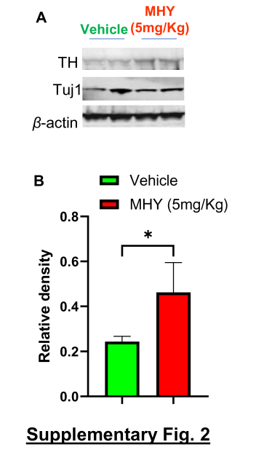
Supplementary Fig. 2
Supplementary Fig. 3

Supplementary Fig. 4

Supplementary Fig. 5

Supplementary Fig. 6
Supplementary Fig. 7

Supplementary Fig. 8
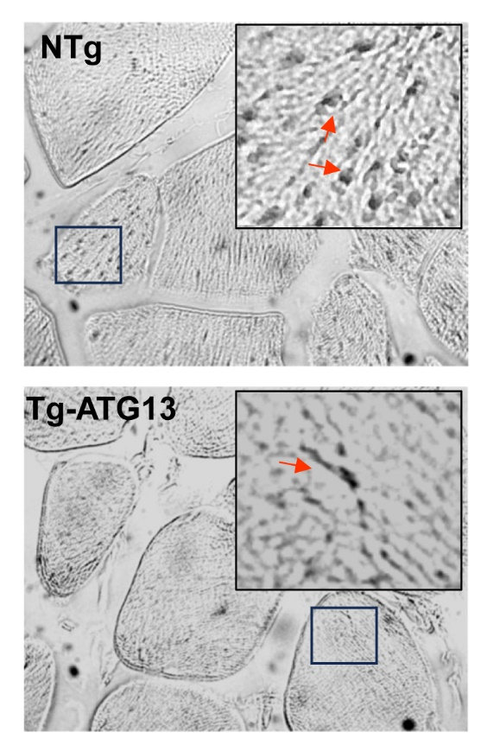
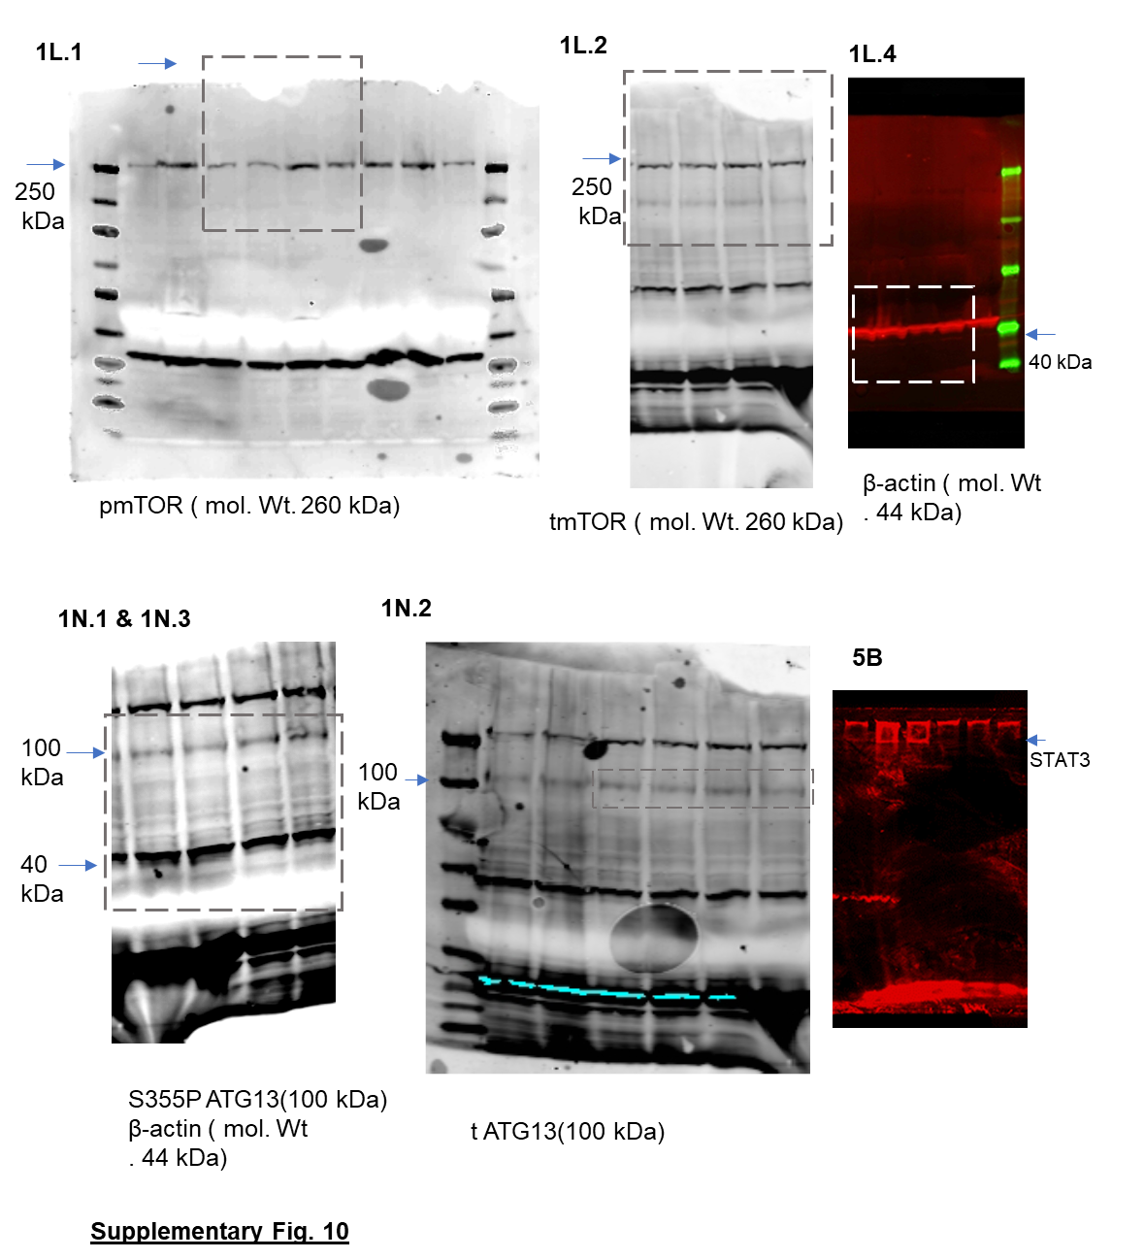
Supplementary Fig. 9

1. Ghosh A, Roy A, Liu X, Kordower JH, Mufson EJ, Hartley DM, Ghosh S, Mosley RL, Gendelman HE, Pahan K. Selective inhibition of nf-kappab activation prevents dopaminergic neuronal loss in a mouse model of parkinson's disease. Proc Natl Acad Sci U S A. 2007;104:18754-18759. doi: 10.1073/pnas.0704908104. PMID: 18000063.
2. Roy A, Jana M, Corbett Grant T, Ramaswamy S, Kordower Jeffrey H, Gonzalez Frank J, Pahan K. Regulation of cyclic amp response element binding and hippocampal plasticity-related genes by peroxisome proliferator-activated receptor α. Cell Reports. 2013;4:724-737. doi: https://doi.org/10.1016/j.celrep.2013.07.028.

