Supplementary material

Table S1. Characteristics of participants in the cross-sectional study (mean ± SD)
Characteristics | Healthy control | COPD
Characteristics | Healthy control | SCOPD | B-ECOPD | NB-ECOPD
 | n=29 | n=63 | n=17 | n=26
Age (Y) | 51.73 ± 10.12 | 63.31 ± 9.07 | 70.12 ± 8.81 | 65.48 ± 10.30
Gender (M/F), n/n | 10/19 | 16/47 | 5/21 | 5/21
BMI | 23.34 ± 2.77 | 23.37 ± 7.80 | 23.39 ± 3.97 | 22.07 ± 3.04
Disease course (Y) | / | 4.36 ± 5.87 | 10.07 ± 9.75 | 5.53 ± 4.60
Smoking index | 216.33 ± 106.49 | 738.63 ± 367.85 | 518.18 ± 252.26 | 591.76 ± 351.00
Comorbidity, n (%)
Atopy | 2 (6.90) | 5 (7.94) | 1 (5.89) | 2 (7.69)
Hypertension | 2 (6.90) | 9 (14.29) | 10 (58.82) | 7 (26.92)
Diabetes | 2 (6.90) | 4 (6.35) | 3 (17.65) | 2 (7.69)
CVD | 0 (0.00) | 3 (4.76) | 1 (5.89) | 2 (7.69)
HLP | 3 (10.34) | 4 (6.35) | 1 (5.89) | 2 (7.69)
GERD | 1 (3.45) | 4 (6.35) | 0 (0.00) | 0 (0.00)
Exacerbation history*
Exacerbations in the past year | / | 2 (0, 3) | 3.5 (3, 5.75) | 3 (2, 4)
Hospitalisation in the past year | / | 0 (0, 1) | 2 (1.25, 3) | 1 (1, 2)
Maintenance inhalation, n (%) | /
LAMA |  | 5 (7.94) | 0 (0.00) | 0 (0.00)
LABA + LAMA |  | 15 (23.81) | 2 (11.76) | 6 (23.08)
LABA + ICS |  | 10 (15.87) | 5 (29.41) | 11 (42.31)
LAMA + ICS |  | 2 (3.17) | 0 (0.00) | 0 (0.00)
LABA + LAMA + ICS |  | 30 (47.62) | 9 (52.94) | 8 (30.77)
No regular inhalation |  | 1 (1.59) | 1 (5.88) | 1 (3.85)
GOLD stage, n (%) | / | n = 55 | n = 13 | n = 23
Stage I |  | 12 (21.82) | 3 (23.08) | 2 (8.70)
Stage II |  | 20 (36.36) | 5 (38.46) | 11 (47.83)
Stage III |  | 16 (39.09) | 3 (23.08) | 5 (21.74)
Stage IV |  | 7 (12.73) | 2 (15.38) | 5 (21.74)
FEV₁ (% pred) | 102.50 ± 14.96 | 60.66 ± 26.57 | 59.79 ± 27.28 | 59.04 ± 24.49
FeNO (ppb) | 16 ± 23 | 28 ± 39 | 24 ± 19 | 26 ± 11

SD: standard deviation; Y: year; M: male; F: female; CVD: cardiovascular disease; HLP: hyperlipidaemia; GERD: gastroesophageal reflux disease; LAMA: long-acting muscarinic antagonist; ICS: inhaled corticosteroids; LABA: long-acting beta-agonist; FEV₁: forced expiratory volume in the first second; FeNO: fractional exhaled nitric oxide; ILC: innate lymphoid cells. *Data were expressed as median and interquartile range; HC: healthy control; SCOPD: stable COPD; B-ECOPD: COPD exacerbation complicated with bacterial infection; NB-ECOPD: COPD exacerbation not complicated with bacterial infection.

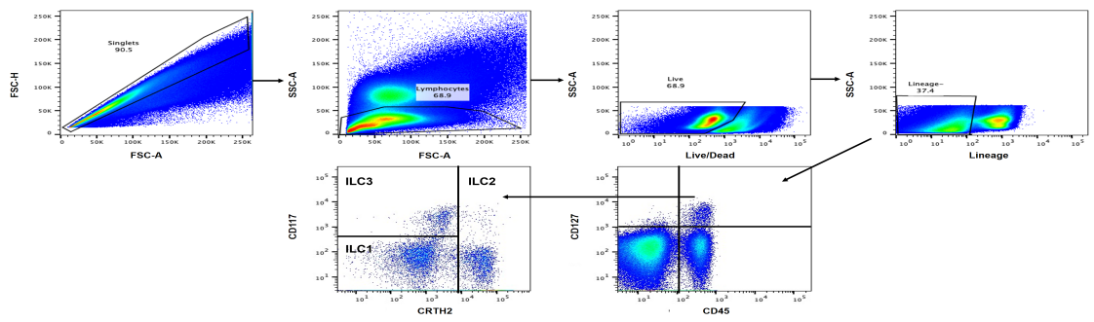
HC |  | SCOPD | B-ECOPD | NB-ECOPD
ILC1 | 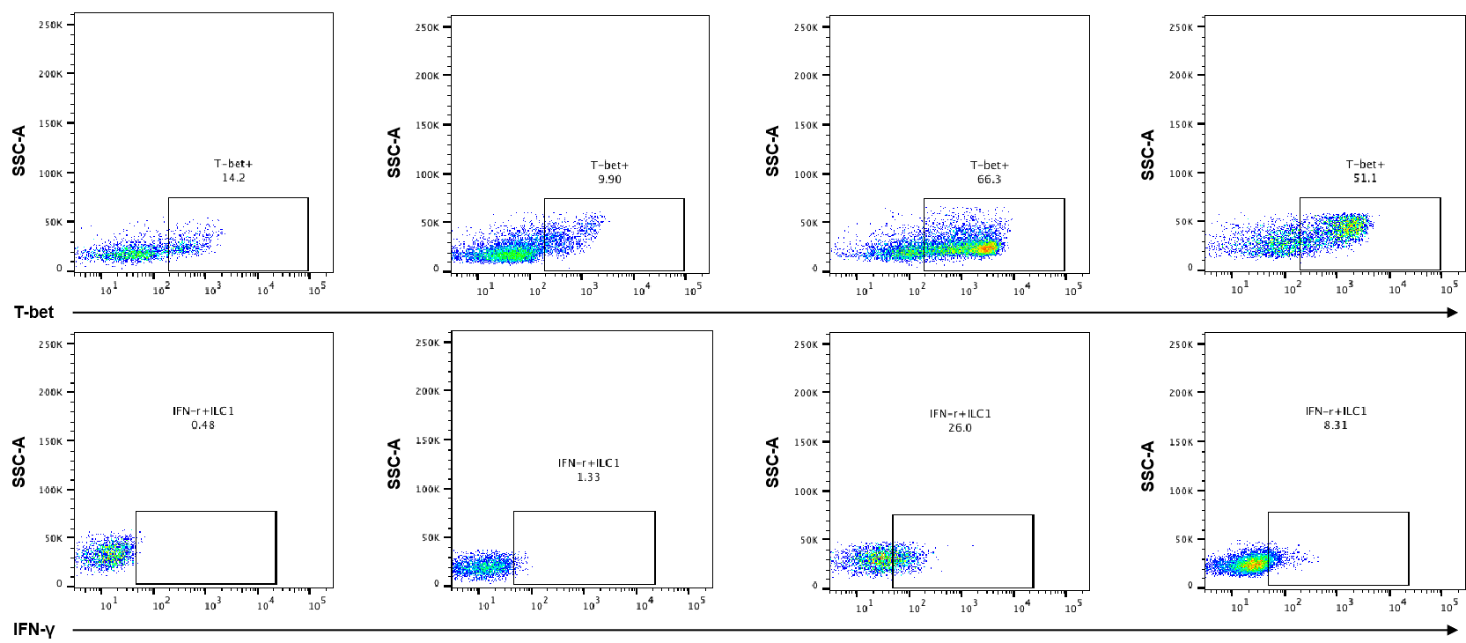
ILC2 | 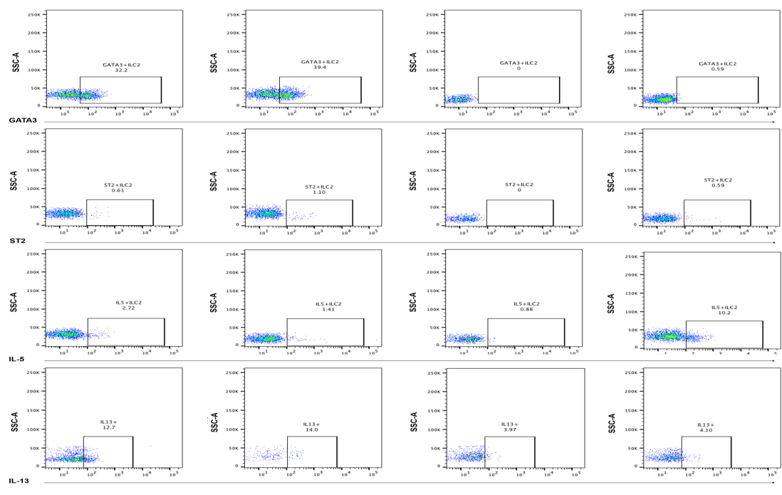
ILC3 | 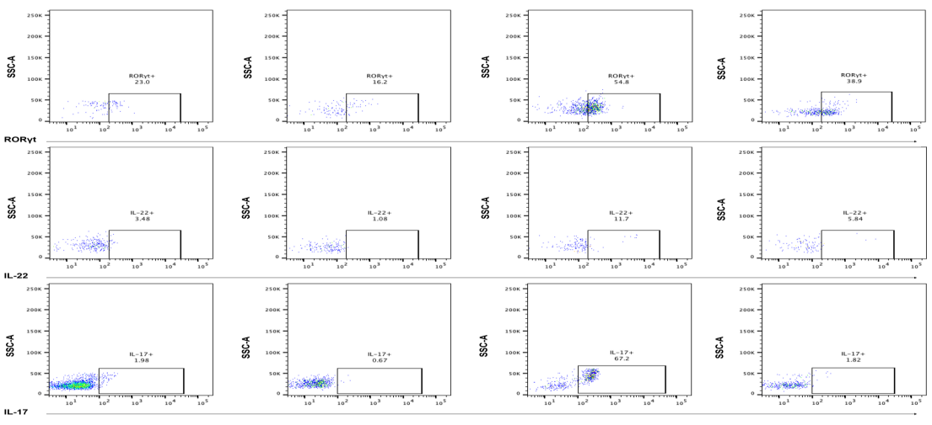

Figure S1. Representative flow cytometric plots demonstrating gating strategy for identifying ILC subsets and their signature markers in peripheral blood of healthy controls and COPD patients. HC: healthy control; SCOPD: stable COPD; COPD exacerbation complicated with bacterial infection; NB-ECOPD: COPD exacerbation not complicated with bacterial infection

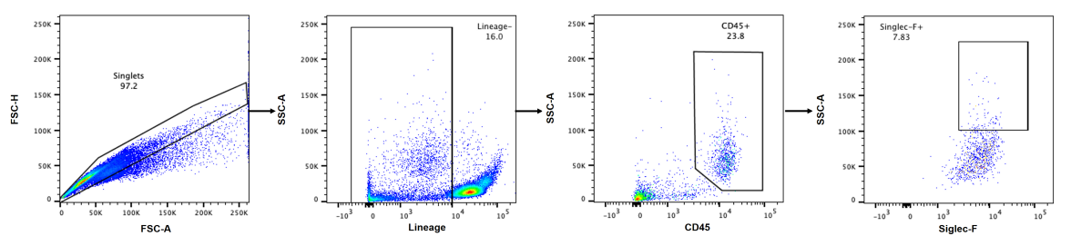
Figure S2. Representative flow cytometric plots demonstrating gating strategy for identifying eosinophils in bronchoalveolar lavage fluid of mice

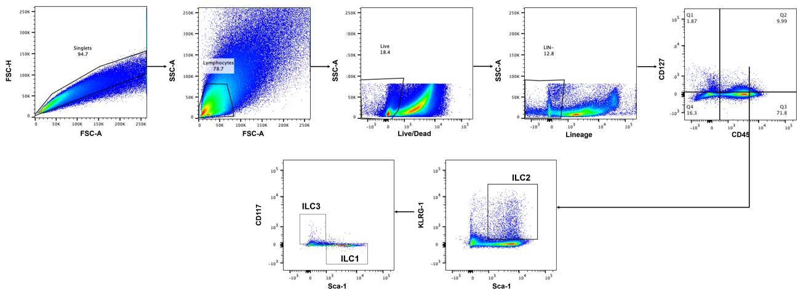

Figure S3. Representative flow cytometric plots demonstrating gating strategy for identifying ILC subsets in lung tissue of mice

