Supplementary data

Supplementary Table 1: Mean Ct values of the DNMT1 and GAPDH genes expression in blood samples derived from patients with ALL in comparison with healthy individuals (Control) using qRT-PCR.
Samples | GAPDH |  |  |  | DNMT1 |  |  |  | Δ  Ct1 |  | Δ  Ct2 |  | Δ- Δ Ct1 | Δ- Δ Ct2 |  | Ct1  Gene expression |  | Ct2  Gene expression | Mean | SD | P  Value
Samples | MeanCt1 |  | MeanCt2 |  | MeanCt1 |  | Mean Ct2
Control |  | 19.33 |  | 20.94 |  | 30.14 |  | 32.00 |  | 10.81 |  | 11.51 | 0.00 |  | 0.00 |  | 1.00 | 1.00 | 1.0 | 0.00
ALL |  | 19.32 |  | 18.89 |  | 26.64 |  | 27.21 |  | 7.32 |  | 8.32 | -3.49 |  | -3.19 |  | 11.24 | 9.13 | 10.18** | 1.4 | 0.01

Samples | GAPDH |  | DNMT3a |  |  | Δ  Ct1 |  | Δ  Ct2 | Δ- Δ Ct1 | Δ- Δ Ct2 |  | Ct1  Gene expression |  | Ct2  Gene expression | Mean | SD | P  Value
Samples | MeanCt1 | MeanCt2 | MeanCt1 | Mean Ct2
Control | 19.87 | 19.99 | 30.84 |  | 31.63 |  | 10.97 | 11.6 | 0.00 |  | 0.00 |  | 1.00 | 1.00 | 1.0 | 0.00
ALL | 19.32 | 18.89 | 26.64 |  | 27.11 |  | 7.10 | 8.2 | -3.87 |  | -3.42 |  | 14.65 | 10.72 | 12.6** | 2.78 | 0.01
Supplementary Table 2: Mean Ct values of the DNMT3a and GAPDH gene expression in blood samples derived from patients with ALL in comparison with healthy individuals (Control) using qRT-PCR.

Supplementary Table 3: Mean Ct values of the MS and GAPDH genes expression in blood samples derived from patients with ALL in comparison with healthy individuals (Control) using qRT-PCR.
Samples | GAPDH |  | MS |  | Δ  Ct1 |  | Δ  Ct2 | Δ- Δ Ct1 | Δ- Δ Ct2 |  | Ct1  Gene expression |  | Ct2  Gene expression | Mean | SD | P  Value
Samples | MeanCt1 | MeanCt2 | MeanCt1 | Mean Ct2
Control | 18.7 | 18.1 | 21.2 | 22.1 |  | 2.5 | 4 | 0.00 |  | 0.00 |  | 1.00 | 1.00 | 1.00 | 0.00
ALL | 19.5 | 19.8 | 19.9 | 20.2 |  | 0.4 | 0.3 | 3.4 |  | 3.4 |  | 0.3 | 0.1 | 0.2** | 0.17 | 0.01

Supplementary Table 4: Mean Ct values of the TET1 and GAPDH gene expression in blood samples derived from patients with ALL in comparison with healthy individuals (Control) using qRT-PCR.
Samples | GAPDH |  |  |  | TET1 |  |  | Δ  Ct1 |  | Δ  Ct2 | Δ- Δ Ct1 | Δ- Δ Ct2 |  | Ct1  Gene expression |  | Ct2  Gene expression | Mean | SD | P  Value
Samples | MeanCt1 |  | MeanCt2 |  | MeanCt1 | Mean Ct2
Control |  | 17.7 |  | 17.1 | 20.2 |  | 21.1 |  | 2.5 | 4 | 0.00 |  | 0.00 |  | 1.00 | 1.00 | 1.00 | 0.00
ALL |  | 20.2 |  | 20.53 | 19.93 |  | 20.15 |  | -0.27 | -0.38 | 3.23 |  | 2.72 |  | 0.37 | 0.16 | 0.27** | 0.26 | 0.01

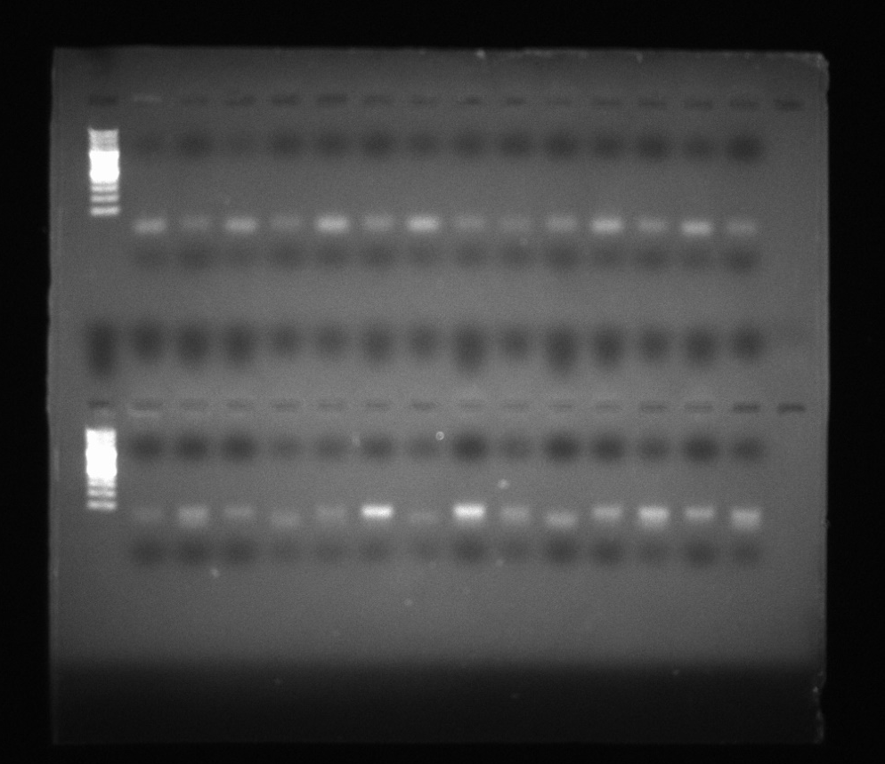

Supp. Figure 1: The original, uncropped agarose gel displays amplified fragments from genomic DNA isolated from healthy individuals (upper gel) and from ALL patients (lower gel). Prior to amplification, the DNA was treated with sodium bisulfite and then subjected to PCR using either methylation-specific or unmethylation-specific primers targeting the promoter region of LAMP1. A 100 bp molecular weight ladder was included as a size reference.

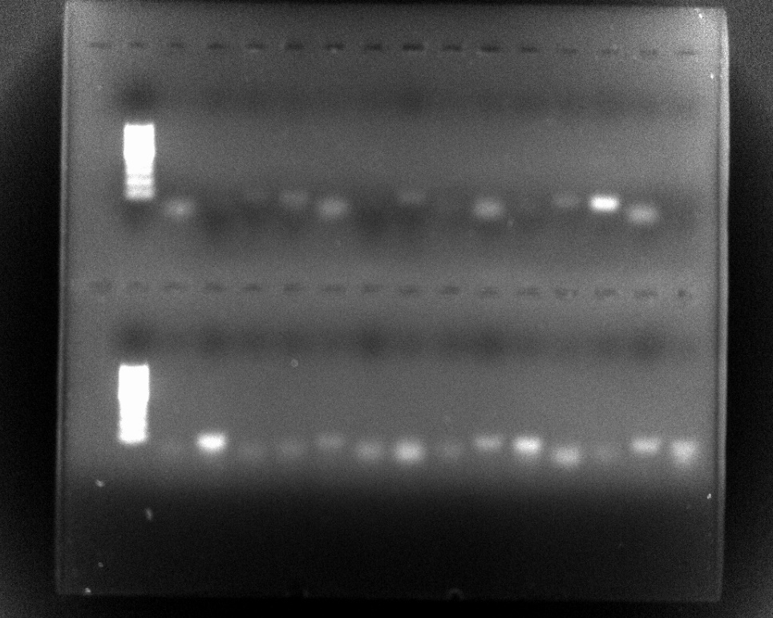

Supp. Figure 2: The original, uncropped agarose gel displays amplified fragments from genomic DNA isolated from healthy individuals (upper gel) and from ALL patients (lower gel). Prior to amplification, the DNA was treated with sodium bisulfite and then subjected to PCR using either methylation-specific or unmethylation-specific primers targeting the promoter region of LAMP2. A 100 bp molecular weight ladder was included as a size reference.
.

Supplementary Table 5: Mean Ct values of the LAMP1 and GAPDH genes expression in blood samples derived from patients with ALL in comparison with healthy individuals (Control) using qRT-PC
Samples | GAPDH |  | LAMP1 |  |  | Δ  Ct1 |  | Δ  Ct2 | Δ- Δ Ct1 | Δ- Δ Ct2 |  | Ct1  Gene expression |  | Ct2  Gene expression | Mean | SD | P  Value
Samples | MeanCt1 | MeanCt2 | MeanCt1 | Mean Ct2
Control | 19.51 | 20.05 | 27.52 |  | 27.41 |  | 8 | 7..36 | 0.00 |  | 0.00 |  | 1.00 | 1.00 | 1.0 | 0.00
ALL | 19.32 | 18.89 | 30.84 |  | 31.63 |  | 11.52. | 12.7 | 3.51 |  | 5.38 |  | 0.09 | 0.02 | 0.06*** | 0.05 | 0.0011

Samples | GAPDH |  | LAMP2 |  |  | Δ  Ct1 |  | Δ  Ct2 |  | Δ- Δ Ct1 | Δ- Δ Ct2 |  | Ct1  Gene expression |  | Ct2  Gene expression | Mean | SD | P  Value
Samples | MeanCt1 | MeanCt2 | MeanCt1 | Mean Ct2
Control | 19.11 | 19.45 | 27.52 |  | 27.41 |  | 8 |  | 7..36 | 0.00 |  | 0.00 |  | 1.00 | 1.00 | 1.0 | 0.00
ALL | 19.13 | 18.79 | 30.64 |  | 31.23 |  | 11.51. |  | 12.44 | 2.80 |  | 4.48 |  | 0.14 | 0.04 | 0.09*** | 0.07 | 0.0011
Supplementary Table 6: Mean Ct values of the LAMP2 and GAPDH genes expression in blood samples derived from patients with ALL in comparison with healthy individuals (Control) using qRT-PCR

Supplementary Table 7: Mean Ct values and fold changes in the ATG5 and GAPDH gene expression in blood samples obtained from patients with ALL in comparison with healthy individuals using the qRT-PCR

Samples | GAPDH |  | ATG5 |  | Δ  Ct1 | Δ  Ct2 | Δ- Δ Ct1 | Δ- Δ Ct2 | Ct1  Fold change | Ct2  Fold change | Mean  Fold change | STDV | P  Value
Samples | MeanCt1 | MeanCt2 | MeanCt1 | Mean Ct2
Control | 19.07 | 19.08 | 29.74 | 29.80 | 10.66 | 10.7 | 0.00 | 0.00 | 1.00 | 1.00 | 1.00 | 0.00
ALL | 18.92 | 18.89 | 28.14 | 27.81 | 9.22 | 8.92 | -1.45 | -1.81 | 2.72 | 3.50 | 3.11* | 0.55 | 0.03

Supplementary Table 8: Mean Ct values and fold changes in the LC3B and GAPDH gene expression in blood samples obtained from patients with ALL in comparison with healthy individuals using the qRT-PCR

Samples | GAPDH |  | LC3B |  | Δ  Ct1 | Δ  Ct2 | Δ- Δ Ct1 | Δ- Δ Ct2 | Ct1  Fold change | Ct2  Fold change | Mean  Fold change | STDV | P  Value
Samples | MeanCt1 | MeanCt2 | MeanCt1 | Mean Ct2
Control | 19.07 | 19.08 | 30.43 | 29.63 | 11.36 | 10.6 | 0.00 | 0.00 | 1.00 | 1.00 | 1.00 | 0.00
ALL | 18.92 | 19.39 | 28.14 | 27.61 | 9.22 | 8.22 | -2.14 | -2.34 | 4.42 | 5.06 | 4.74** | 0.46 | 0.007

