Supplementary figure 3A-F. Arterial content in relation to CBF and CDO₂ in the early phase
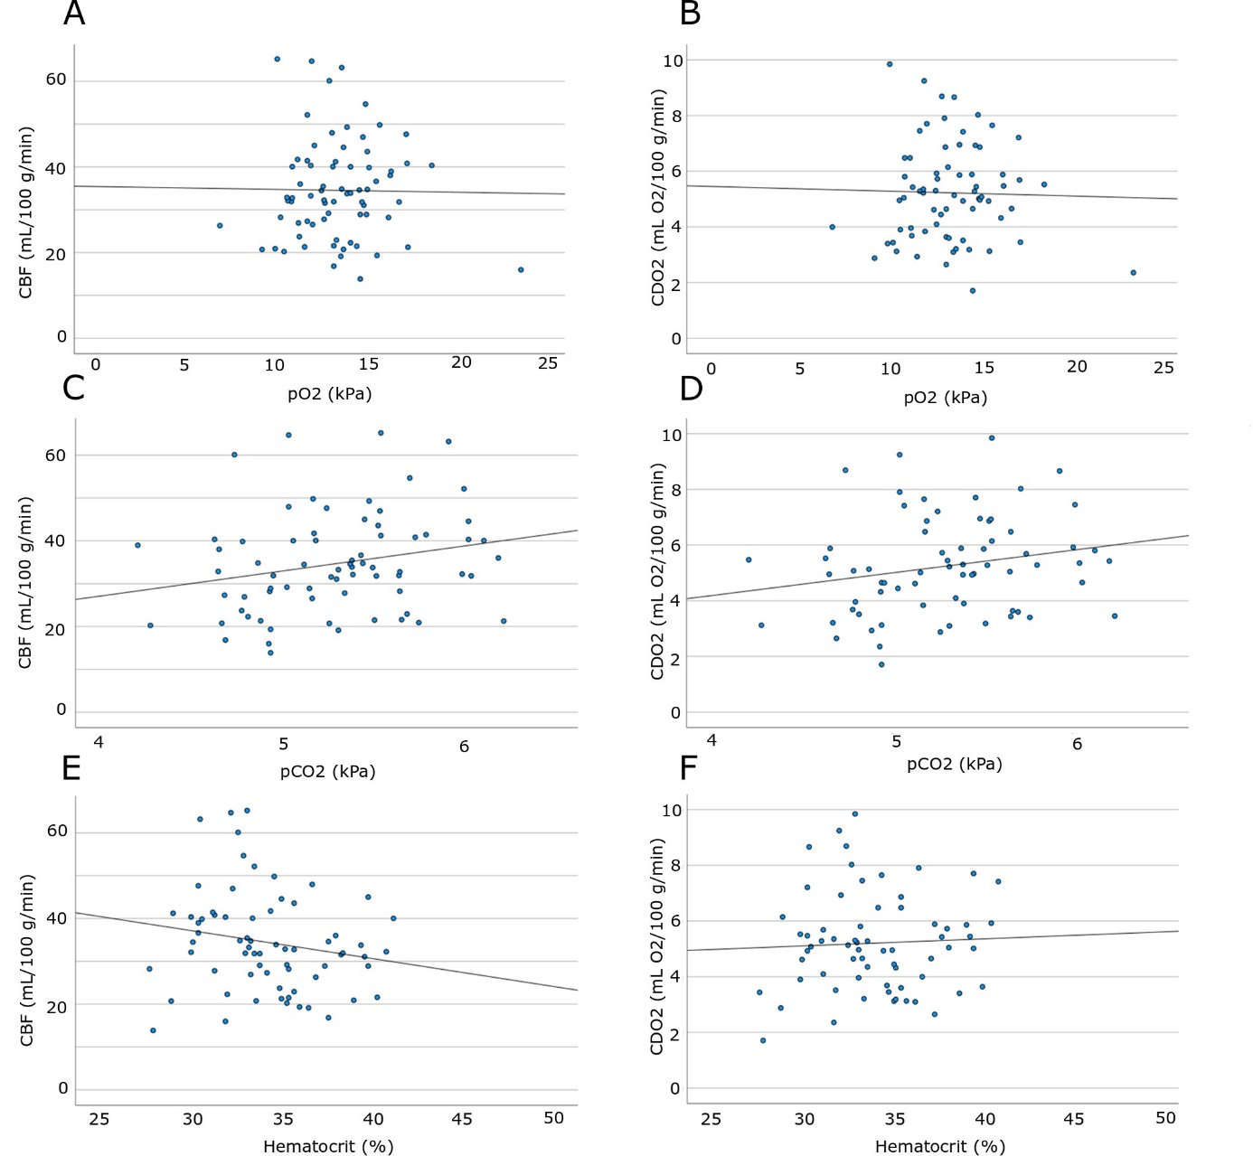
The figure demonstrates the associations among CBF and CDO₂ with pO₂ (2A-B), pCO₂ (2C-D), and hematocrit (2E-F) in the vasospasm phase. Higher pCO₂ was significantly associated (Spearman) with higher CBF (r = 0.27, p < 0.05), but not with CDO₂. There were no association among pO₂ and hematocrit with CBF and CDO₂.
CBF = Cerebral blood flow. CDO₂ = Cerebral delivery of oxygen.

