Supplementary figure 4A-J. Systemic and cerebral physiological variables in relation to CBF and CDO₂ in the vasospasm phase
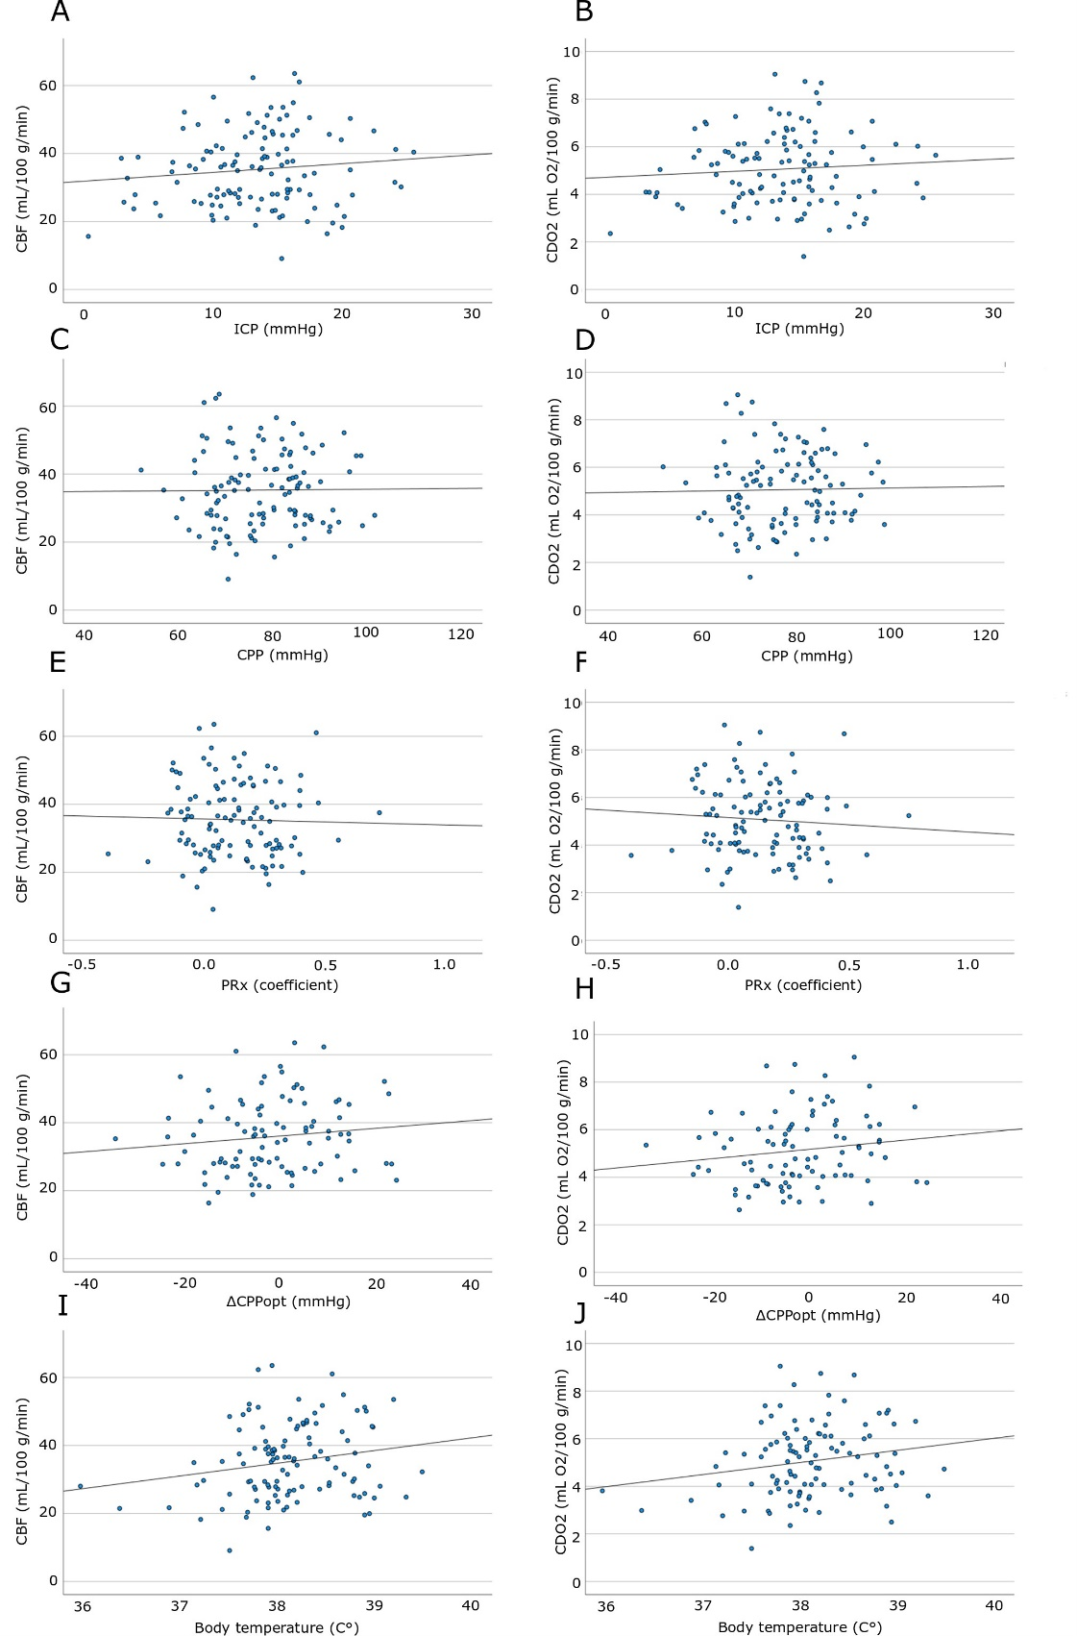
The figure demonstrates the associations among CBF and CDO₂ with ICP (3A-B), CPP (3C-D), PRx (3E-F), ∆CPPopt (3G-H), and body temperature (3I-J) in the vasospasm phase. There was no association among any of the physiological variables with global CBF and CDO₂.
CBF = Cerebral blood flow. CDO₂ = Cerebral delivery of oxygen. CPP = Cerebral perfusion pressure. CPPopt = Optimal CPP. ICP = Intracranial pressure. PRx = Pressure reactivity index. ∆CPPopt = CPP-CPPopt

