Appendix 1.
EMBASE Search Strategy

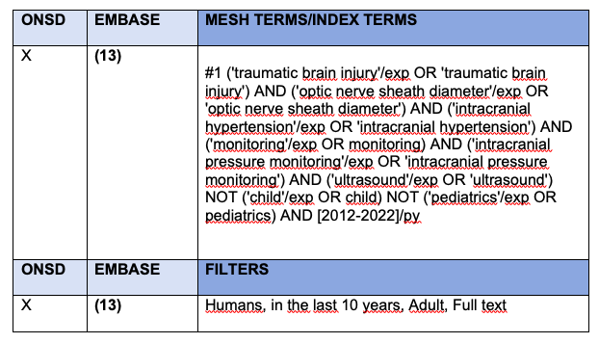

Appendix 2.
PUBMED Search Strategy
