Supplementary Material 2.

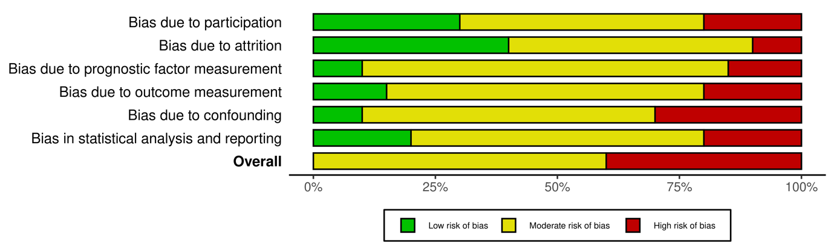
QUIPS Summary Plot
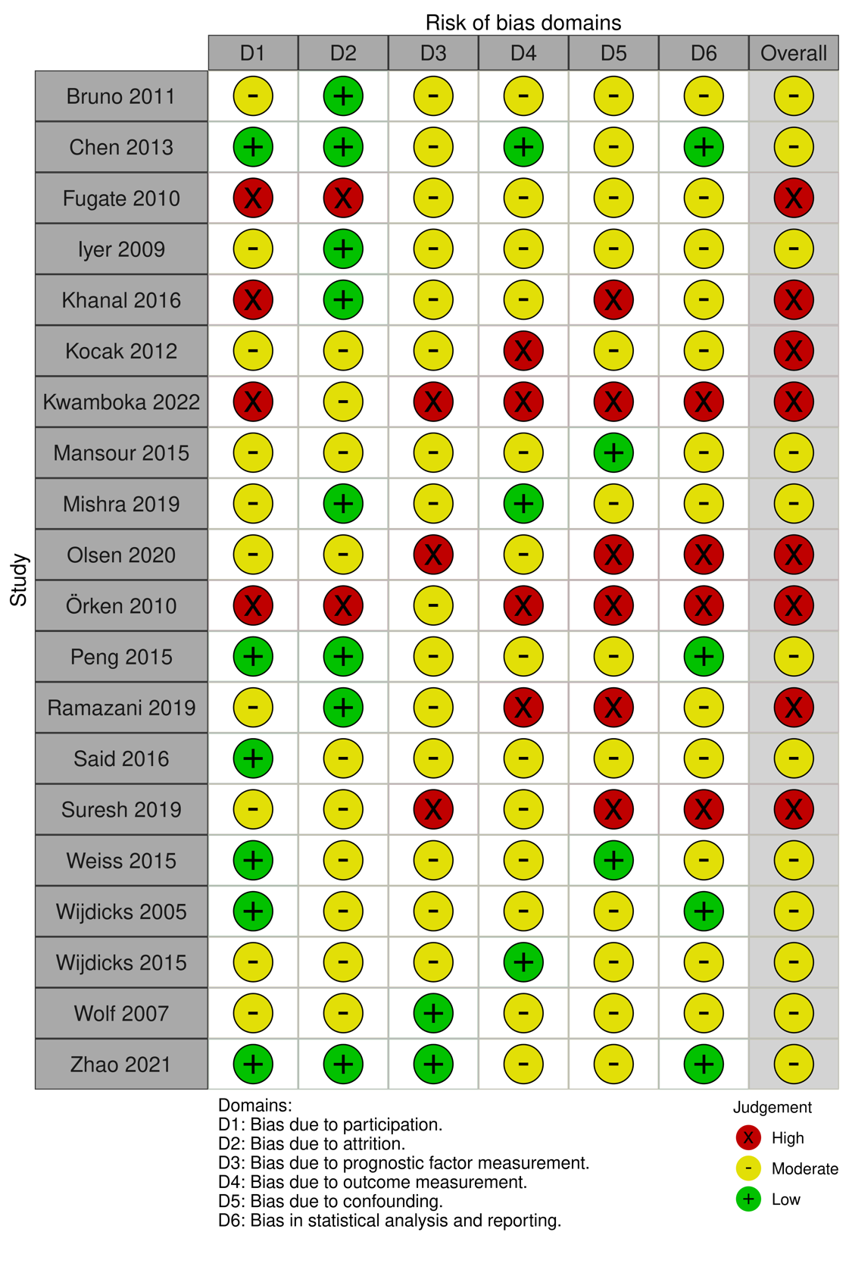
QUIPS Traffic Light Plot

