Prognostic Value of MRI Anatomical Radiologic Scores for one-Year Neurological Outcome after Severe Traumatic Brain Injury

-

Supplementaries

Table of contents

Supplementary Table 1. MRI acquisition parameters for each scanner 3
Supplementary Table 2. Radiological scores 4
Supplementary Figure 1. Illustration of diffuse axonal injury quantification on MRI 6
Supplementary Table 3. Extended Glasgow Outcome Scale (GOSE) 7
Supplementary Table 4. Clinical data at ICU admission 8
Supplementary Table 5. Specific management in ICU 9
Supplementary Table 6. AUC according to each scoring system and each rater 10
Supplementary Table 7. Results of AUC comparison tests between intensivists and radiologists 11
Supplementary Table 8. Sensitivity, specificity, PPV, and NPV analyses for each scoring system according to each rater 12
Supplementary Figure 2. Distribution of GOSE scores by grade and by rater for each radiological scoring system 1
Supplementary Table 9. Median GOSE values for each scoring system and each grade according to each rater 10
References 11

Supplementary Table 1. MRI acquisition parameters for each scanner
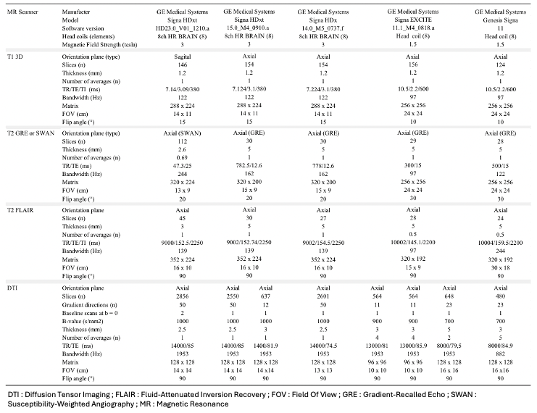

Supplementary Table 2. Radiological scores
DAI Score (1) | Radiological description
Grade 1 | Lobar white matter lesions only
Grade 2 | Corpus callosum lesions
Grade 3 | Brainstem lesions

Firsching Score (2) | Radiological description
Grade 1 | Supratentorial lesions only, without brainstem involvement
Grade 2 | Unilateral brainstem lesions at any level, with or without grade 1 lesions
Grade 3 | Bilateral midbrain lesions, with or without grade 2 lesions
Grade 4 | Bilateral pontine lesions, with or without grade 3 lesions

Hamdeh Score (3) | Radiological description
Grade 1 | Hemispheric lesions
Grade 2 | Corpus callosum lesions
Grade 3 | Brainstem lesions
Grade 4 | Substantia nigra or mesencephalic tegmentum lesions

Stockholm Score (4) | Radiological description
Grade 1 | All patients not fulfilling the criteria for grades 2 to 4
Grade 2 | Unilateral thalamic or pontine lesions, and/or unilateral or bilateral lesions of the corpus callosum or midbrain outside the tegmentum
Grade 3 | Mesencephalic tegmentum lesions (unilateral or bilateral) and/or bilateral thalamic lesions and/or lesions of the posterior limb of the internal capsule
Grade 4 | Bilateral pontine lesions

Trondheim Score (5) | Radiological description
Grade 1 | Lobar or cerebellar white matter lesions
Grade 2 | Corpus callosum lesions
Grade 3 | Unilateral brainstem or thalamic lesions, or unilateral/bilateral basal ganglia lesions
Grade 4 | Bilateral midbrain or thalamic lesions
Grade 5 | Bilateral pontine lesions

Supplementary Figure 1. Illustration of diffuse axonal injury quantification on MRI 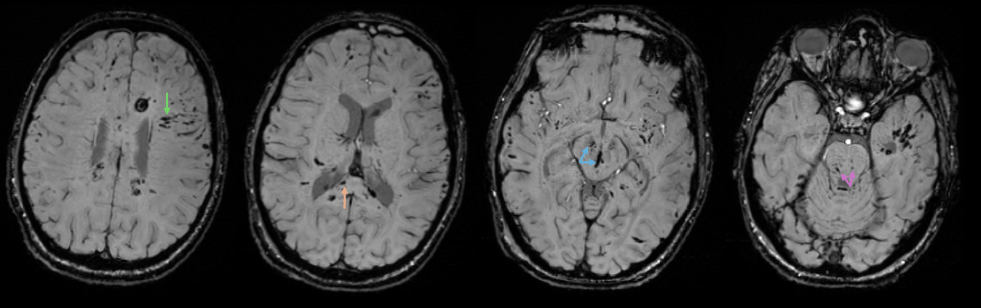
Axial SWI images at different brain levels show multiple diffuse axonal injuries (DAI) appearing as hypointense foci: in the hemispheric lobar white matter (green arrow), the corpus callosum (orange arrow), and bilaterally in the midbrain (blue arrow) and pons (pink arrow). Radiological grading by the three evaluators was concordant: grade 3 on the DAI Score, grade 4 on the Firsching scale, grade 4 on the Hamdeh scale, grade 4 on the Stockholm scale, and grade 5 on the Trondheim scale.

Supplementary Table 3. Extended Glasgow Outcome Scale (GOSE)
The GOSE is a global functional outcome scale comprising eight categories. It subdivides the original categories of severe disability, moderate disability, and good recovery into upper and lower levels.
Score | Level | Description
1 | Death | Patient deceased
2 | Vegetative state | Patient alive but without conscious interaction with the environment
3 | Severe disability, lower level (fully dependent) | Requires daily assistance for all activities
4 | Severe disability, upper level (partially dependent) | Able to perform some activities of daily living independently, but requires assistance for others
5 | Moderate disability, lower level (some dependence) | Independent in most activities of daily living, but limited in social or occupational functioning
6 | Moderate disability, upper level (independent at home) | Independent, but with restrictions in certain complex or social activities
7 | Good recovery, lower level (with residual limitations) | Able to resume almost all activities, with only mild limitations
8 | Good recovery, upper level (return to normal life) | No significant functional deficits ; full retunr to pre-injury activities

Supplementary Table 4. Clinical data at ICU admission

 | Global population  (n = 185) | Good neurological outcome  (GOSE 5-8, n = 74) | Poor neurological outcome  (GOSE 1-4, n = 111) | p-value
Hypotension,  n (%) | 25 (15) | 8 (11) | 17 (15) | 0.59
Use of vasopressors.  n (%) | 109 (76) | 44 (59) | 65 (59) | 0.34
Maximum dose of norepinephrine dose on admission in mg/h.  mean (± SD) | 3.27 (3.20) | 2.53 (2.21) | 3.77 (3.70) | 0.02
Hemoglobin on admission.  mean (± SD) | 12.5 (6.9) | 12.3 (2.2) | 12.6 (8.7) | 0.75
pH on admission.  mean (± SD) | 7.28 (0.50) | 7.33 (0.11) | 7.25 (0.64) | 0.32
Lactate level on admission.  mean (± SD) | 2.6 (2.2) | 2.7 (2.4) | 2.6 (2.0) | 0.56
Hypoxemia.  n (%) | 33 (19) | 14 (19) | 19 (17) | 0.85
ARDS.  n (%) | 57 (40) | 27 (36) | 30 (27) | 0.5
Hypocapnia.  n (%) | 19 (14) | 11 (15) | 8 (7) | 0.21
Hypercapnia.  n (%) | 19 (14) | 11 (15) | 8 (7) | 0.21
Blood glucose.  mean (± SD) | 8.4 (3.9) | 7.7 (3.9) | 8.8 (3.8) | 0.08
Presence of myoclonic epilepsy.  n (%) | 1 (1) | 0 | 1 (1) | 1
Seizure during ICU stay.  n (%) | 7 (5) | 3 (4) | 4 (4) | 1
Mydriasis. n (%)  - Absent  - Unilateral  - Bilateral | 96 (54)  36 (20)  46 (26) | 43 (58)  12 (16)  14 (19) | 51 (46)  24 (22)  32 (29) | 0.11  0.36  0.13
Extracranial orthopedic trauma.  n (%) | 87 (59) | 36 (49) | 51 (46) | 0.94
Extracranial spinal trauma.  n (%) | 40 (27) | 20 (27) | 20 (18) | 0.32

Supplementary Table 5. Specific management in ICU

 | Global population  (n = 185) | Good neurological outcome  (GOSE 5-8, n = 74) | Poor neurological outcome  (GOSE 1-4, n = 111) | p-value
Osmotherapy.  n (%) | 90 (63) | 37 (50) | 53 (48) | 0.68
ICP monitoring.  n (%) | 125 (87) | 51 (69) | 74 (67) | 0.35
EVD placement.  n (%) | 103 (72) | 45 (61) | 58 (52) | 0.83
Therapeutic hypothermia.  n (%) | 29 (20) | 15 (20) | 14 (13) | 0.37
Metabolic suppression.  n (%) | 13 (9) | 7 (9) | 6 (5) | 0.60
Decompressive craniectomy.  n (%) | 19 (11) | 3 (4) | 16 (14) | 0.05
Temperature >38.5° during ICU stay.  n (%) | 35 (24) | 12 (16) | 23 (21) | 0.31
Duration of sedation in days.  mean (± SD) | 15.4 (10.6) | 14.7 (8.3) | 16.4 (8.7) | 0.30
Duration of mechanical ventilation.  mean (± SD) | 22.2 (12.6) | 18.3 (10.8) | 25.1 (13.1) | 0.001
Tracheostomy.  n (%) | 87 (60) | 43 (58) | 44 (40) | 0.52
VAP.  n (%) | 107 (75) | 41 (55) | 66 (59) | 0.18
Infections other than VAP.  n (%) | 55 (38) | 20 (27) | 35 (32) | 0.37
RRT during ICU stay.  n (%) | 4 (3) | 2 (3) | 2 (2) | 1
ICU LOS in days.  mean (± SD) | 36.1 (18.1) | 32.2 (14.6) | 38.9 (19.9) | 0.03
WLST.  n (%) | 54 (32) | 0 | 54 (49) | <0.0001

ICP = intracranial pressure ; EVD = external ventricular drain ; ICU = intensive care unit ; VAP = ventilator-associated pneumoniae ; RRT = renal replacement therapy ; LOS = length of stay ; WLST = withdrawal life-sustaining therapy

Supplementary Table 6. AUC according to each scoring system and each rater

Score | Rater | IC (95%)
DAI | Intensivist | 0.65 [0.58- 0.73]
DAI | Radiologist 1 | 0.69 [0.61- 0.76]
DAI | Radiologist 2 | 0.62 [0.55- 0.7]
Firsching | Intensivist | 0.68 [0.61- 0.75]
Firsching | Radiologist 1 | 0.65 [0.58- 0.71]
Firsching | Radiologist 2 | 0.65 [0.57- 0.72]
Hamdeh | Intensivist | 0.65 [0.57- 0.72]
Hamdeh | Radiologist 1 | 0.69 [0.61- 0.76]
Hamdeh | Radiologist 2 | 0.6 [0.52- 0.68]
Stockholm | Intensivist | 0.66 [0.59- 0.74]
Stockholm | Radiologist 1 | 0.69 [0.62- 0.76]
Stockholm | Radiologist 2 | 0.63 [0.56- 0.71]
Trondheim | Intensivist | 0.68 [0.61- 0.76]
Trondheim | Radiologist 1 | 0.7 [0.63- 0.77]
Trondheim | Radiologist 2 | 0.68 [0.6- 0.75]

Data are shown as n [IC 95%]

Supplementary Table 7. Results of AUC comparison tests between intensivists and radiologists

Score | p-value  (H₀ : Intensivist = Radiol.1) | p-value  (H₀ : Intensivist = Radiol.2) | p-value  (H₀ : Radiol.1 = Radiol.2)
DAI | 0.39 | 0.32 | 0.12
Firsching | 0.46 | 0.29 | 0.94
Hamdeh | 0.33 | 0.14 | 0.07
Stockholm | 0.51 | 0.33 | 0.21
Trondheim | 0.72 | 0.76 | 0.56

Supplementary Table 8. Sensitivity, specificity, PPV, and NPV analyses for each scoring system according to each rater
 | Intensivist |  |  |  |  | Radiologist 1 |  |  |  | Radiologist 2
Scores | Sensitivity | Specificity | PPV | NPV | Sensitivity |  | Specificity | PPV | NPV |  | Sensitivity | Specificity | PPV | NPV
DAI
Grade 1 | 1  [0.97- 1] | 0  [0- 0.05] | 0.6  [0.53- 0.67] | - | 1  [0.97- 1] |  | 0  [0- 0.05] | 0.6  [0.53- 0.67] | - |  | 1  [0.97- 1] | 0  [0- 0.05] | 0.6  [0.53- 0.67] | -
Grade 2 | 0.89  [0.82- 0.94] | 0.28  [0.19- 0.4] | 0.65  [0.57- 0.72] | 0.64  [0.47- 0.78] | 0.75  [0.66- 0.82] |  | 0.58  [0.47- 0.69] | 0.73  [0.64- 0.8] | 0.61  [0.49- 0.71] |  | 0.86  [0.78- 0.91] | 0.35  [0.25- 0.46] | 0.66  [0.58- 0.74] | 0.62  [0.47- 0.75]
Grade 3 | 0.67  [0.57- 0.75] | 0.61  [0.49- 0.71] | 0.72  [0.62- 0.8] | 0.55  [0.44- 0.65] | 0.47  [0.38- 0.56] |  | 0.8  [0.69- 0.87] | 0.78  [0.66- 0.86] | 0.5  [0.41- 0.59] |  | 0.7  [0.61- 0.78] | 0.51  [0.4- 0.62] | 0.68  [0.59- 0.76] | 0.54  [0.42- 0.65]
Firsching
Grade 1 | 1  [0.97- 1] | 0  [0- 0.05] | 0.6  [0.53- 0.67] | - | 1  [0.97- 1] |  | 0  [0- 0.05] | 0.6  [0.53- 0.67] | - |  | 1  [0.97- 1] | 0  [0- 0.05] | 0.6  [0.53- 0.67] | -
Grade 2 | 0.67  [0.57- 0.75] | 0.61  [0.49- 0.71] | 0.72  [0.62- 0.8] | 0.55  [0.44- 0.65] | 0.47  [0.38- 0.56] |  | 0.8  [0.69- 0.87] | 0.78  [0.66- 0.86] | 0.5  [0.41- 0.59] |  | 0.7  [0.61- 0.78] | 0.51  [0.4- 0.62] | 0.68  [0.59- 0.76] | 0.54  [0.42- 0.65]
Grade 3 | 0.46  [0.37- 0.55] | 0.82  [0.72- 0.89] | 0.8  [0.68- 0.88] | 0.5  [0.42- 0.59] | 0.26  [0.19- 0.35] |  | 0.95  [0.87- 0.98] | 0.88  [0.73- 0.95] | 0.46  [0.38- 0.54] |  | 0.32  [0.24- 0.42] | 0.86  [0.77- 0.92] | 0.78  [0.64- 0.88] | 0.46  [0.38- 0.54]
Grade 4 | 0.16  [0.11- 0.24] | 0.97  [0.91- 0.99] | 0.9  [0.7- 0.97] | 0.44  [0.36- 0.51] | 0.13  [0.07- 0.2] |  | 0.99  [0.93- 1] | 0.93  [0.7- 0.99] | 0.43  [0.36- 0.5] |  | 0.15  [0.1- 0.23] | 0.97  [0.91- 0.99] | 0.89  [0.69- 0.97] | 0.43  [0.36- 0.51]
Hamdeh
Grade 1 | 1  [0.97- 1] | 0  [0- 0.05] | 0.6  [0.53- 0.67] | - | 1  [0.97- 1] |  | 0  [0- 0.05] | 0.6  [0.53- 0.67] | - |  | 1  [0.97- 1] | 0  [0- 0.05] | 0.6  [0.53- 0.67] | -
Grade 2 | 0.89  [0.82- 0.94] | 0.28  [0.19- 0.4] | 0.65  [0.57- 0.72] | 0.64  [0.47- 0.78] | 0.75  [0.66- 0.82] |  | 0.58  [0.47- 0.69] | 0.73  [0.64- 0.8] | 0.61  [0.49- 0.71] |  | 0.86  [0.78- 0.91] | 0.35  [0.25- 0.46] | 0.66  [0.58- 0.74] | 0.62  [0.47- 0.75]
Grade 3 | 0.67  [0.57- 0.75] | 0.61  [0.49- 0.71] | 0.72  [0.62- 0.8] | 0.55  [0.44- 0.65] | 0.47  [0.38- 0.56] |  | 0.8  [0.69- 0.87] | 0.78  [0.66- 0.86] | 0.5  [0.41- 0.59] |  | 0.7  [0.61- 0.78] | 0.51  [0.4- 0.62] | 0.68  [0.59- 0.76] | 0.54  [0.42- 0.65]
Grade 4 | 0.57  [0.47- 0.66] | 0.65  [0.54- 0.75] | 0.71  [0.61- 0.79] | 0.5  [0.4- 0.6] | 0.23  [0.17- 0.32] |  | 0.89  [0.8- 0.94] | 0.76  [0.6- 0.88] | 0.44  [0.36- 0.52] |  | 0.56  [0.47- 0.65] | 0.55  [0.44- 0.66] | 0.65  [0.55- 0.74] | 0.46  [0.36- 0.56]
Stockholm
Grade 1 | 1  [0.97- 1] | 0  [0- 0.05] | 0.6  [0.53- 0.67] | - | 1  [0.97- 1] |  | 0  [0- 0.05] | 0.6  [0.53- 0.67] | - |  | 1  [0.97- 1] | 0  [0- 0.05] | 0.6  [0.53- 0.67] | -
Grade 2 | 0.9  [0.84- 0.95] | 0.27  [0.18- 0.38] | 0.65  [0.57- 0.72] | 0.67  [0.49- 0.81] | 0.76  [0.67- 0.83] |  | 0.55  [0.44- 0.66] | 0.72  [0.63- 0.79] | 0.6  [0.48- 0.71] |  | 0.87  [0.8- 0.92] | 0.34  [0.24- 0.45] | 0.66  [0.58- 0.74] | 0.64  [0.48- 0.77]
Grade 3 | 0.6  [0.53- 0.71] | 0.61  [0.49- 0.71] | 0.7  [0.61- 0.79] | 0.52  [0.41- 0.62] | 0.41  [0.32- 0.5] |  | 0.82  [0.72- 0.89] | 0.78  [0.65- 0.86] | 0.48  [0.4- 0.57] |  | 0.64  [0.55- 0.72] | 0.53  [0.41- 0.64] | 0.67  [0.58- 0.75] | 0.49  [0.39- 0.6]
Grade 4 | 0.16  [0.11- 0.24] | 0.97  [0.91- 0.99] | 0.9  [0.7- 0.97] | 0.44  [0.36- 0.51] | 0.14  [0.08- 0.21] |  | 0.99  [0.93- 1] | 0.94  [0.72- 0.99] | 0.43  [0.36- 0.51] |  | 0.14  [0.08- 0.21] | 0.97  [0.91- 0.99] | 0.88  [0.66- 0.97] | 0.43  [0.36- 0.5]
Trondheim
Grade 1 | 1  [0.97- 1] | 0  [0- 0.05] | 0.6  [0.53- 0.67] | - | 1  [0.97- 1] |  | 0  [0- 0.05] | 0.6  [0.53- 0.67] | - |  | 1  [0.97- 1] | 0  [0- 0.05] | 0.6  [0.53- 0.67] | -
Grade 2 | 0.91  [0.84- 0.95] | 0.24  [0.16- 0.35] | 0.64  [0.57- 0.71] | 0.64  [0.46- 0.79] | 0.76  [0.67- 0.83] |  | 0.55  [0.44- 0.66] | 0.72  [0.63- 0.79] | 0.6  [0.48- 0.71] |  | 0.87  [0.8- 0.92] | 0.34  [0.24- 0.45] | 0.66  [0.58- 0.74] | 0.64  [0.48- 0.77]
Grade 3 | 0.73  [0.64- 0.8] | 0.49  [0.38- 0.6] | 0.68  [0.59- 0.76] | 0.55  [0.43- 0.66] | 0.49  [0.4- 0.58] |  | 0.77  [0.66- 0.85] | 0.76  [0.65- 0.84] | 0.5  [0.41- 0.59] |  | 0.76  [0.67- 0.83] | 0.49  [0.38- 0.6] | 0.69  [0.6- 0.76] | 0.57  [0.45- 0.69]
Grade 4 | 0.5  [0.41- 0.6] | 0.8  [0.69- 0.87] | 0.79  [0.68- 0.87] | 0.52  [0.43- 0.61] | 0.3  [0.22- 0.39] |  | 0.95  [0.87- 0.98] | 0.89  [0.75- 0.96] | 0.47  [0.39- 0.55] |  | 0.35  [0.27- 0.44] | 0.86  [0.77- 0.92] | 0.8  [0.66- 0.89] | 0.47  [0.39- 0.55]
Grade 5 | 0.16  [0.11- 0.24] | 0.97  [0.91- 0.99] | 0.9  [0.7- 0.97] | 0.44  [0.36- 0.51] | 0.13  [0.07- 0.2] |  | 0.99  [0.93- 1] | 0.93  [0.7- 0.99] | 0.43  [0.36- 0.5] |  | 0.14  [0.09- 0.22] | 0.97  [0.91- 0.99] | 0.89  [0.67- 0.97] | 0.43  [0.36- 0.51]
Data are shown as n [95% IC]

Supplementary Figure 2. Distribution of GOSE scores by grade and by rater for each radiological scoring system
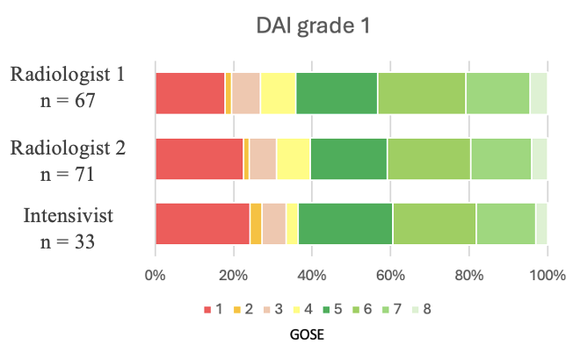
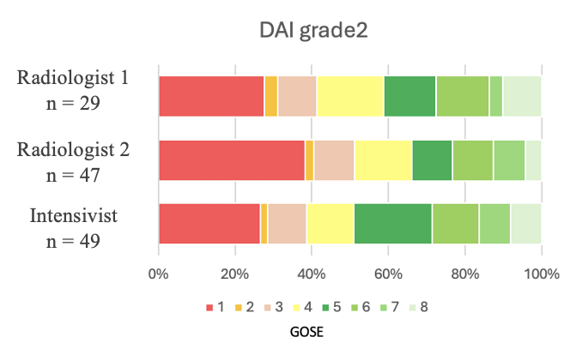
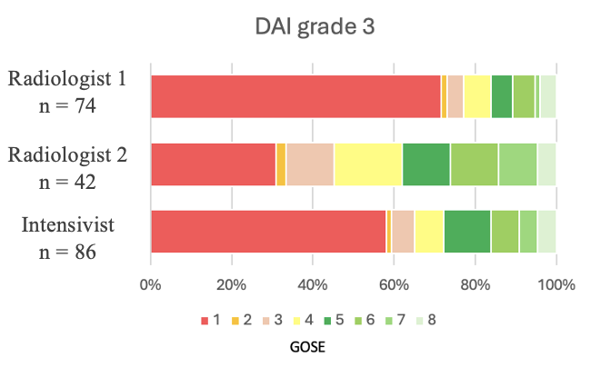
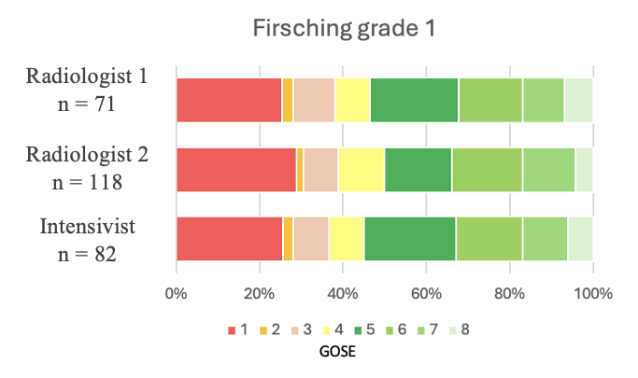
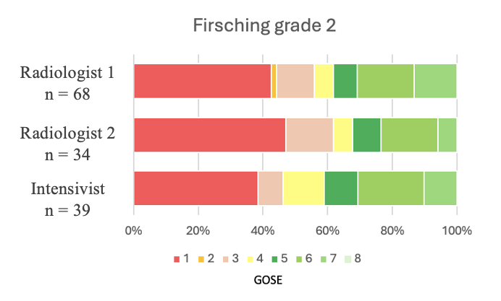
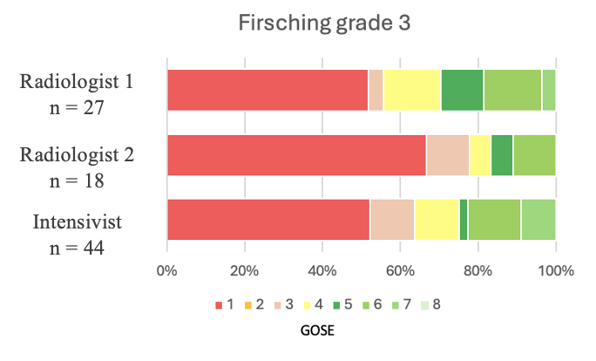
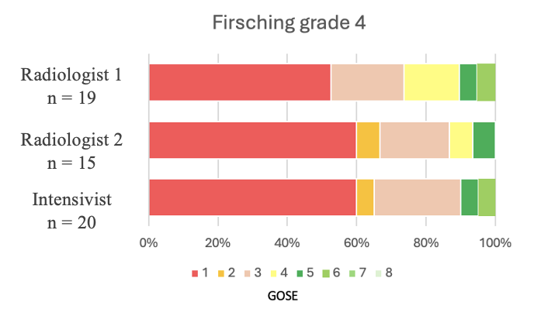

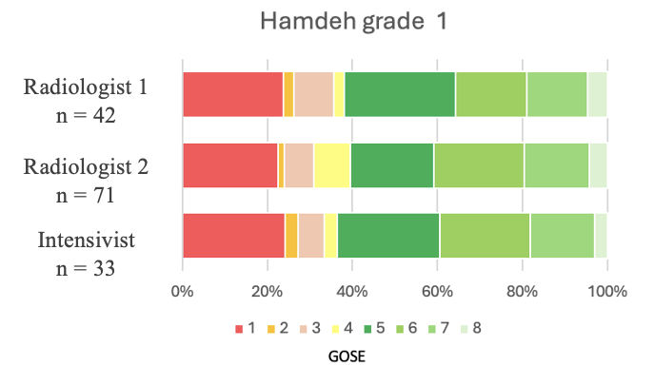
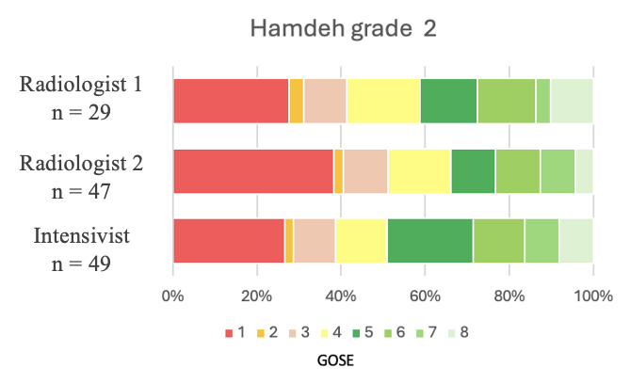
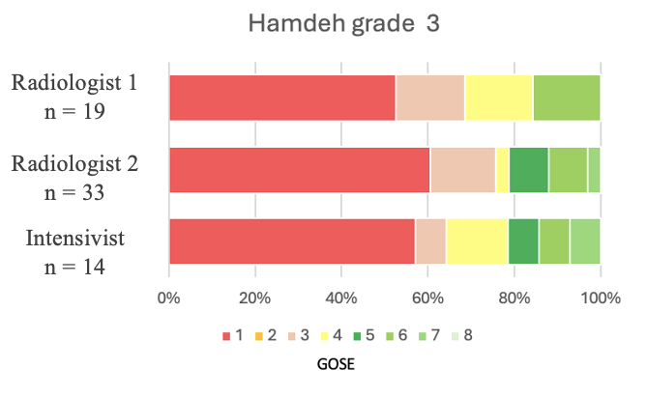
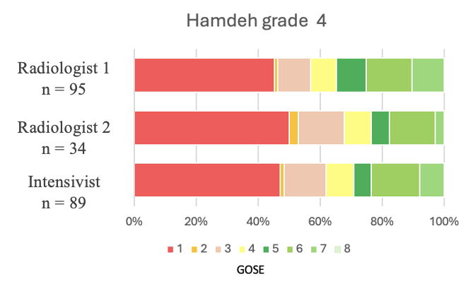

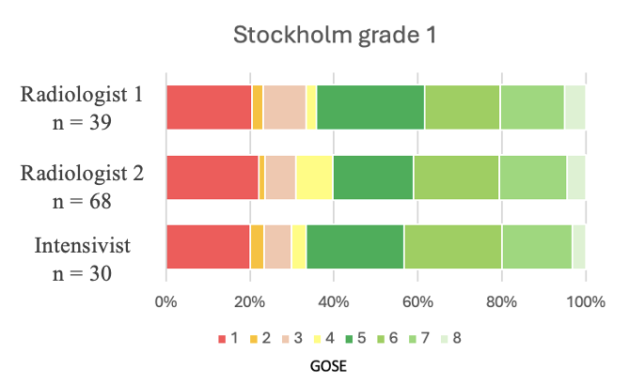
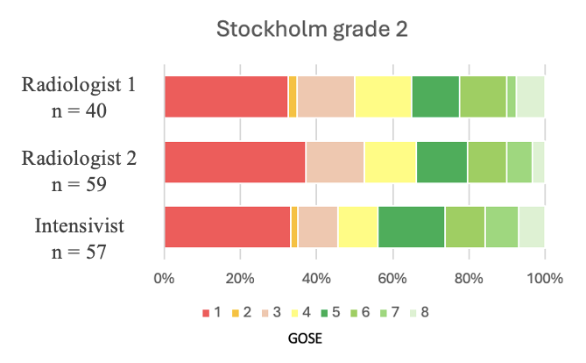
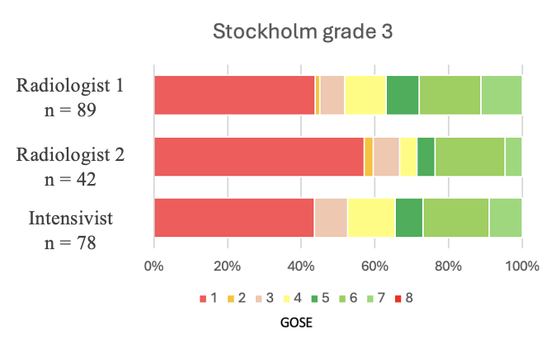
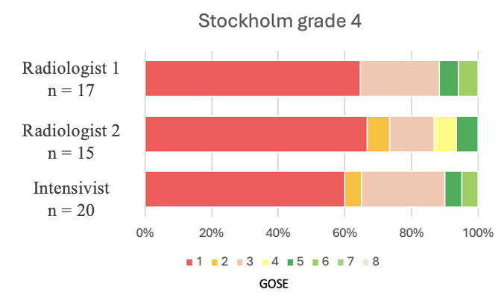

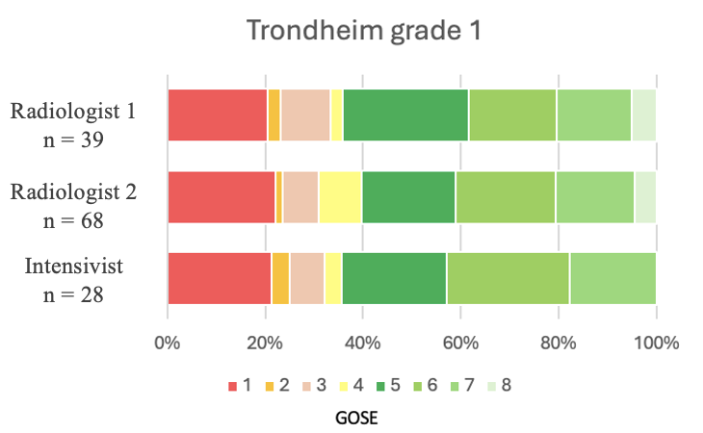
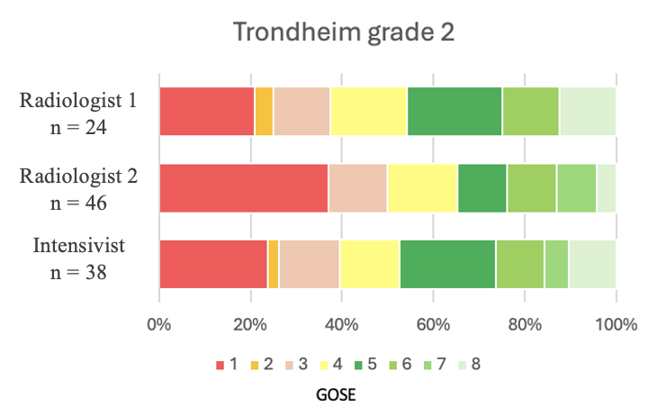
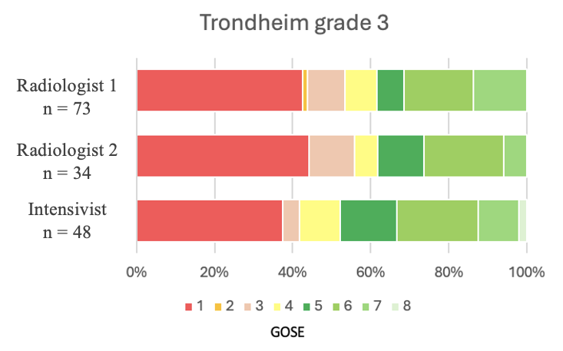
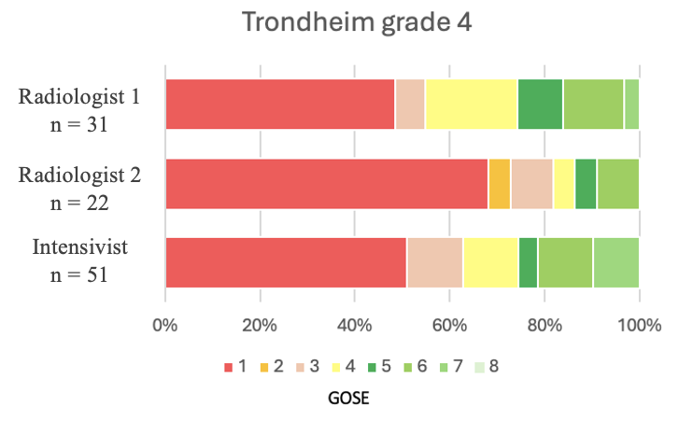
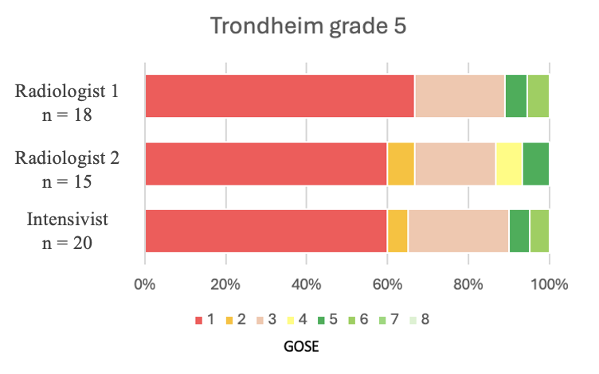

Supplementary Table 9. Median GOSE values for each scoring system and each grade according to each rater
 |  | Rater |  |  | p-values
Score | Intensivist | Radiologist 1 | Radiologist 2 | p-value  (H₀ : Intensivist = Radiol.1) | p-value  (H₀ : Intensivist = Radiol.2) | p-value  (H₀ : Radiol.1 = Radiol.2)
DAI
Grade 1 | 5 [2–6] | 5 [3–6] | 5 [2.25–6] | 0.898 | 0.913 | 0.783
Grade 2 | 4 [1–6] | 3 [1–5] | 4 [1–6] | 0.185 | 0.761 | 0.383
Grade 3 | 3 [1–5] | 1 [1–4] | 3 [1–5] | 0.245 | 0.667 | 0.119
Firsching
Grade 1 | 5 [1.25–6] | 4.5 [1–6] | 5 [1.5–6] | 0.71 | 0.942 | 0.78
Grade 2 | 4 [1–6] | 3 [1–5] | 3 [1–6] | 0.331 | 0.741 | 0.478
Grade 3 | 1 [1–4.25] | 1 [1–3] | 1.5 [1–4.25] | 0.239 | 0.942 | 0.255
Grade 4 | 1 [1–3] | 1 [1–3] | 1 [1–3.5] | 1 | 0.463 | 0.489
Hamdeh
Grade 1 | 5 [2–6] | 5 [3–6] | 5 [2.25–6] | 0.898 | 0.945 | 0.78
Grade 2 | 4 [1–6] | 3 [1–5] | 4 [1–6] | 0.182 | 0.761 | 0.38
Grade 3 | 1 [1–4] | 1 [1–3] | 1 [1–4] | 0.743 | 1 | 0.65
Grade 4 | 3 [1–5] | 1.5 [1–4] | 3 [1–5.5] | 0.549 | 0.61 | 0.33
Stockholm
Grade 1 | 5 [3–6] | 5 [3–6] | 5 [3–6] | 0.823 | 0.844 | 0.995
Grade 2 | 4 [1–6] | 3 [1–5] | 3.5 [1–5] | 0.379 | 0.658 | 0.728
Grade 3 | 3 [1–6] | 1 [1–5] | 3 [1–6] | 0.193 | 0.873 | 0.156
Grade 4 | 1 [1–3] | 1 [1–3] | 1 [1–3] | 0.682 | 0.902 | 0.84
Trondheim
Grade 1 | 5 [2.75–6] | 5 [3–6] | 5 [3–6] | 0.984 | 0.99 | 0.995
Grade 2 | 4 [2.25–5.75] | 4 [1–6] | 4 [2.75–5.25] | 0.25 | 0.988 | 0.294
Grade 3 | 4 [1–6] | 1.5 [1–4] | 3 [1–6] | 0.339 | 0.515 | 0.671
Grade 4 | 1 [1–4.5] | 1 [1–4.75] | 3 [1–4.5] | 0.149 | 0.815 | 0.107
Grade 5 | 1 [1–3] | 1 [1–3] | 1 [1–3] | 0.917 | 0.798 | 0.983

P-values were obtained using the Wilcoxon test. Results are presented as median [IQR]

References
1. Adams JH, Doyle D, Ford I, Gennarelli TA, Graham DI, Mclellan DR. Diffuse axonal injury in head injury: Definition, diagnosis and grading. Histopathology. juill 1989;15(1):49‑59.
2. Woischneck D, Klein S, Rei�berg S, D�hring W, Peters B, Firsching R. Classification of Severe Head Injury Based on Magnetic Resonance Imaging. Acta Neurochir (Wien). 15 avr 2001;143(3):263‑71.
3. Abu Hamdeh S, Marklund N, Lannsjö M, Howells T, Raininko R, Wikström J, et al. Extended Anatomical Grading in Diffuse Axonal Injury Using MRI: Hemorrhagic Lesions in the Substantia Nigra and Mesencephalic Tegmentum Indicate Poor Long-Term Outcome. J Neurotrauma. 15 janv 2017;34(2):341‑52.
4. Tjerkaski J, Nyström H, Raj R, Lindblad C, Bellander BM, Nelson DW, et al. Extended Analysis of Axonal Injuries Detected Using Magnetic Resonance Imaging in Critically Ill Traumatic Brain Injury Patients. J Neurotrauma. 1 janv 2022;39(1‑2):58‑66.
5. Moen KG, Flusund AMH, Moe HK, Andelic N, Skandsen T, Håberg A, et al. The prognostic importance of traumatic axonal injury on early MRI: the Trondheim TAI-MRI grading and quantitative models. Eur Radiol. 19 juin 2024;34(12):8015‑29.

