Supplementary table 1 – Literature search terms
1 | palliative gastrectomy.ti,ab. | 312
2 | palliative total gastrectomy.ti,ab. | 48
3 | palliative subtotal gastrectomy.ti,ab. | 21
4 | palliative resection.ti,ab. | 2234
5 | 1 or 2 or 3 or 4 | 2581
6 | exp Stomach Neoplasms/ | 221931
7 | gastric cancer.ti,ab. | 138103
8 | gastric adenocarcinoma.ti,ab. | 16016
9 | stomach cancer.ti,ab. | 13760
10 | 6 or 7 or 8 or 9 | 261158
11 | exp INTRAOPERATIVE COMPLICATIONS/ or exp POSTOPERATIVE COMPLICATIONS/ | 1156960
12 | complications.ti,ab. | 1785921
13 | Post-operative complications.ti,ab. | 17738
14 | exp HOSPITAL MORTALITY/ or exp MORTALITY/ | 1378262
15 | mortality.ti,ab. | 1939489
16 | exp DISEASE-FREE SURVIVAL/ or exp SURVIVAL ANALYSIS/ or exp SURVIVAL/ or exp SURVIVAL RATE/ | 1398135
17 | overall survival.ti,ab. | 634483
18 | disease-free survival.ti,ab. | 100973
19 | exp Patient Reported Outcome Measures/ | 13943
20 | exp "Quality of Life"/ | 647781
21 | quality of life.ti,ab. | 758027
22 | 11 or 12 or 13 or 14 or 15 or 16 or 17 or 18 or 19 or 20 or 21 | 6677652
23 | 5 and 10 and 22 | 579
24 | palliation.ti,ab. | 36141
25 | palliative.ti,ab. | 173076
26 | non-curative gastrectomy.ti,ab. | 42
27 | palliative surgery.ti,ab. | 4814
28 | palliative treatment.ti,ab. | 16146
29 | adenocarcinoma of gastric antrum.ti,ab. | 10
30 | adenocarcinoma of the gastric antrum.ti,ab. | 39
31 | noncurative.ti,ab. | 1550
32 | gastric carcinoma.ti,ab. | 28755
33 | 5 or 24 or 25 or 26 or 27 or 28 or 31 | 201744
34 | 10 or 29 or 30 or 32 | 265350
35 | 22 and 33 and 34 | 4202

Supplementary table 1 – Newcastle Ottawa Scores for studies
Study Names | S | C | O | T | Study Names | S | C | O | T
Lulu 1974 | 4 | 0 | 3 | 7 | Lello 2007 | 4 | 2 | 3 | 9
Zacho 1974 | 3 | 0 | 3 | 6 | Mizutani 2007 | 4 | 2 | 2 | 8
Zwaveling 1976 | 4 | 0 | 2 | 6 | Nazli 2007 | 4 | 2 | 2 | 8
Nelson 1982 | 4 | 0 | 2 | 6 | Kim 2008 | 4 | 2 | 3 | 9
Yap 1982 | 4 | 0 | 3 | 7 | Pacelli 2008 | 4 | 0 | 3 | 7
Choi 1982 | 3 | 0 | 3 | 6 | Du 2008 | NC
Meijer 1983 | 4 | 0 | 2 | 6 | Lin 2008 | 4 | 1 | 3 | 8
Yan 1985 | 4 | 0 | 3 | 7 | Park 2009 | 4 | 2 | 3 | 9
Cunningham 1987 | 4 | 1 | 3 | 8 | Lupascu 2010 | 4 | 0 | 2 | 6
Bozzetti 1987 | 4 | 0 | 2 | 6 | Huang 2010 | 4 | 2 | 2 | 8
de 1988 | 4 | 0 | 2 | 6 | Hioki 2010 | 4 | 2 | 3 | 9
Butler 1989 | 3 | 1 | 3 | 7 | Sah 2010 | 4 | 2 | 3 | 9
Haugstvedt 1989 | 4 | 2 | 3 | 9 | Ozer 2010 | 4 | 1 | 2 | 7
Carmalt 1990 | 4 | 0 | 3 | 7 | Li 2010 | 4 | 1 | 2 | 7
Habu 1990 | 4 | 1 | 3 | 8 | Xue 2010 | 4 | 2 | 3 | 9
Nakajima 1991 | 4 | 0 | 1 | 5 | Turanli 2010 | 4 | 2 | 2 | 8
Yonemura 1991 | 3 | 0 | 2 | 5 | Schauer 2011 | 4 | 2 | 3 | 9
Monson 1991 | NC |  |  |  | Al-Amawi 2011 | 4 | 0 | 2 | 6
Maehara 1992 (1) | 4 | 2 | 3 | 9 | Tanizawa 2011 | 4 | 0 | 3 | 7
Maehara 1992 | 4 | 0 | 2 | 6 | Zhang 2011 | 4 | 0 | 3 | 7
Huguier 1992 | 4 | 0 | 2 | 6 | Izuishi 2011 | 4 | 2 | 3 | 9
Maehara 1992 | 4 | 0 | 2 | 6 | Lai 2011 | 4 | 2 | 3 | 9
Baba 1992 | 4 | 2 | 3 | 9 | Miki 2012 | 4 | 2 | 2 | 8
Geoghegan 1993 | 4 | 0 | 2 | 6 | Kokkola 2012 | 4 | 2 | 3 | 9
Ti 1993 | NC |  |  |  | Shim 2012 | 2 | 1 | 2 | 5
Crookes 1995 | 4 | 0 | 2 | 6 | Alonso-Larraga 2012 | 4 | 0 | 3 | 7
Chow 1995 | 4 | 2 | 3 | 9 | Tokunaga 2012 | 4 | 1 | 3 | 8
Arak 1996 | 4 | 2 | 2 | 8 | Amaral 2012 | 3 | 0 | 3 | 6
Saito 1996 |  |  |  |  | Naka 2012 | 4 | 1 | 3 | 8
Cenitagoya 1998 | 4 | 1 | 3 | 8 | Chang 2012 | 4 | 2 | 2 | 8
Kikuchi 1998 | 4 | 2 | 3 | 9 | Kang 2013 | 4 | 2 | 2 | 8
Sanchez-Bueno 1998 | 4 | 2 | 3 | 8 | Keranen 2013 | 4 | 2 | 3 | 9
Piso 1998 | NC |  |  |  | He 2013 | 4 | 2 | 3 | 9
Ouchi 1998 | 4 | 2 | 2 | 8 | Ikeguchi 2013 | 4 | 2 | 3 | 9
Piso, | NC |  |  |  | Xia 2014 | 3 | 2 | 3 | 8
Lo 1999 | 4 | 2 | 2 | 8 | Kwon 2014 | 4 | 2 | 2 | 8
Doglietto 1999 | 4 | 2 | 2 | 8 | Zeeneldin 2014 | 4 | 2 | 3 | 9
Llanos 1999 | 4 | 0 | 2 | 6 | Zeng 2014 | 4 | 2 | 3 | 9
Saidi 1999 | 4 | 0 | 3 | 7 | Jeong 2014 | 4 | 2 | 3 | 9
Doglietto 2000 | 4 | 2 | 2 | 8 | Kim 2014 | 4 | 1 | 3 | 8
Ikeguchi 2001 | 4 | 2 | 2 | 8 | da 2015 | 4 | 2 | 3 | 9
Hanazaki 2001 | 4 | 0 | 2 | 6 | Matsumoto 2015 | 4 | 2 | 3 | 9
Dhar 2001 | 4 | 2 | 3 | 9 | Yao 2015 | 4 | 0 | 3 | 7
Fujisaki 2001 | 4 | 2 | 2 | 8 | Yang 2015 | 4 | 2 | 2 | 8
Bonenkamp 2001 | 4 | 1 | 3 | 8 | Ebinger 2016 | 4 | 2 | 2 | 8
Liu 2002 | 3 | 1 | 3 | 7 | Dong 2016 | 4 | 0 | 2 | 6
Wang 2002 | 4 | 2 | 3 | 9 | Coimbra 2016 | 4 | 2 | 2 | 8
Collard 2003 | 3 | 2 | 3 | 8 | Chiu 2016 | 4 | 2 | 2 | 8
Yoshikawa 2003 | 4 | 2 | 2 | 8 | Musri 2016 | 4 | 2 | 3 | 9
Gill, | 3 | 2 | 2 | 7 | Ikeguchi 2016 | 4 | 0 | 3 | 7
Kobayashi 2004 | 4 | 2 | 2 | 8 | Nie 2016 | 4 | 2 | 3 | 9
Moriwaki 2004 | 4 | 0 | 3 | 7 | Tokunaga 2016 | 4 | 2 | 3 | 9
Kahlke 2004 | 4 | 0 | 2 | 6 | Al-Batran 2017 | RCT
Medina-Franco | 4 | 0 | 3 | 7 | Fujitani 2017 | 4 | 0 | 3 | 7
Zhang 2004 | 4 | 2 | 3 | 9 | Hsu 2017 | 4 | 2 | 1 | 7
Gorbunov 2005 | 4 | 1 | 2 | 7 | Fornaro 2017 | 4 | 2 | 2 | 8
Kunisaki 2005 | 3 | 1 | 3 | 7 | Yuan 2017 | 4 | 2 | 3 | 9
Alici 2006 | 4 | 2 | 3 | 9 | Fukuchi 2018 | 4 | 2 | 3 | 9
Saidi 2006 | 4 | 0 | 2 | 6 | Warschkow 2018 | 4 | 2 | 2 | 8
Samarasam 2006 | 4 | 0 | 3 | 7 | Picado 2018 | 4 | 2 | 2 | 8
Onate-Ocana 2007 | 4 | 0 | 2 | 6 | Yuan 2018 | 4 | 2 | 2 | 8
Nazli 2007 | 4 | 0 | 2 | 6 | Yang 2019 | 3 | 2 | 3 | 8
Lim 2007 | 4 | 2 | 3 | 9 | Omori 2019 | 3 | 2 | 2 | 7
 |  |  |  |  | Matsubara 2019 | 2 | 2 | 2 | 6

Abbreviations: S: Selection, C: Comparability, O: Outcome, T:Total out of 9, NC: Non-comparative cohort

Supplementary Figure 1 – Forest plots showing odds ratios and 95% confidence intervals for palliative gastrectomy compared to curative surgery for A) overall complications B) major complications C) anastomotic leak D) mortality
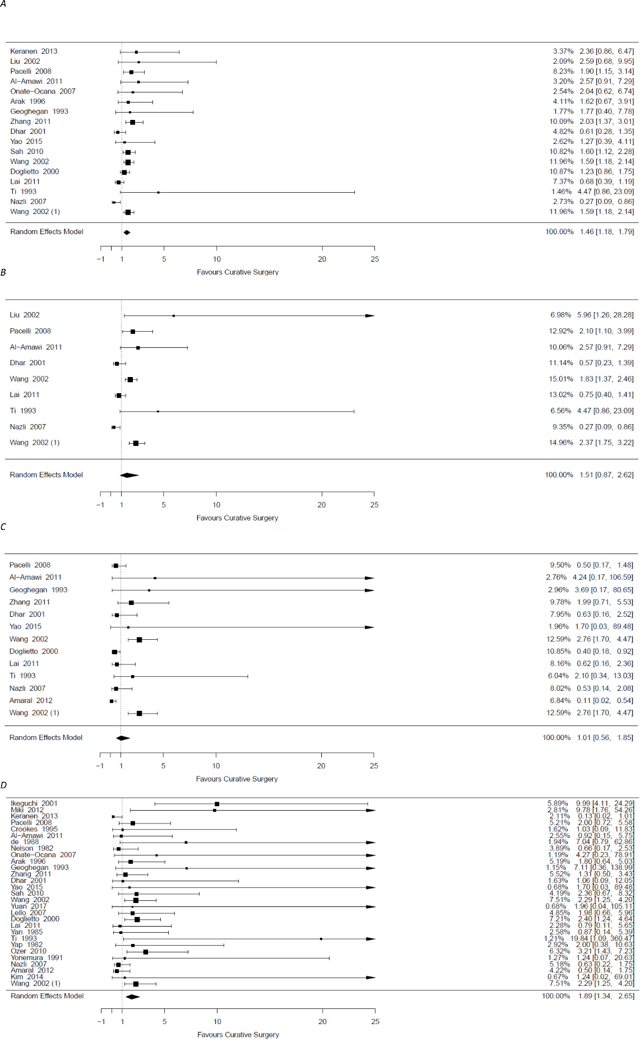
Supplementary Figure 2 – Forest plots showing odds ratios and 95% confidence intervals for palliative gastrectomy compared to non tumour resective surgery for A) overall complications B) major complications C) anastomotic leak D) mortality
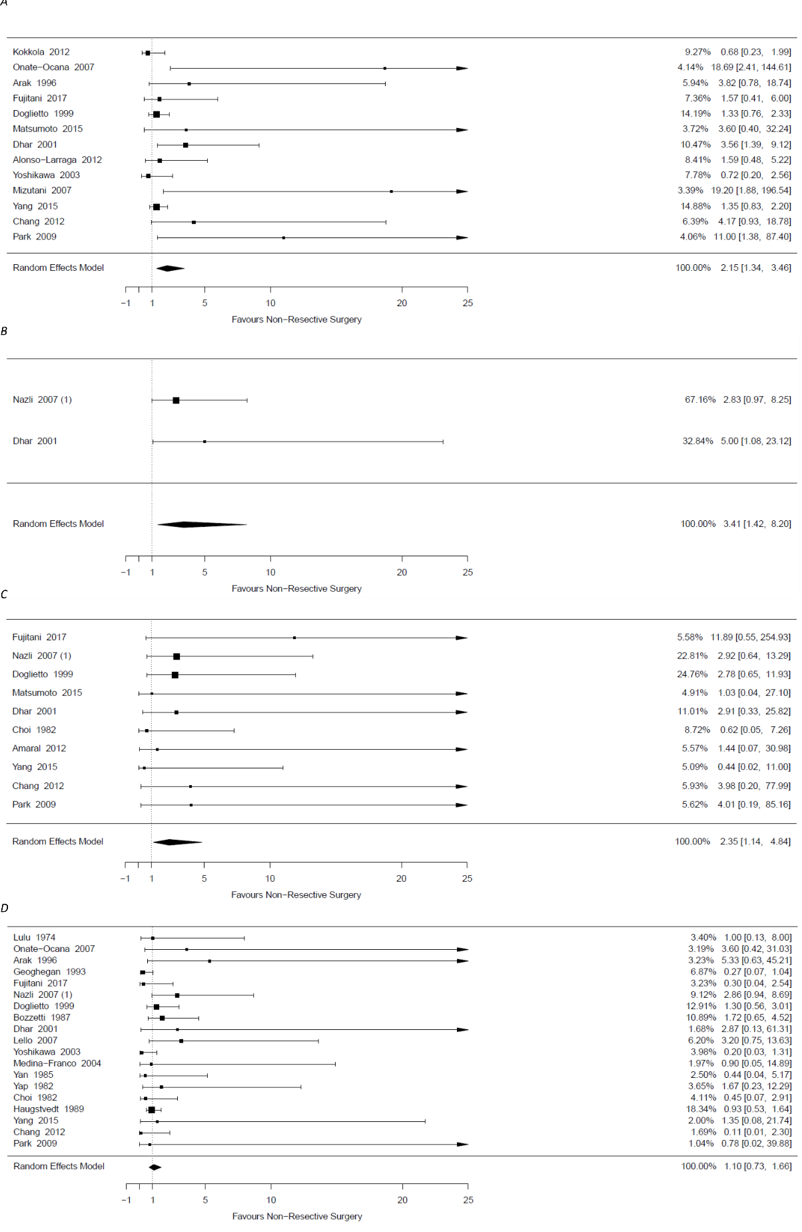
Supplementary Figure 3 – Forest plots showing relative risk of survival at 1 year for palliative gastrectomy compared to A) Chemotherapy only B) Non tumour resectional surgery C) No intervention
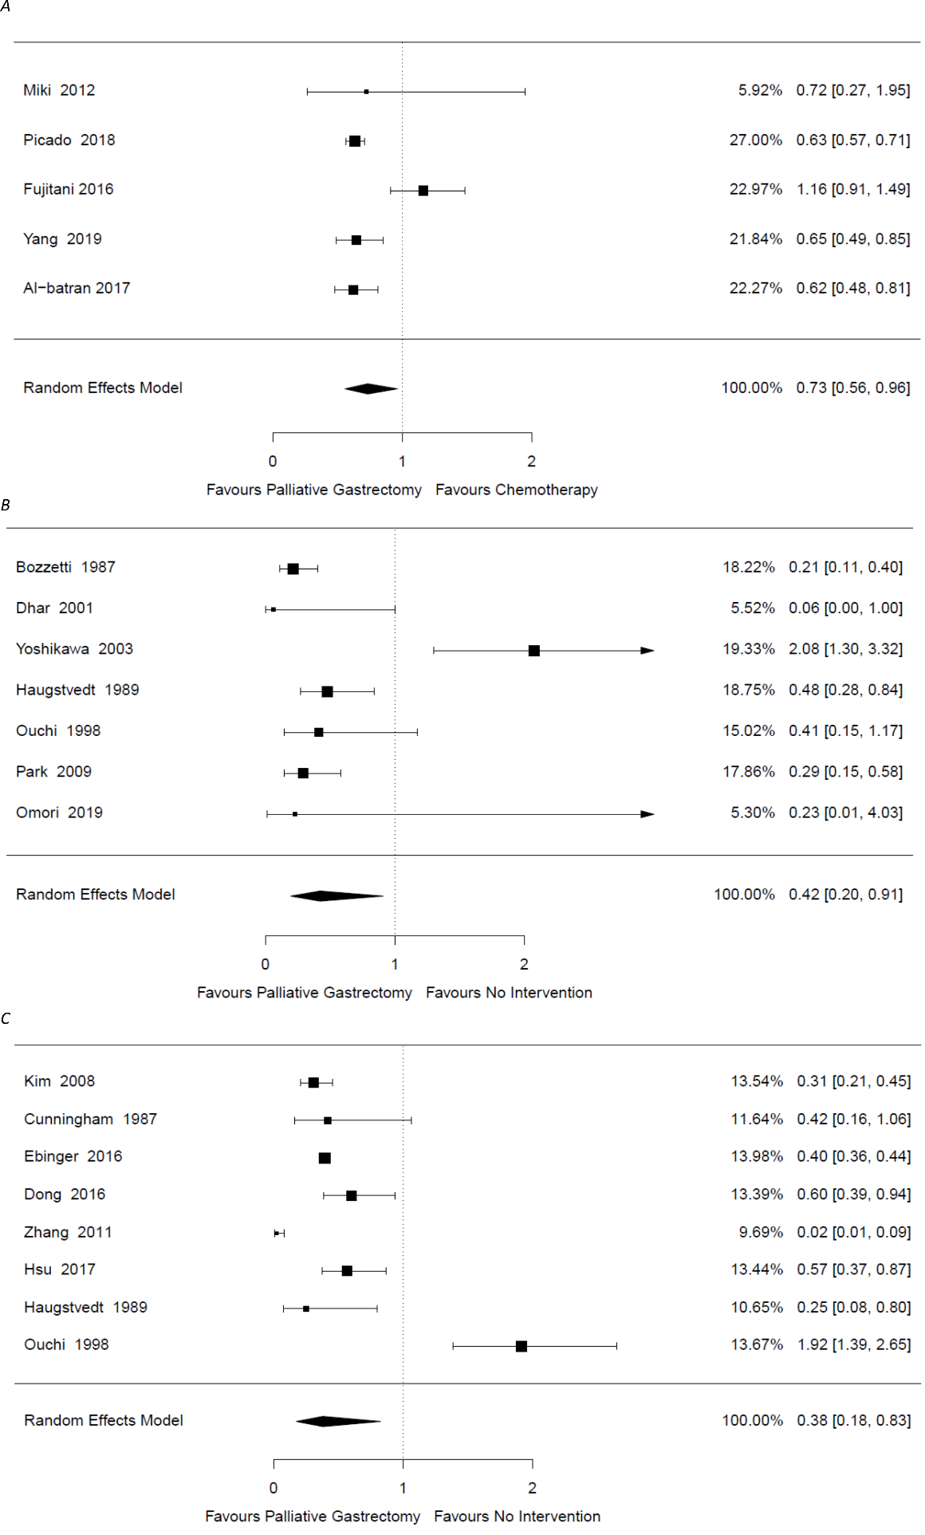
Supplementary Figure 4 – Forest plots showing relative risk of survival at 2 years for palliative gastrectomy compared to A) Chemotherapy only B) Non tumour resectional surgery C) No intervention
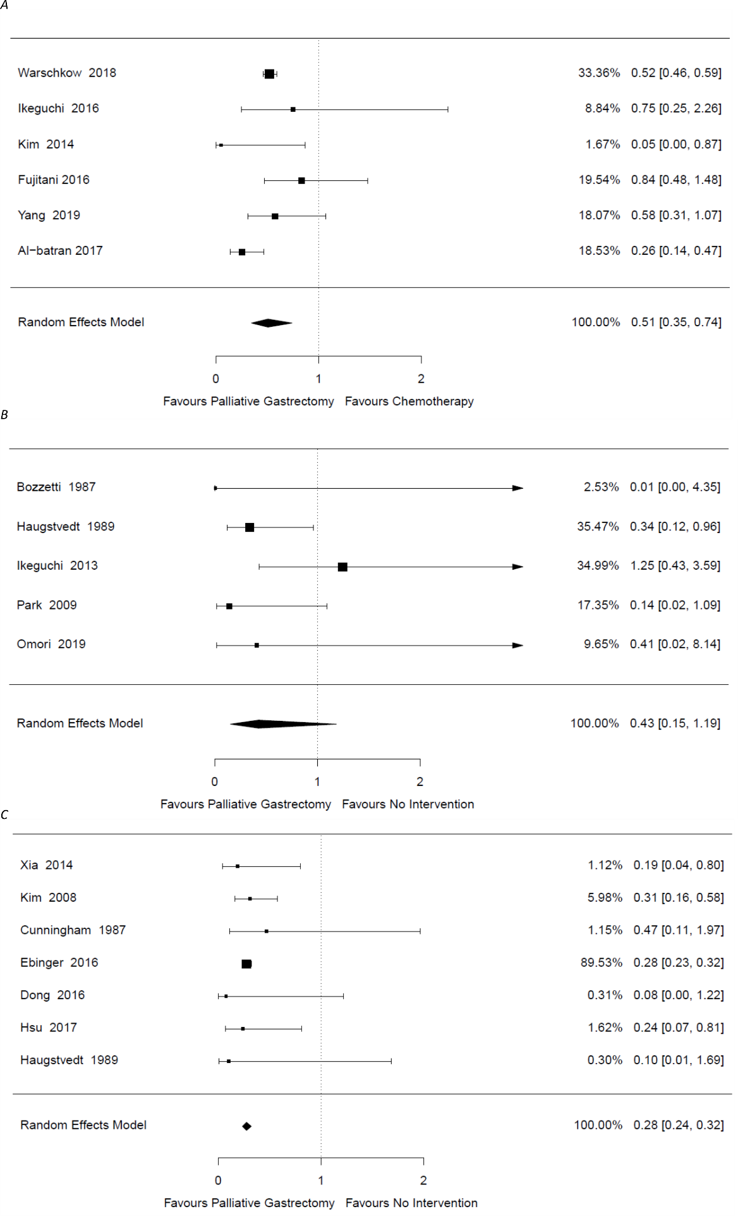
Supplementary Figure 5 – Forest plots showing relative risk of survival at 2 years for palliative gastrectomy compared to A) Chemotherapy only B) No intervention


