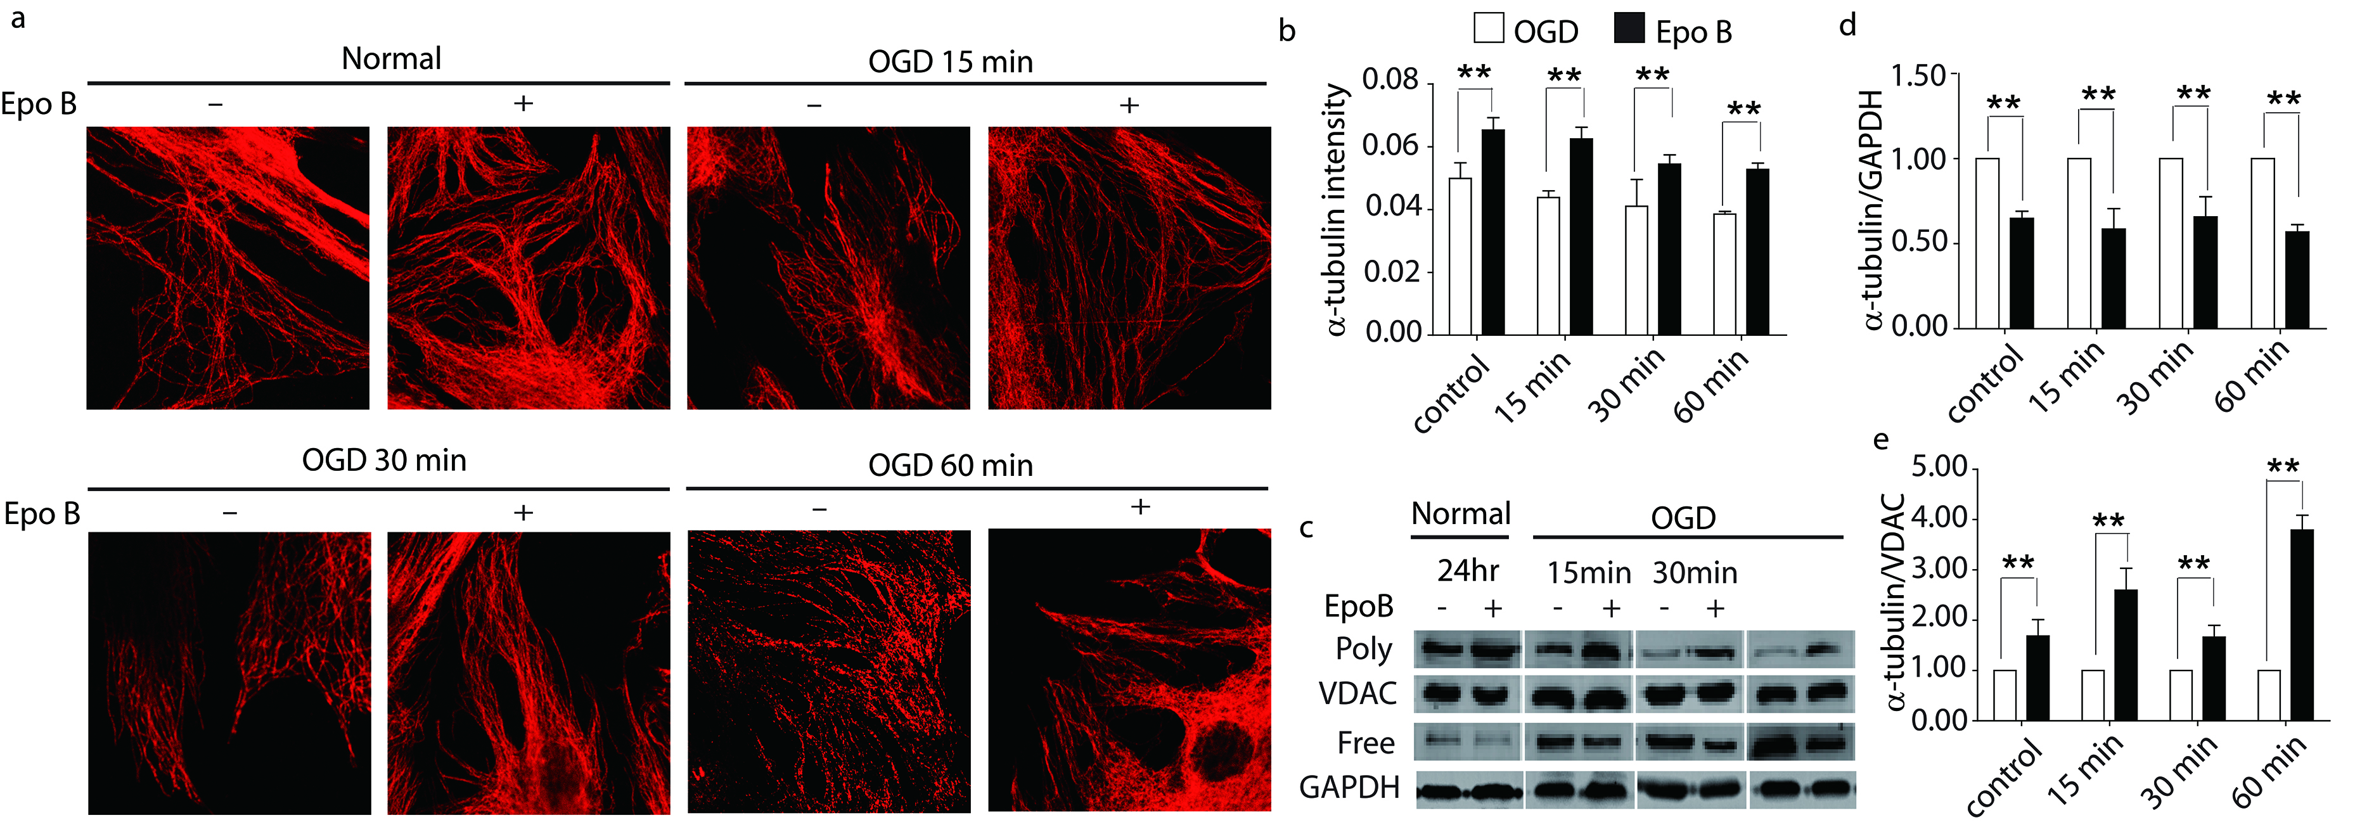
Fig.S1 Epo B stabilizes microtubule of OGD conditioned pericytes. a Immunofluorescence staining of α-tubulin in pericyte. Scale bar 6 μm. b Statistical analysis of the fluorescence intensity of α-tubulin in pericytes. c Immunoblotting analysis of expression of free and polymerized tubulin in pericytes. d-e Statistical analysis of the relative intensity of free and polymerized tubulin in pericytes. The data represents the mean $±$± SD (n=6). *p<0.05, **p<0.01. Significance was determined by student t-tests.
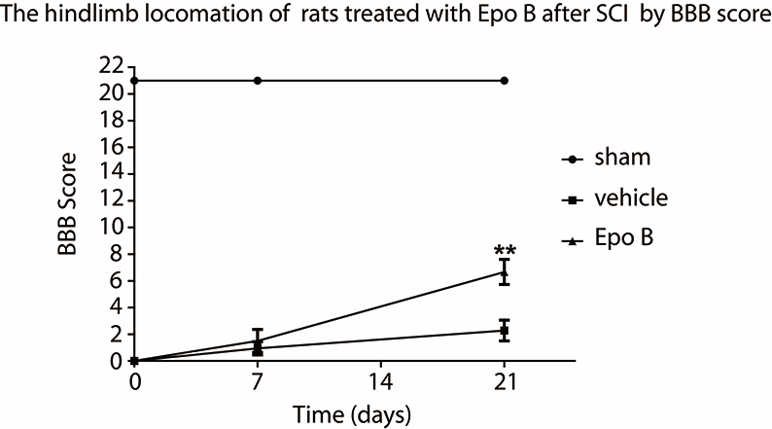
Fig.S2 Microtubule stabilization promotes the recovery of the motor function of hind limbs after SCI. Statistical analysis of Basso-Beaie-Bresnehan (BBB) score. The data represents the mean $±$± SD (n=9). **p<0.01. Significance was determined by student t-tests.
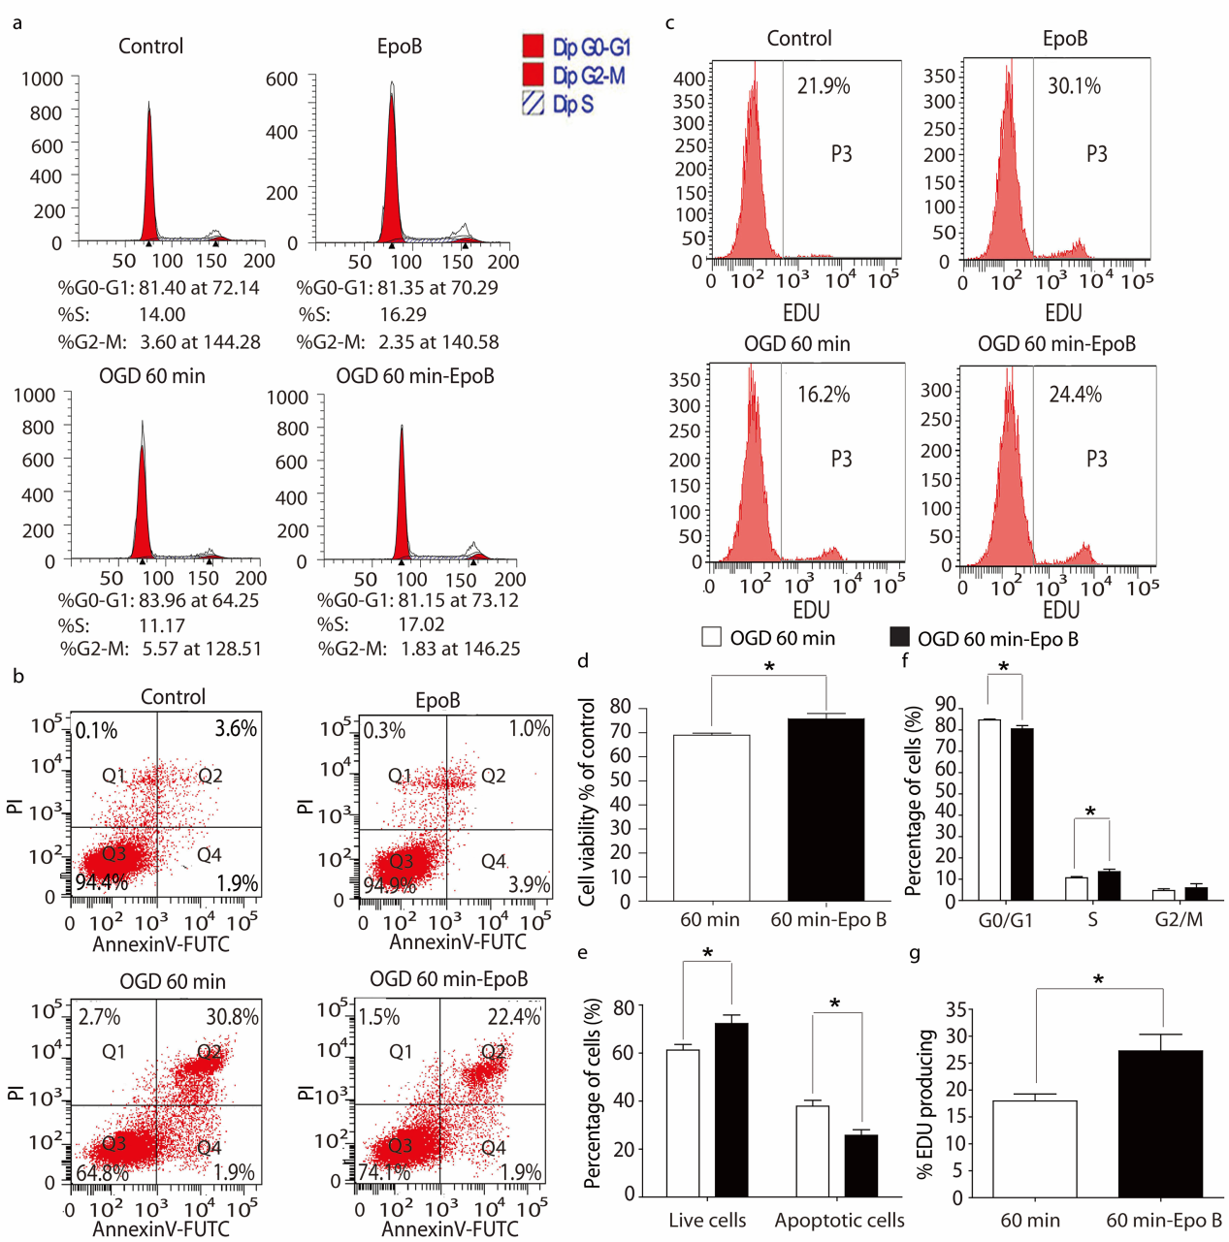
Fig.S3 Microtubule stabilization promotes cell proliferation and inhibits apoptosis in pericytes. a The cell cycle of pericytes in each group was determined by flow cytometry. b The pericytes apoptosis in each group was tested by flow cytometry. c The fluorescence intensity of EDU expressing pericytes in each group was measured by flow cytometry. d The viabilities of pericytes were analyzed by CCK-8 assay. e Statistical analysis of the number of apoptosis of pericytes. f Statistical analysis of the number of pericytes in each phase in each group. g Statistical analysis of the fluorescence intensity of EDU expressing pericytes in each group. Results are expressed as mean $±$$±$± SD (n=6). *p<0.05. Significance is determined by student t-tests.
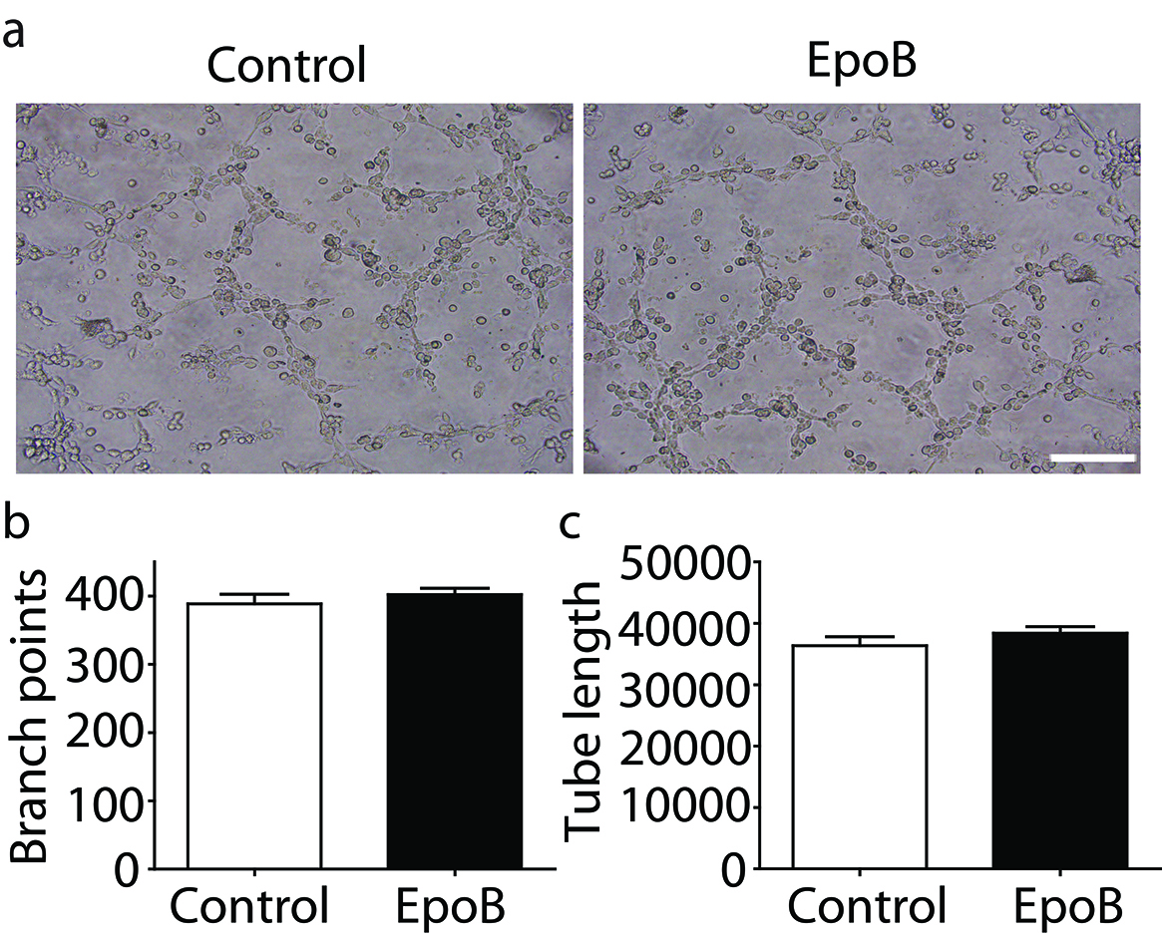
Fig.S4 Microtubule stabilization does not promote lumenogenesis of endothelial cells. a The lumenogenesis was determined by cell tube formation assay. b Statistical analysis of the branch points. c Statistical analysis of the tube length. Results are expressed as mean $±$± SD (n=6). p>0.05. Significance is determined by student t-tests.

