Supplemental Figures

Sex-Related Differences in Circular RNA Expression in Multiple Sclerosis: a pilot study

Valeria Lodde ^{1,}*, Igrazio Roberto Zarbo ^{2,3}, Gabriele Farina ³, Enrico Zoroddu¹, Paolo Solla ^{2,3}, Giuseppe Delogu ¹, Myriam Gorospe ⁴, Matteo Floris ¹, Ilaria Campesi ¹, Maria Laura Idda ¹
¹ Department of Biomedical Sciences, University of Sassari, Sassari 07100, Italy
² Department of Medicine, Surgery and Pharmacy, University of Sassari, Sassari 07100, Italy
³ Unit of Clinical Neurology, AOU Sassari, Sassari 07100, Italy
⁴ Laboratory of Genetics and Genomics, National Institute on Aging Intramural Research Program, National Institutes of Health, Baltimore, MD 21224, United States
* Correspondence author: Valeria Lodde: vlodde@uniss.it

Supplemental Figure S1: Overview of the workflow and different cohorts used in the study.

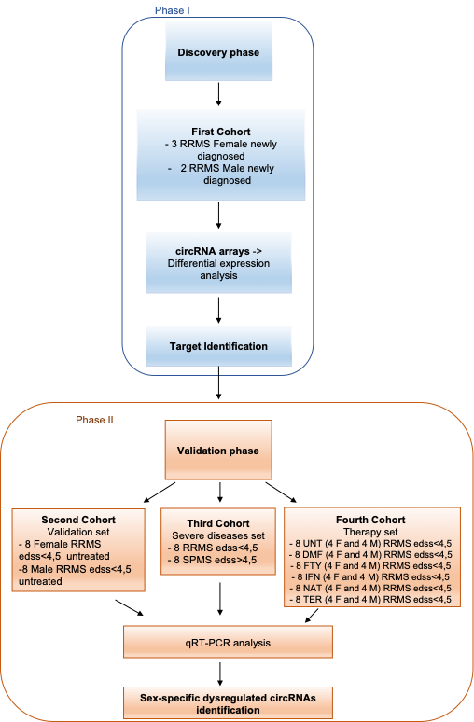

Supplemental Figure S2: Table showing the list of circRNAs differentially abundant in Female HCs compared to male HCs, depicting the top 5 elevated and 7 reduced circRNAs.

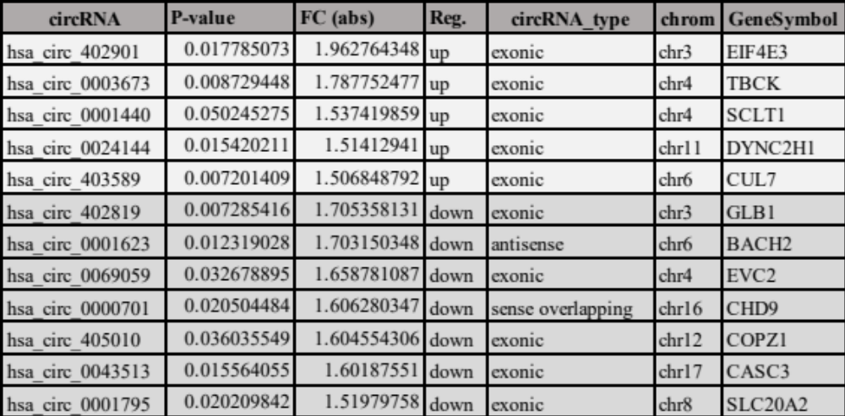

Supplemental Figure S3: hsa_circ_0140253 and LOC_389906 levels in healthy PBMCs (10 females and 10 males) (A), and healthy HUVEC (B) (5 females and 5 males). (C) expression of LOC_389906 analyzed in public RNAseq dataset from PBMCs of female MS patients compare to male MS patients and in female HCs compared male HCs.

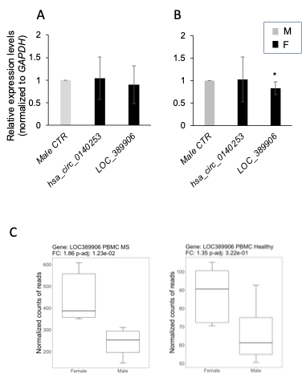

Supplemental Figure S4: Identification of the miRNAs and RBP Targets. (A) Schematic representation of circRNAs with putative miRNA binding site (MRE) and RNA-binding protein binding site (RBP-bs). (B,C) Tables showing lists of human circRNAs identified from our studies and target miRNAs and interacting RNA-binding proteins, as determined by analysis performed using miRanda and circInteractome, respectively.

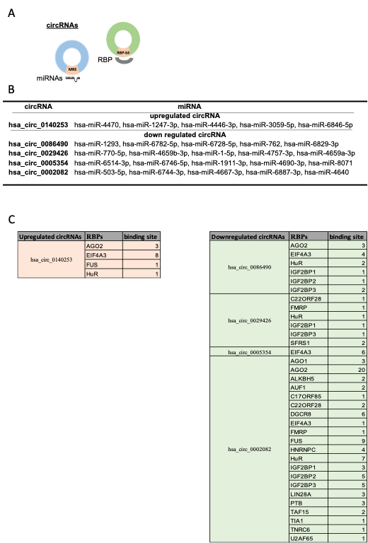

Supplemental Table 1: RNA-specific primer pairs.

RT-(q)PCR primers | Primer Sequences (5’ - 3’)
hsa_circ_0140253 | FW: GCTTACCTGGAATCACGTGTC
 | RV: GGCCATTCCTGACCTTTTGTT
hsa_circ_0086490 | FW: TGCTTCTTCACCCCTACATCA
 | RV: TGGTCTGGGATGGTGTGAAG
hsa_circ_0029426 | FW: GTGAAACGTCATTTGACTGGT
 | RV: TTTCCAGTACCACCATCACCA
hsa_circ_0005354 | FW: TCTCCCGGACTTCTTATCGTG
 | RV: GTCCACACCCACATAGTACCT
hsa_circ_0002082 | FW: GCTGAGTGATAAAGGCTGAGTG
 | RV: TTCGTTCTTCCGCTCAAATCC
LOC_389906 | FW: CCTGCCATTCAACAAACGCATT
 | RV: GACTACTGAGGGCATCTGGAA
MLLT3 | FW: ACGACTGGATGGTGTTCGTAC
 | RV: GCTTTCGTGCAAGTGGAAGA
RAN | FW: GGTTCATCCCCTAGTGTTCCA
 | RV: CCATCTCTCAGTCCACCGAAT
FGGY | FW: TACTATGTGGGTGTGGACGTT
 | RV: CTGCTCATGGTGGTTGAACTG
MALAT1 | FW: TGGGGGAGTTTCGTACTGAG
 | RV: TCTCCAGGACTTGGCAGTCT
GAPDH | FW: ATTTGGTCGTATTGGGCGCC
 | RV: TTGAGGTCAATGAAGGGGTC

Supplemental Table 2. Main characteristics of the individuals enrolled in the therapy set.

Therapy set | UNT | DMF | FTY | IFN | NAT | TER
No. tot | 8 | 8 | 8 | 8 | 8 | 8
Female | 4 | 4 | 4 | 4 | 4 | 4
Male | 4 | 4 | 4 | 4 | 4 | 4
Female - Age, yrs, mean ± SD | 40.25 ± 13.27 | 54 ± 3.16 | 45.25 ± 7.27 | 47 ± 11.28 | 31.75 ± 6.70 | 50 ± 4.24
Male - Age, yrs, mean ± SD | 47.87 ± 15.28 | 46.25 ± 8.46 | 46.25 ± 11.61 | 44 ± 10.51 | 37.75 ± 8.18 | 56 ± 6.97
Female - Disease duration, mean ± SD | 3.41 ± 4.83 | 6 ± 1.82 | 16.25 ± 3.77 | 13.75 ± 8.95 | 10.5 ± 4.04 | 14.75 ± 2.98
Male - Disease duration, mean ± SD | 5 ± 2.54 | 9 ± 2.94 | 12.25 ± 4.92 | 11 ± 4.83 | 11.25 ± 3.86 | 8.25 ± 4.34
Fermale- EDSS, mean ± SD | 2.2 ± 0.91 | 1.5 ± 0.40 | 1.65 ± 0.47 | 1.62 ± 0.75 | 1.75 ± 0.64 | 2.37 ± 0.75
Male - EDSS, mean ± SD | 2.5 ± 1.22 | 1.62 ± 0.47 | 2.5 ± 1.29 | 2.37 ± 0.75 | 1.87 ± 0.62 | 2 ± 0.81
Abbreviations: UNT, untreated; DMF, dimethyl fumarate; FTY, fingolimod; IFN, interferon; NAT, natalizumab; TER, teriflunomide; SD, standard deviation; EDSS, Expanded Disability Status Scale.

