Cancer/testis antigen expression and co-expression patterns in Gastroesophageal Adenocarcinoma
Sukumar Kalvapudi¹, Akhil Goud Pachimatla¹, R.J. Seager², Jeffrey Conroy², Sarabjot Pabla², Sarbajit Mukherjee¹

¹ Roswell Park Comprehensive Cancer Center, Elm and Carlton Streets, Buffalo, NY 14206, USA
² Labcorp Oncology, 700 Ellicott Street, Buffalo, NY 14203, USA

Running Title: Cancer/testis antigens in Gastroesophageal Cancer
Journal name: Targeted Oncology
Corresponding Author:
Dr. Sarbajit Mukherjee,
Department of Medicine,
Roswell Park Comprehensive Cancer Center,
Buffalo, NY, USA, 14263;
Email: Sarbajit.mukherjee@roswellpark.org;
Phone: +1-716-845-3099; Fax: +1-716-845-8935

Table S1 Demographic and Disease Characteristics of the TCGA Cohort
Characteristics | n (%) (N = 329)
Age at Initial Diagnosis
< 40 | 3 (0.9%)
40 - 49 | 21 (6.4%)
50 - 59 | 74 (22.5%)
60 - 69 | 93 (28.3%)
70 - 79 | 106 (32.2%)
≥ 80 | 30 (9.1%)
Gender
Male | 232 (70.5%)
Female | 97 (29.5%)
Race
White | 245 (74.5%)
Black | 6 (1.8%)
Asian | 51 (15.5%)
No Data | 27 (8.2%)
Stage
1 | 47 (14.3%)
2 | 122 (37.1%)
3 | 121 (36.8%)
4 | 23 (7%)
No Data | 16 (4.9%)

Characteristics of the patient population in the TCGA cohort including age, gender, race and stage of cancer, are listed. All values are given as total numbers and percentages. *N = number

Figure S1 CTA prevalence in the TCGA Cohort
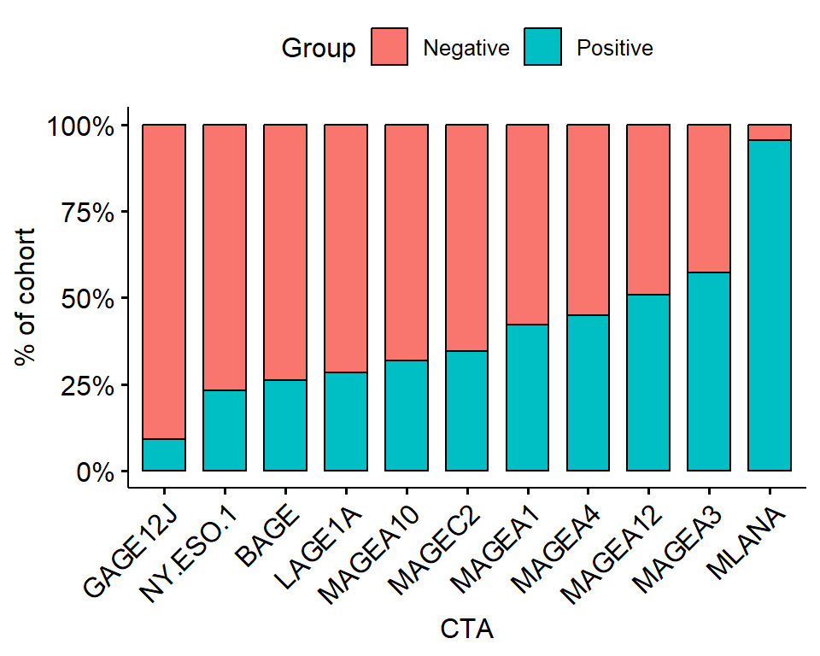

Gene expression ranks of various cancer testis antigen genes in the TCGA cohort

Figure S2 Kaplan-Meier survival analysis of the study cohort
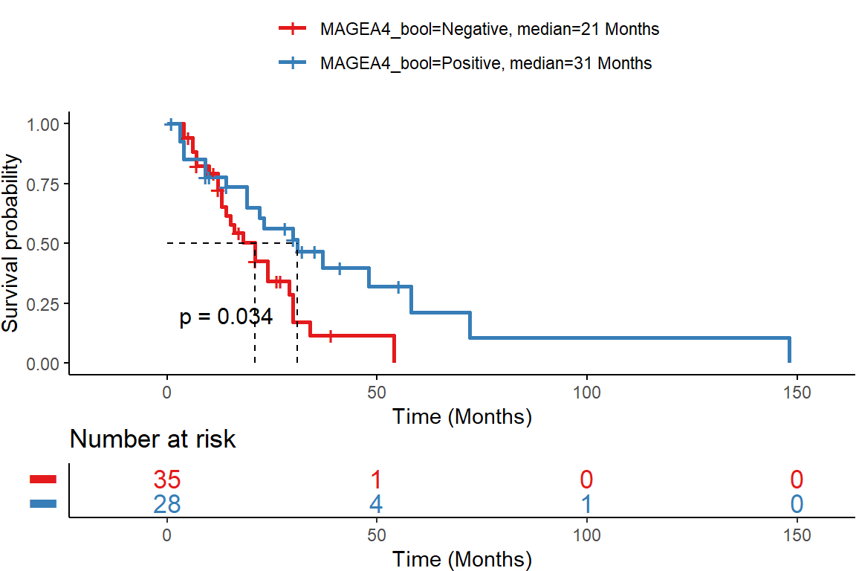

Kaplan-Meier survival analysis of the study cohort with patients split into MAGEA4 positive (blue) and MAGEA4 negative (red) patients. MAGEA4-positive patients had significantly better survival (p = 0.034) compared to MAGEA4-negative patients

Figure S3 Kaplan-Meier survival analysis of the TCGA cohort
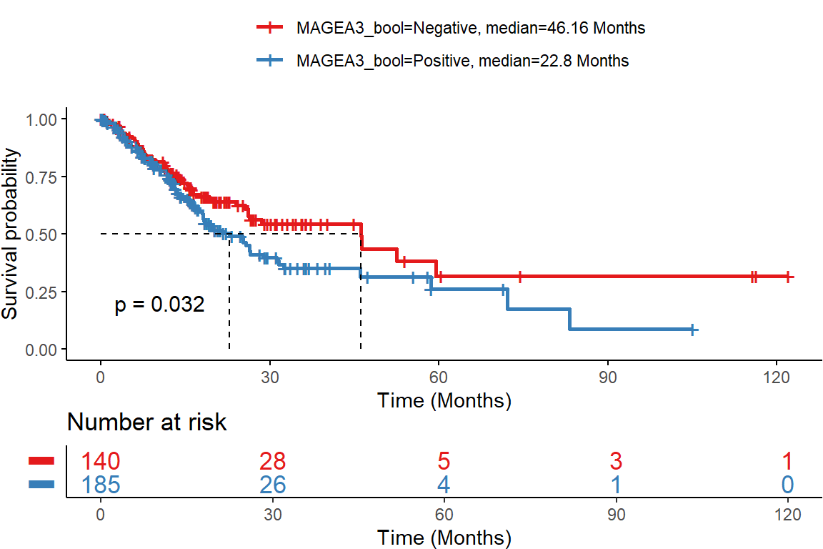
a)

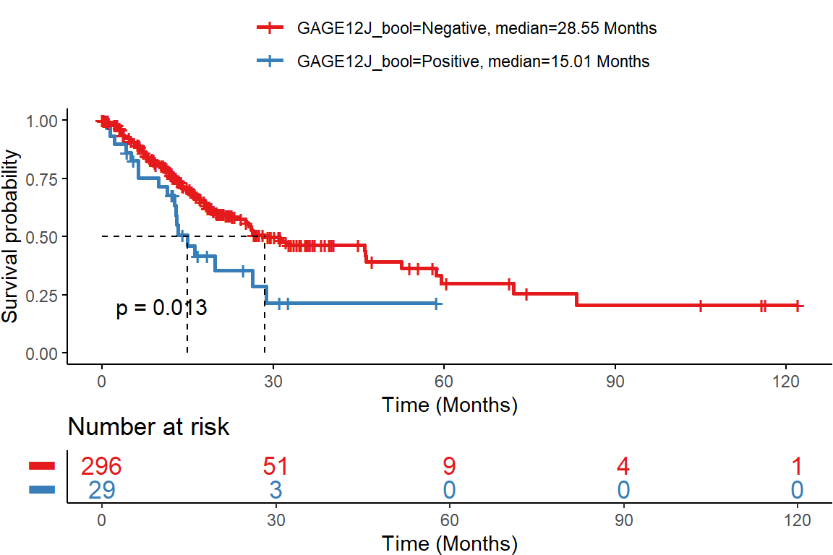
b)

Kaplan-Meier survival analysis of the TCGA cohort with patients split into a) MAGEA3 positive (blue) and MAGEA3 negative (red) patients. MAGEA3-positive patients had significantly worse survival (p = 0.032) compared to MAGEA3-negative patients. b) GAGE12J positive (blue) and GAGE12J negative (red) patients. GAGE12J-positive patients had significantly worse survival (p = 0.013) compared to GAGE12J-negative patients
Figure S4 Survival analysis of study cohort in patients treated and not treated with Immune Checkpoint Inhibitors
No ICI
ICI
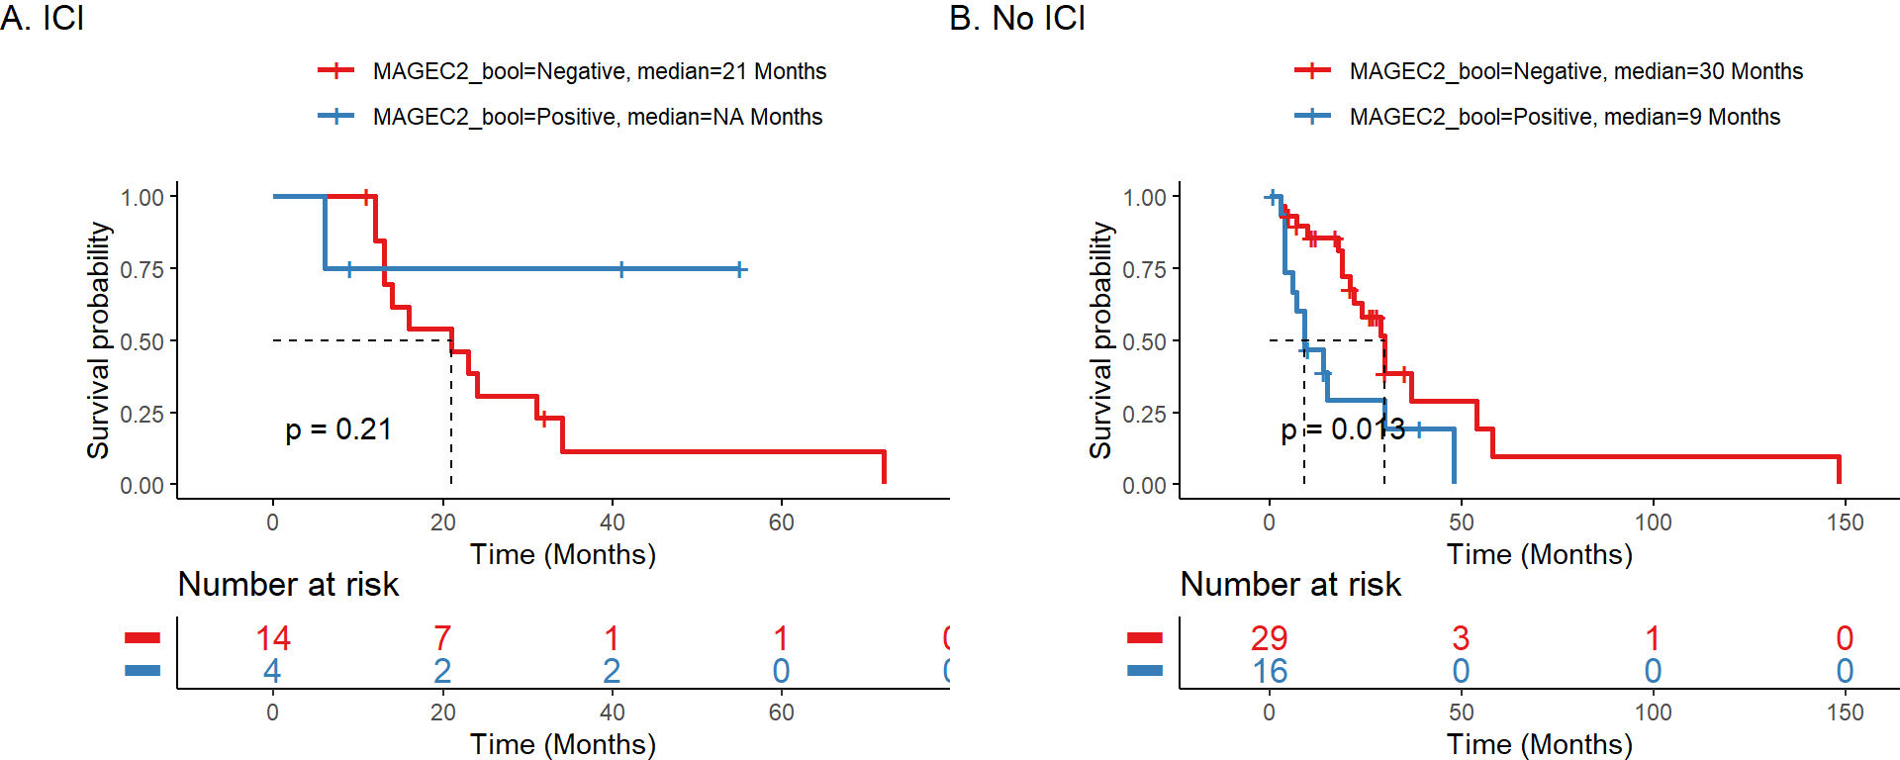
b)
a)

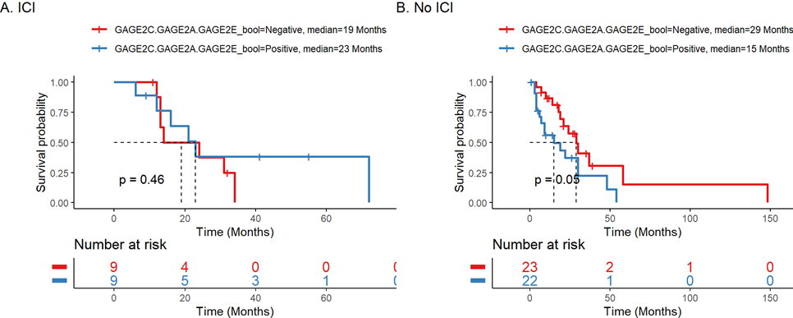
d)
c)

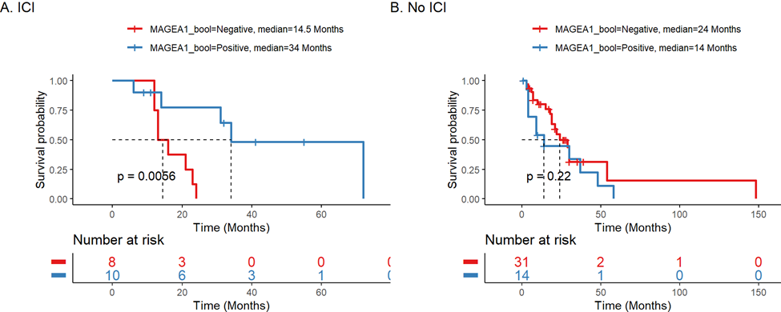
h)
g)
e)
f)
No ICI
ICI
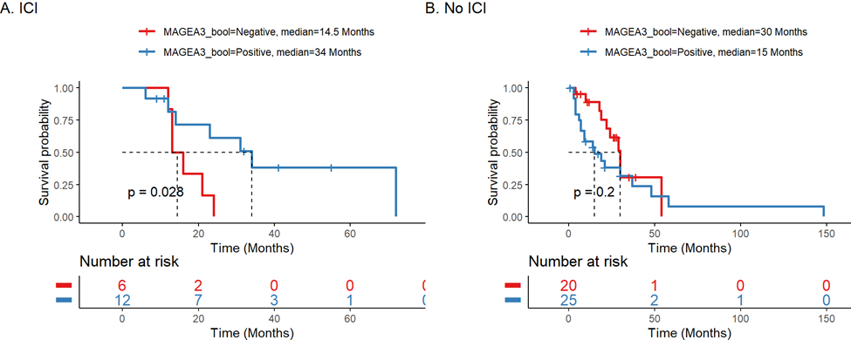
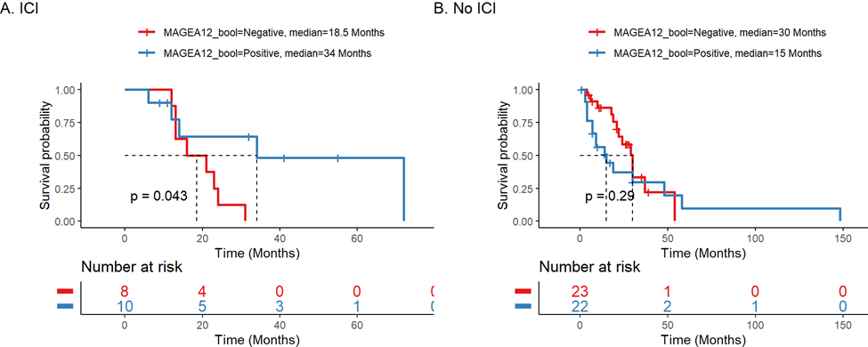
j)
i)

k)
No ICI
ICI
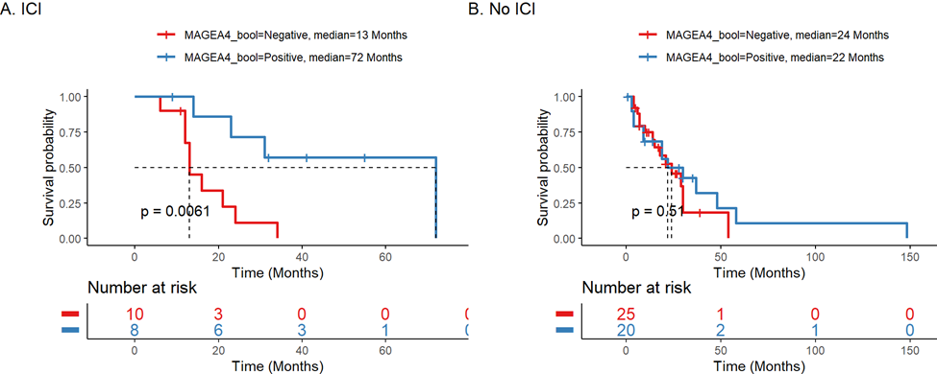
l)

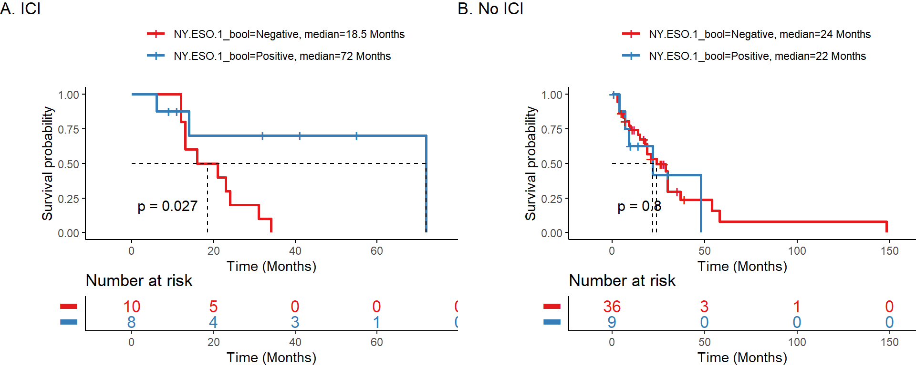
n)
m)

Kaplan-Meier survival analysis of the study cohort with patients split into groups based on immune checkpoint inhibitor (ICI) treatment status. a, c, g, e, i, k, m – patients treated with ICI. b, d, f, h, j, l, n – patients not treated with ICI. a, b - MAGEC2-positive patients had worse overall survival than MAGEC2-negative patients (p = 0.013) in patients not treated with ICI. No difference in patients treated with ICI. c, d - GAGE2C.GAGE2A.GAGE2E-positive patients had worse overall survival than GAGE2C.GAGE2A.GAGE2E-negative patients (p = 0.05) in patients not treated with ICI. No difference in patients treated with ICI. In ICI-treated patients, MAGEA1-positive patients (p < 0.01), MAGEA12-positive patients (p = 0.043), MAGEA3-positive patients (p = 0.028), MAGEA4-positive patients (p < 0.01), and NY-ESO-1-positive patients (p = 0.027) all had significantly better overall survival than those negative for the corresponding CTA genes (e, g, i, k, m). No similar difference was observed in patients not treated with ICI (f, h, j, l, n)

