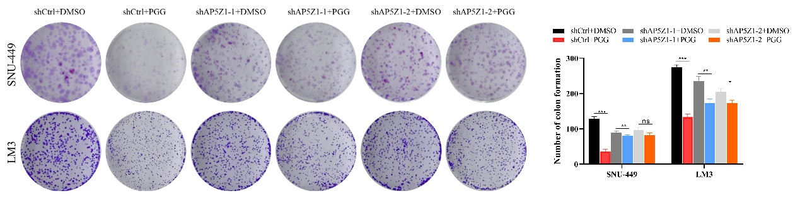
Figure S1: PGG inhibits HCC cell proliferation in an AP5Z1-dependent manner. P < 0.05; *P < 0.01; ***P < 0.001. NS indicates a lack of significance (P ≥ 0.05).

