Supplementary Figure 1. Graphic abstract

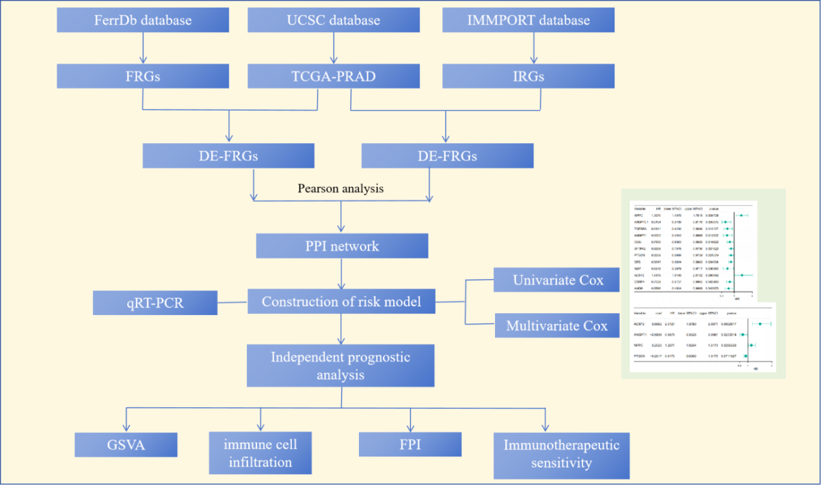

Supplementary Figure 2

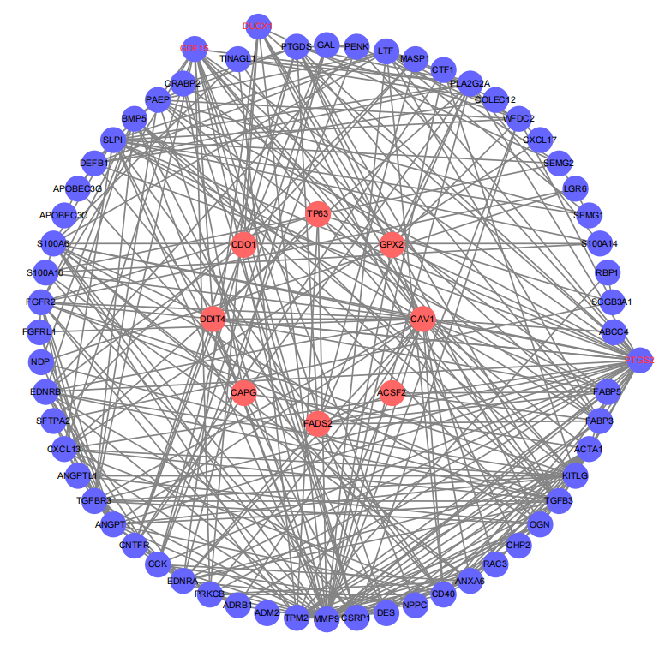
Supplementary Figure 2. The PPI network. The red ovals represent FRGs, whereas the blue ovals indicate IRGs. The red fonts are both FRGs and IRGs.

Supplementary Figure 3.
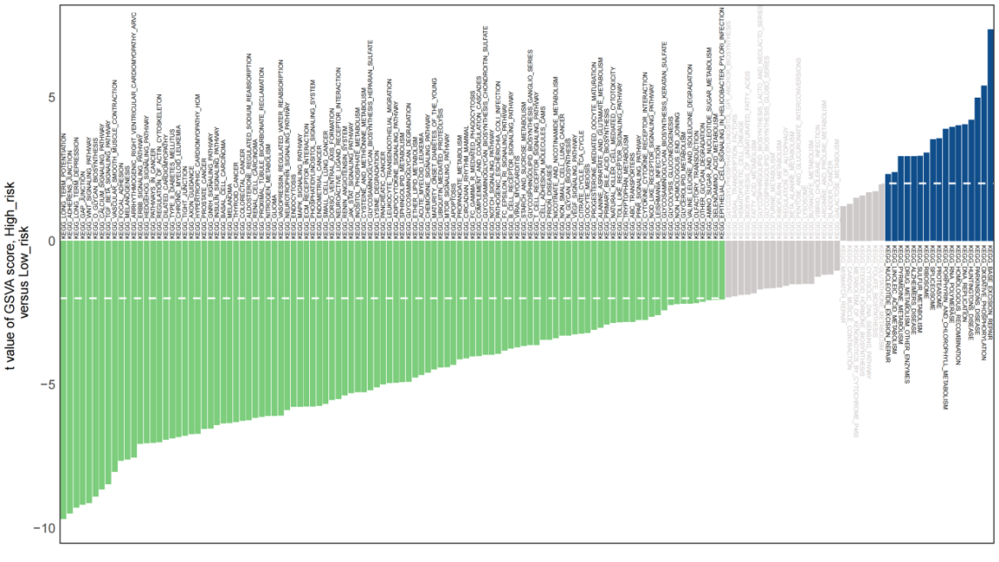
Supplementary Figure 3. GSVA analysis of high-and low-risk groups

Supplementary Figure 4.

Supplementary Figure 4. Correlation between risk signature and immunotherapy. A, The immune infiltration of 24 immune cells between the high- and low- risk groups. The boxplots displayed the scores of 24 immune cells. ns represents not significant; * represents adjusted P <0.05; ** represents adjusted P <0.01; *** represents adjusted P <0.001. B, ferroptosis index between the high and low risk groups. ** represents adjusted P <0.01. C, the correlation between ferroptosis index and immune cells. D, the expression levels of immune checkpoint molecules between the high- and low-risk groups. ns represents not significant; * represents adjusted P <0.05; ** represents adjusted P <0.01; *** represents adjusted P <0.001. E, the TIDE score between the high- and low-risk groups. TIDE, tumor immune dysfunction and exclusion

Supplementary Figure 5.
Supplementary Figure 5. The qRT-PCR verification of the expression of DE-FRGs and DE-IRGs.
The expression of selected genes was verified by quantitative real-time PCR (qRT-PCR), and compared to normal prostate epithelial RWPE-1 the mRNA expression levels of ACSF2(A), ANGPT1(B), NPPC(C), and PTGDS(D)in normal prostate epithelial cell (RWPE-1) were higher than that in PCa cells (PC-3, 22RV1, and DU-145). Data show the mean ± standard deviation (SD) of three independent analyses with statistical analyses performed using Student's t‐test in graphpad prizm with statistical significance set at *P < 0.05.

