Supporting information

Increased expression of transferrin receptor 1 in the brain cortex of 5xFAD mouse model of Alzheimer’s disease is associated with activation of HIF-1 signalling pathway
Sabrina Petrallaª, Liudmila Saveleva^{b}, Katja M. Kanninen^{b}, Julia S. Osterª, Maria Panayotovaª, Gert Frickerª, Elena Puris^{a*}
ªInstitute of Pharmacy and Molecular Biotechnology, Ruprecht-Karls-University, Im Neuenheimer Feld 329, 69120 Heidelberg, Germany
^{b}A.I. Virtanen Institute for Molecular Sciences, University of Eastern Finland, P.O. Box 1627, 70211 Kuopio, Finland

*Corresponding author: Elena Puris, Institute of Pharmacy and Molecular Biotechnology, Ruprecht-Karls-University, Im Neuenheimer Feld 329, 69120 Heidelberg, Germany;
phone: +(358)449789164; email: elena.puris@uni-heidelberg.de
ORCID ID: https://orcid.org/0000-0002-1769-389X

Table S1. Mouse primer sequences for SYBR Green qRT-PCR
Gene | Forward Primer | Reverse Primer
Tfrc | 5′-GGAGGACGCGCTAGTGTTC-3′ | 5′-TCCAACAAGGAACATGATGC-3′
Hif1a | 5′-CCTGCACTGAATCAAGAGGTTGC-3′ | 5′-CCATCAGAAGGACTTGCTGGCT-3′
Sirt3 | 5′-GCTACATGCACGGTCTGTCGAA-3′ | 5′-CAATGTCGGGTTTCACAACGCC-3′
Il1b | 5′-GCAACTGTTCCTGAACTCAACT-3′ | 5′-ATCTTTTGGGGTCCGTCAACT-3′
Actb | 5′-AAGTCCCTCACCCTCCCAAAAG-3′ | 5′-ACACAGAAGCAATGCTGTCACC-3′

Table S2. Human primer sequences for SYBR Green qRT-PCR
Gene | Forward Primer | Reverse Primer
TFRC | 5′-GCACAGCTCTCCTATTGAAAC-3′ | 5′-GGTATCCCTCTAGCCATTCAG-3′
GAPDH | 5′-CCATCACCATCTTCCAGGAGCGA-3′ | 5′-GGATGACCTTGCCCACAGCCTTG-3′

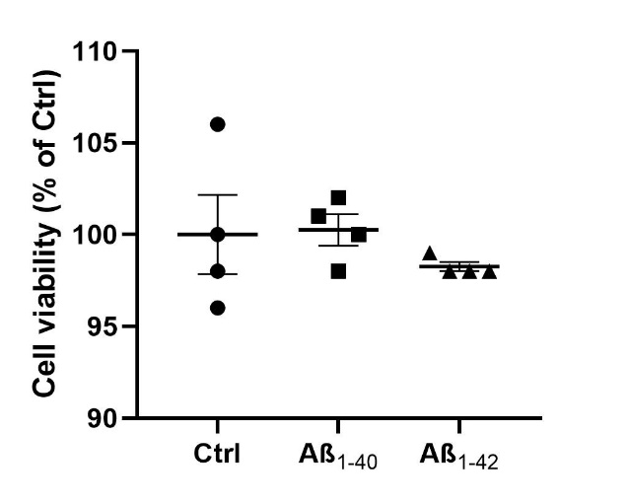
Fig. S1. Effect of 0.1 µM of Aβ₁₋₄₀ and Aβ₁₋₄₂ on hCMEC/D3 cell viability after 48h treatment compared to untreated cells (Ctrl). Results are the mean ± SEM of 4 samples per condition.
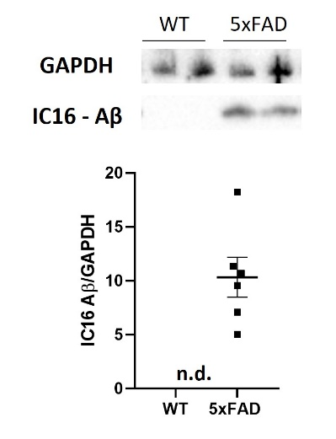
Fig. S2. Western Blot and relative densitometry of Aβ IC16 expression in brain cortical samples of 5xFAD transgenic mice versus age-matched wild-type (WT) mice. Data are shown as the ratio between Aβ IC16 and GAPDH as reference loading control. Bar represents the mean ± SEM of 6 animals for 5xFAD mice and 2 animals for WT mice; n.d. = not detectable.

