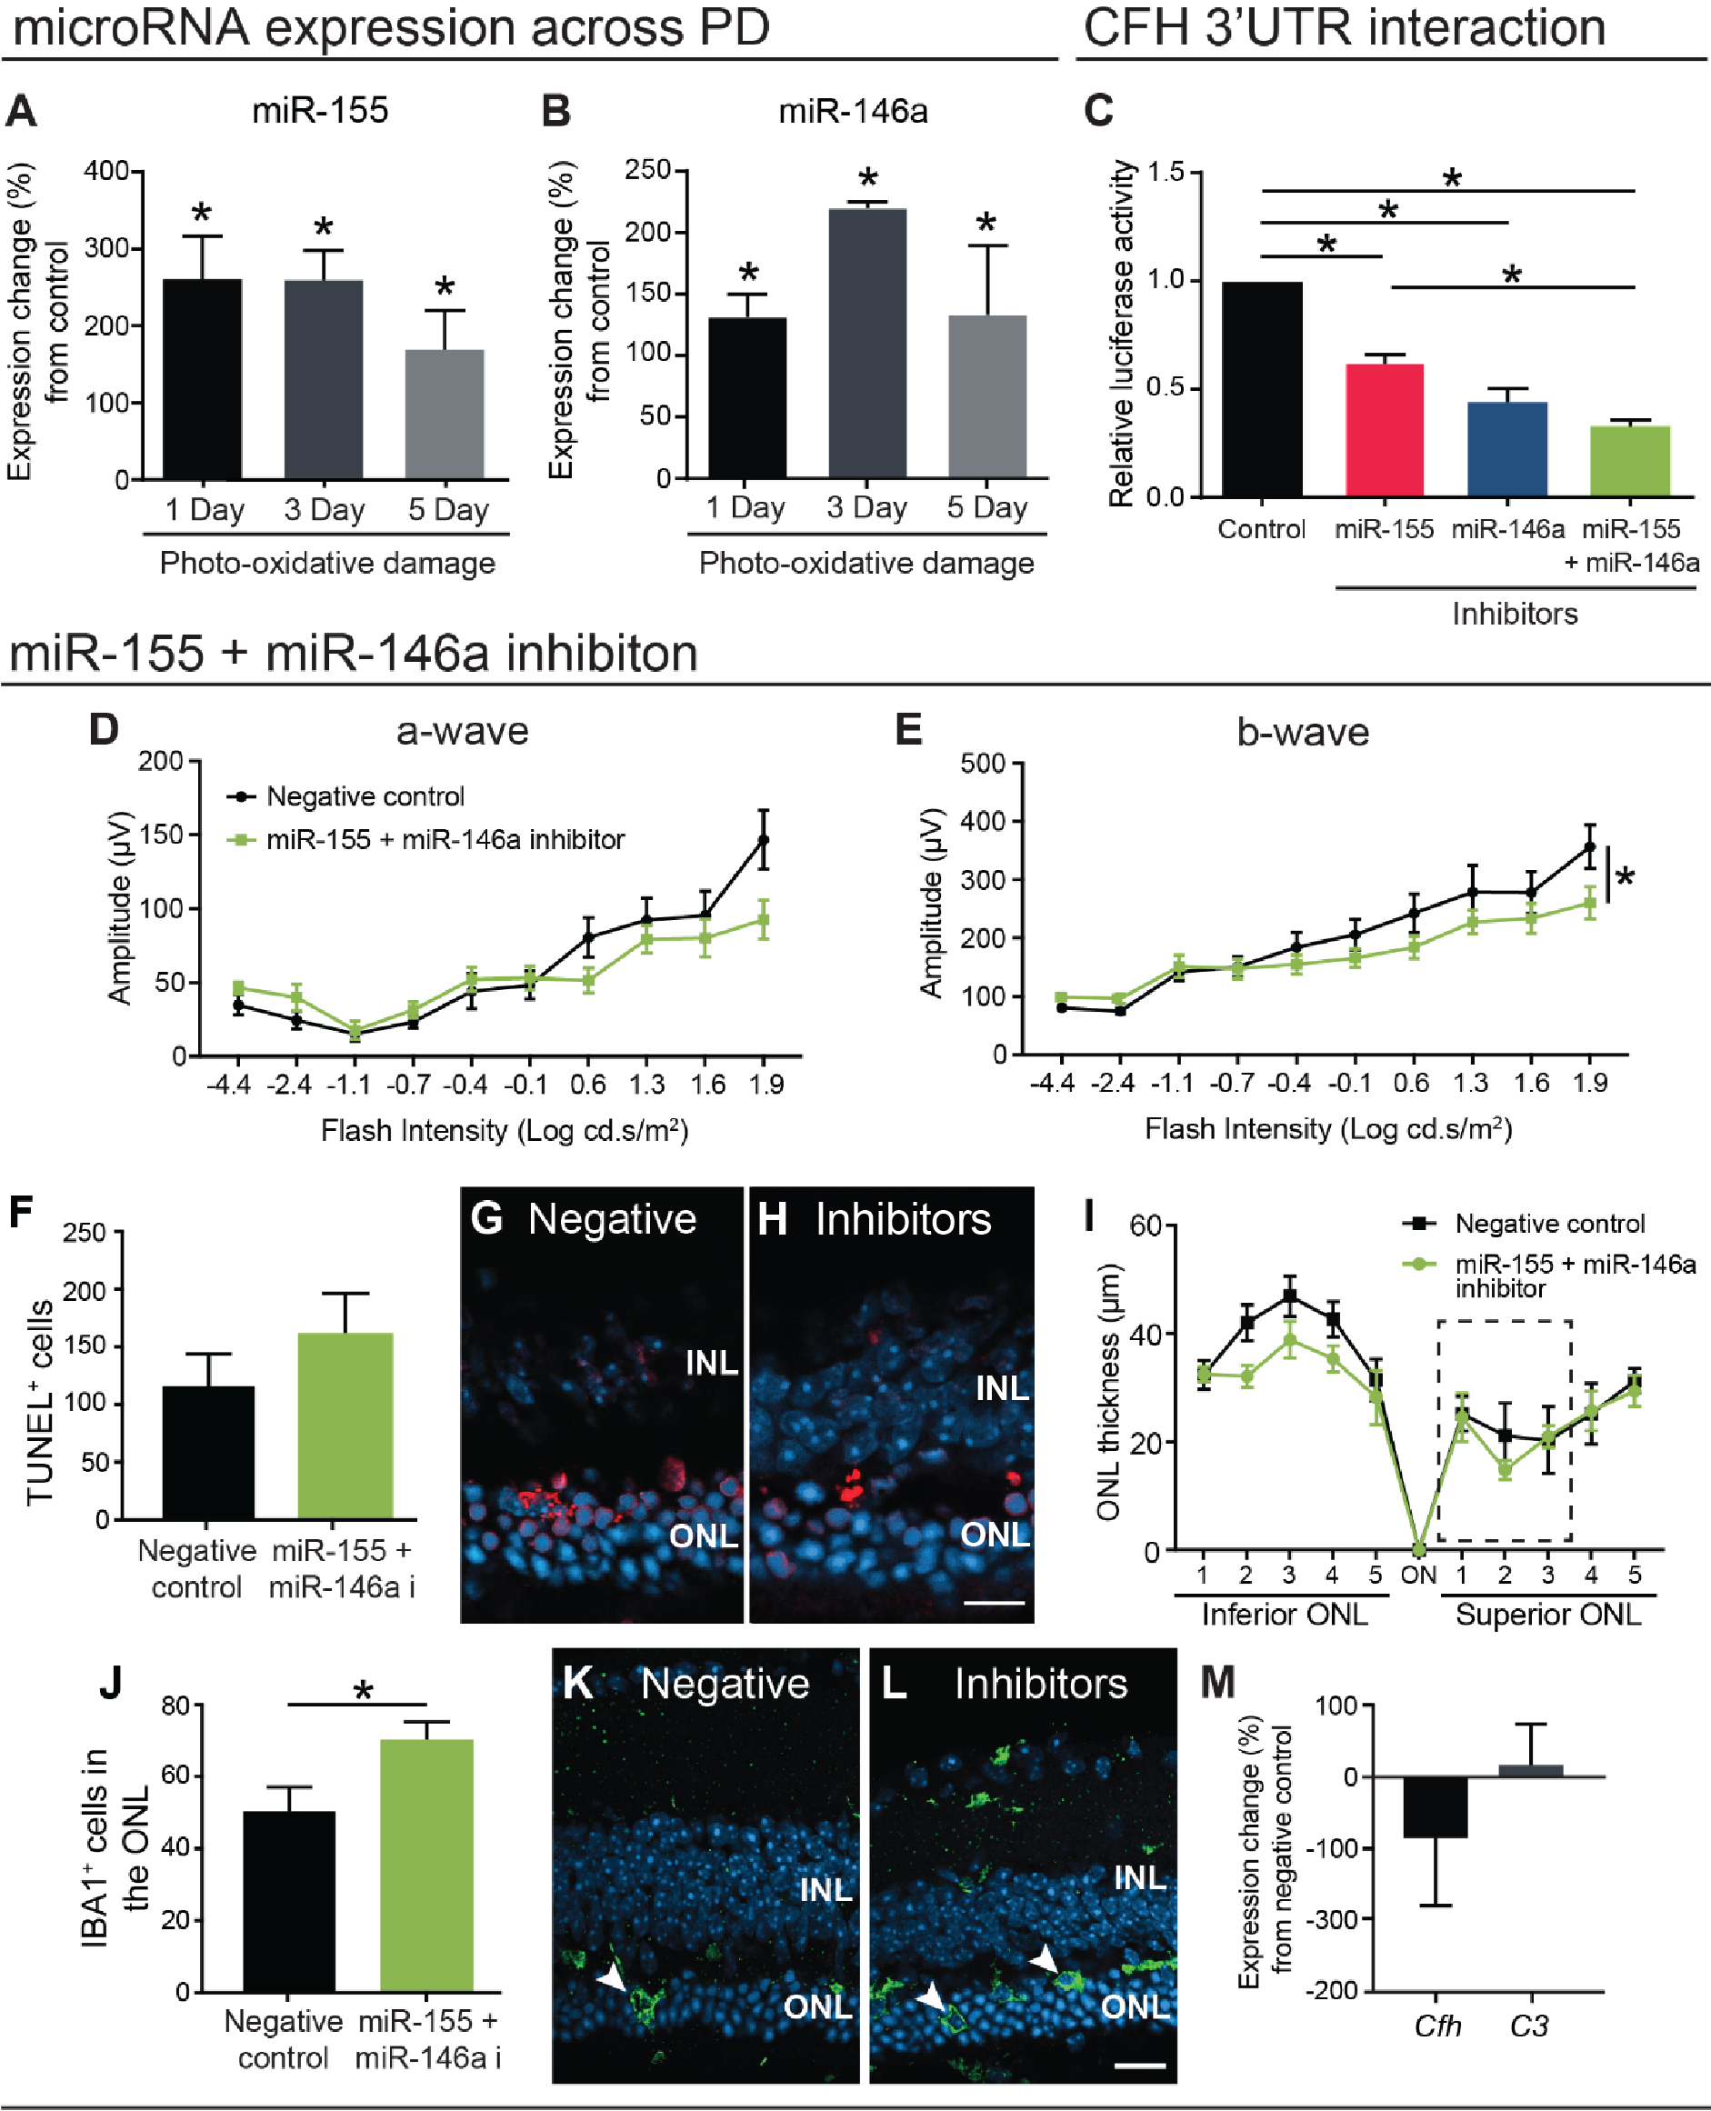

Supplementary Fig. 2. Inhibition of miR-155 and miR-146a in photo-oxidative damaged (PD) retinas exacerbated degeneration.
a-b Gene expression analysis of miR155 and miR146a across PD using qRT-PCR. Compared to dim-reared (DR) controls both (a) miR-155 and (b) miR-146a were significantly increased across all time points (p < 0.05). c A luciferase assay was used in HeLa cells to measure the interaction of miR-155 and miR-146a with the 3’UTR of CFH. CFH luciferase fluorescence was significantly decreased by the addition of each miRNA mimic individually, and was further reduced from miR-155 alone when used in combination (p < 0.05). d-e Retinal function as measured by ERG in mice intravitreally injected with miR-155+miR-146a inhibitors compared to negative, scrambled miRNA controls. Mice injected with miR-155+miR-146a inhibitors showed no change in (d) a-wave responses, but (e) significantly lower b-wave amplitudes compared to controls (p < 0.05). f No difference was shown in the levels of photoreceptor cell death as quantified using TUNEL immunolabelling, between treated and control groups (p > 0.05). Representative images indicating TUNEL⁺ cells in the focal lesion site of (g) miR-155+miR-146a inhibited and (h) negative control mice. (i) ONL thickness measured across the length of the retina showed no significant difference between groups (p > 0.05). The box indicates the region of focal cell death. (j) IBA1⁺ cells in the ONL were quantified, demonstrating more cells in miR-155+miR-146a inhibited retinas compared to negative controls (p < 0.05). Representative images of ONL IBA1⁺ cells in (k) miR-155+miR-146a inhibitor and (l) negative control retinas. (m) The retinal expression of Cfh and C3, measured by qRT-PCR was not significantly different from controls following miR-155/miR-146a inhibition (p > 0.05). Statistical significance was determined by student t-test and two-way ANOVA with post-hoc multiple comparison (n = 5-10 animals per group, *represents p < 0.05). ONL, outer nuclear layer; INL, inner nuclear layer. For all images, scale bars represent 20 μm.

