Supplementary Figures
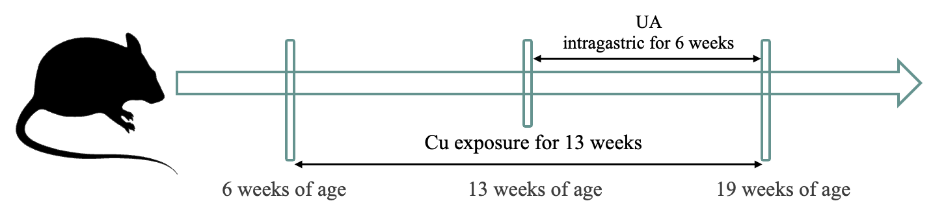

Fig. S1 Flow chart of the experimental protocol.

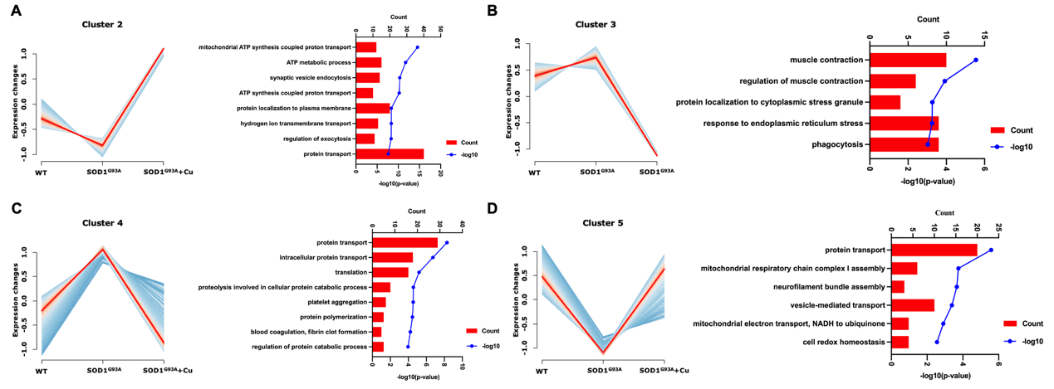
Fig. S2 Cluster analysis of spinal cord proteomics and important biological processes.
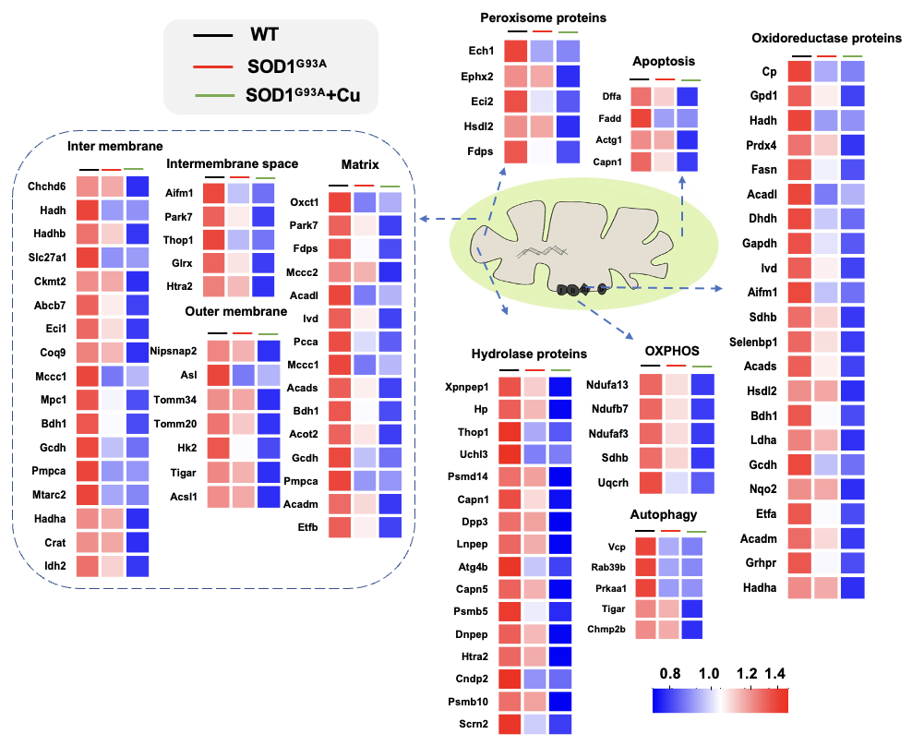
Fig. S3 Differential expression profiles of mitochondrial proteins in the spinal cord proteomic results. Based on GO annotation and the biological function of the uniprot database, differentially expressed proteins localized to spinal cord mitochondria were mapped to peroxisomal proteins, hydrolase proteins, outer membrane proteins, intermembrane proteins, inner membrane proteins, mitochondrial matrix proteins, oxidoreductase proteins, OXPHOS, apoptosis, and autophagy. Heatmaps are color-coded based on the log 10 abundance of proteins. Blue represents low abundance, and red represents high abundance.

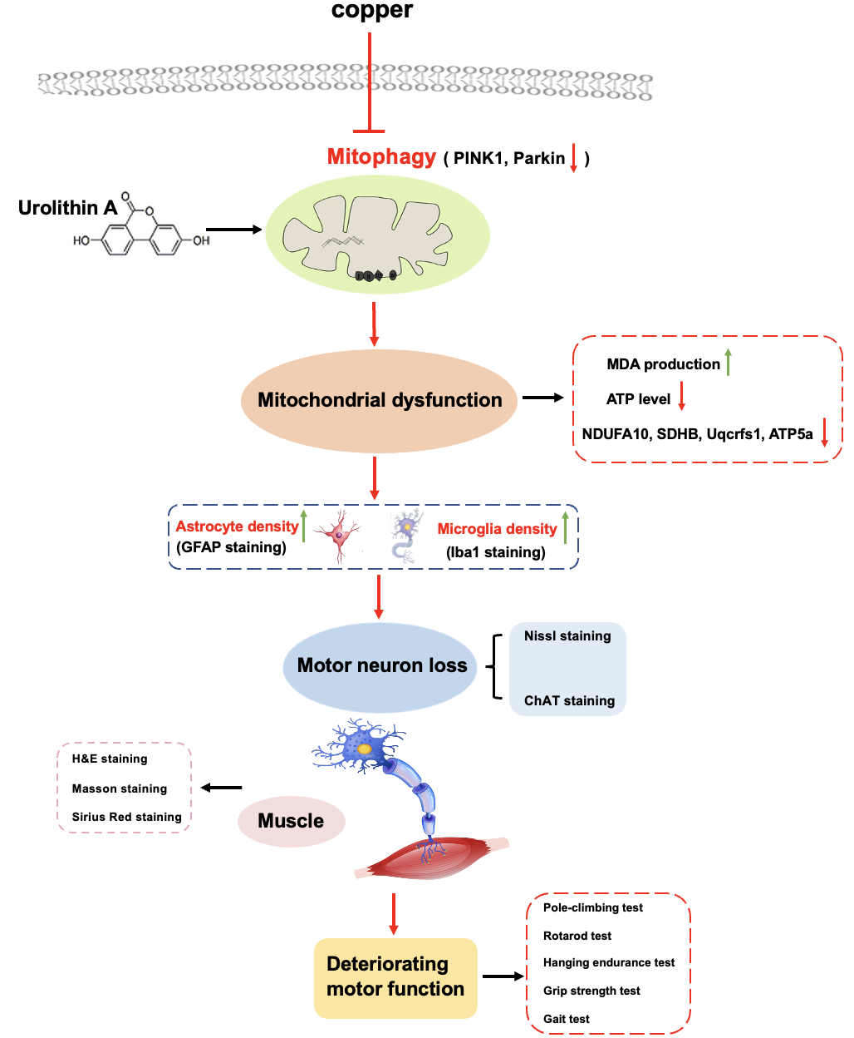
Fig. S4 Possible mechanism of UA slows progression in Cu exposed SOD1^{G93A} mice.
The cell and muscle images are from the freepik website(https://www.freepik.com, https://www.freepik.com/free-vector/amyotrophic-lateral-sclerosis-concept_2589894.htm#fromView=search&page=2&position=30&uuid=354c109f-8035-4960-946d-94435b72b40f; https://www.freepik.com/free-vector/different-biology-cells-white-background_1169191.htm#fromView=search&page=3&position=10&uuid=789b27ba-36f0-4954-84af-2ec397cb29d0).

Supplementary Table
Supplementary Table 1 The dilution ratios and product information of antibodies