Supplementary figures
Fig. S1
Fig. S1 Immunocytochemistry (ICC) staining of human iPSC-derived cortical neurons shows presence of classical neuronal markers.
(a.) Schematic diagram of the experimental protocol implemented for iPSC differentiation into iPSC-derived cortical neurons. Conditioned media for EV isolation was collected between DAI 27 and 40. (b.) Representative ICC images of iPSC-derived neurons stained for CTIP2 (layer V cortical neuron marker, in green), TBR1 (layer VI cortical neuron marker, in far-red), TUJ (neuronal differentiation marker, in red[left]/orange[right]) and DAPI (nuclear marker, in blue) at day 36 of neuronal differentiation. Magnification = 20X, scale bars = 50 μm

Fig. S2
Fig. S2 NfL levels in CSF-derived EVs isolated by PPT also increase with increasing CSF starting volume.
The line plots denote SIMOA measurements of EV- associated (black) and free-floating (grey) NfL concentrations (pg/mL), with the purple dashed line represents the lower limit of quantitation (LLoQ) value (n=1)

Tables
Table S1
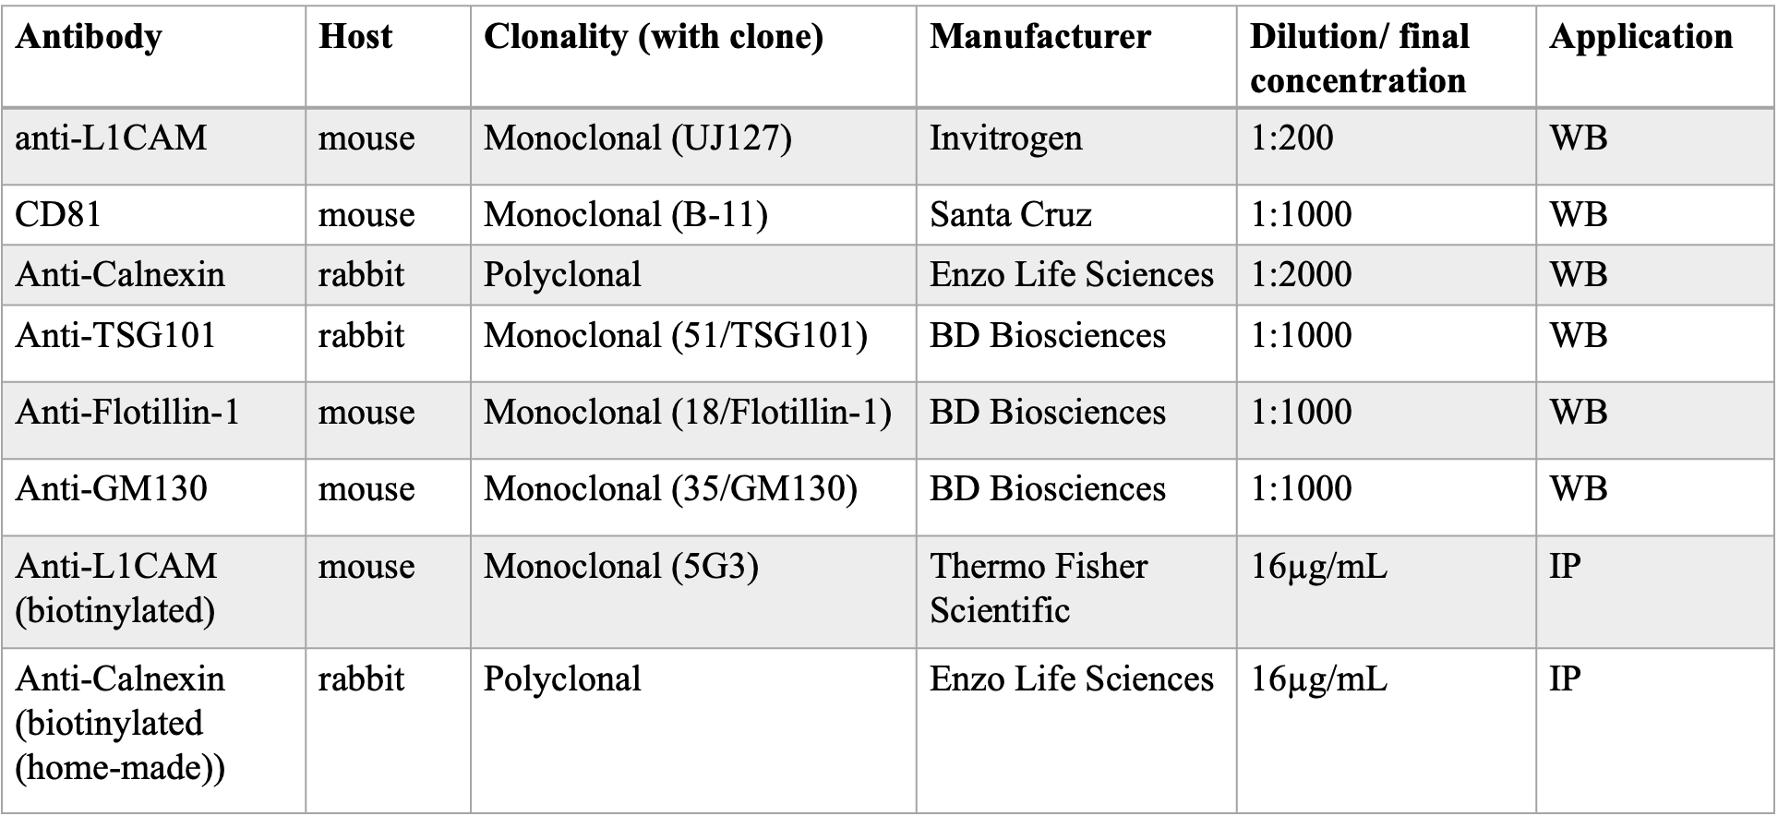
Table S1 List of antibodies used. WB, western blotting; IP, immunoprecipitation

