Supplementary Information

ERRα Knockout Promotes M2 Microglial Polarization and Inhibits Ferroptosis in Sepsis-Associated Brain Dysfunction

Jun Jin^{1,2#}, Yang Dong^{3,4#}, Yu Huang^{1#}, Lili Wu², Lei Yu², Yuanyuan Sun^{5,} Qingshan Zhou MD, PhD ^{2*}, Hai-yan Yin, MD, PhD^{1*}, Wan-jie Gu, MD, PhD^{1*}
#Jun Jin and Yang Dong, Yu Huang contributed equally to this work.
¹Department of Intensive Care Unit, The First Affiliated Hospital of Jinan University, Guangzhou, China;
²Department of Intensive Care Unit, The University of Hong Kong-Shenzhen Hospital, Shenzhen, China;
³Department of Obstetrics and Gynecology, School of Clinical Medicine, LKS Faculty of Medicine, The University of Hong Kong, Hong Kong SAR, China;
⁴Shenzhen Huarui Model Organisms Biotechnology Co., LTD, Shenzhen, China; ⁵Department of Medical Genetics, China Medical University, Shenyang, China.
*Corresponding author:
Prof. Qingshan Zhou, Department of Intensive Care Unit, The University of Hong Kong-Shenzhen Hospital, No.1,Haiyuan 1st Road,Futian District,Shenzhen 518000, China; Tel: +86-13995521001; Email: Zhouqsh@hku-szh.org.
Prof. Hai-Yan Yin, Department of Intensive Care Unit, The First Affiliated Hospital of Jinan University, 613 Huangpu Avenue West, Guangzhou 510630, China; Tel: +86-13318831222; Email: haiyanyin1867@126.com.
Dr. Wan-Jie Gu, Department of Intensive Care Unit, The First Affiliated Hospital of Jinan University, 613 Huangpu Avenue West, Guangzhou 510630, China; Tel: +86-15850546835; Email: guwanjie@jnu.edu.cn.

This file contains 5 tables (Table ST1 - ST5) and 2 figures (Fig. S1-S3).

Supplemental Table ST1 Antibodies carried out in Western blot analyses.
Name | Company | Cat no. | Species | Dilution
NOX1 | Affinity | DF8684 | Rabbit | 1:1000
FTH1 | Abmart | PA4412 | Rabbit | 1:1000
GPX4 | Proteintech | 67763 | Mouse | 1:1000
NRF2 | Proteintech | 16396 | Rabbit | 1：1000

Supplemental Table ST2 Primers used in qPCR.
Gene | Primer sequence （5’-3’）
NOX1 | Forward Primer：GTGCCTTTGCCTGGTTCAACAAC
 | Reverse Primer：AGCCAGTGAGGAAGAGACGGTAG
GPX4 | Forward Primer：ATAAGAACGGCTGCGTGGTGAAG
 | Reverse Primer：TAGAGATAGCACGGCAGGTCCTTC
FTH1 | Forward Primer：CGAGATGATGTGGCTCTGAA
 | Reverse Primer：GTGCACACTCCATTGCATTC
NRF2 | Forward Primer：TGCCACCGCCAGGACTACAG
 | Reverse Primer：GCGTGCTCAGAAACCTCCTTCC
18S rDNA | Forward Primer：GGACACGGACAGGATTGACAGATTG
 | Reverse Primer：TAACCAGACAAATCGCTCCACCAAC

Supplemental Table ST3 gRNAs for CRISPER CAS-9.
gRNA | Sequence （5’-3’）
gRNA-A1 | TTCTCCAGATGTACTCCAGGAGG
gRNA-A2 | CTAACTCTAGGCACAGTTTATGG

Supplemental Table ST4 Antibodies performed in Immunofluorescence.
Name | Company | Cat no. | Species | Dilution
Iba-1 | Proteintech | 10904-1-AP | Rabbit | 1：300
iNOs | Proteintech | 22226-1-AP | Rabbit | 1：300
Arg-1 | Proteintech | 16001-1-AP | Rabbit | 1：300

Supplemental Table ST5 Antibodies carried out in Western blot analyses.
Name | Company | Cat no. | Species | Dilution
Phospho-IKKα(Ser176) | CellSignaling | #2078 | rabbit | 1:1000
Phospho-IκBα（Ser32） | CellSignaling | #2859 | Rabbit IgG | 1:1000
IκBα | CellSignaling | #4812 | Rabbit IgG | 1：1000
IKKβ | CellSignaling | #8943 | Rabbit IgG | 1：1000

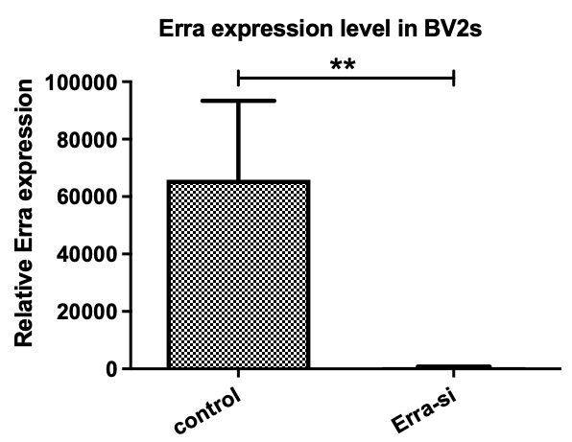
Supplementary Figure 1. Transfection efficiency of ERRα to BV2 microglia. N=5. ** p<0.01.

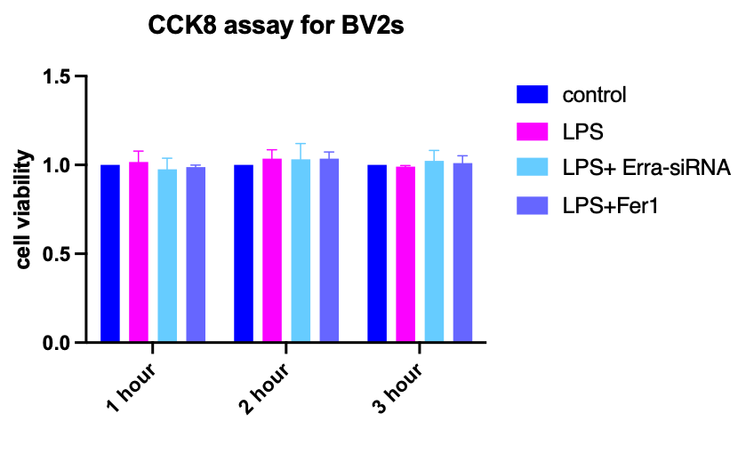
Supplementary Figure 2. Different treatments did not affect BV2 microglia cell viability. N=3.

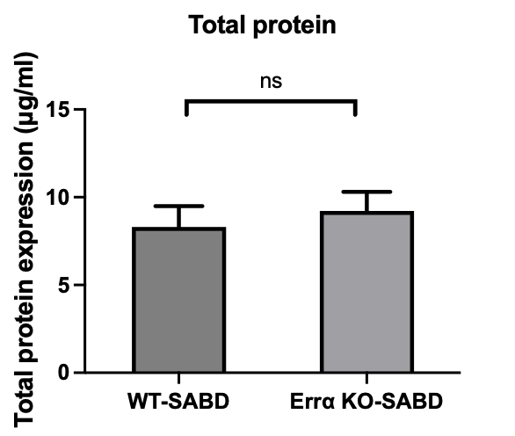
Supplementary Figure 3. Normalization of hippocampal tissue and serum measurements based on protein content for accurate comparability of results.

