Accurate Quantification of Mutant and Wild-Type polyQ Proteins Using Simple Western Capillary Immunoassays
Molecular Neurobiology
Bas Röttgering^{1,2}, Janwillem Testerink¹, Rudie Weij¹, Chantal Beekman¹, Nicole Datson^{1*}
¹VICO Therapeutics B.V., J.H. Oortweg 21, 2333 CH Leiden, The Netherlands
²Leiden University Medical Center, Albinusdreef 2, 2333 ZA Leiden, The Netherlands

*Corresponding author
Email: nicole.datson@vicotx.com

Online Resource 5

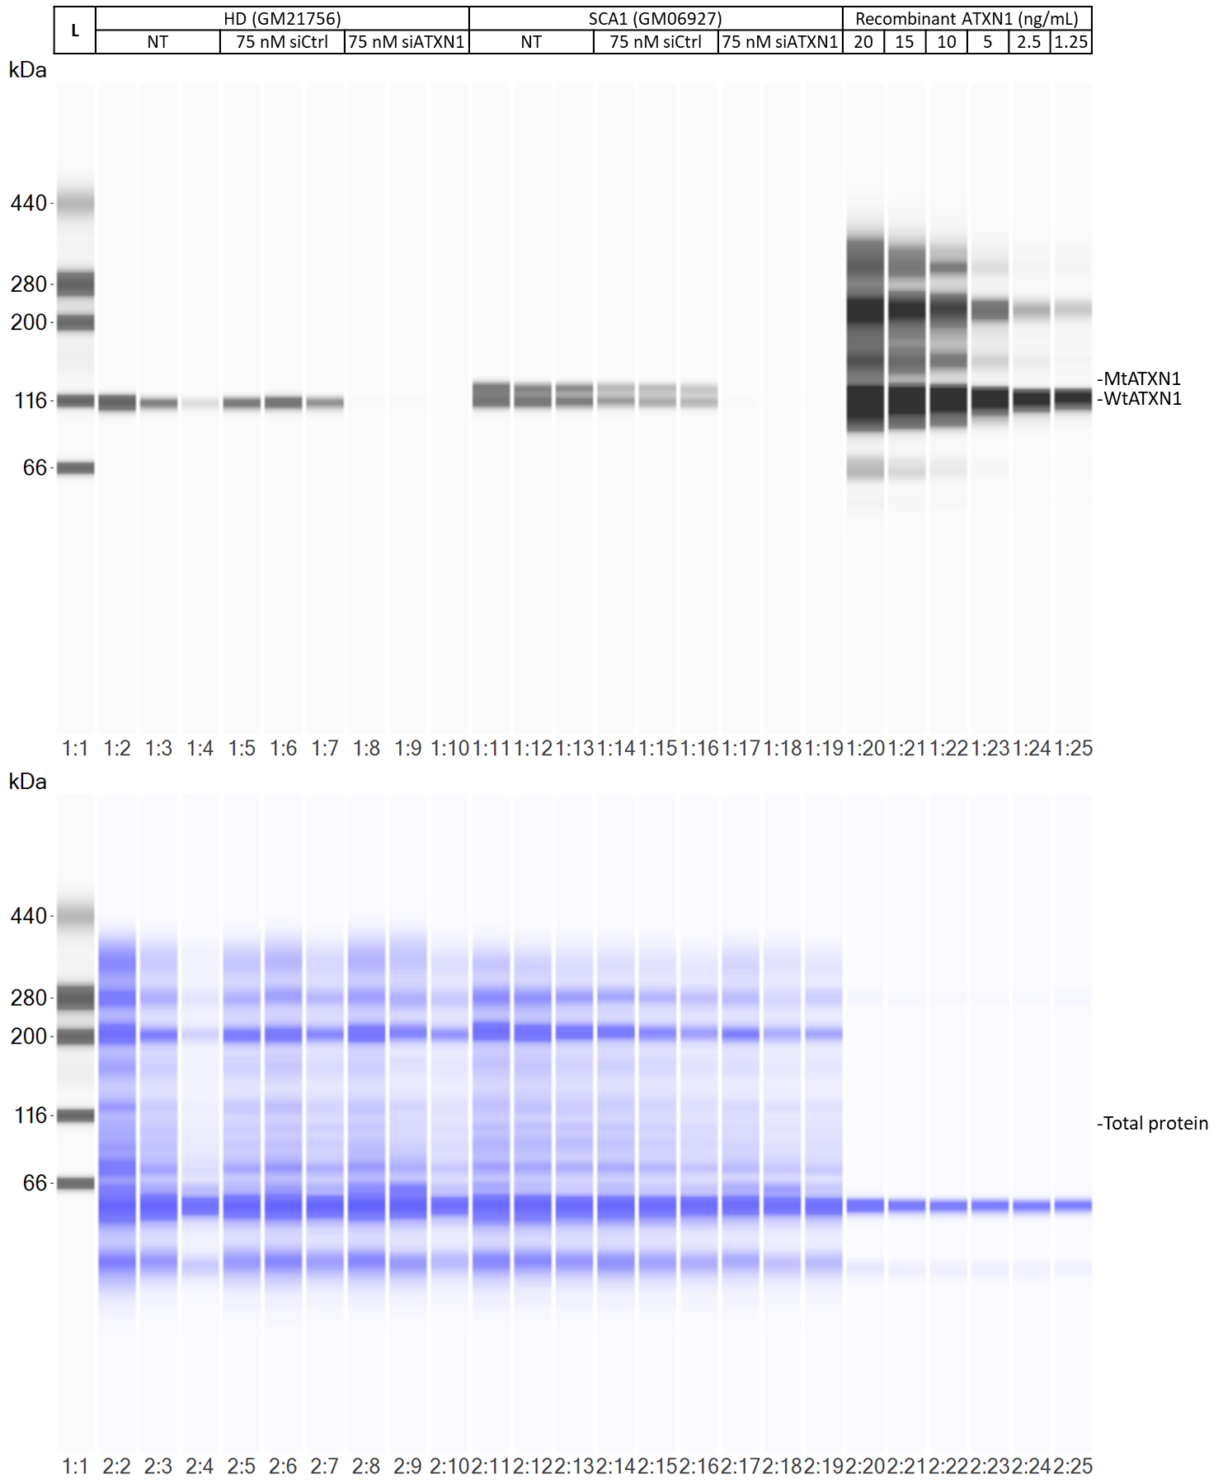
ESM. 5a uncropped blot views of the total protein RePlex SW assay used for fig. 1a-e

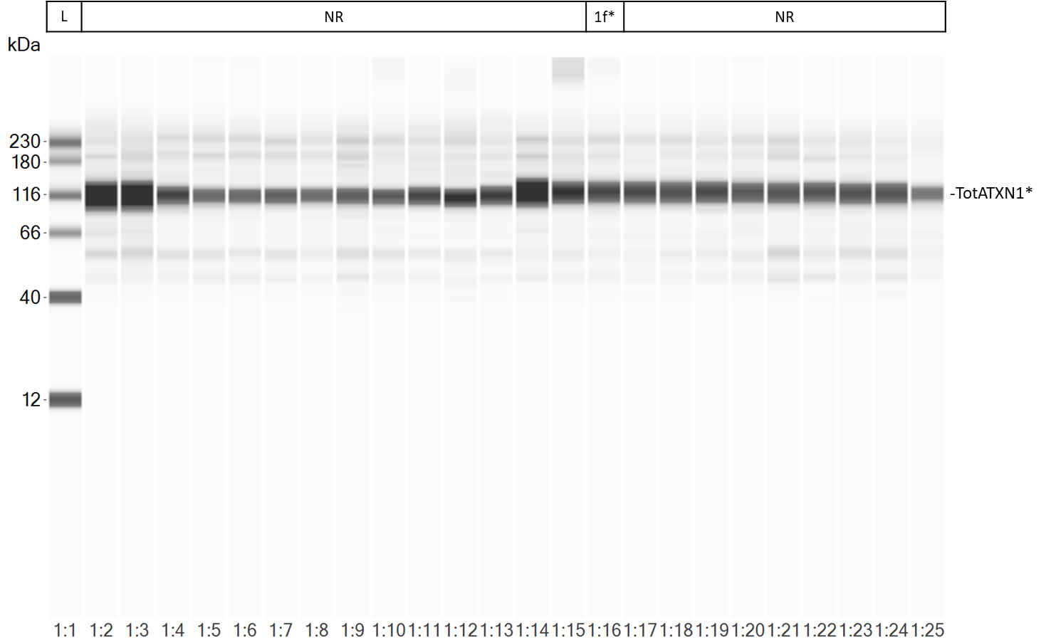
*Refers to the capillary used for fig. 1f
ESM. 5b uncropped blot view of the SW assay used for fig. 1f

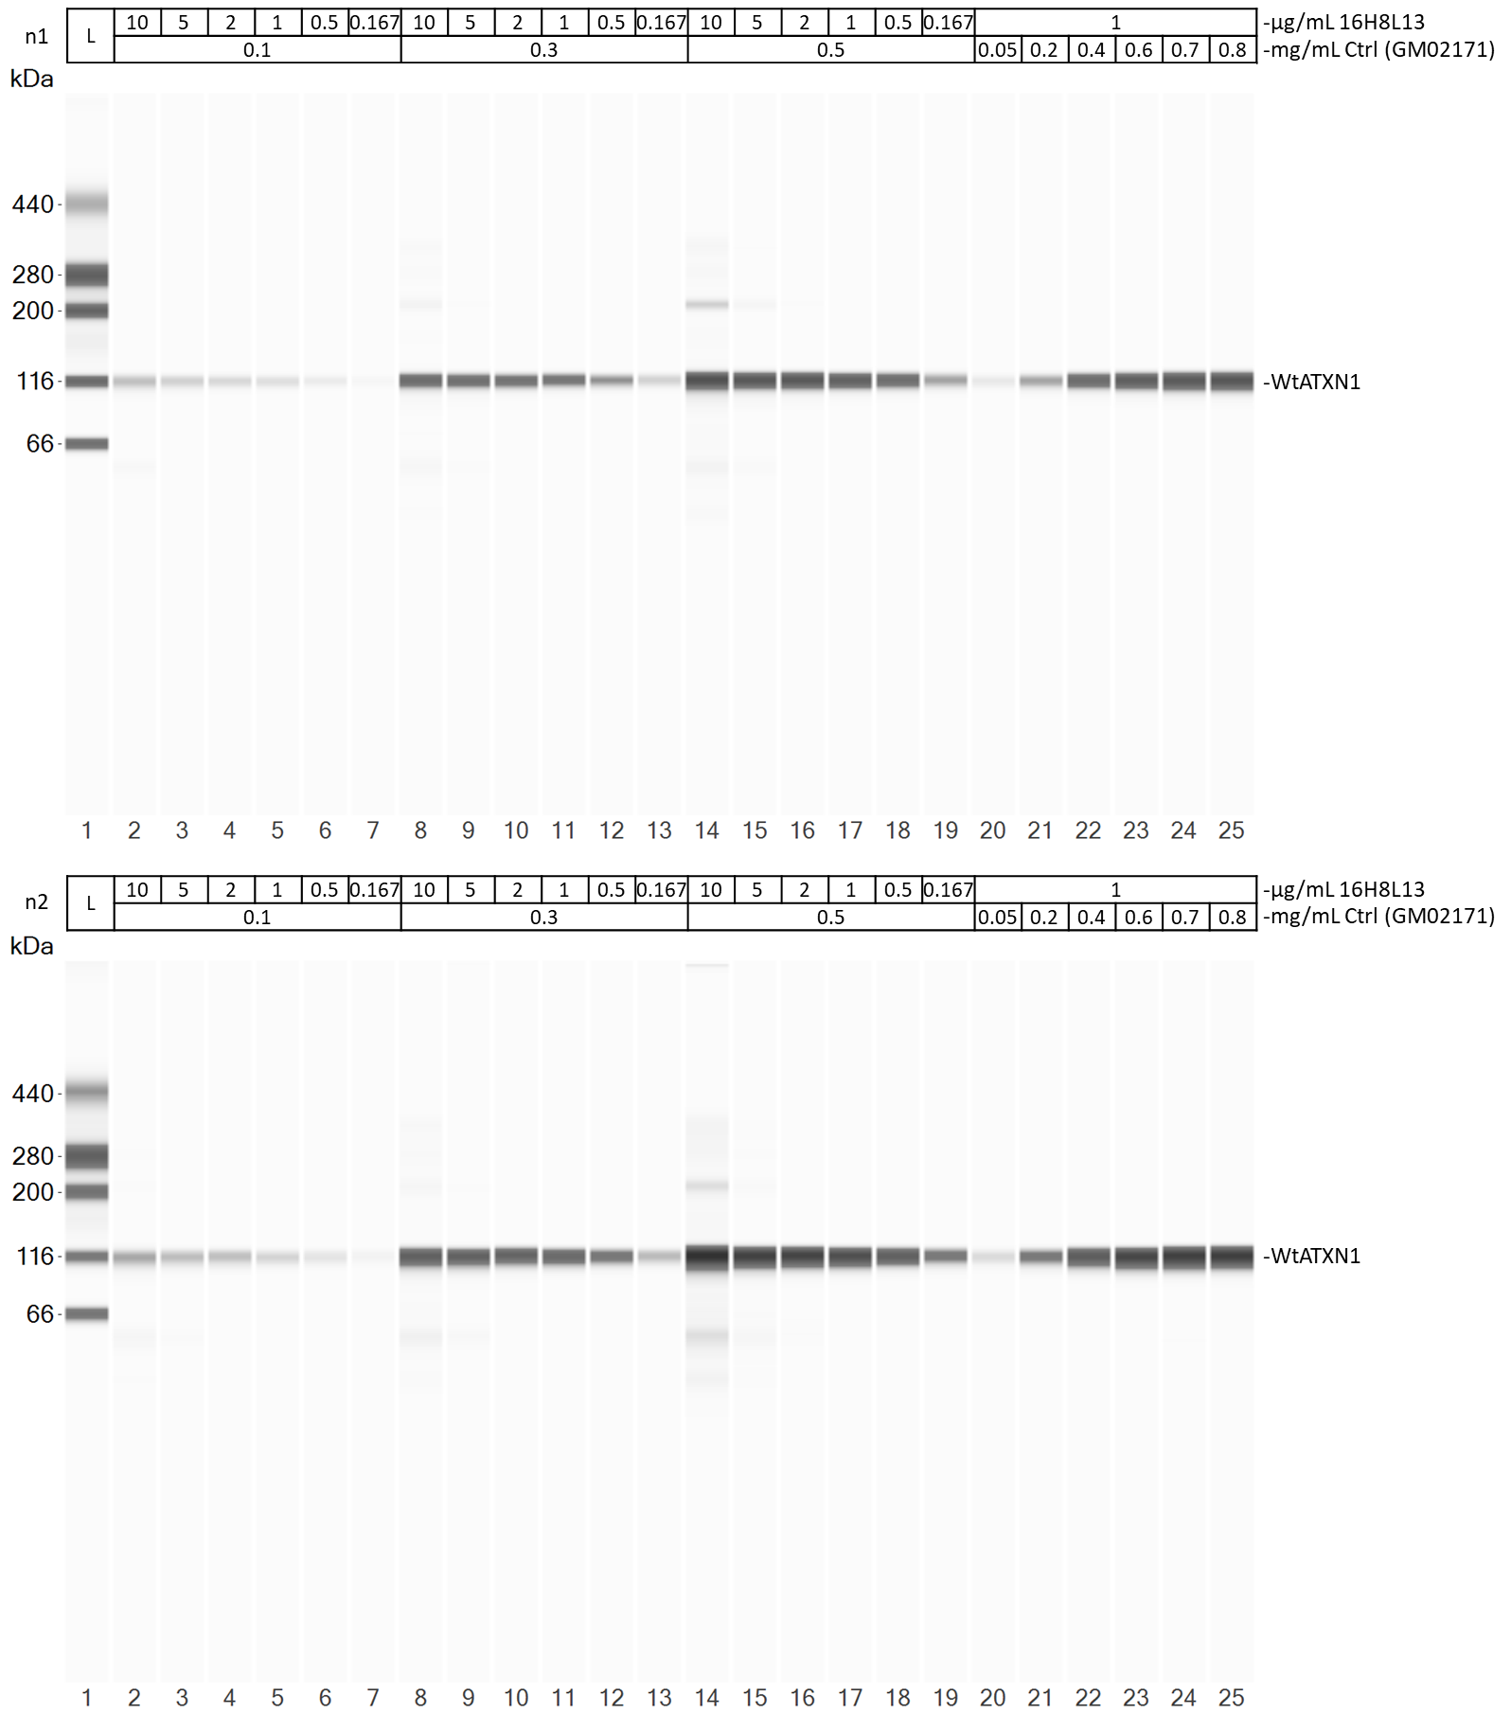
ESM. 5c uncropped blot views of both SW assays used for fig. 1g/h

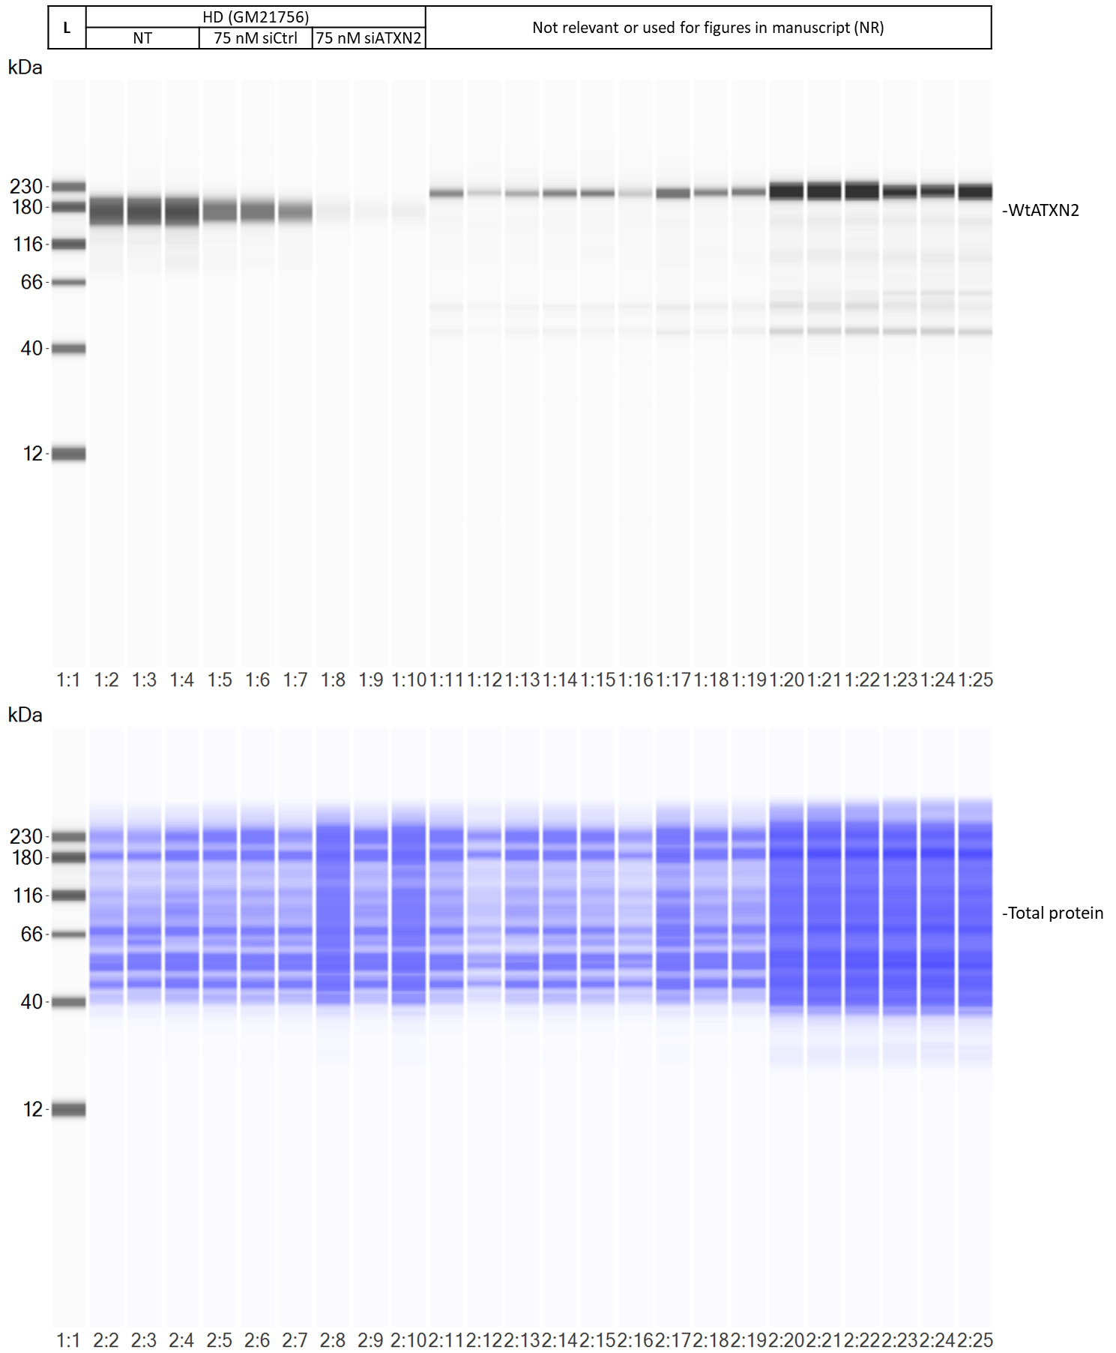
ESM. 5d uncropped blot views of the total protein RePlex SW assay used for fig. 2a-c
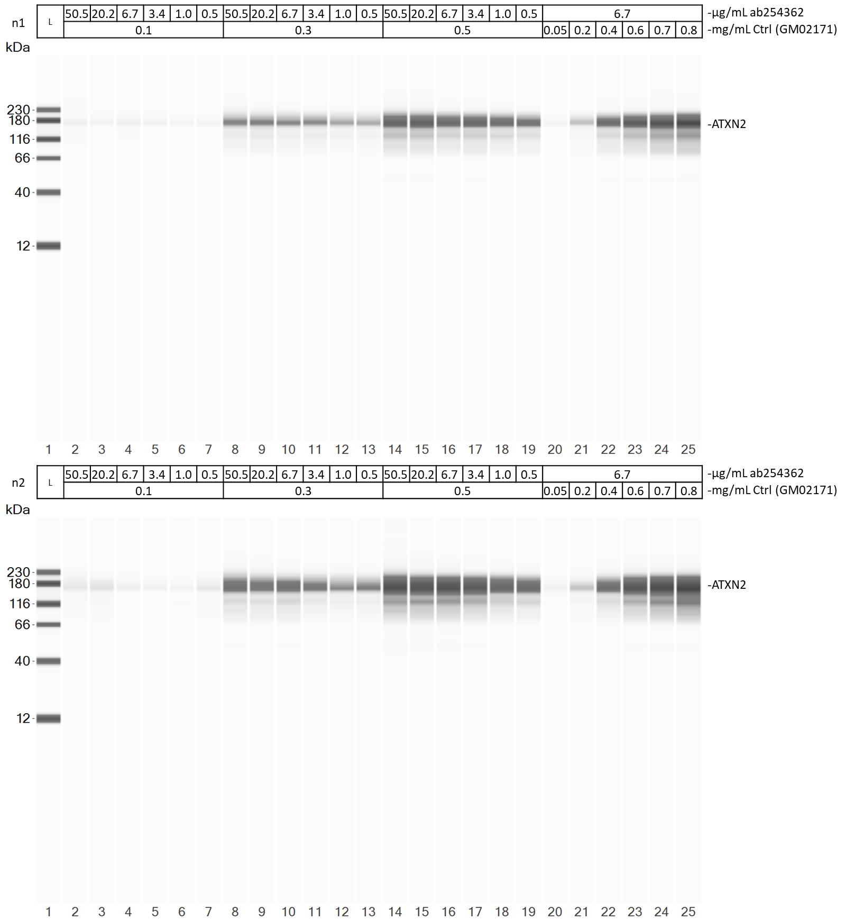
ESM. 5e uncropped blot views of both SW assays used for fig. 2d/e

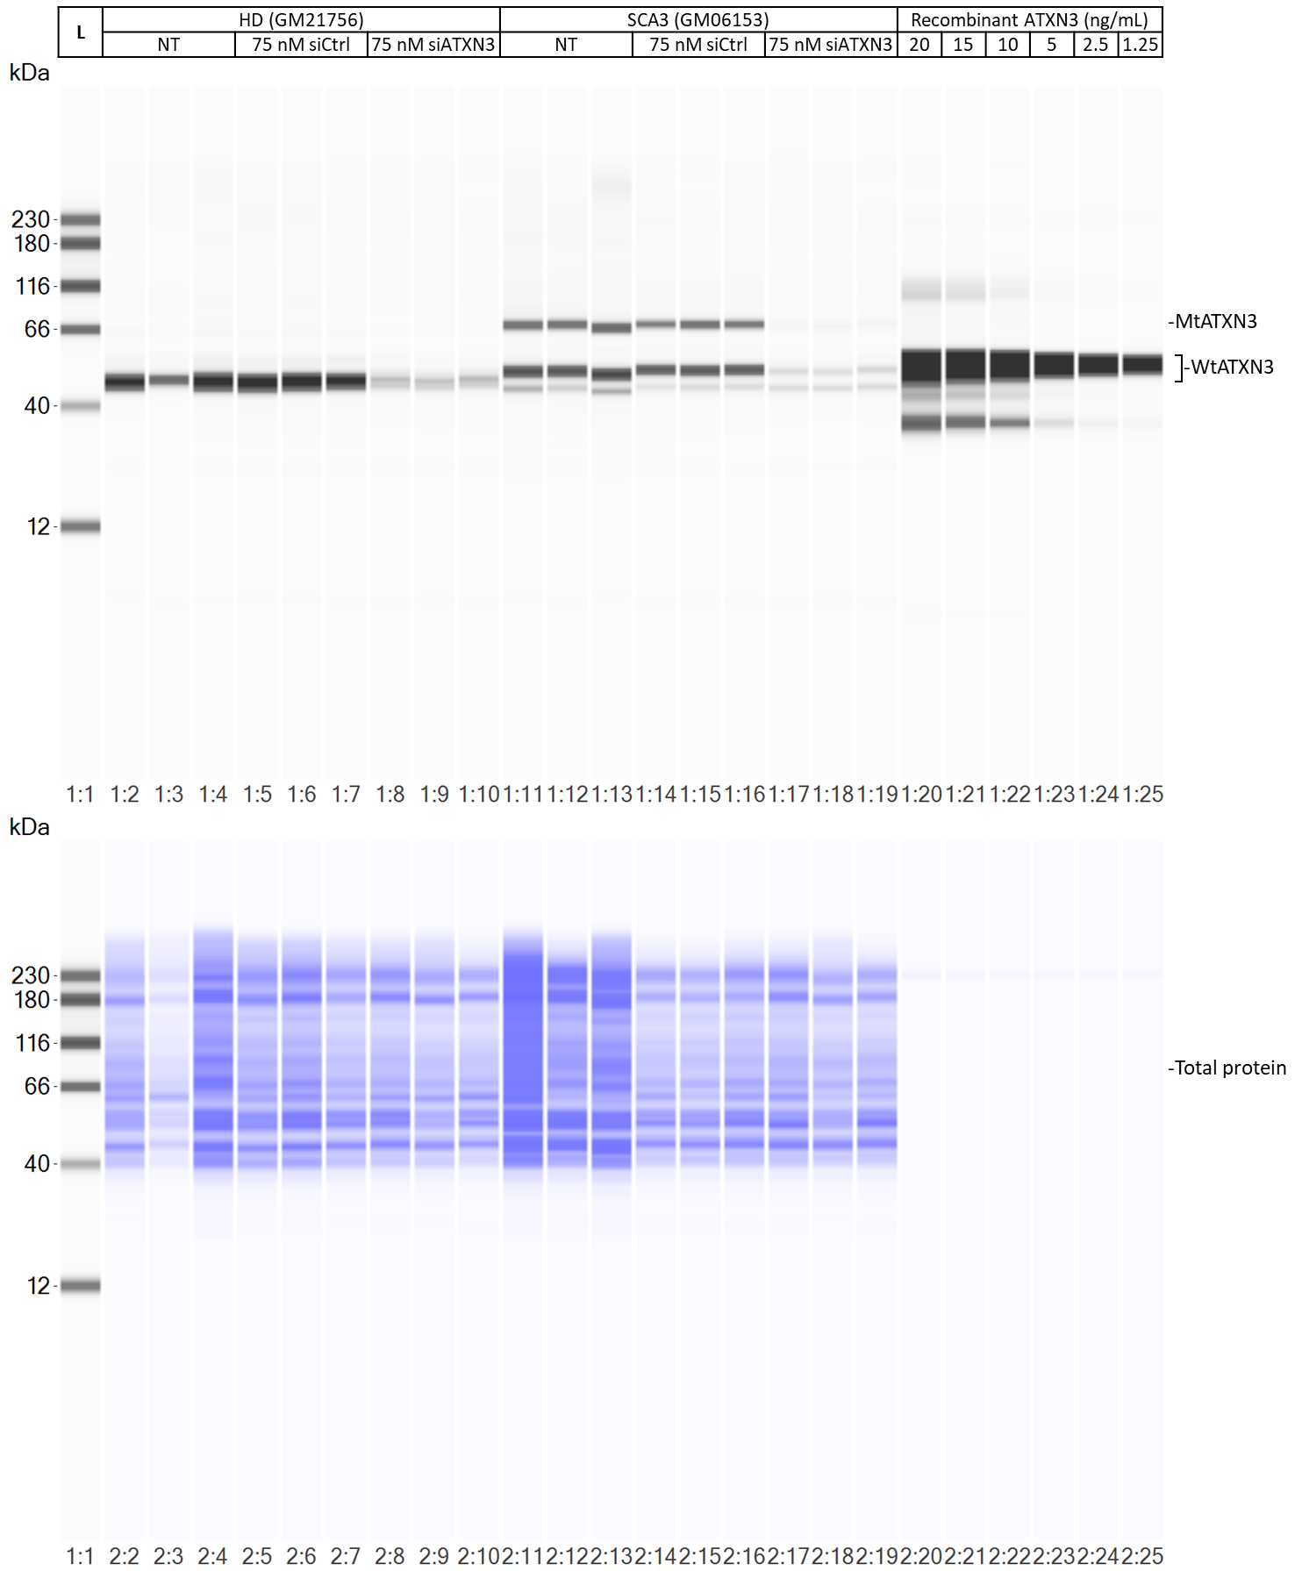
ESM. 5f uncropped blot views of the total protein RePlex SW assay used for fig. 3a-e
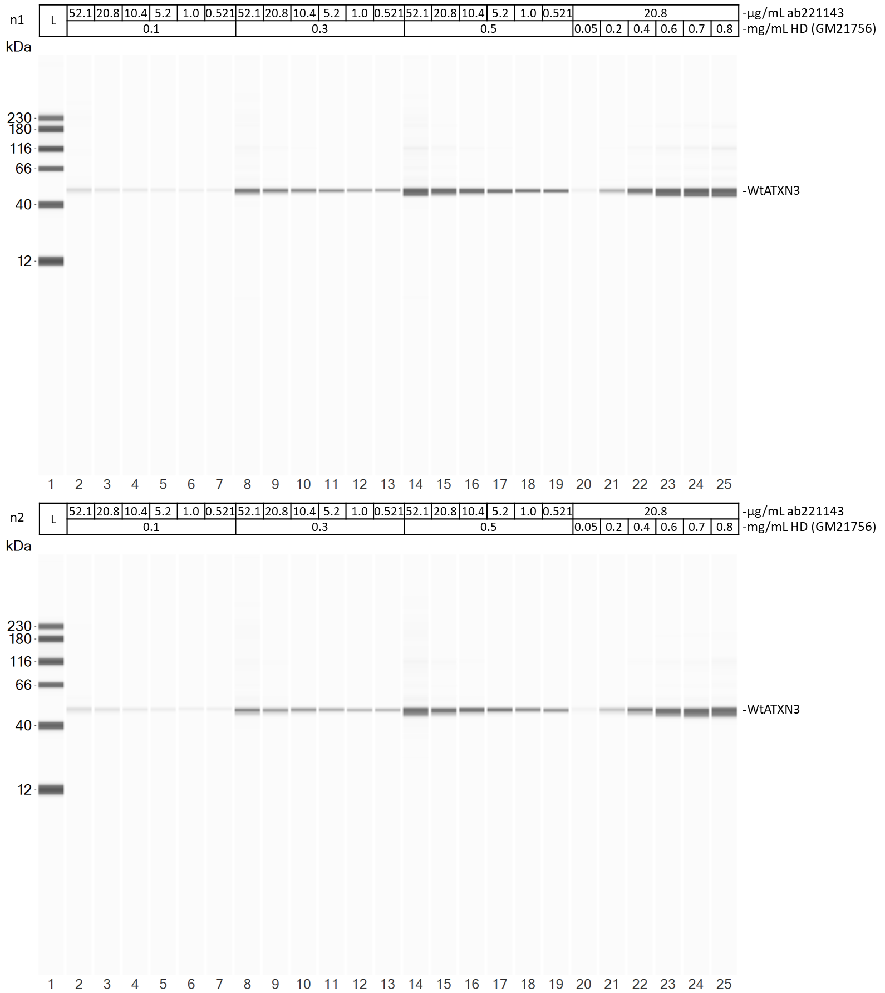
ESM. 5g uncropped blot views of both SW assays used for fig. 3f-h (data shown in fig. 3f came from the n1 experiment)

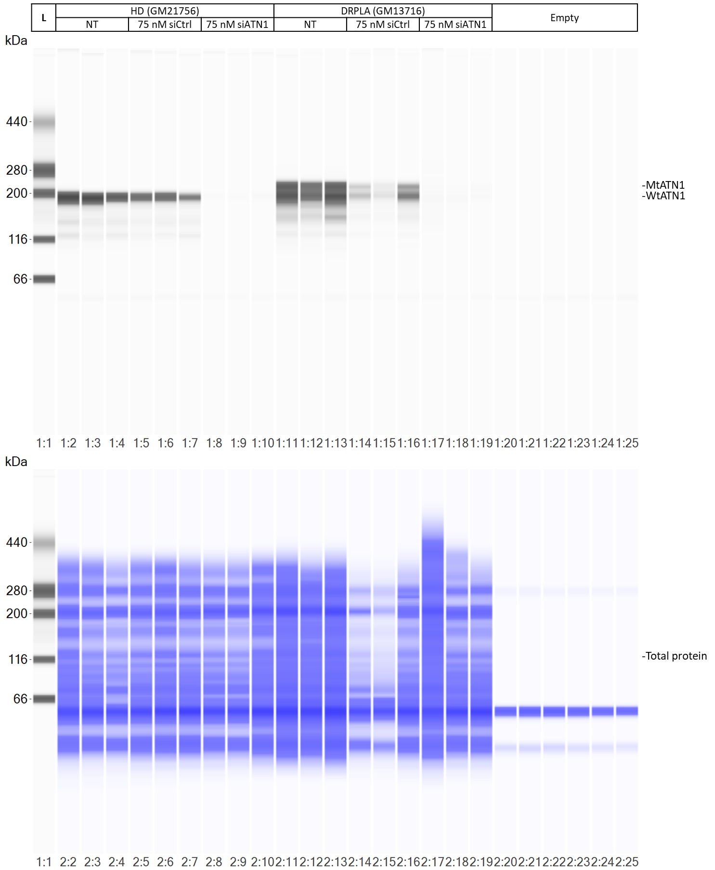
ESM. 5h uncropped blot views of the total protein RePlex SW assay used for fig. 4a-e

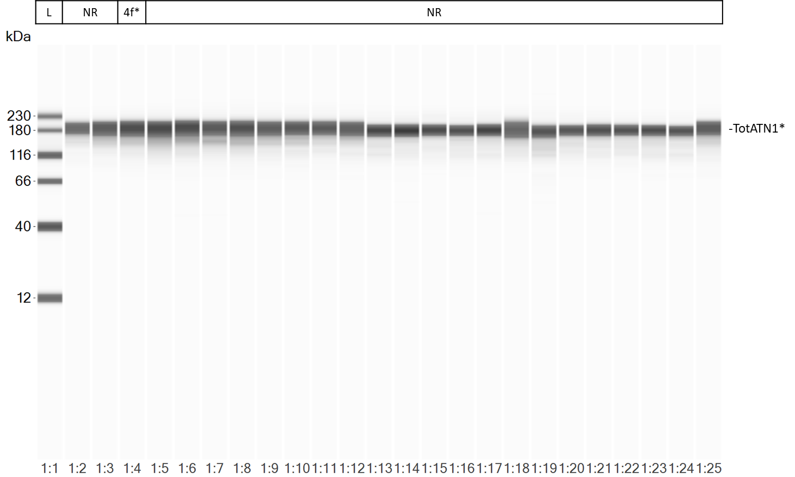
*Refers to the capillary used for fig. 4f
ESM. 5i uncropped blot view of the SW assay used for fig. 4f
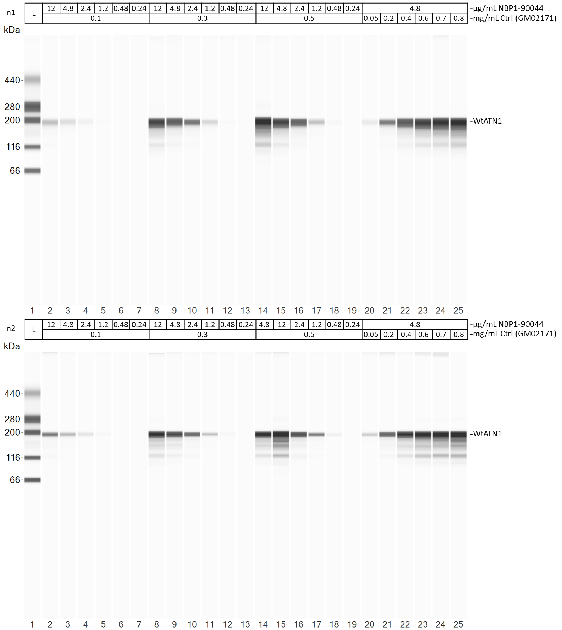
ESM. 5j uncropped blot views of both SW assays used for fig. 4g/h
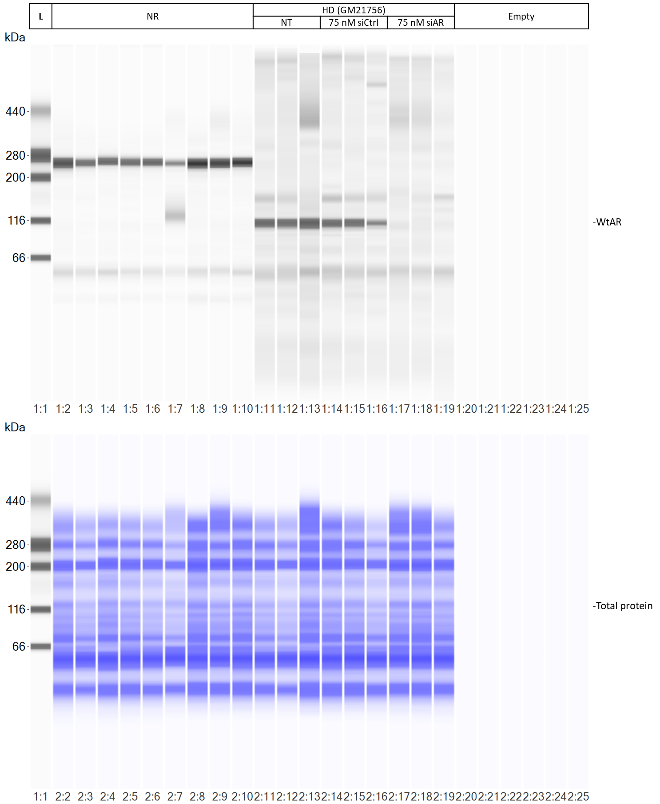
ESM. 5k uncropped blot views of the total protein RePlex SW assay used for fig. 5a-c
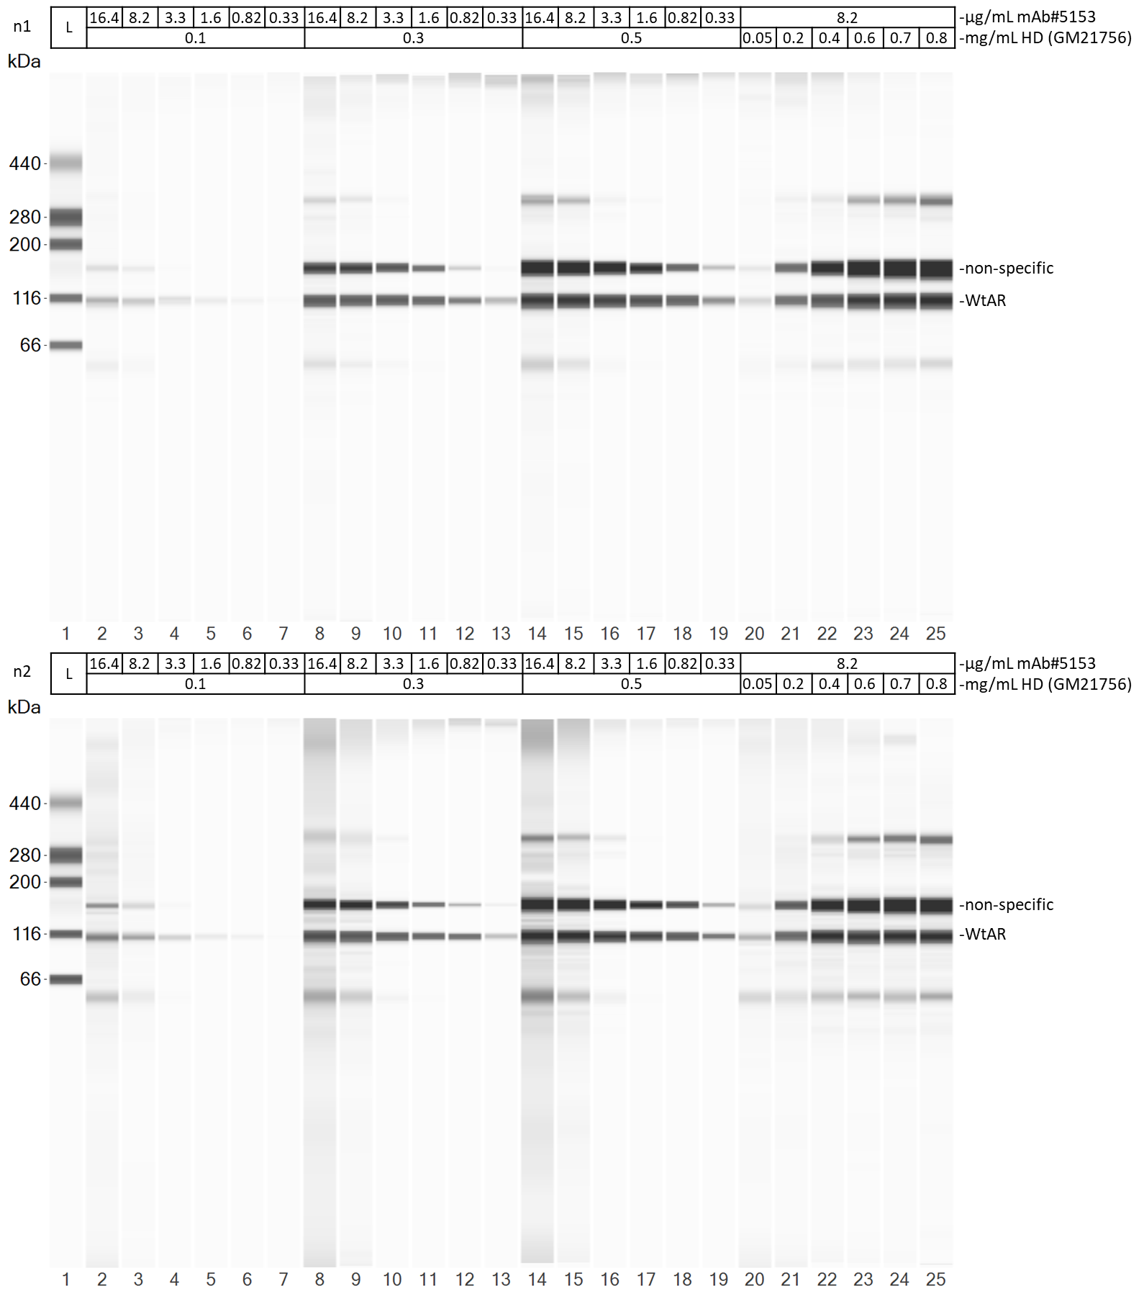
ESM. 5l uncropped blot views of both SW assays used for fig. 5d/e

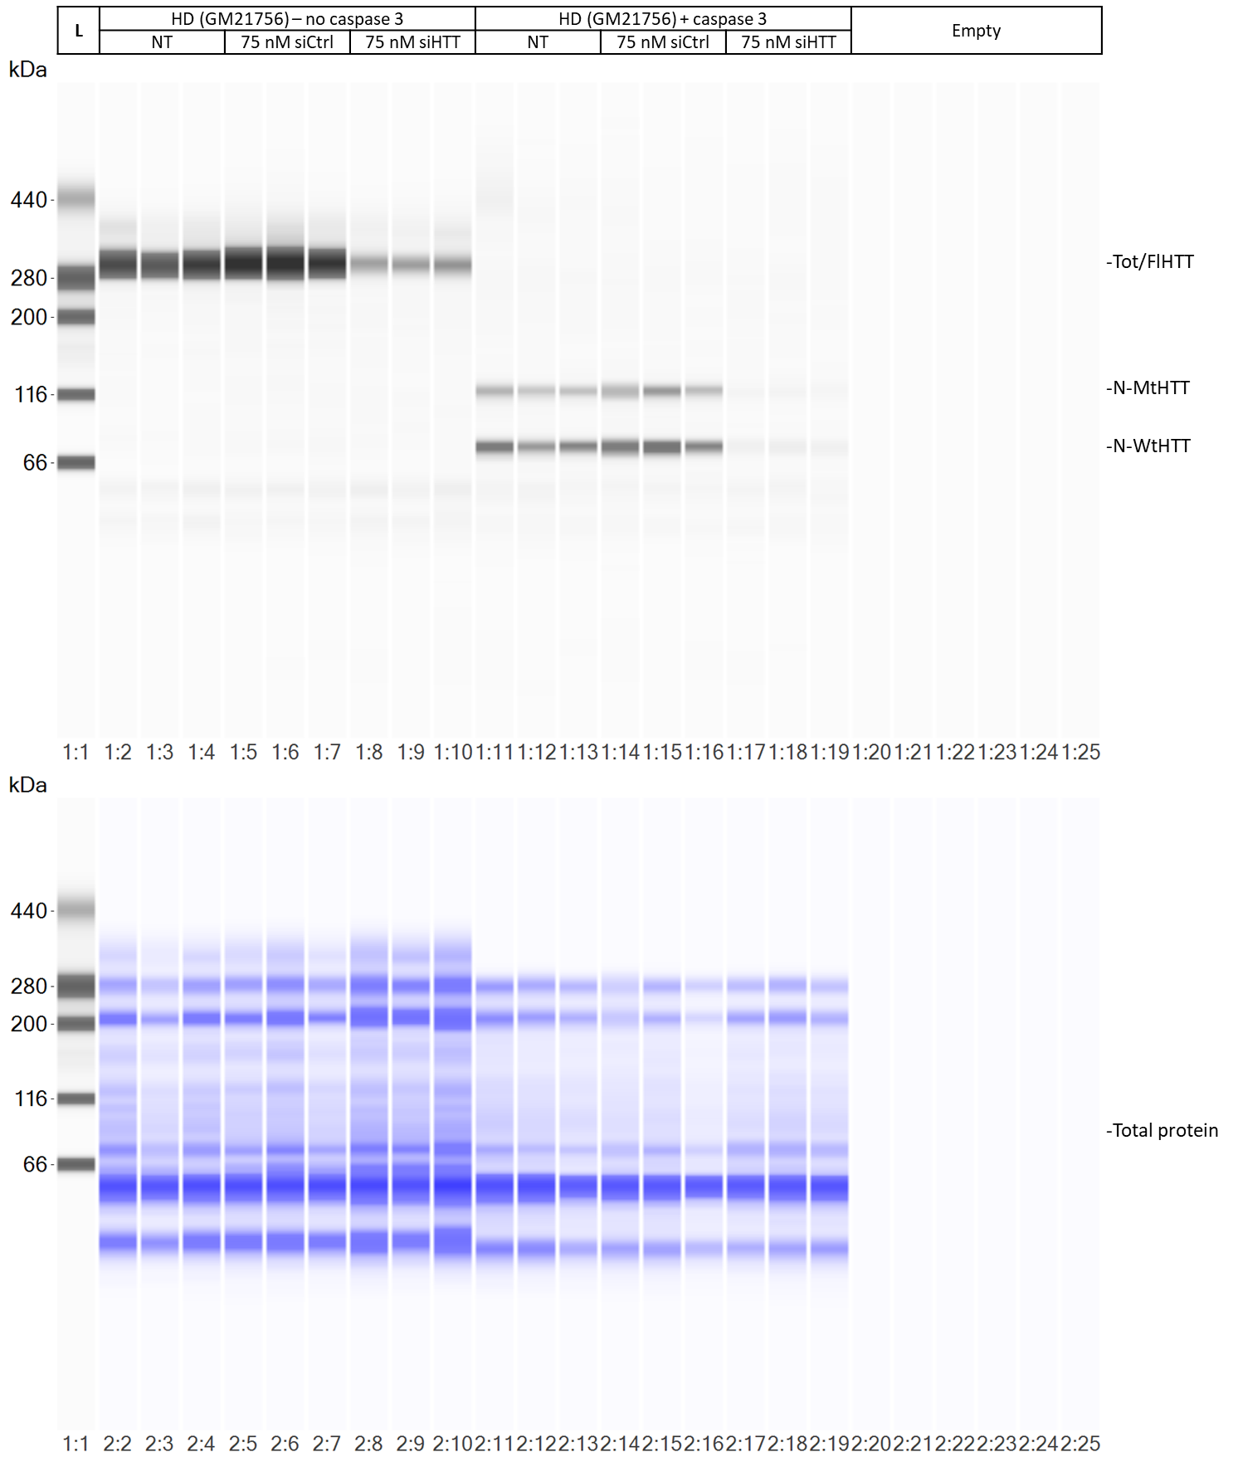
ESM. 5m uncropped blot views of the total protein RePlex SW assay used for fig. 6a-c and fig. 7b-d

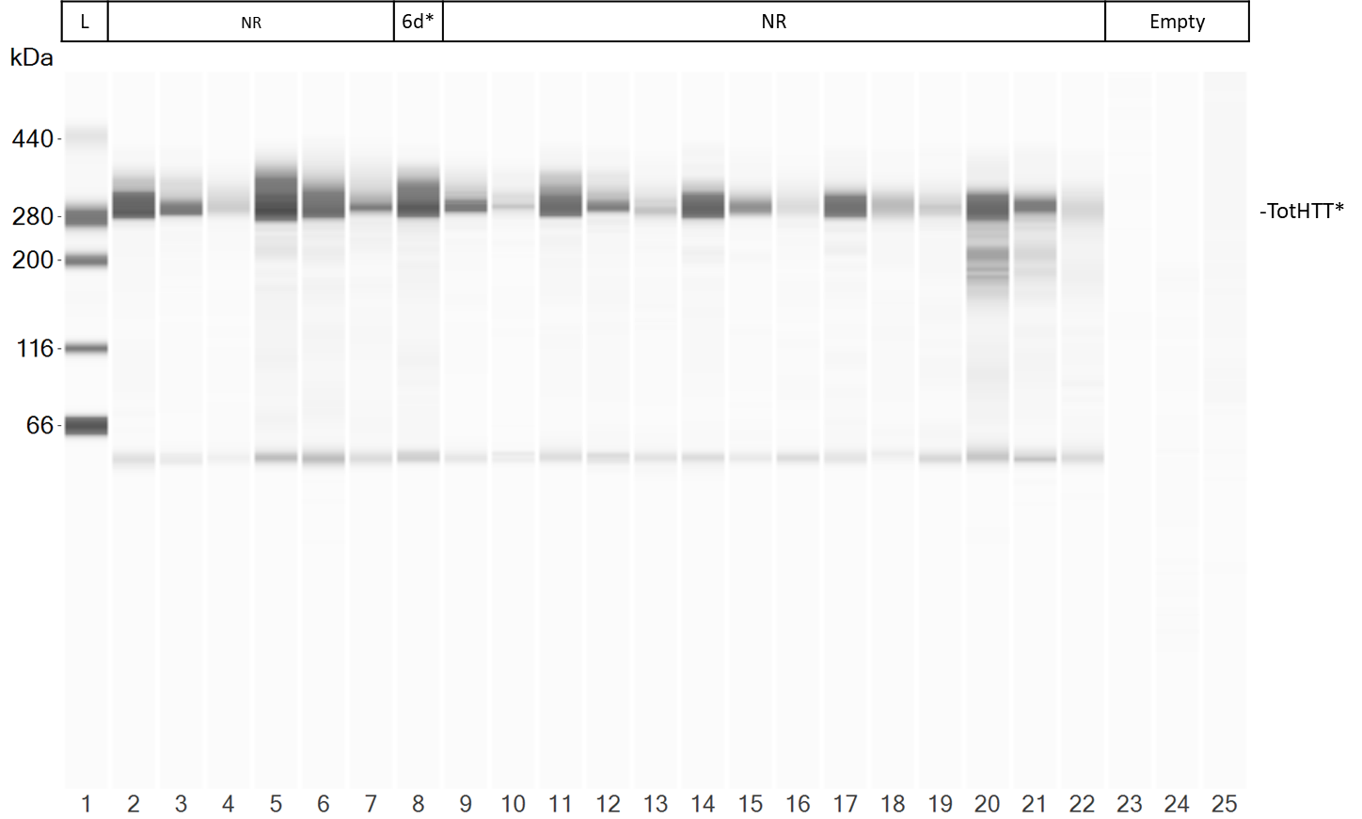
*Refers to the capillary used for fig. 6d
ESM. 5n uncropped blot view of the SW assay used for fig. 6d
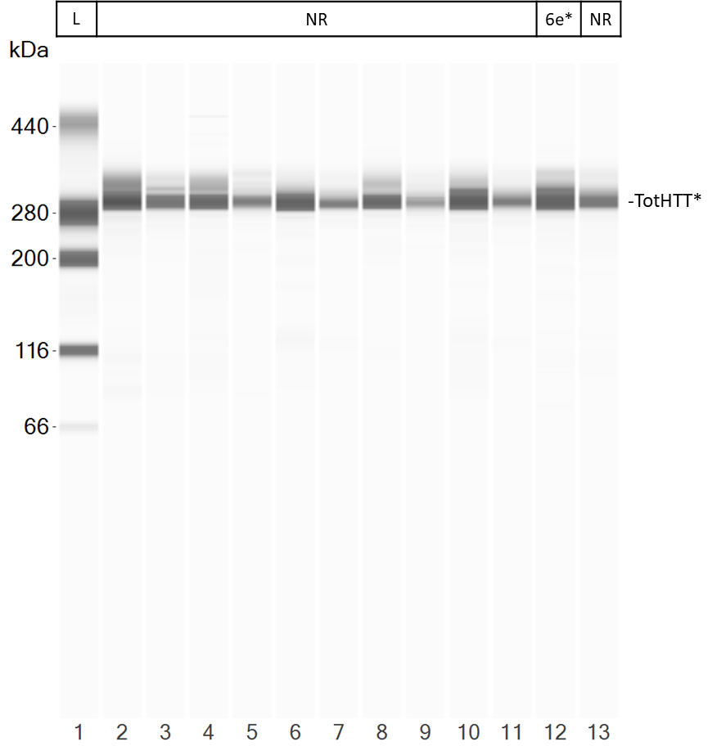
*Refers to the capillary used for fig. 6e
ESM. 5o uncropped blot view of the 13 capillary SW assay used for fig. 6e

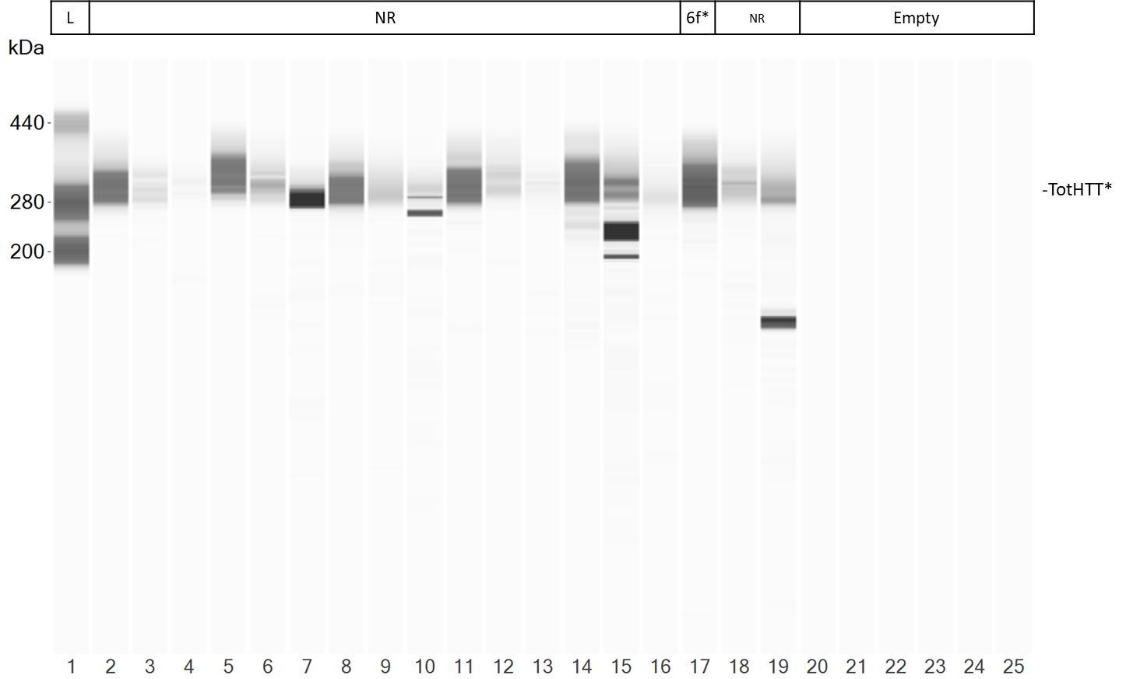
*Refers to the capillary used for fig. 6f
ESM. 5o uncropped blot view of the SW assay used for fig. 6f

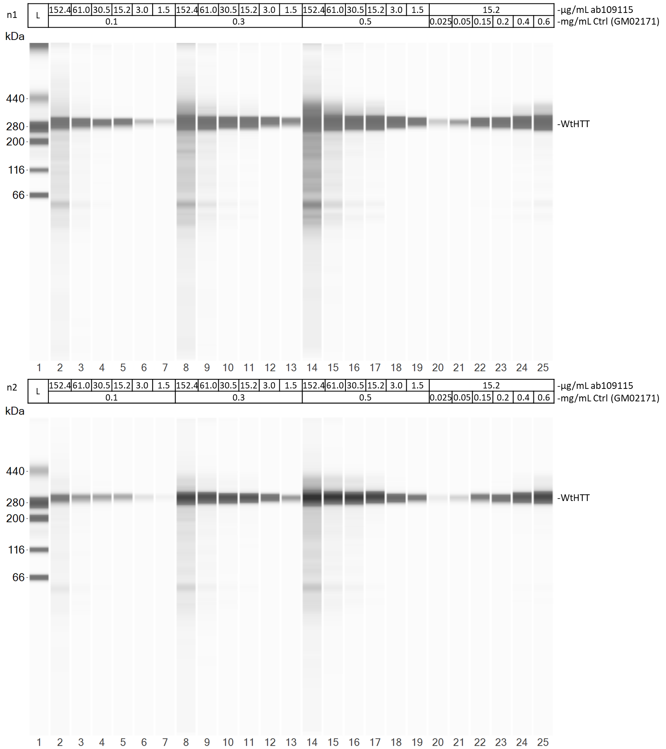
ESM. 5p uncropped blot views of both SW assays used for fig. 6g/h
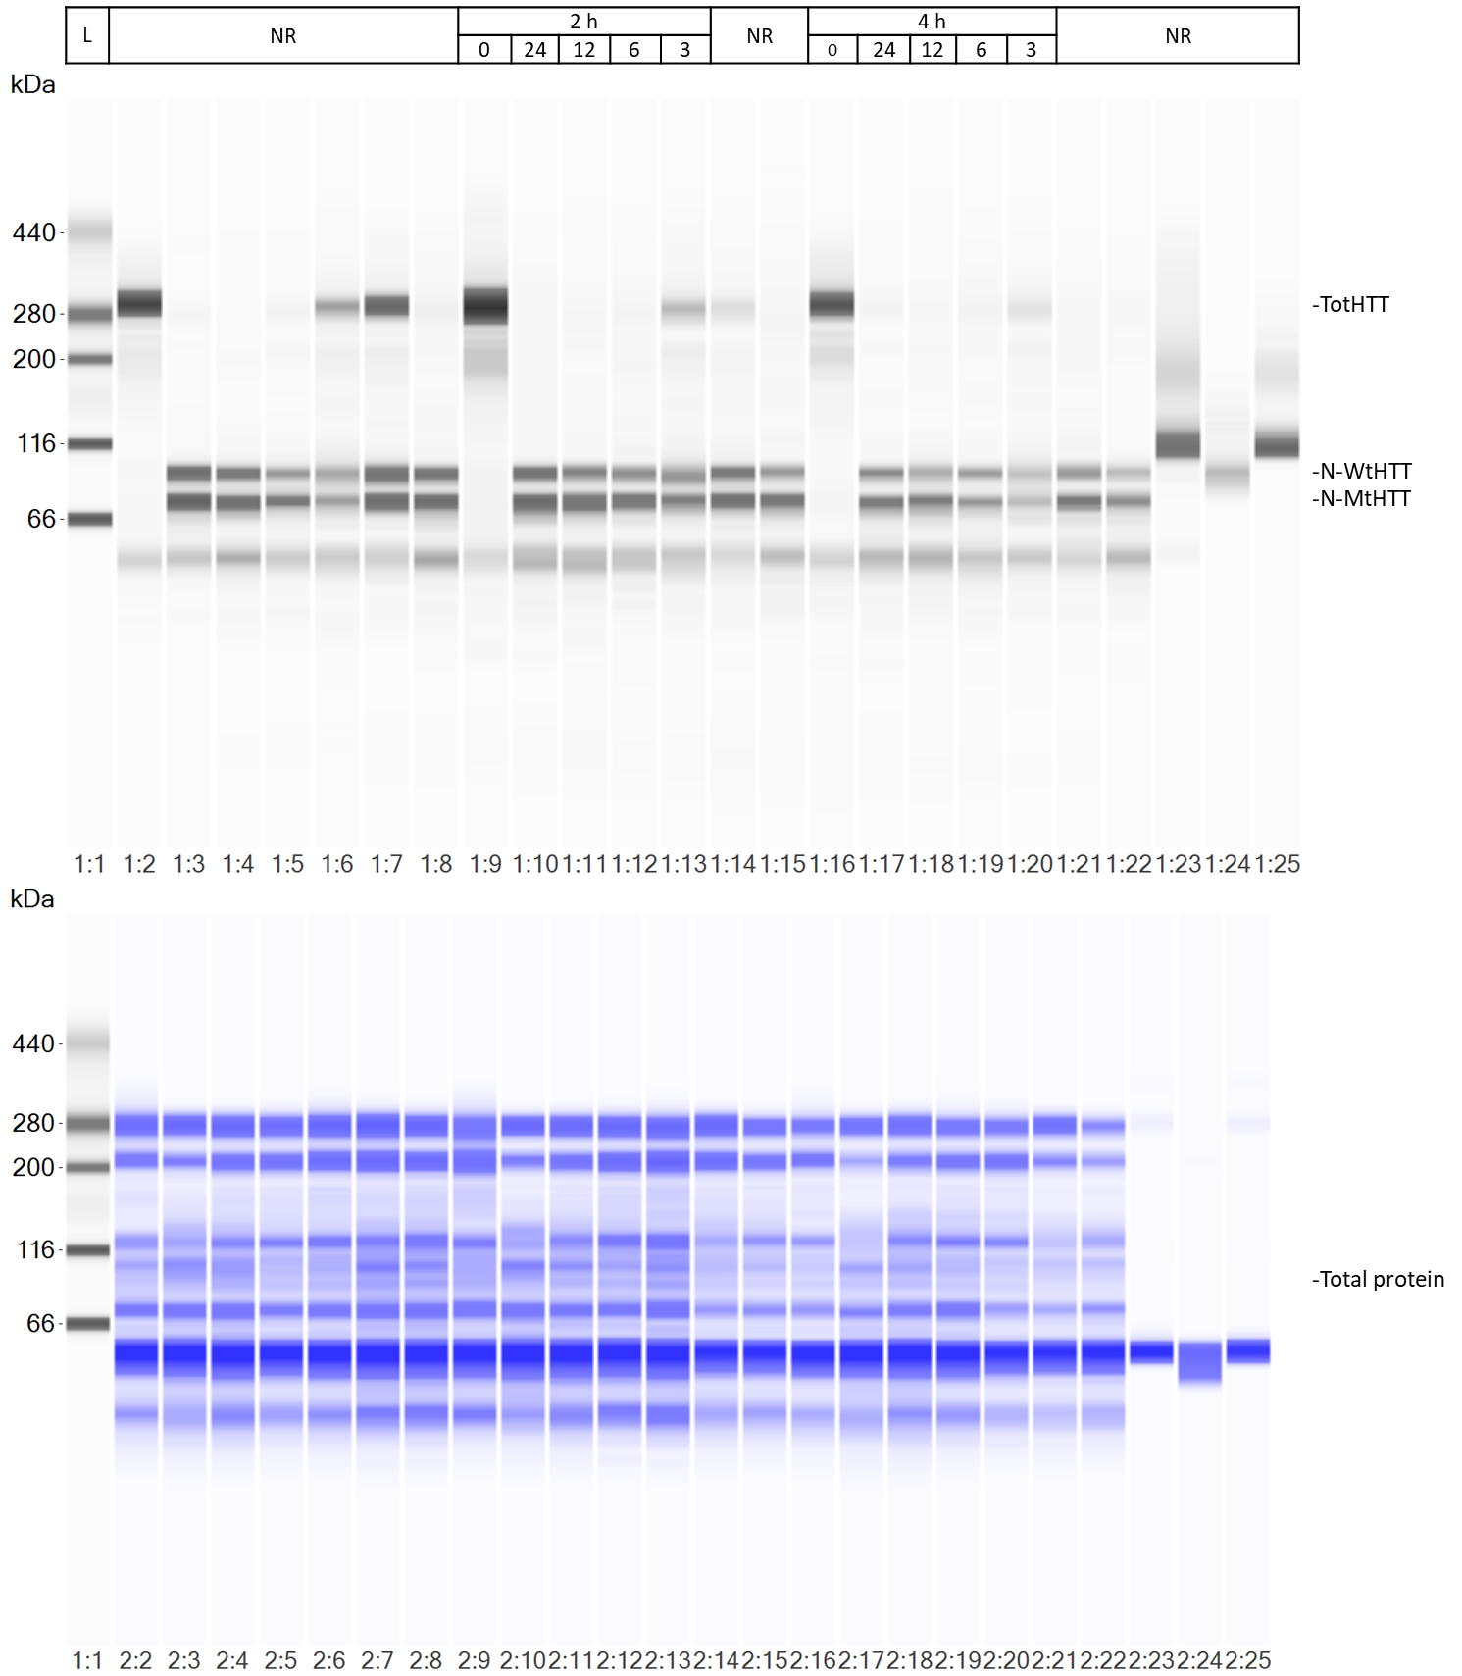
ESM. 5q uncropped blot views of the total protein RePlex SW assay used for fig. 7e
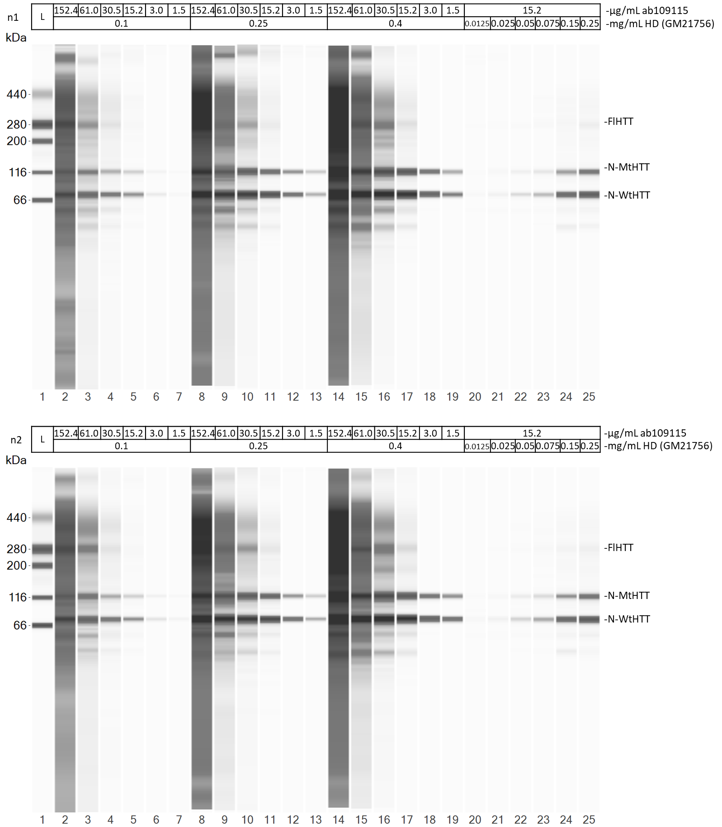
ESM. 5r uncropped blot views of both SW assays used for fig. 7f-h

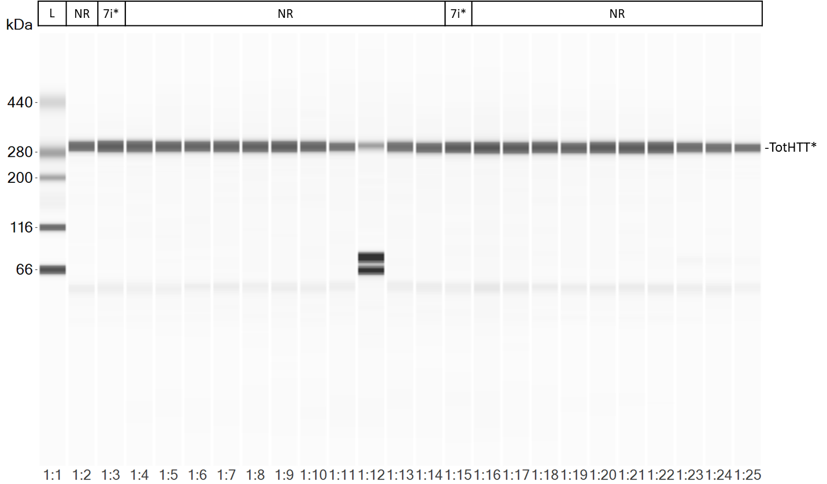
*Refers to the capillaries used for fig. 7i
ESM. 5s uncropped blot view of one of the SW assays used for the graphs in fig. 7i without caspase 3 treatment. HD (GM02147) patient fibroblast lysate was loaded in capillary 3. SCA7 (GM03561) patient fibroblast lysate was loaded in capillary 15.

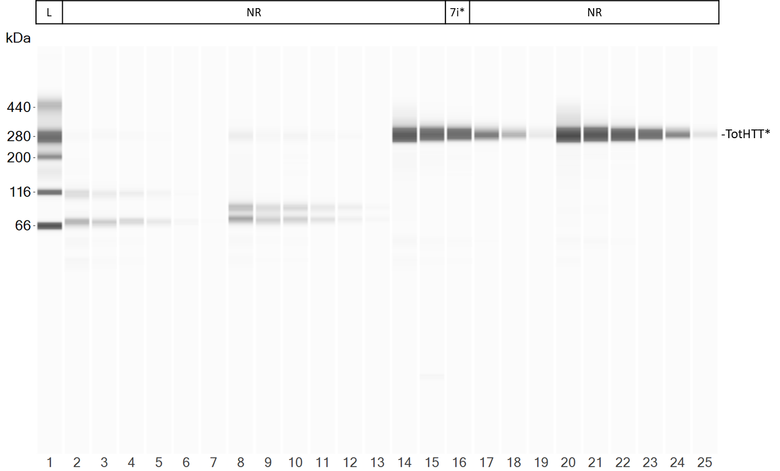
*Refers to the capillaries used for fig. 7i.
ESM. 5s uncropped blot view of the SW assay used for the HD (GM21756) graph without caspase 3 treatment in fig. 7i
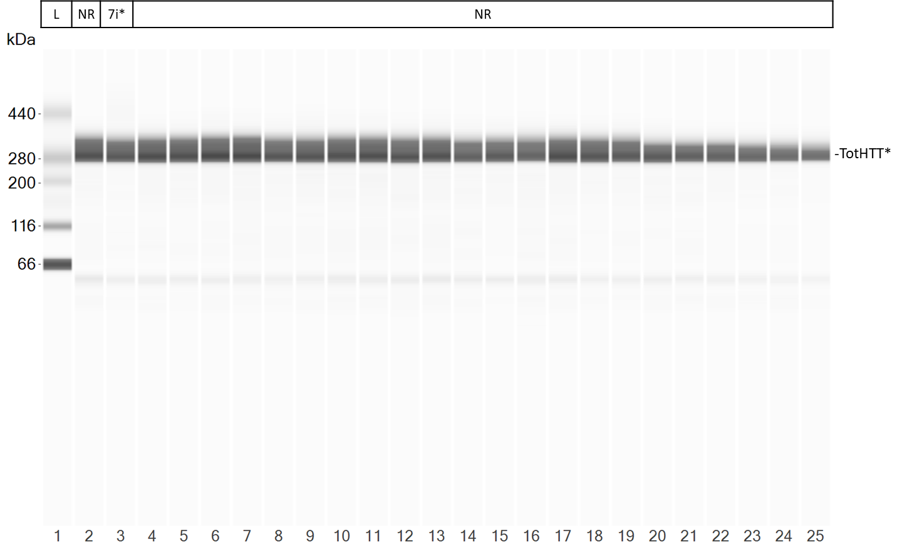
*Refers to the capillaries used for fig. 7i.
ESM. 5t uncropped blot view of the SW assay used for the HD (GM09197) graph without caspase 3 treatment in fig. 7i
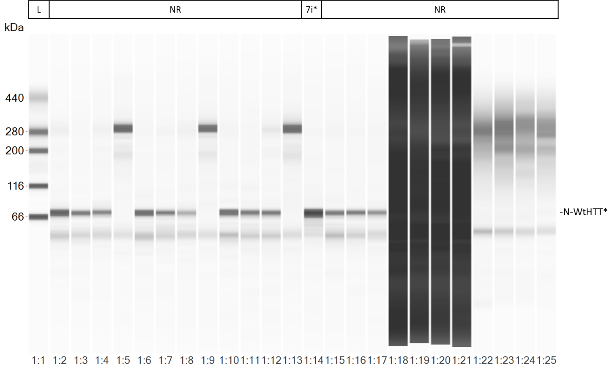
*Refers to the capillaries used for fig. 7i.
ESM. 5u uncropped blot view of the SW assay used for the SCA3 (GM06153) graph with caspase 3 treatment in fig. 7i

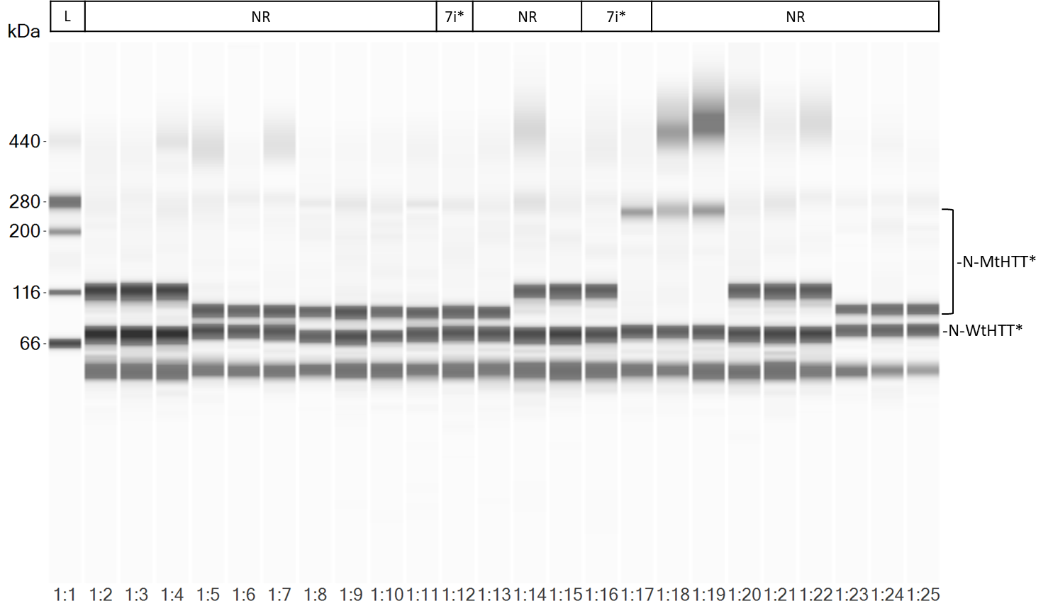
*Refers to the capillaries used for fig. 7i.
ESM. 5v uncropped blot view of one of the SW assays used for graphs in fig. 7i with caspase 3 treatment. HD (GM02147) patient fibroblast lysate was loaded in capillary 12. HD (GM21756) patient fibroblast lysate was loaded in capillary 16. HD (GM09197) patient fibroblast lysate was loaded in capillary 16.
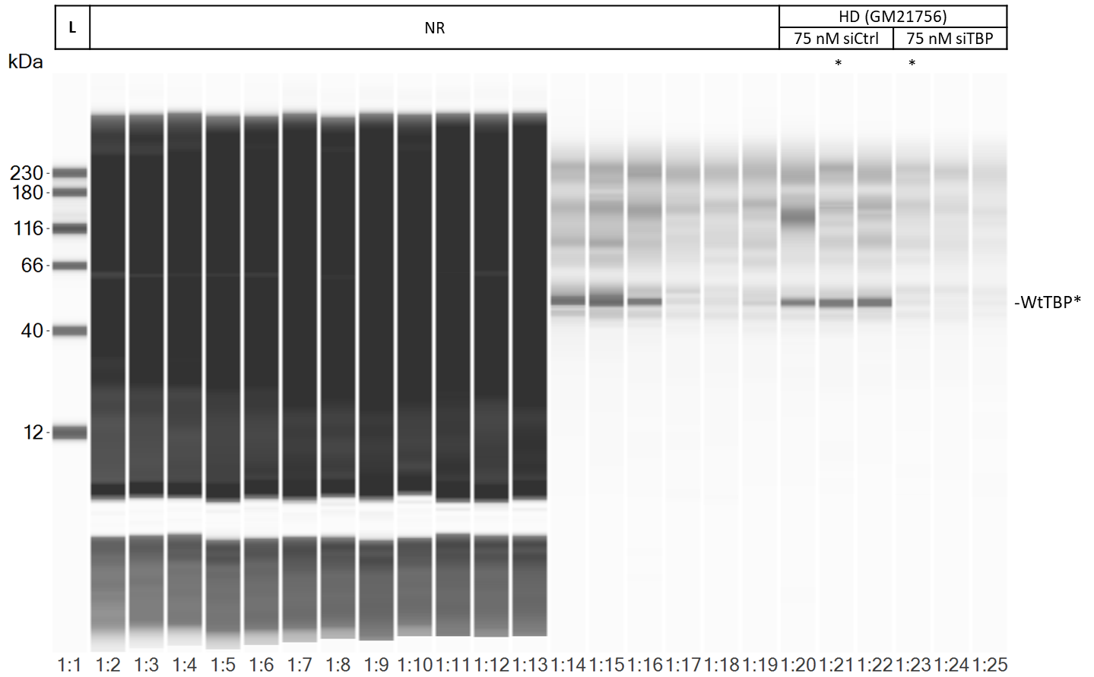
*Refers to the capillaries shown in Online Resource 3a
ESM. 5w uncropped blot view of the SW assay used for the graph in Online Resource 3a (ESM. 3a)

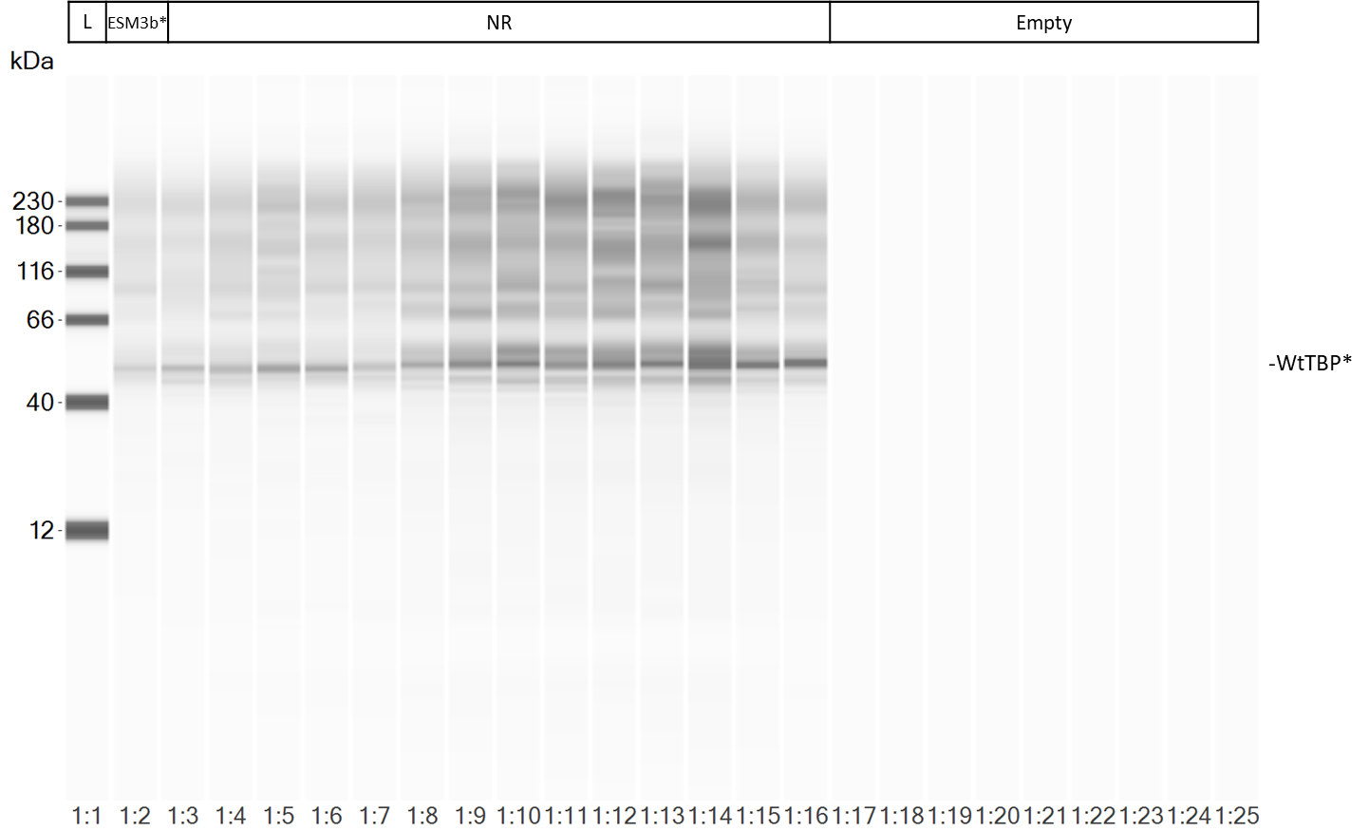
*Refers to the capillaries shown in Online Resource 3b
ESM. 5x uncropped blot view of the SW assay used for the graph in Online Resource 3b (ESM. 3b)
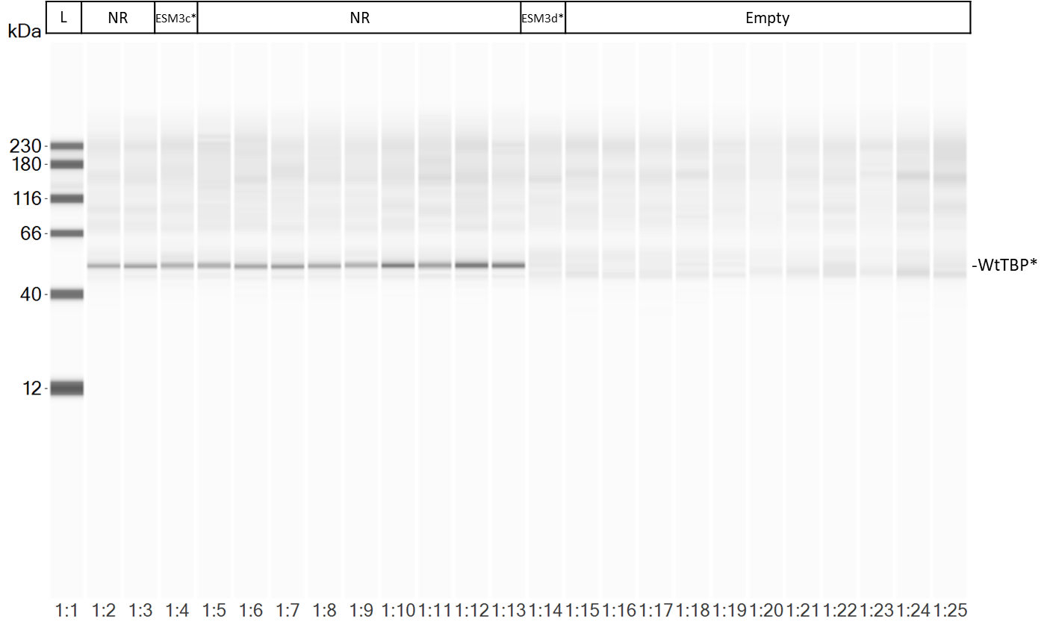
*Refers to the capillaries shown in Online Resource 3c and 3d
ESM. 5y uncropped blot view of the SW assay used for the graphs in Online Resource 3c/d (ESM. 3c/d)

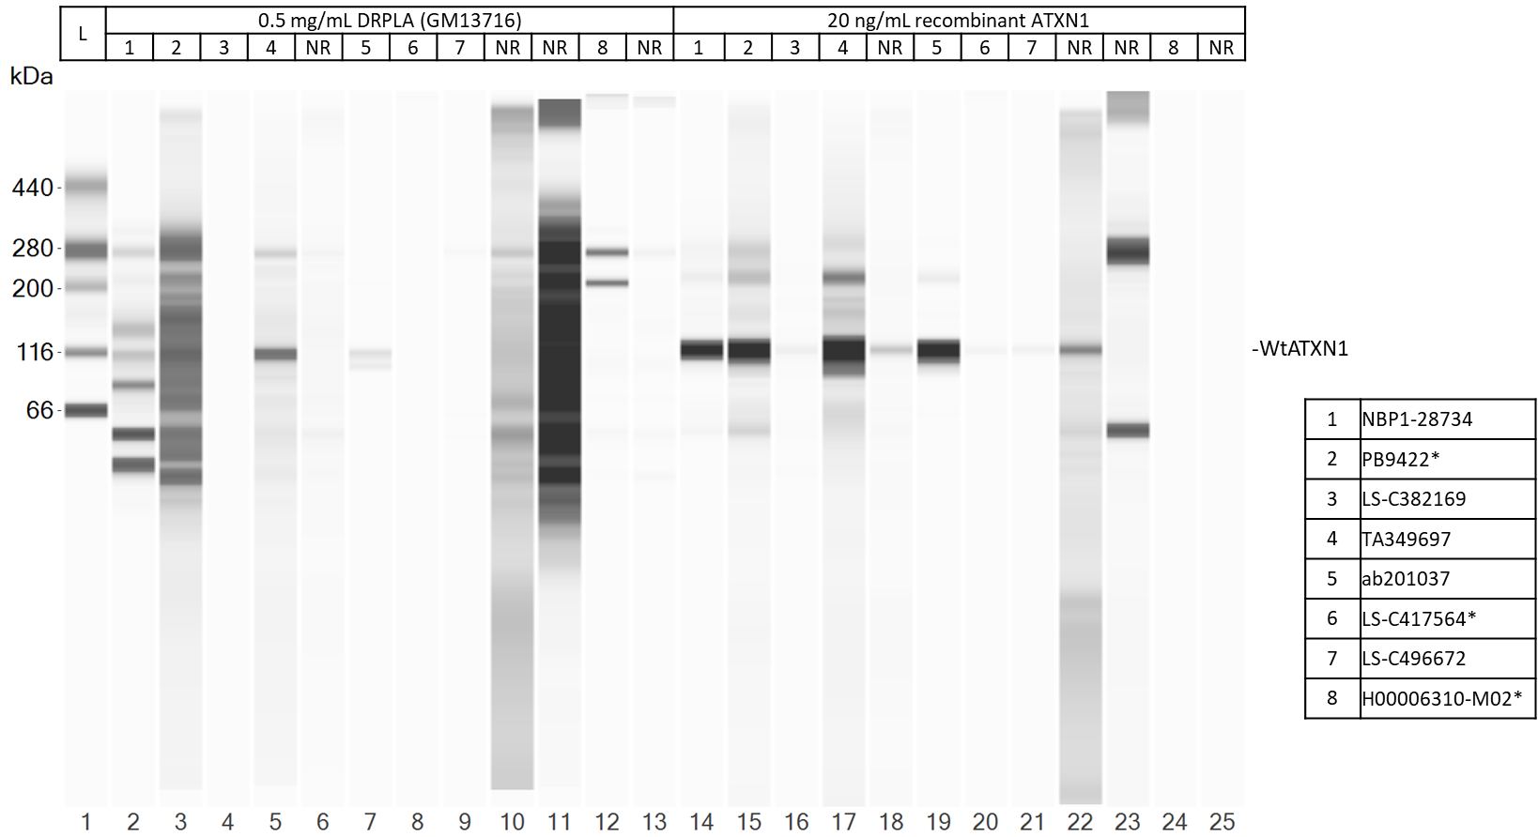
*ATXN1 antibodies shown in Online Resource 4a-c
ESM. 5z uncropped blot view of the SW assay used for the graphs in Online Resource 4a-c (ESM. 4a-c)
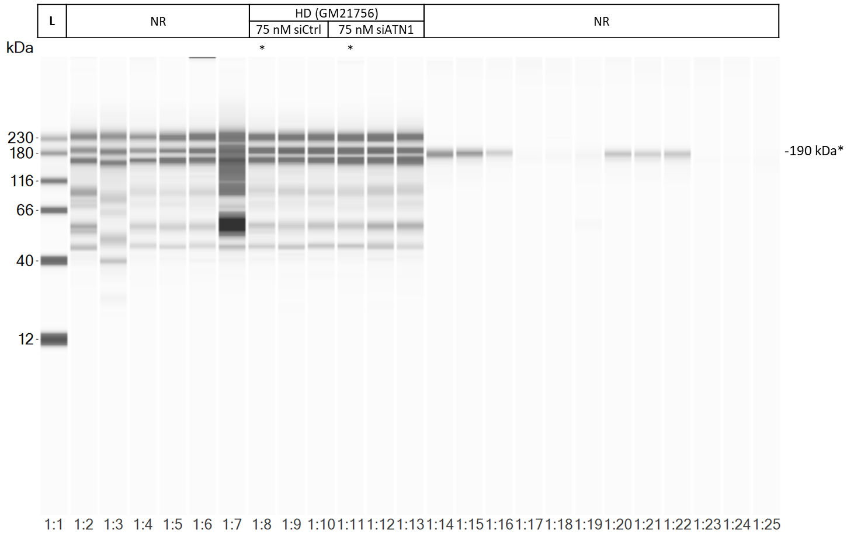
*Refers to the capillaries shown in Online Resource 4d
ESM. 5aa uncropped blot view of the SW assay used for the graph in Online Resource 4d (ESM. 4d)

