Supplementary Information:

Defining the Cis-Regulatory Elements of SCN1A in GABAergic Interneurons
Joachim Luginbühl^{1,#}, Anika Prabhu^{1,#}, Chi Wai Yip¹, Yoshinari Ando¹, Julio Leon¹, Kayoko Yasuzawa¹, Chung Chau Hon², Jonathan Moody², Filip Roudnicky^{3,$}, Thomas Kremer^{4,$}, Jay W. Shin^{1,5,$,*}

Affiliations
- Laboratory for Advanced Genomics Circuit, RIKEN Center for Integrative Medical Sciences (IMS), 230-0045, Yokohama, Japan
- Laboratory for Genome Information Analysis, RIKEN Center for Integrative Medical Sciences (IMS), 230-0045, Yokohama, Japan
- Pharma Research and Early Development, Therapeutic Modalities, F. Hoffmann-La Roche Ltd, 4070 Basel, Switzerland
- Pharma Research and Early Development, Neuroscience and Rare Diseases, F. Hoffmann-La Roche Ltd, 4070 Basel, Switzerland
- Genome Institute of Singapore (GIS), Agency for Science, Technology and Research (A∗STAR), 60 Biopolis Street, Genome, Singapore 138672, Singapore

$ co-senior authors
*corresponding author: jay.shin@riken.jp
# equal contribution

Supplementary Figures:

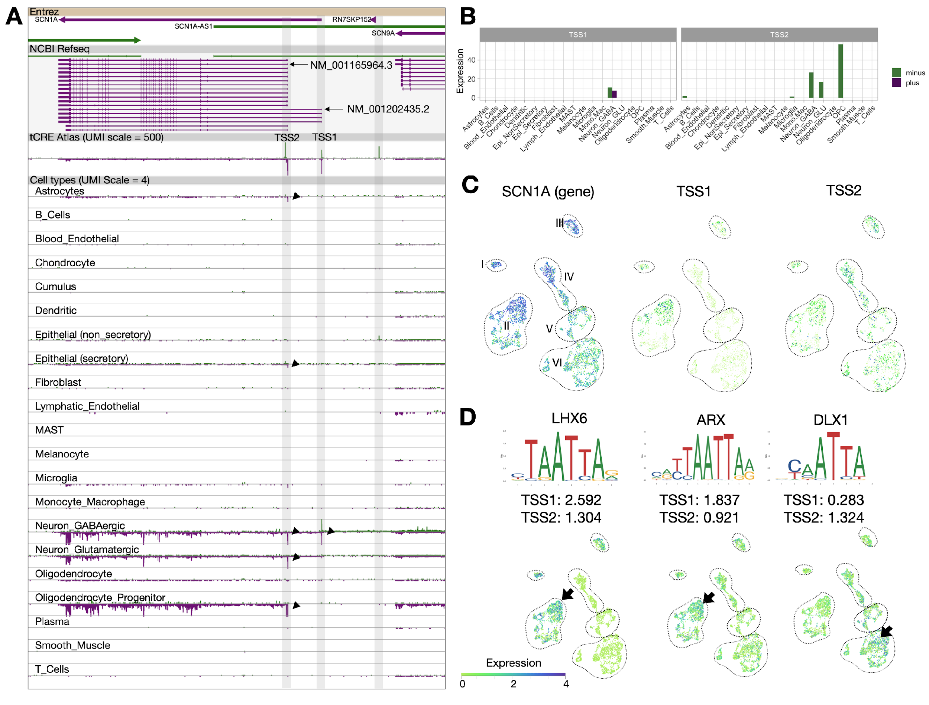
Supplementary Figure 1. Annotation of SCN1A promoters based on TSS. A) Genome browser view of SCN1A locus highlighting two distinct TSS peaks: TSS1, TSS2. Two TSS peaks are compared across ENTREZ gene hg38, NCBI Refseq and across various cell types defined in the tCRE Atlas. Arrows indicate TSS of SCN1A transcripts. B) Expression levels of SCN1A TSS1 and TSS2 across tCRE Atlas cell types. Purple bars represent minus strand (e.g. SCN1A) and green bars represent plus strand (e.g. antisense to SCN1A). C) UMAP representation of GABAergic neurons from the tCRE Atlas highlighting SCN1A gene-, TSS1-, and TSS2-level expressions. Dotted shapes: I: Pvalb+ type A, II: Pvalb+ type B, III: Lamp5+ type A, IV: Lamp5+ type B, V: Scng+, VI: Vip+ D) Odds ratio of transcription factor motif for each TSS and their respective expressions in GABAergic neurons from the tCRE Atlas.

Supplementary Material and Methods:

Processing sc-end5-dT data
Reads were aligned to hg19 with Cell Ranger and the gene-based expression matrixes were processed with Seurat v3. Briefly, cells were excluded with ≥4 median absolute deviation from the mean for number of features, UMI count, and percentage of mitochondrial UMI. Top 2,000 variable features were selected. All samples were integrated with Canonical correlation analysis (CCA) implemented in Seurat using principal component (PC) 1 to 20 based on gene-based expression matrix. Bam files were processed with SCAFE (v1.0.0) to generate filtered CTSS bed files and de novo define tCRE. tCRE-based expression matrices from SCAFE were added to the Seurat object for downstream analysis. Cell annotation was performed by manually combining annotations from scMatch (Hou et al., 2019) (version at 2020-10-10) and known marker genes. cell type-specificity and stimulation-specificity of tCREs were calculated with Seurat FindMarkers function with min.pct=0, return.thresh=Inf, logfc.threshold=0, min.cells.group=0

Differentiation of GABAergic interneurons from human iPSCs
Stage I: Induction of forebrain neuroepithelial cells from human iPSCs (duration 14 days)
Day | Procedure | Quality control
Day 1 | 1. Maintain undifferentiated human iPSCs on 6-well plates until ~70% confluence. Remove the old medium, wash once with 1 mL PBS per well and add 1 mL accutase to each well. Incubate at 37ºC 5% CO₂ for 10 min. | A uniform population of undifferentiated iPSC is needed. Partially differentiated iPSCs or heterogeneous iPSC cultures will decrease the synchronized neuroepithelial differentiation. Avoid culturing the iPSC until the colonies touch each other, as this will induce differentiation of the cells.
 | 2. Add 1 mL of Stemfit with supplement to each well and use a 1 mL pipette to gently blow off the cells.
 | 3. Collect the cells in a 15 mL falcon tube and centrifuge at 160 x g for 5 min.
 | 4. Remove the supernatant and resuspend the cells in 1-2 mL of Stemfit with supplement by pipetting up and down ~5 times. Count the cells and dilute them to 60’000 cells / mL in Stemfit with supplement supplemented with 10 μM ROCKi.
 | 5. Add 150 μL of this cell suspension (9000 cells) to each well of an ultra-low attachment 96-well plate and incubate at 37ºC 5% CO₂ for 2 days.
Day 3 | - Add 100 μL of Stemfit + 10 μM ROCKi to each well. Adding the medium fast will swirl the EB and remove the dead cells around their surface. Incubate at 37ºC 5% CO2 for 2 days. | Observe the plate under the tissue culture microscope. Small embryoid bodies (EBs) with clear borders should be visible, although many dead cells will decorate the area around the EB. This is completely normal and will not disturb the formation of the EB at the center
Day 5 | - Remove 100 µL of the old medium from each well without disturbing the EB and add another 150 μL of Stemfit with suplement without ROCKi to each well. Adding the medium fast will swirl the EB and remove the dead cells around their surface. Incubate at 37ºC 5% CO₂ for 2 days.
Day 7 | - Remove 200 µL media, and refresh with 200 µL warm Neural Induction Medium | At day 7, the EBs should have sharp edges and be at least 500 μm in diameter  Keep EBs in 96-well plate to reduce labor. EBs will continue to grow and develop.
Day 9 | Repeat Step 9: remove and refresh with 200 µL warm Neural Induction Medium (NIM; DMEM/F12 + 1X NEAA + 1X N2 Supplement + 20 μg/mL heparin)
Day 11 | - Coat 6-well plates with 1mL of mouse laminin-solution (15 μg/mL in PBS) for at least 1 h.  - Remove the laminin solution and add 1 mL NIM in each well of the 6-well plate. Be careful not to let the 6- well plate dry after removing the laminin-solution, as this will render the coating ineffective.  - Add 1 mL of fresh NIM to a 1.5 mL or 15 mL tube  - Collect the first 24-32 EBs into the tube using a cut 200-μL pipette tip (less EBs per well is fine, it just uses more media).  - Use a 1 mL pipette tip to pipette the EBs gently ~2 times to remove cell debris from the surface of the EBs.  - Discard the supernatant (containing debris) and add 1 mL fresh NIM to the EBS.  - Seed ~24-32 EBs per well (less is fine, it will just use more media).  - Repeat Steps 13-17 until all EBs are transferred  - Before placing the 6-well plate with the EBs into the incubator, be sure to evenly disperse the EBs (avoid swirling the plate as this will aggregate the EBs in the center of the well).  - Incubate the 6-well plates over night at 37ºC 5% CO₂ to attach EBs to plate. Do not disturb the EBs during this time.
Day 12 | - Gently remove the plate from the incubator. Carefully remove the old medium and add fresh NIM. Be careful to add the medium from the edge of the well gently to avoid dislodging the attached EBs. Feed the culture with the fresh NIM every day until day 14, when neural rosettes should appear. | All EBs should have attached and already show multilayered tissue in the  center and outgrowth of flat cells at the surrounding.

Stage II: Patterning neuroepithelia to MGE progenitors (duration 12 days)
Day | Procedure | Quality control
Day 14 | - When neural rosettes become obvious at around day 14 during stage I differentiation, the primitive neuroepithelia has formed. The neuroepithelia is now ready to be patterned toward regional progenitors.  - Aspirate off the old medium, and then carefully add 3 mL of NIM containing 1.5 μM purmorphamine (1:6,666 dilution of the stock solution / add 1.5 μL of 10 mM stock solution into 10 mL NIM). Be sure to dilute the purmorphamine completely in NIM before feeding the cells. Incubate the cells for another 2 days at 37ºC 5% CO₂. | The majority of attached EBs should show neural rosette formation before adding purmorphamine. Colonies of only flat cells will not yield any neurospheres later.
Day 16 | - On day 16, the differentiating colonies should contain neural tube–like rosettes formed by multiple layers of columnar epithelia surrounded by a ring of flat cells.  - Aspirate off the old medium and add 1.5 mL of fresh NIM to each well. Gently blow off the neural tube–like rosettes with a 1-mL pipette until most of the colonies are detached. Avoid pipetting too hard and repeatedly. The rosettes attach to the well loosely, whereas the surrounding flat cells adhere more tightly. Pointing the pipette tip toward the colonies will effectively blow off the colonies without much force and leave the surrounding cells attached.  - Gently transfer the lifted cell clusters into a 15-mL falcon tube and centrifuge the cells for 1 min at 50 x g at room temperature.  - Aspirate off the supernatant. Add 1 mL of NIM containing B27 w/o vitamin A (1:50 from stock solution) and purmorphamine (1.5 μM) and use a 1 mL pipette to gently pipette the cell clusters ~ 5 times. Transfer cell clusters into T25 flasks (cells from a six-well plate may be transferred to three T25 flasks). Add NIM to each T25 flask to a total volume of 10 mL. Culture the cells at 37ºC 5% CO₂ for one day.
Day 17 | - The neural rosettes should have transformed into round neurospheres floating in the medium. If there is a high number of attaching cells and spheres, we recommend transferring the floating spheres to a new T25 flask.  - Use a 10-mL pipette to gently pipette the spheres two or three times to remove dead cells on the surface of the spheres and then lay the flask at a 45-degree angle for ~ 3 min to let the spheres sink to one corner. Gently aspirate off two-thirds of the medium without disturbing the spheres. Add 7 mL of NIM containing B27 without vitamin A and purmorphamine.  - Repeat step 2 every other day until day 26 (or until day 22~25 if you plan to cryopreserve the neurospheres).  - If the medium becomes yellow within one day, perform the medium change every day instead.  - If the flask appears crowded (many neurospheres and rapid media color change to yellow), transfer some neurospheres to a separate flask. | Under optimal conditions, there will be only very little attaching cells on day 17, and the majority of floating clusters will have  rounded up into neurospheres. A certain number of attaching cells can be rescued by transferring the floating cells into new flasks, but a too large number of attached cells indicates failed neurosphere  formation

Day 23 | - The neurospheres can be cryopreserved at day 22~25 (see freeze/thaw process below).

Stage III: Differentiation of MGE progenitors to GABA interneurons (duration 5 days until wanted differentiation stage)
Day | Procedure | Quality control
Day 25 | - Coat 12-well plates with 500 μL of poly-L-ornithine (PLO) per well (0.1 mg/mL final concentration) for at least 1 h (overnight is fine) at 37ºC 5% CO2. The number of 12-well plates depends on the number and viability of neurospheres, one T25 flask usually yields enough cells for ~2-3 12-well plates.
Day 26 | - Remove the PLO solution from the 12-well plates and wash the plates twice with 1 mL sterile H2O and add 500 μL of NDM (Neurobasal Media + 1X NEAA + 1X N2 Supplement (+ supplements as instructed: B27, IGF, BDNF, GDNF, cAMP, compound E)) containing 15 μg/mL mouse laminin solution.  Incubate at 37ºC 5% CO₂ for at least an hour.  - Collect the neurospheres into a 15-mL tube and let them settle at the bottom of tube. Aspirate off the supernatant, add 1 mL of TrypLE to resuspend the spheres, and then incubate the mixture for 4 min at 37 °C until the spheres become loose. One can place on shaker if available in the incubator.  - Remove tube from incubator and add 1 mL NIM to stop TrypLE activity. Allow neurospheres to settle and aspirate off the supernatant. Add 5 mL of NIM to wash the neurospheres.  - Repeat step 3 once.  - Aspirate off the supernatant, add 1 mL of NDM containing B27 without vitamin A (1: 50 dilution of stock solution), 1 μM cAMP (1 : 10,000 dilution of stock solution), 10 ng/mL BDNF, 10 ng/mL GDNF, 10 ng/mL IGF1.  - Transfer spheres in 1 mL of NDM to a 2 mL tube (Tube A) and gently break apart the sphere using a bent glass pipette:  - Pipette up and down 4-6 times, then transfer the supernatant to a fresh 2 mL tube (Tube B)  - Add 1 mL fresh NDM to the remaining spheres in Tube A and repeat by pipetting up and down 4-6 times. Transfer the supernatant to Tube B.  - There is 2 mL neuronal solution in Tube B  - Further disassociation can be performed with remaining spheres in Tube A. Count and check viability of cells at each round, to decide when to stop (usually 2 rounds, resulting in 2 mL neuronal solution caused optimal number of cells at a reasonable viability).  - Discard remaining spheres/clusters  - Count the cells and dilute them to 200,000 cells/mL of NDM containing B27 without vitamin A.  - Add 500 μL of the cell solution into each well, which already contains 500 µL of NDM with laminin. Incubate the cells over night at 37ºC 5% CO₂. | On day 26, the majority of neurospheres should be small and bright. Dark neurospheres are usually the result of too large neurospheres, which leads to cell death in the center. The size of the neurospheres depends on the amount of pipetting on day 16 step 4.  Avoiding cell clusters when seeding the cells onto PLO/laminin-coated 12-well plates is a critical step to obtain mature neurons and minimize the amount of proliferating neuronal progenitor cells and astrocytes, which will eventually overgrow the post-mitotic neurons.
Day 28-30 | - Very gently remove 500 µL NDM and replace with NDM containing compound E (1:5,000 dilution from stock solution) to each well. The cells attach loosely to the plate, be sure to add the medium very slowly from the edge of the well to avoid washing them off.  - Incubate the cells for 3 days at 37ºC 5 % CO₂.
Day 30 - End | - Continue to incubate the cells, replacing 400 μL of the medium twice a week with 500 μL of NDM containing cAMP, BDNF, GDNF and IGF1, but without compound E. Compound E is intended for stopping cell proliferation; it is needed only once (3 d). If there is obvious cell proliferation, compound E may be extended for 1 week. | The purity and maturity of GABAergic neurons can be assessed by  immunostainings for  MAP2, GABA, SCN1A  and GFAP.

Freezing of neurospheres
Between days 22 and 25, neurospheres were collected, and the supernatant was discarded. 1 mL of freezing media (10% DMSO, 30% FBS, and 60% NIM) was added to the neurospheres, and the mixture was transferred to a cryovial (approximately one T25 flask equivalent per cryovial, avoiding overcrowding). Cryovials were cooled to -80 °C using a controlled-rate freezing device. For long-term storage, cryovials were placed in liquid nitrogen.

Thawing of neurospheres
Cryovials were thawed in a 37 °C water bath. The supernatant was then discarded, and the neurospheres were washed with fresh, warm NIM. Following another supernatant discard, the neurospheres were transferred to a T25 flask containing 10 mL of NIM supplemented with B27 and 1.5 μM purmorphamine. Two days post-thawing, approximately 7 mL of the media was replaced with fresh NIM containing B27 and 1.5 μM purmorphamine. Three days after thawing, neurons were seeded as described above. Throughout the thawing process, neurospheres were checked daily to ensure they appeared light (with visible rosette patterning) and to monitor for signs of cell death (dark/black spheres).

