Supplemental Information

Co-expression of mutant tau and α-synuclein in neurons promotes tau phosphorylation, neuronal loss and neuroinflammation in mouse brain

Yuki Yamamoto¹, Toshiki Kubota¹, Daisuke Noguchi¹, Takaomi C Saido² and Toshio Ohshima^{1,3}

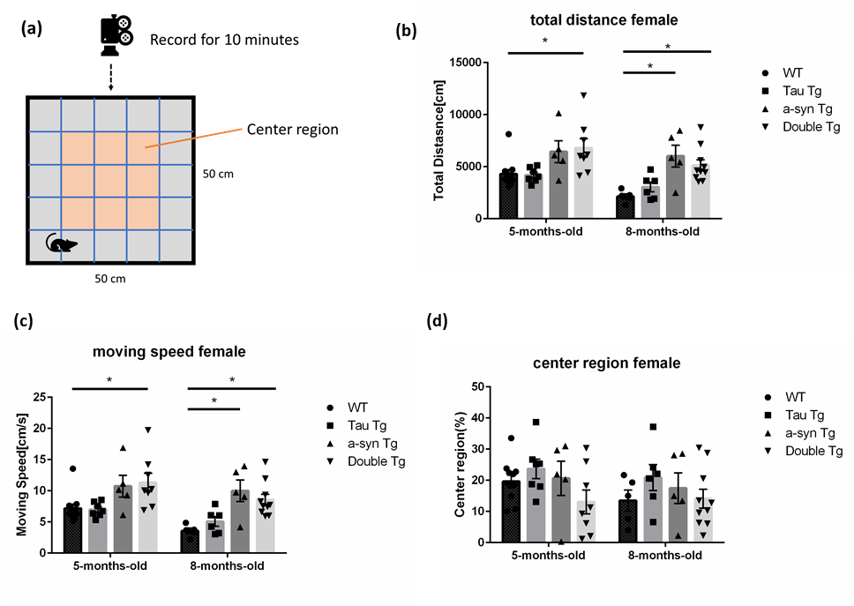

Supplemental Fig.1. The difference between genotype on amount of activity in open field test
(a) Overview of the open field test. (b) The total distance that the mice run in the field in 10 min of 5- and 8-month-old mice. (c) The average moving speed that the mice run in the field in 10 min of 5- and 8-months-old mice. (d) The rate of time that mice stayed in center region in the field in 10 min of 5- and 8-months-old mice. Data are shown with mean±SEM. Kruskal-Wallis test. *p<0.05. 5-month-old; number of mice=11, 7, 5, 8; 8-month-old; number of mice=5, 6, 5, 1.

