The peripheral epigenome predicts white matter volume contingent on developmental stage: An ECHO study
Molecular Neurobiology
Hanson, Taena, Spencer, Sophie, Harker, Samantha A., Barry, Fatoumata, Beauchemin, Jennifer, Braden, B. Blair, Burton, Phoebe, D’sa, Viren, Koinis-Mitchell, Daphne, Mennenga, Sarah E., Deoni, Sean C.L., *Lewis, Candace R.1,2, on behalf of program collaborators for Environmental influences on Child Health Outcomes.
*Corresponding author email: candace.lewis@asu.edu
¹School of Life Sciences and Psychology, Arizona State University, Tempe, AZ 85287, USA. ²Neurogenomics, Translational Genomics Research Institute, Phoenix, AZ 85004, USA.

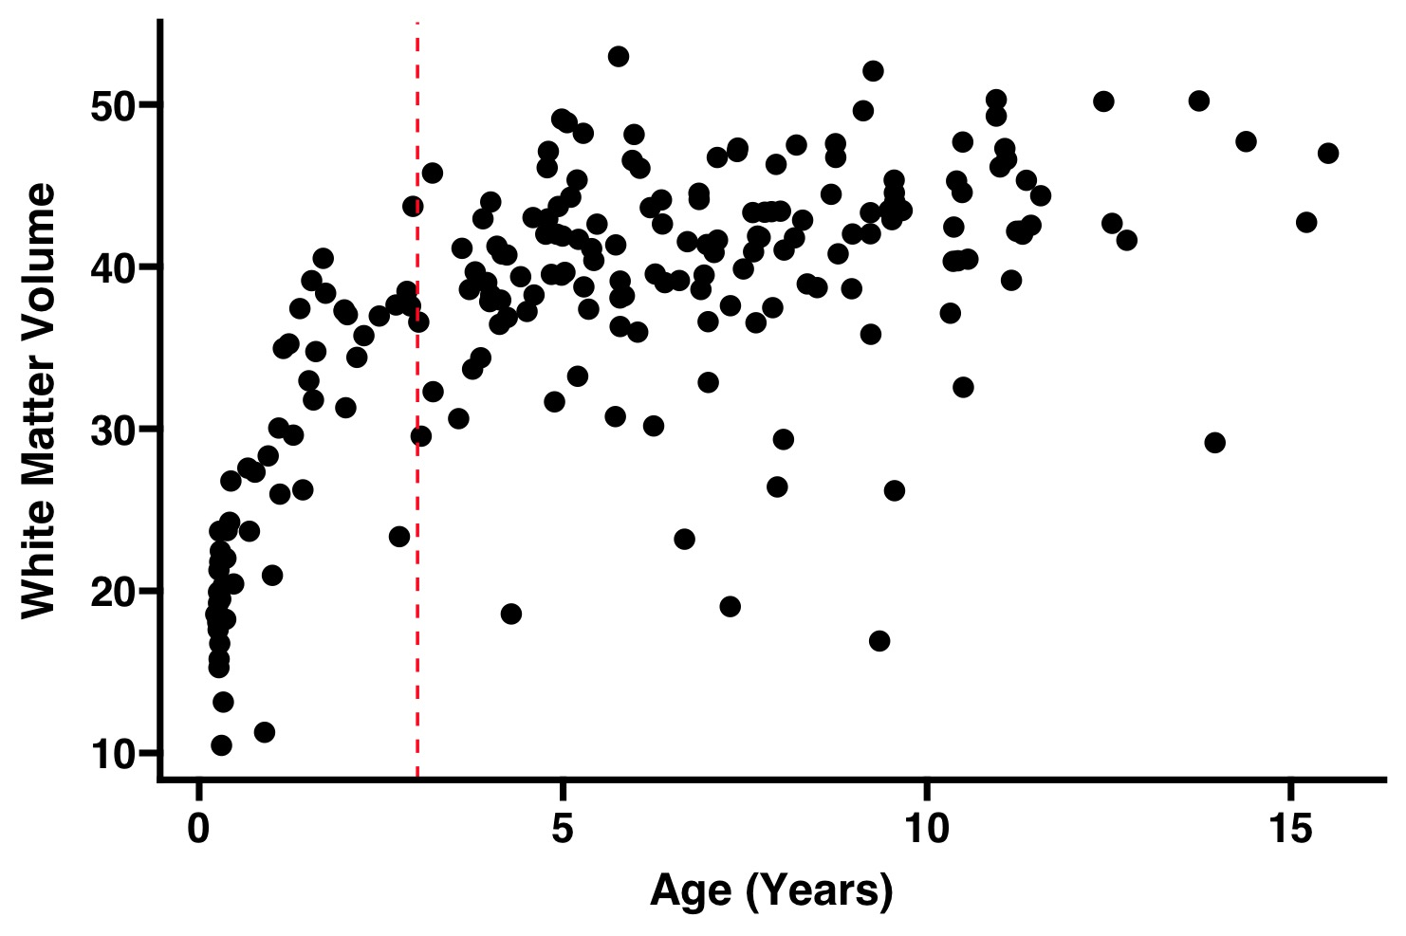

Supplementary Fig 1 White matter volume across age. Each points represents the one participant. The red line represents three years, where our sample was split for age group interactions.

