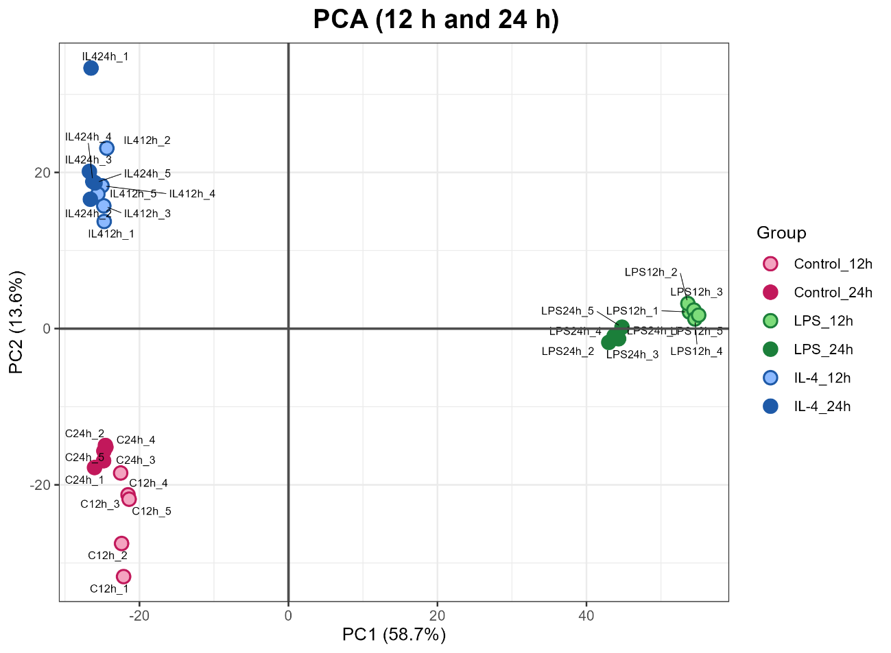
Supplementary Figure 1. Principal Component Analysis (PCA) of RNA-seq samples. PCA was performed on variance-stabilized (VST) gene-level counts (DESeq2) from control, LPS- and IL-4–treated samples collected at 12 h and 24 h. The first two principal components are shown; PC1 and PC2 explain 58.7% and 13.6% of the total variance, respectively (cumulative variance, 72.3%). Each point represents one biological replicate, labeled with its sample identifier.

