Supplemental Files
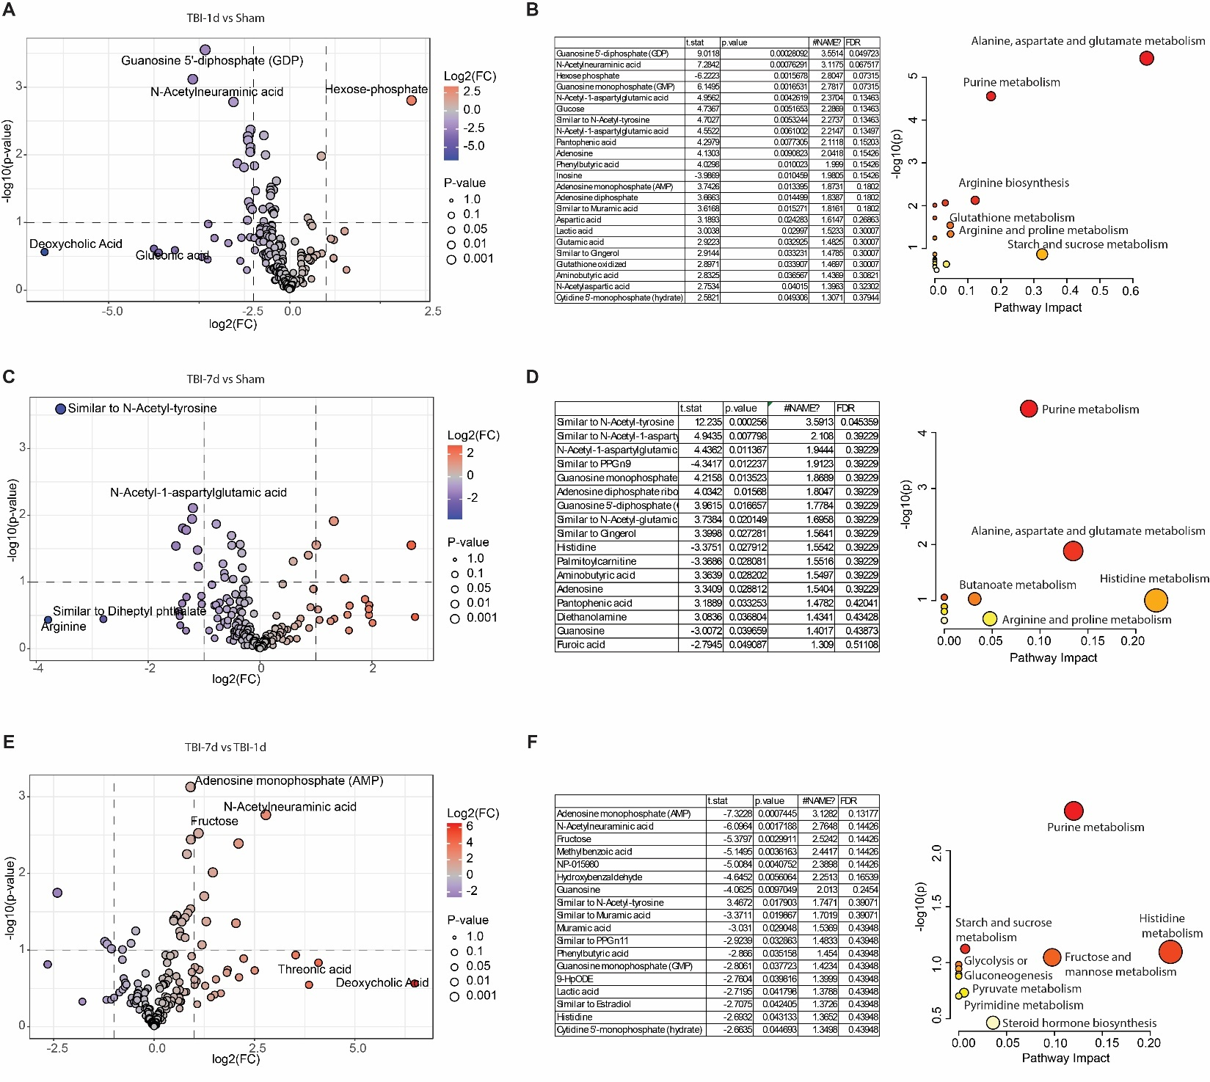
Supplemental Figure 1. Bioinformatics analysis of metabolites in hippocampal DG regions from Sham, TBI-1d, and TBI-7d samples. (A). Volcano Plot analysis of metabolites in hippocampal DG regions from Sham and TBI-1d. (B). Pathway analysis of significantly changed metabolites in hippocampal DG regions from Sham and TBI-1d. (C). Volcano Plot analysis of metabolites in hippocampal DG regions from Sham and TBI-7d. (D). Pathway analysis of significantly changed metabolites in hippocampal DG regions from Sham and TBI-7d. (E). Volcano Plot analysis of metabolites in hippocampal DG regions from TBI-7d and TBI-1d. (F). Pathway analysis of significantly changed metabolites in hippocampal DG regions from TBI-7d and TBI-1d.

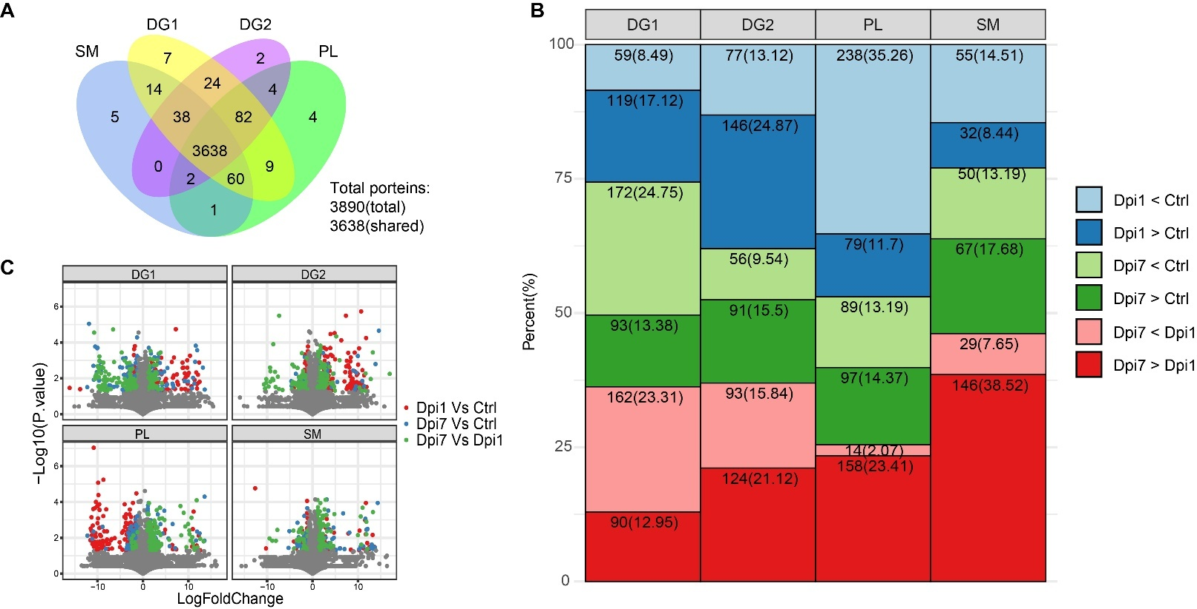
Supplemental Figure 2. Differential proteomes overlap and regulation across DG1, DG2, PL and SM regions. (A) Venn diagram showing the total number of proteins detected in each subregion (DG1, DG2, PL and SM; 3,890 proteins in total, 3,638 shared). Region-specific protein counts are indicated within each sector. (B) Stacked bar plots summarizing, for each subregion and each comparison (Dpi 1 vs Sham; Dpi 7 vs Sham; Dpi 7 vs Dpi 1), the numbers (and percentages) of significantly downregulated (light colors) and upregulated (dark colors) proteins. Each segment is labeled with “count (percent)”. (C) Volcano plots for each subregion, displaying log₂(fold-change) versus –log₁₀(p-value) for Dpi 1 vs Sham (red), Dpi 7 vs Sham (blue) and Dpi 7 vs Dpi 1 (green). Grey points denote non-significant proteins.

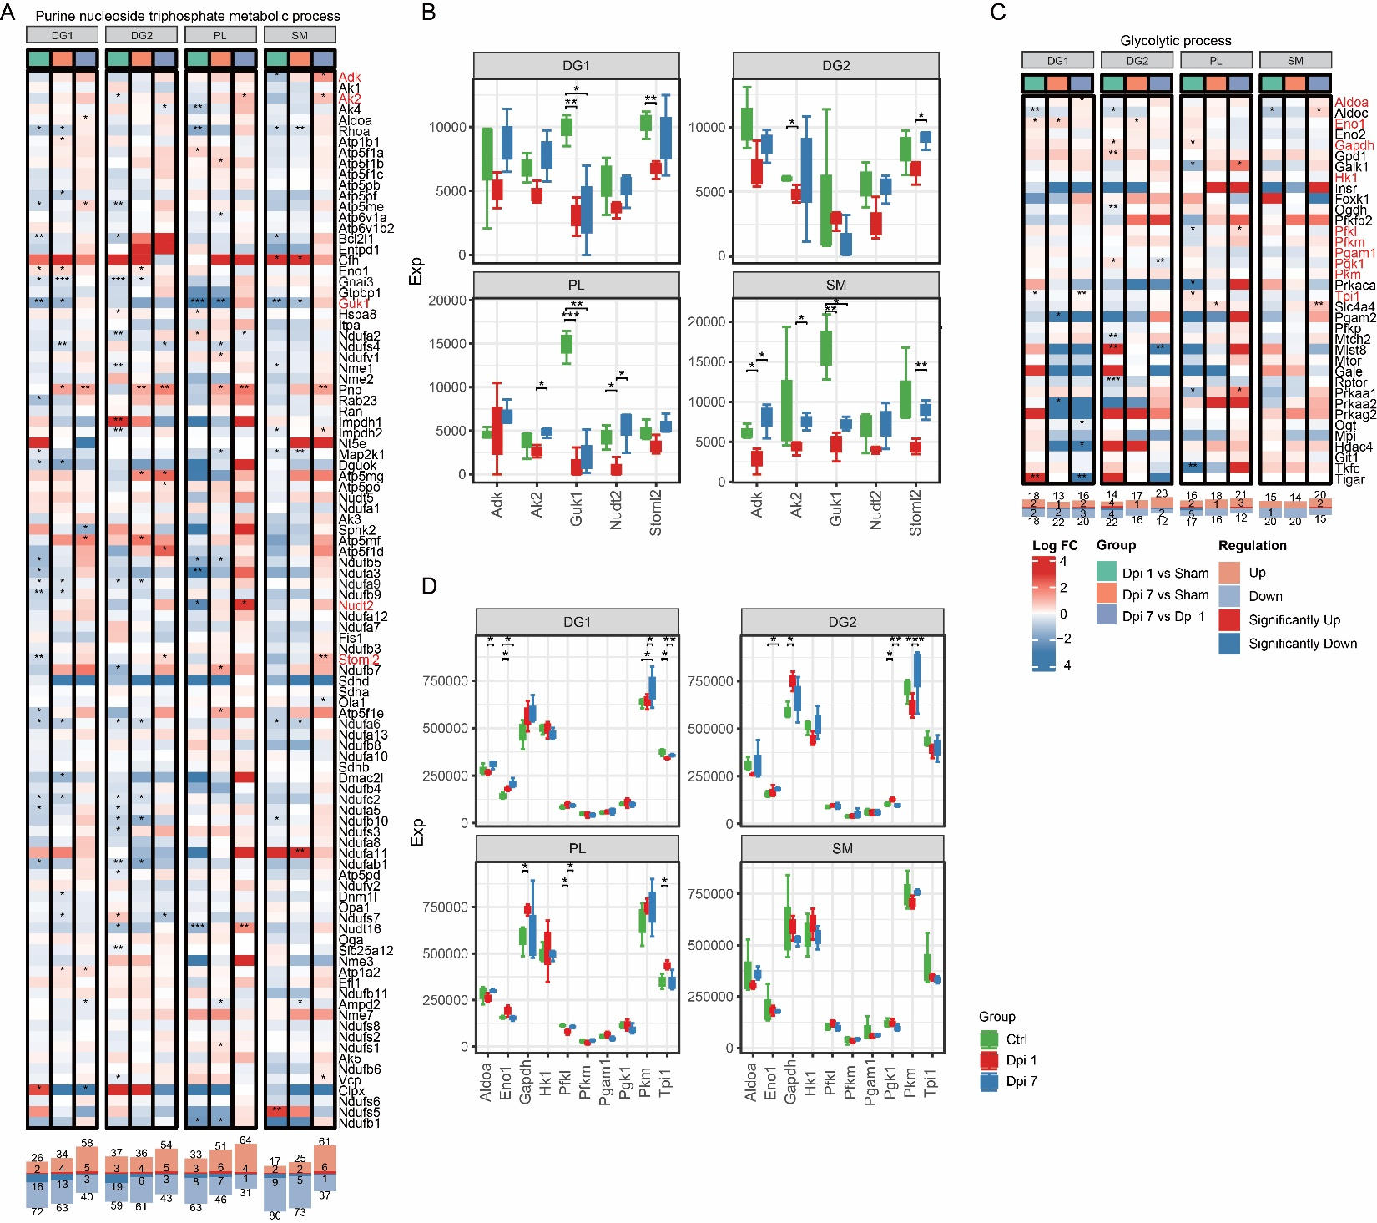
Supplemental Figure 3. Temporal regulation of proteins within selected metabolic processes. (A) Heatmaps of log₂ fold-change for proteins detected in the purine nucleoside triphosphate metabolism process (169 total proteins, 98 detected). (B) Boxplots of normalized abundance for key proteins for purine nucleoside triphosphate metabolism process. (C) Heatmaps of log₂ fold-change for proteins detected in the glycolytic process (104 total proteins, 36 detected). (D) Boxplots of normalized abundance for key proteins for the glycolytic process. For the Heatmaps, columns represent comparisons Dpi 1 vs Sham, Dpi 7 vs Sham, and Dpi 7 vs Dpi 1 (indicated by the colored sidebar). Red/blue shading denotes positive/negative fold-change; asterisks mark significance (*p<0.05; **p<0.01; ***p<0.001). Below each panel, bar plots summarize counts of significantly up- and downregulated proteins for each comparison.

