Table S1. Primer sequences used in this study
Primer | Sequence-Forward (5'-3') | Sequence-Reverse (5'-3')
β-actin | ACATCCGTAAAGACCTCTATGCC | TACTCCTGCTTGCTGATCCAC
iNOS | GTTCTCAGCCCAACAATACAAGA | GTGGACGGGTCGATGTCAC
IL-1β | TGAAATGCCACCTTTTGACAGT | TTCTCCACAGCCACAATGAGT
IL-18 | CCTTTGAGGCATCCAGGACA | GGGAACAGCCAGTGTTCAGT
TNF-α | AGCACAGAAAGCATGATCCG | CACCCCGAAGTTCAGTAGACA
IL-10 | GTTCCCCTACTGTCATCCCC | AGGCAGACAAACAATACACCA
TGF-β | CTCCCGTGGCTTCTAGTGC | GCCTTAGTTTGGACAGGATCTG
FGFR1 | GATCTCCGCACCGACCCAT | CGATCTTACTCCCGTTCACCT
PLCγ1 | TCTGGCGGAATGGGAAAGTC | CGATCTTACTCCCGTTCACCT
Arg1 | CTCCAAGCCAAAGTCCTTAGAG | AGGAGCTGTCATTAGGGACATC

Table S2. Antibody information
 | Indicator | Dilution | Code | Molecular weight | Manufacturer
Primary antibody | Calnexin | 1 μg/mL | ab22595 | 75 kDa | Abcam
Primary antibody | TSG101 | 1:2000 | ab83 | 47 kDa | Abcam
Primary antibody | CD63 | 1:8000 | 67605-1-Ig | 35 kDa | Proteintech
Primary antibody | CD81 | 1:1000 | ab109201 | 26 kDa | Abcam
Primary antibody | Serpinc1 | 1:1000 | 16414-1-AP | 53 kDa | Proteintech
Primary antibody | FEN1 | 1:2000 | 14768-1-AP | 48 kDa | Proteintech
Primary antibody | CNOT1 | 1:1000 | ab241479 | 267 kDa | Abcam
Primary antibody | FGFR1 | 1:1000 | A23390 | 122 kDa | Abclonal
Primary antibody | p-FGFR1 | 1:1000 | ab59194 | 120 kDa | Abcam
Primary antibody | ITIH4 | 1:1000 | 24069-1-AP | 120 kDa | Proteintech
Primary antibody | PLCγ1 | 1:2000 | A8899 | 150 kDa | Abclonal
Primary antibody | Aβ | 1:1000 | AWA42645 | 117 kDa | Abiowell
Primary antibody | p-Tau | 1:1000 | ab32057 | 79 kDa | Abcam
Primary antibody | Tau | 1:1000 | ab254256 | 50-70 kDa | Abcam
Primary antibody | p-NF-κB | 1:1000 | Ab76302 | 65 kDa | Abcam
Primary antibody | NF-κB | 1:2000 | 10745-1-AP | 65 kDa | Proteintech
Primary antibody | β-actin | 1:5000 | AWA80001 | 42 kDa | Abiowell
Secondary antibody | HRP goat anti-rabbit IgG | 1:6000 | AWS0001 | / | Abiowell

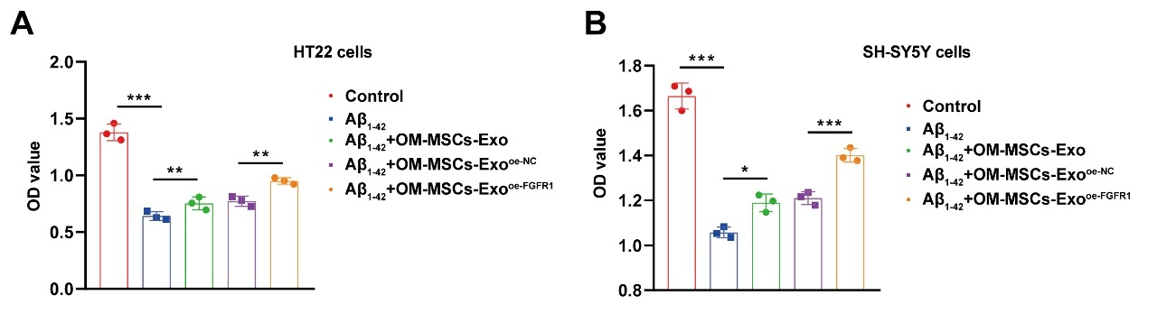
Figure S1 OM-MSCs-Exos enhanced neuronal activity by transmitting FGFR1. (A) CCK8 assay in HT-22 cells. (B) CCK8 assay in SH-SY5Y cells. (n=3) *p < 0.05, **p < 0.01, ***p < 0.001. Normality was confirmed using the Shapiro-Wilk test. Thereafter, data were analyzed with a one-way ANOVA (followed by Tukey's post hoc test) for multiple-group comparisons.

