Supplementary Figures

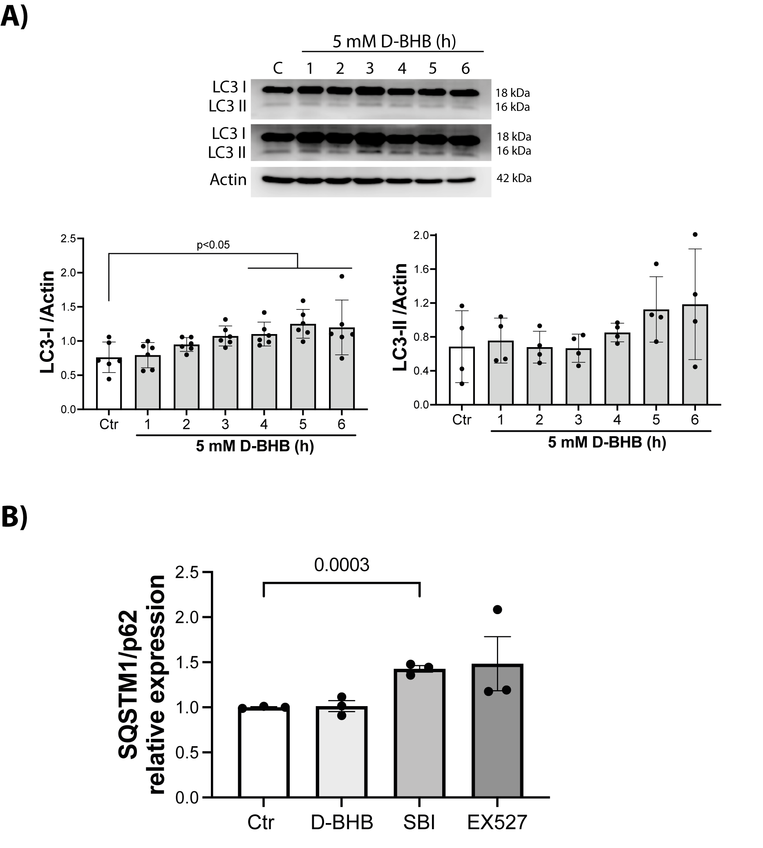

Supplementary Fig. 1 Time-course analysis of LC3-II levels in cultured astrocytes treated with D-BHB. (A) Representative immunoblot of LC3-I (top panel) and LC3-II (under high exposure, middle panel) and actin (bottom panel) levels in astrocytes incubated with 5 mM BHB for different time points (1–6 hours). Graphs show quantitative data of LC3-1/actin and LC3-II/actin levels expressed as mean ± SD from 6 and 4 independent experiments. Statistical analysis was performed using one-way ANOVA followed by Fisher’s post-hoc test. (B) Relative expression of SQSTM1/p62 in cultured astrocytes under control conditions or treated with D-BHB, EX-527, or SBI for 2 h. Data are expressed as mean ± SD from 3 independent experiments. Statistical analysis was performed using unpaired t tests.

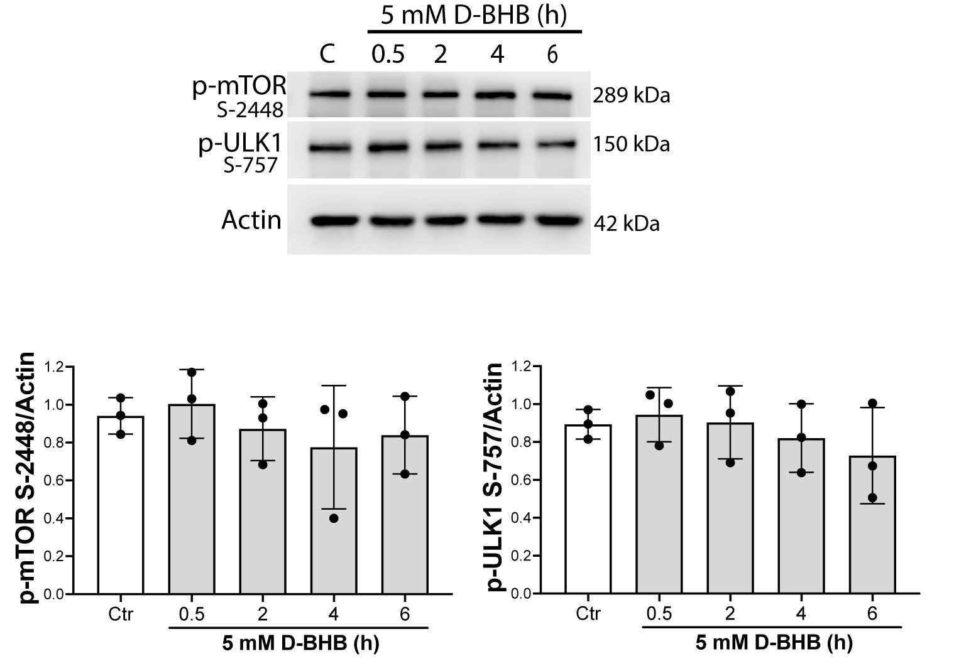
Supplementary Fig. 2 Effect of D-BHB on mTORC1. Representative Western blot and quantification of p-mTOR Ser-2448/Actin and p-ULK1 Ser-757/Actin, n = 3. Data are expressed as mean ± SD and were analyzed using one-way ANOVA followed by Fisher’s post-hoc test.

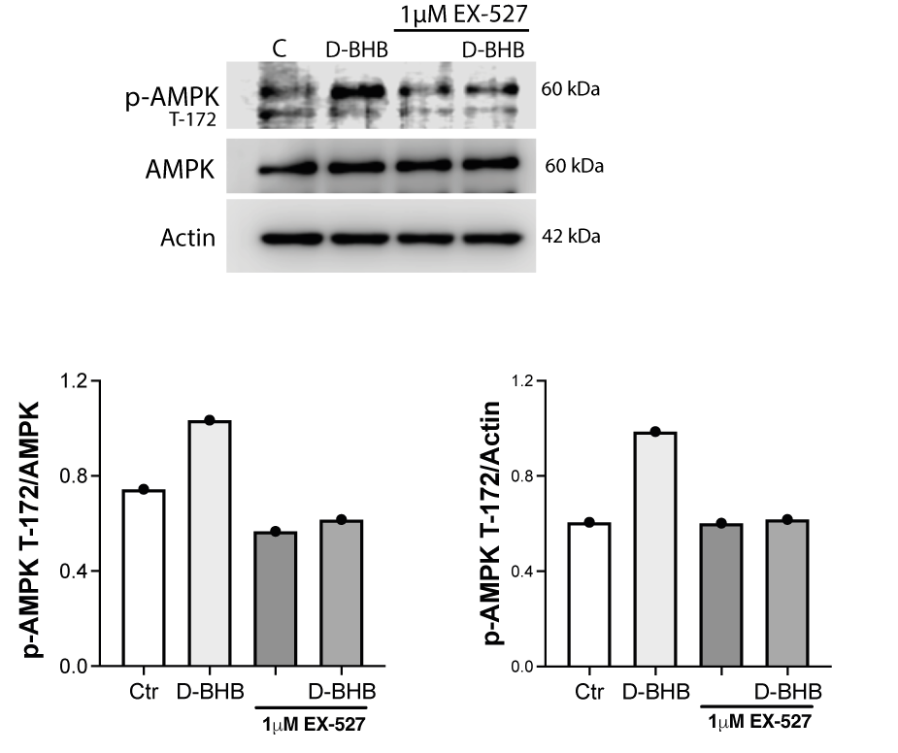
Supplementary Fig. 3. Effect of EX-527 (1 µM) on AMPK phosphorylation in cultured astrocytes. Representative immunoblot showing phosphorylated p-AMPK/AMPK, and p-AMPK/Actin levels in cultured astrocytes under control conditions or treated with D-BHB (5 mM), with or without EX-527 (1 µM), for 6 h. Representative graphs show the relative p-AMPK/AMPK and AMPK/actin ratios.

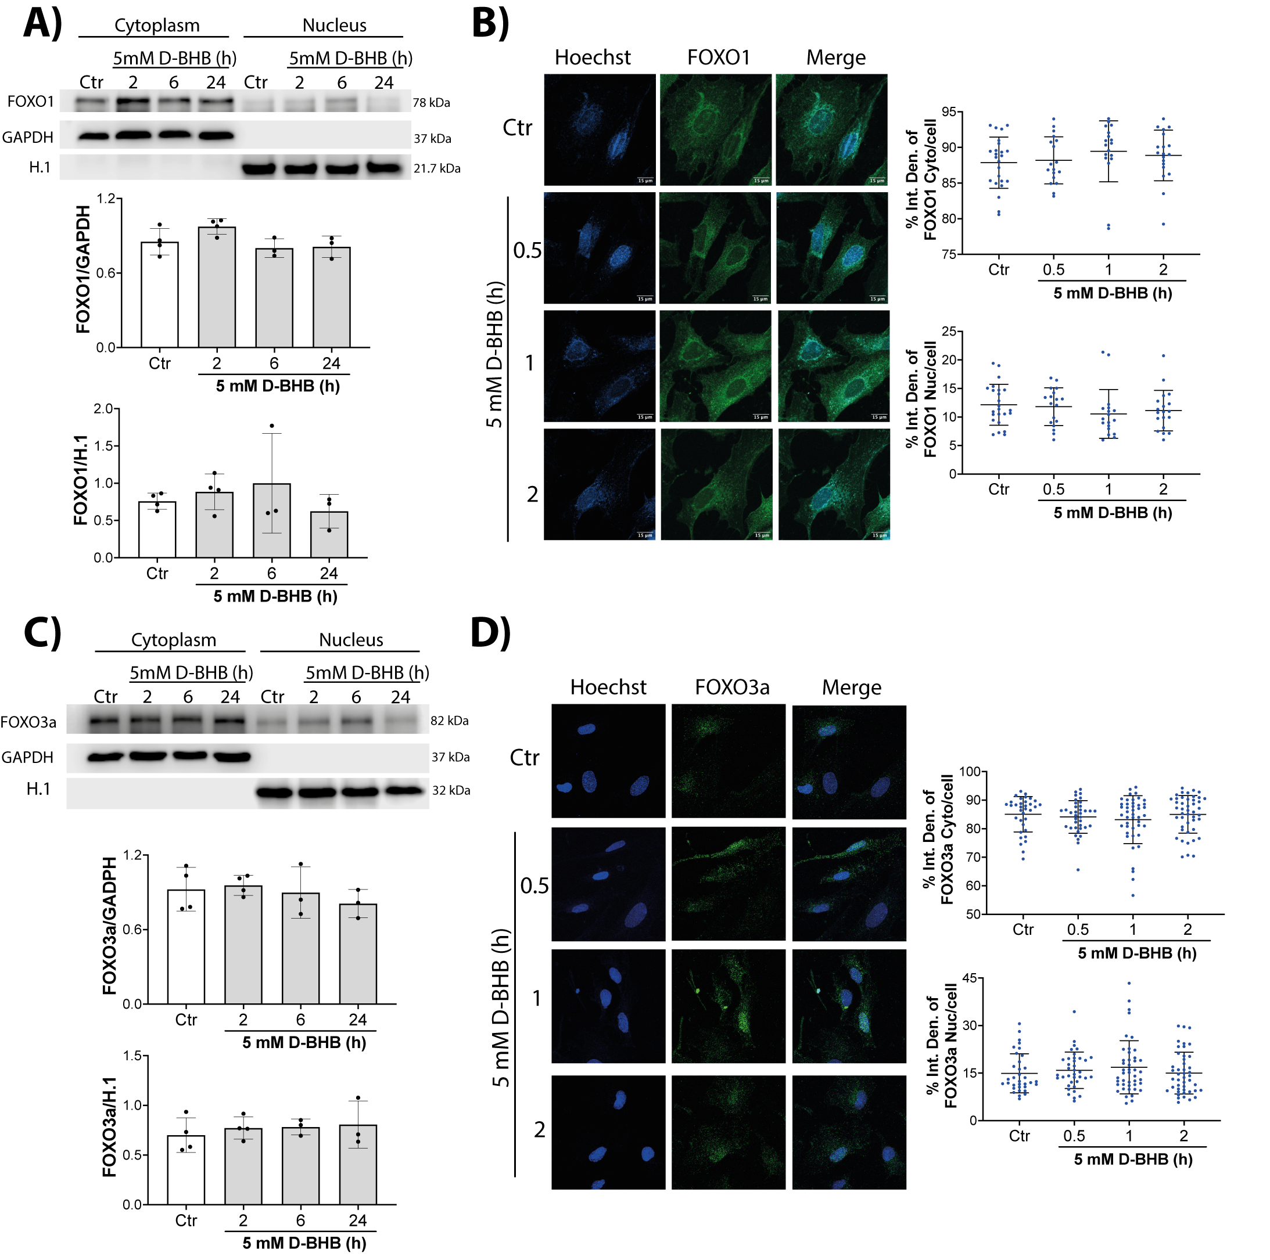

Supplementary Fig. 4 Effect of D-BHB on the subcellular localization of the transcription factors FOXO1 and FOXO3a in cortical astrocytes. Nuclear and cytoplasmic localization analysis of FOXO3a by Western blot (A) and immunofluorescence (B) in cortical astrocytes incubated with 5 mM D-BHB for 2, 4, and 24 h, or 0.5 to 2 h, respectively. Nuclear and cytoplasmic localization analysis of FOXO1 by Western blot (C) and immunofluorescence (D) in cortical astrocytes incubated with 5 mM D-BHB for 2, 4, and 24 h, or 0.5 to 2 h, respectively. Hoechst was used to stain nuclei. Scale bar = 15 µm. Data from A and C are expressed as mean ± SD from 3 and 4 independent experiments and were analyzed using one-way ANOVA followed by Fisher’s post-hoc test. Data from B and D are expressed as the average fluorescence intensity per cell (>6 cells per condition, n = 3).
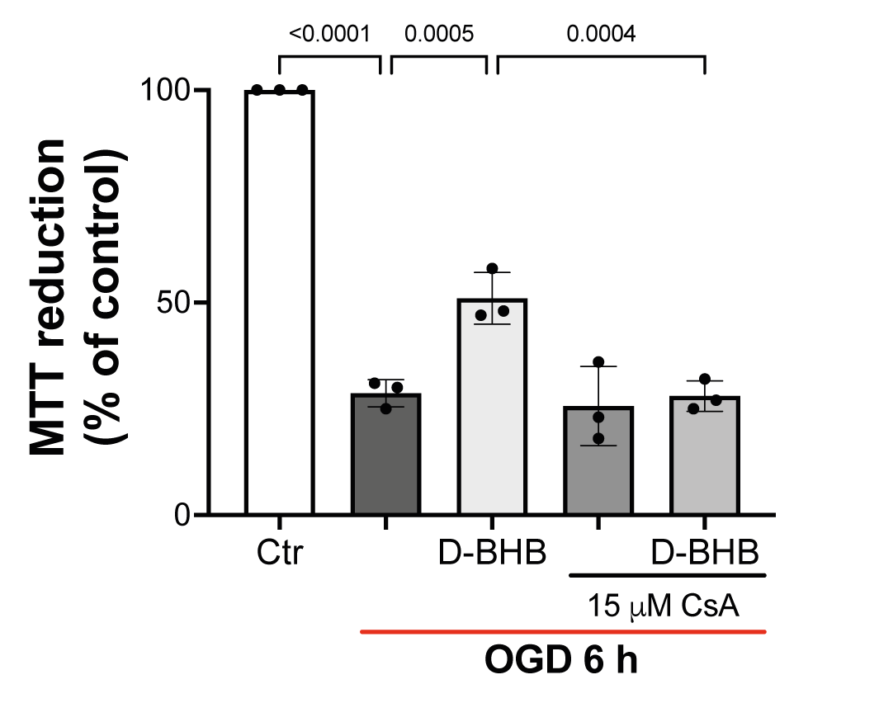
Supplementary Fig. 5 Cyclosporine A abolishes the protective effect of D-BHB on astrocyte viability after OGD. MTT reduction assay in astrocytes subjected to oxygen–glucose deprivation (OGD) and treated with D-BHB in the presence or absence of cyclosporine A (CsA, 15 µM). Data are expressed as mean ± SD from 3 independent experiments. Statistical significance was determined by one-way ANOVA followed by Fisher’s post hoc test.

