Appendix

How do Older Adults Spend Their Time? Gender Gaps and Educational Gradients in Time Use in East Asian and Western Countries

Table A1. Survey Data Sources and Mode of Data Collection by Country
Country | Study Title | Survey Years | Total Diaries | Collector | Mode of Data Collection | Link to data source
Canada | General Social Survey, Cycle 19 - Time Use | 2005, 2010 | 6,934 | Statistics Canada. Social and Aboriginal Statistics Division. | Computer assisted telephone interviewing (CATI) methodology. | https://www.timeuse.org/mtus/surveys/CAN
United States | American Time Use Surveys | 2003-2012 | 23,451 | Bureau of Labor Statistics and U.S. Census Bureau | Computer assisted telephone interviewing (CATI) methodology. | https://www.timeuse.org/mtus/surveys/USA
United Kingdom | National Survey of Time Use | 2000, 2005, 2015 | 7,108 | National Statistics (2005), University of Oxford and NatCen (2015) | These surveys largely followed the Eurostat Harmonised European Time Use Survey guidelines. An interviewer collected individual and household characteristics from the respondent in a face-to-face interview setting. The interviewer demonstrated how to fill in a diary. Then, respondents filled in the diaries and mailed them back. https://ec.europa.eu/eurostat/documents/3859598/5884753/KS-CC-04-007-EN.PDF.pdf/03057369-0bfe-47d5-b584-be0868d65f29?t=1414781110000; https://ec.europa.eu/eurostat/documents/3859598/5909673/KS-RA-08-014-EN.PDF.pdf/a745ca2e-7dc6-48a9-a36c-000ad120380e?t=1414781526000 | https://www.timeuse.org/mtus/surveys/GBR
Denmark | The Time Use of Households | 2001 | 1,036 | Statistics Denmark |  | https://www.timeuse.org/mtus/surveys/DNK
Spain | Encuestra de Empleo del Tiempo | 2002, 2009 | 13,774 | Spanish National Statistical Agency |  | https://www.timeuse.org/mtus/surveys/ESP
Finland | Time Use Survey: Everyday life in Finland | 2009 | 1,636 | Statistics Finland |  | https://www.timeuse.org/mtus/surveys/FIN
France | Time Use Survey | 2009 | 6,645 | INSEE (Institut National de la Statistique et des Etudes Economiques) |  | https://www.timeuse.org/mtus/surveys/FRA
Italy | National Time Use Survey | 2002, 2008 | 16,634 | Istituto Nazionale di Statistica (ISTAT) |  | https://www.timeuse.org/mtus/surveys/ITA
Netherlands | En Week Tijd (2000); ETijdsbestedingsonderzoek 2005 - TBO 2005 | 2000, 2005 | 4,424 | Sociaal en Cultureel Planbureau, in conjunction with other agencies. |  | https://www.timeuse.org/mtus/surveys/NLD
Norway | Time Use Survey | 2000 | 1,190 | Statistics Norway |  | https://www.timeuse.org/mtus/surveys/NOR
Japan | Survey of Time Use and Leisure Activities | 2001, 2006 | 118,791 | Statistics Bureau of Japan | Respondents filled in the diaries and could ask guidance from an interviewer or a household member. | https://www.stat.go.jp/english/data/shakai/index.html
South Korea | The Korean Time Use Survey | 2004, 2009, 2014 | 23,776 | Statistics Korea | An interviewer visited the household on four consecutive days to explain to the respondents how to fill in the diaries and ensure the quality of the diaries. The interviewer or a family member assisted respondents with difficulties in filling in diaries. | http://kostat.go.kr/portal/eng/surveyOutline/5/4/index.static
Taiwan | The Taiwan Survey of Social Development Trends | 2000, 2004 | 9,900 | Academia Sinica | Respondents filled in the diaries when the interviewer was present in the household. | https://srda.sinica.edu.tw/index.php
China | The Chinese Time Use Survey | 2008 | 9,280 | National Bureau of Statistics of China | An interviewer visited the household on two days to explain to the respondents how to fill in the diaries. The interviewer or a family member assisted respondents with literary or other difficulties in filling in diaries. | http://www.stats.gov.cn/english/

Table A2. Sample Descriptive Statistics by Activity type
Paid Work | Country | N | Mean | SD | Min | Max | P25 | P50 | P75 | P95 | Count  >18h/day
 | CA | 6,934 | 79.29 | 183.70 | 0 | 1260 | 0 | 0 | 0 | 525 | 4
 | CN | 9,280 | 151.45 | 223.60 | 0 | 1230 | 0 | 0 | 290 | 610 | 2
 | DK | 1,036 | 58.60 | 149.58 | 0 | 870 | 0 | 0 | 0 | 440 | 0
 | ES | 13,774 | 36.33 | 131.30 | 0 | 1110 | 0 | 0 | 0 | 420 | 1
 | FI | 1,636 | 36.75 | 124.56 | 0 | 811 | 0 | 0 | 0 | 421 | 0
 | FR | 6,645 | 26.71 | 107.94 | 0 | 940 | 0 | 0 | 0 | 220 | 0
 | IT | 16,634 | 28.72 | 115.18 | 0 | 960 | 0 | 0 | 0 | 300 | 0
 | JP | 118,791 | 127.69 | 207.27 | 0 | 1335 | 0 | 0 | 240 | 555 | 6
 | KR | 23,776 | 146.85 | 215.62 | 0 | 1060 | 0 | 0 | 290 | 580 | 0
 | NL | 4,424 | 28.20 | 105.80 | 0 | 750 | 0 | 0 | 0 | 255 | 0
 | NO | 1,190 | 87.39 | 184.42 | 0 | 1120 | 0 | 0 | 0 | 500 | 2
 | TW | 9,900 | 106.69 | 196.59 | 0 | 1020 | 0 | 0 | 120 | 540 | 0
 | UK | 7,108 | 41.65 | 133.23 | 0 | 1100 | 0 | 0 | 0 | 430 | 1
 | US | 23,451 | 83.08 | 186.08 | 0 | 1295 | 0 | 0 | 0 | 525 | 9
Domestic Work
 | CA | 6,934 | 211.86 | 172.77 | 0 | 1230 | 70 | 180 | 320 | 530 | 6
 | CN | 9,280 | 181.60 | 154.84 | 0 | 970 | 50 | 160 | 270 | 470 | 0
 | DK | 1,036 | 203.33 | 136.50 | 0 | 890 | 100 | 180 | 290 | 440 | 0
 | ES | 13,774 | 237.79 | 175.83 | 0 | 1380 | 80 | 230 | 360 | 540 | 4
 | FI | 1,636 | 221.23 | 144.69 | 0 | 1080 | 110 | 210 | 310 | 490 | 0
 | FR | 6,645 | 253.27 | 154.66 | 0 | 1110 | 130 | 240 | 360 | 520 | 1
 | IT | 16,634 | 263.70 | 176.31 | 0 | 1140 | 120 | 260 | 390 | 560 | 1
 | JP | 118,791 | 162.18 | 170.49 | 0 | 1335 | 0 | 120 | 270 | 495 | 6
 | KR | 23,776 | 165.82 | 144.90 | 0 | 930 | 40 | 140 | 260 | 440 | 0
 | NL | 4,424 | 221.97 | 148.10 | 0 | 870 | 105 | 210 | 315 | 495 | 0
 | NO | 1,190 | 214.55 | 138.61 | 0 | 820 | 100 | 200 | 310 | 460 | 0
 | TW | 9,900 | 144.18 | 151.47 | 0 | 960 | 0 | 105 | 225 | 450 | 0
 | UK | 7,108 | 211.06 | 140.76 | 0 | 940 | 100 | 200 | 300 | 460 | 0
 | US | 23,451 | 193.94 | 173.96 | 0 | 1110 | 50 | 150 | 300 | 535 | 3
Broad
Leisure
 | CA | 6,934 | 459.68 | 211.35 | 0 | 1440 | 300 | 450 | 610 | 810 | 18
 | CN | 9,280 | 338.82 | 196.67 | 0 | 990 | 170 | 340 | 490 | 670 | 0
 | DK | 1,036 | 425.33 | 171.93 | 0 | 910 | 300 | 420 | 550 | 720 | 0
 | ES | 13,774 | 397.61 | 173.36 | 0 | 1400 | 280 | 390 | 520 | 685 | 3
 | FI | 1,636 | 445.99 | 174.64 | 0 | 1040 | 320 | 450 | 570 | 720 | 0
 | FR | 6,645 | 370.34 | 173.70 | 0 | 1140 | 250 | 360 | 480 | 660 | 5
 | IT | 16,634 | 374.09 | 167.35 | 0 | 980 | 250 | 360 | 490 | 660 | 0
 | JP | 123,906 | 393.50 | 206.22 | 0 | 1350 | 240 | 375 | 540 | 750 | 15
 | KR | 23,776 | 409.36 | 184.86 | 0 | 1170 | 260 | 400 | 550 | 720 | 1
 | NL | 4,424 | 438.50 | 161.37 | 0 | 1005 | 330 | 435 | 555 | 705 | 0
 | NO | 1,190 | 442.07 | 170.73 | 0 | 1060 | 310 | 440 | 560 | 720 | 0
 | TW | 9,900 | 442.16 | 208.30 | 0 | 1080 | 270 | 450 | 600 | 765 | 0
 | UK | 7,108 | 457.86 | 174.66 | 0 | 1220 | 340 | 460 | 580 | 740 | 3
 | US | 23,451 | 449.56 | 220.40 | 0 | 1395 | 284 | 445 | 606 | 815 | 80

Cont. Table A2. Sample Descriptive Statistics by Activity type
Sleep | Country | N | Mean | SD | Min | Max | P25 | P50 | P75 | P95 | Count  >18h/day | Count 0h/day
 | CA | 6,934 | 510.76 | 115.07 | 0 | 1440 | 450 | 510 | 570 | 690 | 22 | 10
 | CN | 9,280 | 569.33 | 114.45 | 20 | 1440 | 510 | 560 | 620 | 730 | 55 | 0
 | DK | 1,036 | 495.79 | 97.95 | 0 | 1160 | 440 | 490 | 540 | 650 | 1 | 1
 | ES | 13,774 | 558.05 | 115.83 | 0 | 1440 | 490 | 545 | 610 | 740 | 66 | 6
 | FI | 1,636 | 518.96 | 100.25 | 0 | 1110 | 470 | 520 | 570 | 660 | 1 | 1
 | FR | 6,645 | 507.70 | 103.15 | 0 | 1440 | 460 | 510 | 560 | 660 | 9 | 18
 | IT | 16,634 | 533.26 | 103.31 | 60 | 1430 | 470 | 530 | 590 | 700 | 41 | 0
 | JP | 118,791 | 482.21 | 86.49 | 0 | 1395 | 420 | 480 | 540 | 615 | 82 | 31
 | KR | 23,776 | 487.54 | 98.56 | 60 | 1360 | 430 | 480 | 540 | 640 | 25 | 0
 | NL | 4,424 | 531.15 | 87.83 | 0 | 1440 | 480 | 525 | 570 | 660 | 9 | 1
 | NO | 1,190 | 513.12 | 87.24 | 130 | 1070 | 460 | 510 | 570 | 660 | 0 | 0
 | TW | 9,900 | 553.18 | 92.96 | 90 | 1185 | 495 | 555 | 600 | 705 | 1 | 0
 | UK | 7,108 | 500.80 | 104.89 | 0 | 1440 | 450 | 500 | 550 | 650 | 17 | 5
 | US | 23,451 | 525.93 | 126.58 | 0 | 1420 | 450 | 510 | 600 | 730 | 67 | 21

Note: Results from tabstat command in Stata v16. N=total number of diaries in each country, SD=standard deviation, Min=minimum value, Max=maximum value, P25/50/75/95=Percentile25/50/75/95. Count>18h/day=number of diaries reporting over 18 hours (1080 minutes)/day in that activity. Count 0h/day=number of diaries reporting no time sleeping.
Table A3. Predicted Time (minutes/day) Spent in Paid work, Full Regression Estimates

 | Sample (1) China | Sample (2) Japan | Sample (3) South Korea | Sample (4) Taiwan | Sample (5) IT/ES | Sample (6) DK/FI/NO | Sample (7) FR/NL | Sample (8) CA/UK/US
Women (ref.=Men) | -88.052*** | -97.369*** | -85.027*** | -80.516*** | -41.332*** | -36.200*** | -25.463*** | -36.179***
 | (4.481) | (1.705) | (3.591) | (6.188) | (1.868) | (6.130) | (5.521) | (2.455)
Education (ref. Lower than Higher Secondary Education)
HS Edu. | -18.237** | -18.785*** | -12.487* | -43.526*** | 9.036*** | 5.463 | 2.327 | 21.219***
 | (6.229) | (2.122) | (4.955) | (10.409) | (2.599) | (7.555) | (3.371) | (2.407)
Above HS Edu. | -20.343** | -40.151*** | -33.316*** | -35.354** | 35.617*** | 26.818** | 14.057 | 46.003***
 | (6.841) | (3.312) | (7.343) | (13.019) | (4.528) | (9.176) | (10.579) | (3.315)
Partnered (ref.=Singles) | 4.172 | -3.043 | -6.443 | 12.335⁺ | -8.944*** | -15.350 | -7.153 | -13.760***
 | (7.445) | (2.413) | (4.125) | (6.887) | (2.104) | (10.299) | (8.097) | (2.689)
Age (continuous) | 0.548 | -44.336*** | -44.594*** | -36.843⁺ | -106.241*** | -160.400*** | -98.000*** | -121.598***
 | (22.018) | (10.502) | (12.253) | (21.133) | (7.220) | (21.722) | (7.230) | (7.843)
Age2/100 | -5.862 | 25.154** | 25.755** | 19.774 | 74.085*** | 111.820*** | 69.161*** | 82.848***
 | (16.604) | (7.818) | (9.040) | (15.575) | (5.257) | (15.967) | (5.326) | (5.785)
Household size (continuous) | -16.155*** | 11.445*** | -0.758 | -2.192 | 7.147*** | 4.398 | 3.763 | 7.440***
 | (3.072) | (0.715) | (1.581) | (2.136) | (1.020) | (7.202) | (5.708) | (1.658)
Weekday (ref.=Weekend) | 23.588*** | 54.922*** | 39.791*** | 25.350*** | 28.089*** | 69.613*** | 25.490*** | 77.097***
 | (2.030) | (1.571) | (2.892) | (5.472) | (1.645) | (4.859) | (0.831) | (3.007)
Urban (ref.=Rural) | -248.477*** | 25.136*** | -155.470*** | -29.953*** | -8.504*
 | (6.450) | (2.221) | (4.952) | (6.537) | (3.727)
Survey Year |  | 0.803⁺ | -0.451 | 1.356 | -0.070 | -3.424*** | 0.583** | 0.746⁺
 |  | (0.414) | (0.425) | (1.601) | (0.328) | (0.759) | (0.203) | (0.388)
Constant | 564.523 | 349.319 | 3031.278** | -996.333 | 3951.707*** | 12585.900*** | 2294.378*** | 2929.942***
 | (726.791) | (903.277) | (970.845) | (3303.269) | (690.890) | (1714.588) | (379.819) | (801.308)
N Diary-days | 9,280 | 11,8791 | 23,776 | 9,900 | 30,408 | 3,862 | 11,069 | 37,493
R-square | 0.400 | 0.112 | 0.175 | 0.100 | 0.112 | 0.154 | 0.087 | 0.126
Adjusted R2 | 0.400 | 0.111 | 0.175 | 0.099 | 0.112 | 0.152 | 0.086 | 0.126

Note: Results from OLS models controlling for: gender, education level, partnership status, age, age squared, household size, urban area, if survey was conducted on a weekday and survey year. Empty cells (e.g., Survey year for China) indicate that those coefficients were not estimated. Paid work=income generating activities such as one’s main job; see MTUS user guide, Table 3.1. for exact activity codes (https://www.timeuse.org/sites/default/files/9727/mtus-user-guide-r9-february-2016.pdf). IT=Italy; ES=Spain; DK=Denmark; Finland; NO=Norway; FR=France; NL=The Netherlands; JP=Japan; CA=Canada; UK=United Kingdom; US=United States; ref.= reference group; cont.= measured continuously; Edu. = Education; HS= Higher Secondary; Age2/100= Age squared. Age, range [60 to 75]; Household size, range [1 to 12]. Standard errors in parentheses. + p < 0.10, * p < 0.05, ** p < 0.01, *** p < 0.001.

Table A4. Predicted Time (minutes/day) Spent in Domestic work, Full Regression Estimates

 | Sample (1) China | Sample (2) Japan | Sample (3) South Korea | Sample (4) Taiwan | Sample (5) IT/ES | Sample (6) DK/FI/NO | Sample (7) FR/NL | Sample (8) CA/UK/US
Women (ref.=Men) | 142.683*** | 205.697*** | 168.830*** | 149.423*** | 189.516*** | 64.625*** | 65.932*** | 67.237***
 | (3.876) | (1.241) | (2.211) | (4.299) | (2.143) | (5.175) | (2.701) | (2.287)
Survey Year |  | 1.430*** | -0.011 | -2.977** | 0.382 | 1.162⁺ | 2.743*** | -1.641***
 |  | (0.250) | (0.254) | (1.098) | (0.377) | (0.693) | (0.812) | (0.303)
Education (ref. Lower than higher secondary education)
HS Edu. | 8.547 | 8.353*** | -5.900* | 3.689 | -14.301*** | -3.710 | -14.585** | 10.415***
 | (5.453) | (1.356) | (2.613) | (8.698) | (2.598) | (6.927) | (4.994) | (3.149)
Above HS Edu. | 7.504 | 8.760*** | -11.109** | -9.348 | -45.607*** | -22.887** | -43.604*** | 4.578
 | (6.918) | (1.949) | (3.848) | (7.464) | (4.016) | (7.898) | (4.944) | (3.103)
Partnered (ref.=Singles) | 14.538** | 40.507*** | 28.433*** | 25.490*** | 24.338*** | 19.635* | -0.426 | 28.275***
 | (5.452) | (1.806) | (2.850) | (5.052) | (2.799) | (9.266) | (5.494) | (2.441)
Age (continuous) | 18.173 | 27.662*** | 24.591*** | 4.607 | 38.203*** | 59.462** | 24.962 | 27.514***
 | (16.990) | (6.935) | (7.233) | (14.514) | (7.672) | (20.522) | (17.036) | (6.709)
Age2/100 | -15.256 | -20.473*** | -18.147*** | -4.990 | -29.588*** | -43.439** | -18.502 | -19.420***
 | (12.827) | (5.180) | (5.374) | (10.761) | (5.686) | (15.322) | (12.406) | (4.992)
Household size (continuous) | -5.358* | -4.721*** | -2.348* | -3.891** | -0.634 | 10.620 | 11.339*** | 6.529***
 | (2.138) | (0.460) | (1.036) | (1.474) | (1.179) | (6.683) | (2.833) | (1.332)
Weekday (ref.=Weekend) | -0.909 | -0.209 | 4.596** | 13.496*** | 38.771*** | 31.197*** | 55.090*** | 12.584***
 | (1.695) | (0.979) | (1.704) | (3.732) | (2.018) | (4.417) | (3.628) | (2.188)
Urban (ref.=Rural) | 43.504*** | -3.365* | 27.745*** | 6.231 | -18.200***
 | (4.360) | (1.345) | (2.493) | (4.932) | (3.950)
Constant | -442.505 | -3764.643*** | -772.582 | 5930.054** | -1852.721* | -4218.847** | -6179.519** | 2448.598***
 | (561.040) | (558.548) | (573.213) | (2268.463) | (816.772) | (1566.563) | (2043.668) | (645.050)
N Diary-days | 9,280 | 11,8791 | 23,776 | 9,900 | 30,408 | 3,862 | 11,069 | 37,493
R-square | 0.239 | 0.343 | 0.324 | 0.242 | 0.296 | 0.074 | 0.097 | 0.047
Adjusted R2 | 0.239 | 0.343 | 0.324 | 0.241 | 0.295 | 0.072 | 0.097 | 0.047

Note: Results from OLS models controlling for: gender, education level, partnership status, age, age squared, household size, urban area, if survey was conducted on a weekday and survey year. Empty cells (e.g., Survey year for China) indicate that those coefficients were not estimated. Domestic work= includes activities such as: meal preparation, cleaning, shopping; see MTUS user guide, Table 3.1. for exact activity codes (https://www.timeuse.org/sites/default/files/9727/mtus-user-guide-r9-february-2016.pdf). IT=Italy; ES=Spain; DK=Denmark; Finland; NO=Norway; FR=France; NL=The Netherlands; JP=Japan; CA=Canada; UK=United Kingdom; US=United States; ref.= reference group; continuous= measured continuously; Edu. = Education; HS= Higher Secondary; Age2/100= Age squared. Age, range [60 to 75]; Household size, range [1 to 12]. Standard errors in parentheses. + p < 0.10, * p < 0.05, ** p < 0.01, *** p < 0.001.
Table A5. Predicted Time (minutes/day) Spent in Leisure, Full Regression Estimates

 | Sample (1) China | Sample (2) Japan | Sample (3) South Korea | Sample (4) Taiwan | Sample (5) IT/ES | Sample (6) DK/FI/NO | Sample (7) FR/NL | Sample (8) CA/UK/US
Women (ref.=Men) | -49.388*** | -79.474*** | -74.311*** | -63.554*** | -106.894*** | -26.291*** | -42.711*** | -43.191***
 | (4.248) | (1.581) | (2.994) | (6.170) | (2.156) | (6.107) | (2.356) | (2.514)
Survey Year |  | -0.549 | -4.210*** | 18.709*** | 1.167** | 0.118 | -7.642*** | 0.114
 |  | (0.374) | (0.365) | (1.559) | (0.413) | (0.912) | (1.254) | (0.547)
Education (ref. Lower than higher secondary education)
HS Edu. | 20.302** | 11.175*** | 19.268*** | 48.074*** | 22.431*** | -14.172⁺ | 7.232 | -21.801***
 | (6.877) | (1.920) | (4.171) | (11.854) | (2.851) | (8.550) | (4.662) | (4.850)
Above HS Edu. | 19.781* | 13.317*** | 50.259*** | 70.879*** | 33.824*** | -2.611 | 16.865*** | -41.894***
 | (8.450) | (3.094) | (6.728) | (13.071) | (4.703) | (10.251) | (4.939) | (4.637)
Partnered (ref.=Singles) | 0.797 | -21.412*** | -23.187*** | -32.757*** | -8.861** | -15.316 | 0.843 | -25.056***
 | (7.449) | (2.300) | (3.678) | (7.095) | (2.906) | (11.522) | (6.260) | (3.426)
Age (continuous) | 33.595 | 31.547** | 9.097 | 22.115 | 52.462*** | 84.965** | 83.126*** | 79.535***
 | (22.164) | (9.647) | (10.471) | (21.485) | (8.107) | (25.841) | (20.366) | (8.959)
Age2/100 | -21.795 | -18.594** | -0.872 | -10.032 | -34.981*** | -58.518** | -59.082*** | -54.031***
 | (16.781) | (7.203) | (7.779) | (15.915) | (6.006) | (19.295) | (14.767) | (6.679)
Household size (continuous) | 6.605* | -6.085*** | -1.272 | 2.484 | -8.418*** | -6.555 | -15.665*** | -14.276***
 | (2.850) | (0.629) | (1.376) | (2.157) | (1.218) | (7.406) | (3.224) | (1.876)
Weekday (ref.=Weekend) | -12.371*** | -48.816*** | -35.173*** | -36.767*** | -47.331*** | -69.069*** | -61.014*** | -69.461***
 | (2.259) | (1.479) | (2.491) | (5.586) | (2.244) | (5.443) | (5.267) | (2.013)
Urban (ref.=Rural) | 167.586*** | -14.518*** | 106.693*** | 26.704*** | 30.651***
 | (6.168) | (2.065) | (3.808) | (6.920) | (4.231)
Constant | -1002.165 | 318.294 | 8291.379*** | -37988.222*** | -3819.319*** | -2756.981 | 12916.716*** | -2536.695*
 | (729.308) | (814.692) | (835.086) | (3253.087) | (880.650) | (2065.499) | (3084.405) | (1158.722)
N Diary-days | 9,280 | 11,8791 | 23,776 | 9,900 | 30,408 | 3,862 | 11,069 | 37,493
R-square | 0.232 | 0.070 | 0.152 | 0.126 | 0.140 | 0.075 | 0.092 | 0.074
Adjusted R2 | 0.231 | 0.070 | 0.151 | 0.126 | 0.140 | 0.073 | 0.091 | 0.074

Note: Results from OLS models controlling for: gender, education level, partnership status, age, age squared, household size, urban area, if survey was conducted on a weekday and survey year. Empty cells (e.g., Survey year for China) indicate that those coefficients were not estimated. Leisure= includes activities such as attending sports events, going to the cinema, reading; see MTUS user guide, Table 3.1. for exact activity codes (https://www.timeuse.org/sites/default/files/9727/mtus-user-guide-r9-february-2016.pdf). IT=Italy; ES=Spain; DK=Denmark; Finland; NO=Norway; FR=France; NL=The Netherlands; JP=Japan; CA=Canada; UK=United Kingdom; US=United States; ref.= reference group; continuous= measured continuously; Edu. = Education; HS= Higher Secondary; Age2/100= Age squared. Age, range [60 to 75]; Household size, range [1 to 12]. Standard errors in parentheses. + p < 0.10, * p < 0.05, ** p < 0.01, *** p < 0.001.

Table A6. Predicted Time (minutes/day) Spent Sleeping, Full Regression Estimates

 | Sample (1) China | Sample (2) Japan | Sample (3) South Korea | Sample (4) Taiwan | Sample (5) IT/ES | Sample (6) DK/FI/NO | Sample (7) FR/NL | Sample (8) CA/UK/US
Women (ref.=Men) | 10.679*** | -28.196*** | -10.362*** | -4.340 | -17.171*** | 1.505 | 4.609 | 3.047⁺
 | (2.876) | (0.670) | (1.630) | (2.898) | (1.381) | (3.472) | (2.912) | (1.620)
Survey Year |  | -1.398*** | 0.318 | 0.357 | -1.313*** | 0.775 | -2.890*** | 0.568⁺
Education (ref. Lower than higher secondary education)
 |  | (0.155) | (0.209) | (0.737) | (0.270) | (0.485) | (0.447) | (0.299)
HS Edu. | -4.811 | -16.707*** | -19.860*** | -15.721** | -23.222*** | -15.049** | -8.009⁺ | -15.721***
 | (4.148) | (0.808) | (2.235) | (5.575) | (1.780) | (4.746) | (4.462) | (4.586)
Above HS Edu. | -2.075 | -30.695*** | -34.721*** | -36.769*** | -36.241*** | -17.837** | -17.897*** | -24.647***
 | (5.647) | (1.234) | (3.245) | (5.962) | (2.766) | (5.411) | (2.640) | (4.808)
Partnered (ref.=Singles) | -17.742*** | -6.574*** | -7.019*** | -9.169** | -10.974*** | -0.293 | -5.271 | -10.254***
 | (5.294) | (1.044) | (2.103) | (3.404) | (2.042) | (6.715) | (4.222) | (1.667)
Age (continuous) | -33.631* | -7.542⁺ | 0.500 | 4.991 | 2.685 | 1.820 | -16.220* | 10.056⁺
 | (15.774) | (4.026) | (5.882) | (10.325) | (5.305) | (14.196) | (6.300) | (5.189)
Age2/100 | 28.488* | 8.031** | 1.197 | -1.800 | 0.620 | 0.645 | 12.923** | -6.274
 | (12.039) | (3.012) | (4.385) | (7.678) | (3.948) | (10.663) | (4.475) | (3.862)
Household size (continuous) | 11.664*** | 2.705*** | 3.483*** | 4.212*** | 4.306*** | 3.630 | 2.409 | 3.800**
 | (2.085) | (0.263) | (0.780) | (1.018) | (0.849) | (4.413) | (4.105) | (1.200)
Weekday (ref.=Weekend) | -3.961** | -8.503*** | -10.094*** | -4.904⁺ | -12.072*** | -28.941*** | -12.139*** | -22.650***
 | (1.532) | (0.609) | (1.449) | (2.614) | (1.503) | (3.214) | (1.991) | (1.287)
Urban (ref.=Rural) | -12.725** | 6.176*** | -1.053 | -13.051*** | 12.085***
 | (3.879) | (0.863) | (2.119) | (3.478) | (2.764)
Constant | 1539.217** | 3448.840*** | -222.332 | -406.587 | 2979.741*** | -1169.421 | 6833.959*** | -985.644
 | (514.875) | (341.569) | (467.531) | (1532.791) | (581.160) | (1120.334) | (817.920) | (661.661)
N Diary-days | 9280 | 118791 | 23776 | 9900 | 30408 | 3862 | 11069 | 37493
R-square | 0.040 | 0.077 | 0.029 | 0.037 | 0.053 | 0.042 | 0.028 | 0.021
Adjusted R2 | 0.039 | 0.077 | 0.029 | 0.036 | 0.053 | 0.039 | 0.027 | 0.021

Note: Results from OLS models controlling for: gender, education level, partnership status, age, age squared, household size, urban area, if survey was conducted on a weekday and survey year. Empty cells (e.g., Survey year for China) indicate that those coefficients were not estimated. Sleeping= refers to time spent sleeping at any point during the day/night; see MTUS user guide, Table 3.1. for exact activity codes (https://www.timeuse.org/sites/default/files/9727/mtus-user-guide-r9-february-2016.pdf). IT=Italy; ES=Spain; DK=Denmark; Finland; NO=Norway; FR=France; NL=The Netherlands; JP=Japan; CA=Canada; UK=United Kingdom; US=United States; ref.= reference group; continuous= measured continuously; Edu. = Education; HS= Higher Secondary; Age2/100= Age squared. Age, range [60 to 75]; Household size, range [1 to 12]. Standard errors in parentheses. + p < 0.10, * p < 0.05, ** p < 0.01, *** p < 0.001.
Table A7. Predicted Time (minutes/day) Spent in Paid work, Full Regression Estimates including Control for Employment Status

 | Sample (1) China | Sample (2) Japan | Sample (3) South Korea | Sample (4) Taiwan | Sample (5) IT/ES | Sample (6) DK/FI/NO | Sample (7) NL | Sample (8) CA/UK/US
Women (ref.=Men) | -65.909*** | 8.027* | -28.008*** | -13.077*** | -11.079*** | -18.286*** | -21.472*** | -17.381***
 | (4.809) | (3.416) | (2.738) | (3.339) | (1.077) | (4.619) | (4.881) | (1.689)
Employed (ref. Not employed) | 174.259*** | 298.931*** | 297.579*** | 363.072*** | 329.403*** | 216.950*** | 218.367*** | 259.543***
 | (7.900) | (5.176) | (3.154) | (5.295) | (4.764) | (8.768) | (19.414) | (2.576)
Education (ref. Lower than Higher Secondary Education)
HS Edu. | -9.130⁺ | -14.847*** | -2.283 | -14.660* | -0.216 | 0.329 | -3.071 | -0.916
 | (5.440) | (4.455) | (3.164) | (5.811) | (1.436) | (5.653) | (5.140) | (2.006)
Above HS Edu. | -17.528** | -27.411*** | -22.686*** | -31.434*** | -6.702* | -1.751 | -8.050 | 2.882
 | (6.002) | (7.031) | (4.687) | (8.108) | (2.842) | (6.568) | (5.657) | (1.941)
Partnered (ref.=Singles) | -2.464 | 2.715 | -2.149 | -0.731 | -0.751 | -6.118 | -3.646 | -9.816***
 | (6.877) | (4.776) | (2.790) | (3.365) | (1.231) | (7.008) | (10.086) | (1.923)
Age (continuous) | 10.809 | -20.231 | -11.692 | -9.214 | -6.534 | -50.422** | -19.043 | -46.426***
 | (20.377) | (23.445) | (8.573) | (11.312) | (4.201) | (16.785) | (15.646) | (6.169)
Age2/100 | -11.983 | 12.471 | 6.345 | 6.557 | 4.563 | 36.278** | 12.874 | 32.881***
 | (15.370) | (17.435) | (6.330) | (8.302) | (3.070) | (12.301) | (11.442) | (4.526)
Hh size (continuous) | -8.386** | 4.837*** | 2.634** | -0.455 | 1.596** | -1.532 | -4.071 | 4.377***
 | (2.621) | (1.439) | (1.014) | (1.155) | (0.604) | (4.704) | (8.214) | (1.180)
Weekday (ref.=Weekend) | 23.588*** | 60.930*** | 37.615*** | 25.871*** | 26.716*** | 69.229*** | 25.354*** | 73.844***
 | (1.885) | (3.475) | (2.191) | (3.105) | (1.132) | (4.441) | (3.967) | (1.538)
Urban (ref.=Rural) | -132.954*** | 11.744** | 9.896* | -0.004 | -2.367
 | (7.392) | (4.337) | (4.430) | (3.364) | (1.947)
Survey Year |  | -0.276 | -1.005*** | 1.061 | -0.003 | -0.395 | -0.710 | 0.257
 |  | (0.764) | (0.287) | (0.827) | (0.188) | (0.561) | (0.888) | (0.195)
Constant | 2.289 | 1330.496 | 2505.145*** | -1808.962 | 227.298 | 2510.550⁺ | 2132.381 | 1070.873*
 | (673.069) | (1764.697) | (652.730) | (1714.358) | (406.047) | (1296.371) | (1699.818) | (443.506)
N Diary-days | 9280 | 123761 | 23776 | 9900 | 30408 | 3862 | 4424 | 37150
R-square | 0.467 | 0.456 | 0.511 | 0.713 | 0.620 | 0.415 | 0.389 | 0.466
Adjusted R2 | 0.467 | 0.456 | 0.510 | 0.713 | 0.620 | 0.414 | 0.387 | 0.466

Note: Results from OLS models including controls for individual level factors (gender, education level, partnership status, age, age squared, household size, urban area, if survey was conducted on a weekday and survey year) and employment status (1=employed, 0=not employed). Empty cells (e.g., Survey year for China) indicate that those coefficients were not estimated. Paid work=income generating activities such as one’s main job; see MTUS user guide, Table 3.1. for exact activity codes (https://www.timeuse.org/sites/default/files/9727/mtus-user-guide-r9-february-2016.pdf). IT=Italy; ES=Spain; DK=Denmark; Finland; NO=Norway; FR=France; NL=The Netherlands; JP=Japan; CA=Canada; UK=United Kingdom; US=United States; ref.= reference group; cont.= measured continuously; Edu. = Education; HS= Higher Secondary; Age2/100= Age squared. Age, range [60 to 75]; Household size, range [1 to 12]. Standard errors in parentheses. + p < 0.10, * p < 0.05, ** p < 0.01, *** p < 0.001.

Table A8. Predicted Time (minutes/day) Spent in Domestic work, Full Regression Estimates including Control for Employment Status

 | Sample (1) China | Sample (2) Japan | Sample (3) South Korea | Sample (4) Taiwan | Sample (5) IT/ES | Sample (6) DK/FI/NO | Sample (7) NL | Sample (8) CA/UK/US
Women (ref.=Men) | 138.852*** | 176.761*** | 153.773*** | 135.978*** | 178.844*** | 60.515*** | 64.081*** | 62.189***
 | (3.981) | (1.320) | (2.208) | (4.210) | (2.199) | (5.318) | (8.066) | (1.950)
Employed (ref. Not employed) | -30.143*** | -81.407*** | -74.443*** | -73.390*** | -116.006*** | -56.917*** | -73.004*** | -65.511***
 | (5.691) | (1.207) | (2.231) | (3.940) | (3.176) | (6.762) | (12.429) | (2.174)
HS Edu. | 6.972 | 7.546*** | -8.577*** | -1.617 | -11.101*** | -3.363 | -21.643* | 15.587***
 | (5.351) | (1.281) | (2.421) | (8.442) | (2.409) | (6.625) | (8.859) | (2.694)
Above HS Edu. | 7.017 | 7.014*** | -13.814*** | -9.927 | -30.912*** | -17.889* | -37.382*** | 14.784***
 | (6.665) | (1.847) | (3.553) | (7.456) | (3.736) | (7.622) | (9.058) | (2.456)
Partnered (ref.=Singles) | 15.686** | 37.975*** | 26.777*** | 27.917*** | 21.355*** | 17.533⁺ | -13.291 | 26.361***
 | (5.487) | (1.724) | (2.690) | (4.950) | (2.656) | (9.109) | (14.826) | (2.333)
Age (continuous) | 16.398 | 18.018** | 16.054* | -0.647 | 2.888 | 40.601* | 0.136 | 8.953
 | (16.836) | (6.666) | (6.862) | (14.212) | (7.386) | (20.416) | (27.759) | (7.098)
Age2/100 | -14.197 | -14.723** | -13.060* | -2.566 | -4.936 | -30.964* | -0.563 | -7.101
 | (12.712) | (4.982) | (5.106) | (10.539) | (5.475) | (15.220) | (20.544) | (5.270)
Hh size (continuous) | -6.702** | -2.976*** | -3.019** | -4.218** | 1.381 | 14.102* | 22.064⁺ | 7.546***
 | (2.045) | (0.427) | (0.966) | (1.445) | (1.098) | (6.422) | (12.829) | (1.356)
Weekday (ref.=Weekend) | -0.909 | -0.401 | 4.937** | 13.293*** | 38.950*** | 29.373*** | 62.290*** | 13.360***
 | (1.633) | (0.925) | (1.593) | (3.606) | (1.901) | (4.066) | (3.979) | (1.832)
Urban (ref.=Rural) | 23.521*** | -0.754 | -14.500*** | 0.086 | -19.926***
 | (5.797) | (1.279) | (2.597) | (4.910) | (3.604)
Survey Year |  | 1.412*** | 0.188 | -2.932** | 0.479 | 0.319 | -1.692 | -1.427***
 |  | (0.235) | (0.230) | (1.074) | (0.349) | (0.646) | (1.496) | (0.232)
Constant | -345.251 | -3304.712*** | -751.095 | 6112.180** | -778.417 | -1818.998 | 3543.824 | 2722.004***
 | (556.118) | (527.567) | (522.440) | (2223.623) | (756.623) | (1486.681) | (3087.463) | (519.408)
N Diary-days | 9280 | 118791 | 23776 | 9900 | 30408 | 3862 | 4424 | 37150
R-square | 0.244 | 0.383 | 0.370 | 0.284 | 0.332 | 0.098 | 0.127 | 0.075
Adjusted R2 | 0.243 | 0.383 | 0.369 | 0.283 | 0.331 | 0.096 | 0.125 | 0.075

Note: Results from OLS models including controls for individual level factors (gender, education level, partnership status, age, age squared, household size, urban area, if survey was conducted on a weekday and survey year) and employment status (1=employed, 0=not employed). Empty cells (e.g., Survey year for China) indicate that those coefficients were not estimated. Domestic work= includes activities such as: meal preparation, cleaning, shopping; see MTUS user guide, Table 3.1. for exact activity codes (https://www.timeuse.org/sites/default/files/9727/mtus-user-guide-r9-february-2016.pdf). IT=Italy; ES=Spain; DK=Denmark; Finland; NO=Norway; FR=France; NL=The Netherlands; JP=Japan; CA=Canada; UK=United Kingdom; US=United States; ref.= reference group; cont.= measured continuously; Edu. = Education; HS= Higher Secondary; Age2/100= Age squared. Age, range [60 to 75]; Household size, range [1 to 12]. Standard errors in parentheses. + p < 0.10, * p < 0.05, ** p < 0.01, *** p < 0.001.

Table A9. Predicted Time (minutes/day) Spent in Leisure, Full Regression Estimates including Control for Employment Status

 | Sample (1) China | Sample (2) Japan | Sample (3) South Korea | Sample (4) Taiwan | Sample (5) IT/ES | Sample (6) DK/FI/NO | Sample (7) NL | Sample (8) CA/UK/US
Women (ref.=Men) | -63.525*** | -135.093*** | -107.925*** | -106.998*** | -121.858*** | -37.658*** | -45.731*** | -54.729***
 | (4.795) | (4.506) | (2.851) | (5.374) | (2.232) | (6.406) | (9.156) | (2.350)
Employed (ref. Not employed) | -111.257*** | -179.196*** | -178.335*** | -232.969*** | -162.438*** | -127.097*** | -104.090*** | -163.131***
 | (7.478) | (5.354) | (3.011) | (5.704) | (3.595) | (7.783) | (15.484) | (2.570)
HS Edu. | 14.488* | 8.053⁺ | 13.057*** | 28.892** | 27.004*** | -9.781 | 15.364 | -9.235**
 | (6.590) | (4.831) | (3.436) | (10.331) | (2.527) | (7.854) | (9.639) | (3.251)
Above HS Edu. | 17.984* | 16.991* | 43.610*** | 68.398*** | 54.829*** | 16.788⁺ | 22.564* | -15.567***
 | (8.130) | (7.507) | (5.366) | (11.083) | (4.080) | (9.317) | (10.656) | (2.997)
Partnered (ref.=Singles) | 5.034 | -16.249** | -25.091*** | -24.198*** | -12.891*** | -16.649 | 13.116 | -26.540***
 | (7.144) | (5.720) | (3.164) | (6.004) | (2.653) | (10.475) | (15.912) | (2.779)
Age (continuous) | 27.044 | 27.662 | -9.748 | 3.754 | 3.556 | 14.391 | 50.007⁺ | 31.470***
 | (21.086) | (25.071) | (9.014) | (18.145) | (7.606) | (24.410) | (29.941) | (8.490)
Age2/100 | -17.887 | -18.685 | 10.130 | -1.040 | -0.909 | -9.688 | -35.986 | -22.074***
 | (15.975) | (18.736) | (6.701) | (13.456) | (5.640) | (18.211) | (22.277) | (6.316)
Hh size (continuous) | 1.645 | -2.390⁺ | -3.480** | 1.394 | -5.684*** | -7.060 | -22.797⁺ | -12.707***
 | (2.529) | (1.409) | (1.130) | (1.839) | (1.074) | (6.804) | (12.637) | (1.605)
Weekday (ref.=Weekend) | -12.371*** | -50.095*** | -33.660*** | -37.074*** | -46.442*** | -67.584*** | -71.886*** | -68.061***
 | (2.108) | (3.736) | (2.140) | (4.715) | (1.986) | (4.844) | (4.605) | (2.172)
Urban (ref.=Rural) | 93.830*** | 4.960 | 7.366* | 7.586 | 27.254***
 | (7.555) | (4.746) | (3.642) | (5.853) | (3.608)
Survey Year |  | -0.483 | -3.908*** | 18.909*** | 1.025** | -1.631* | -0.137 | 0.122
 |  | (0.845) | (0.298) | (1.320) | (0.361) | (0.779) | (1.634) | (0.282)
Constant | -643.204 | 491.549 | 8636.946*** | -37470.050*** | -1772.965* | 3301.621⁺ | -910.840 | -735.667
 | (693.725) | (1874.889) | (687.837) | (2750.783) | (779.021) | (1822.976) | (3325.486) | (628.121)
N Diary-days | 9280 | 123761 | 23776 | 9900 | 30408 | 3862 | 4424 | 37150
R-square | 0.269 | 0.210 | 0.317 | 0.359 | 0.218 | 0.151 | 0.102 | 0.185
Adjusted R2 | 0.268 | 0.210 | 0.317 | 0.359 | 0.217 | 0.149 | 0.100 | 0.184

Note: Results from OLS models including controls for individual level factors (gender, education level, partnership status, age, age squared, household size, urban area, if survey was conducted on a weekday and survey year) and employment status (1=employed, 0=not employed). Empty cells (e.g., Survey year for China) indicate that those coefficients were not estimated. Leisure= includes activities such as attending sports events, going to the cinema, reading; see MTUS user guide, Table 3.1. for exact activity codes (https://www.timeuse.org/sites/default/files/9727/mtus-user-guide-r9-february-2016.pdf). IT=Italy; ES=Spain; DK=Denmark; Finland; NO=Norway; FR=France; NL=The Netherlands; JP=Japan; CA=Canada; UK=United Kingdom; US=United States; ref.= reference group; cont.= measured continuously; Edu. = Education; HS= Higher Secondary; Age2/100= Age squared. Age, range [60 to 75]; Household size, range [1 to 12]. Standard errors in parentheses. + p < 0.10, * p < 0.05, ** p < 0.01, *** p < 0.001.
Table A10. Predicted Time (minutes/day) Spent Sleeping, Full Regression Estimates including Control for Employment Status

 | Sample (1) China | Sample (2) Japan | Sample (3) South Korea | Sample (4) Taiwan | Sample (5) IT/ES | Sample (6) DK/FI/NO | Sample (7) NL | Sample (8) CA/UK/US
Women (ref.=Men) | 7.079* | -39.901*** | -16.816*** | -11.821*** | -20.980*** | -0.864 | 7.233 | 1.147
 | (3.183) | (2.261) | (1.787) | (2.969) | (1.514) | (3.728) | (5.788) | (1.440)
Employed (ref. Not employed) | -28.336*** | -20.559*** | -34.468*** | -40.418*** | -41.949*** | -24.915*** | -24.492** | -32.604***
 | (4.798) | (2.610) | (1.918) | (2.999) | (2.201) | (4.704) | (8.183) | (1.551)
HS Edu. | -6.292 | -12.100*** | -20.796*** | -19.153*** | -21.965*** | -11.754** | -3.060 | -11.218***
 | (4.035) | (2.395) | (2.135) | (5.598) | (1.671) | (4.445) | (6.077) | (2.082)
Above HS Edu. | -2.532 | -27.014*** | -35.688*** | -37.597*** | -30.681*** | -13.532* | -14.015* | -17.140***
 | (5.371) | (3.378) | (3.052) | (5.742) | (2.621) | (5.295) | (6.598) | (1.915)
Partnered (ref.=Singles) | -16.663** | -7.220** | -7.459*** | -7.590* | -12.021*** | -3.099 | -1.201 | -10.992***
 | (5.140) | (2.771) | (2.001) | (3.341) | (1.924) | (6.198) | (9.797) | (1.723)
Age (continuous) | -35.300* | -25.207* | -3.483 | 1.599 | -10.014⁺ | -10.077 | -31.364⁺ | 0.043
 | (15.262) | (12.097) | (5.746) | (10.110) | (5.195) | (13.823) | (18.823) | (5.220)
Age2/100 | 29.484* | 20.807* | 3.572 | -0.094 | 9.470* | 8.776 | 23.967⁺ | 0.442
 | (11.647) | (9.043) | (4.283) | (7.522) | (3.864) | (10.355) | (14.066) | (3.878)
Hh size (continuous) | 10.401*** | 4.867*** | 3.108*** | 4.063*** | 5.011*** | 4.653 | 0.359 | 4.489***
 | (1.911) | (0.791) | (0.701) | (0.978) | (0.771) | (3.925) | (7.649) | (0.994)
Weekday (ref.=Weekend) | -3.961** | -11.091*** | -9.982*** | -4.958⁺ | -11.490*** | -27.533*** | -15.982*** | -21.844***
 | (1.449) | (1.757) | (1.320) | (2.541) | (1.376) | (2.881) | (2.106) | (1.306)
Urban (ref.=Rural) | -31.510*** | 6.684** | -19.850*** | -16.387*** | 11.130***
 | (4.924) | (2.354) | (2.230) | (3.384) | (2.486)
Survey Year |  | -0.305 | 0.392* | 0.404 | -1.410*** | 0.515 | -0.275 | 0.456*
 |  | (0.420) | (0.192) | (0.723) | (0.245) | (0.455) | (1.040) | (0.182)
Constant | 1630.640** | 1878.366* | -176.670 | -335.520 | 3630.389*** | -213.167 | 2118.457 | -391.130
 | (498.386) | (933.212) | (434.305) | (1501.999) | (530.999) | (1071.489) | (2067.696) | (400.286)
N Diary-days | 9280 | 123761 | 23776 | 9900 | 30408 | 3862 | 4424 | 37150
R-square | 0.047 | 0.081 | 0.052 | 0.072 | 0.066 | 0.049 | 0.028 | 0.034
Adjusted R2 | 0.046 | 0.081 | 0.051 | 0.071 | 0.065 | 0.046 | 0.025 | 0.033

Note: Results from OLS models including controls for individual level factors (gender, education level, partnership status, age, age squared, household size, urban area, if survey was conducted on a weekday and survey year) and employment status (1=employed, 0=not employed). Empty cells (e.g., Survey year for China) indicate that those coefficients were not estimated. Sleeping= refers to time spent sleeping at any point during the day/night; see MTUS user guide, Table 3.1. for exact activity codes (https://www.timeuse.org/sites/default/files/9727/mtus-user-guide-r9-february-2016.pdf). IT=Italy; ES=Spain; DK=Denmark; Finland; NO=Norway; FR=France; NL=The Netherlands; JP=Japan; CA=Canada; UK=United Kingdom; US=United States; ref.= reference group; cont.= measured continuously; Edu. = Education; HS= Higher Secondary; Age2/100= Age squared. Age, range [60 to 75]; Household size, range [1 to 12]. Standard errors in parentheses. + p < 0.10, * p < 0.05, ** p < 0.01, *** p < 0.001.

Table A11. Predicted Time (minutes/day) Spent in Paid Work, Full Regression Estimates, Samples Ages 70-75

 | Sample (1) China | Sample (2) Japan | Sample (3) South Korea | Sample (4) Taiwan | Sample (5) IT/ES | Sample (6) DK/FI/NO | Sample (7) FR/NL | Sample (8) CA/UK/US
Women (ref.=Men) | -40.131*** | -54.157*** | -38.752*** | -31.451*** | -7.984*** | -20.632*** | -4.782* | -25.795***
 | (9.760) | (7.332) | (5.878) | (8.891) | (1.448) | (6.110) | (2.137) | (2.808)
HS Edu. | -5.089 | -14.502 | -7.415 | -51.621*** | 5.778* | 4.690 | 0.868 | 14.745***
 | (11.370) | (9.347) | (7.506) | (10.899) | (2.348) | (7.737) | (2.442) | (3.187)
Above HS Edu. | -10.911 | -28.309* | -14.978 | -14.734 | 11.579** | -5.290 | 5.132 | 19.222***
 | (9.856) | (13.645) | (11.584) | (19.915) | (4.428) | (6.252) | (3.819) | (3.061)
Partnered (ref.=Singles) | 0.790 | 7.896 | -3.492 | 29.282*** | 2.294* | -8.493 | 2.606 | -12.655***
 | (11.553) | (8.437) | (5.368) | (8.697) | (1.164) | (8.299) | (2.232) | (3.370)
Age (continuous) | 132.390 | 0.000 | -124.384 | -250.532 | 29.840 | -168.950 | 12.527 | 49.558
 | (454.268) | (.) | (141.860) | (250.709) | (42.394) | (165.087) | (73.953) | (75.358)
Age2/100 | -96.487 | 0.000 | 81.224 | 165.965 | -21.012 | 114.768 | -8.952 | -36.935
 | (316.966) | (.) | (97.755) | (172.623) | (29.258) | (113.330) | (50.756) | (51.841)
Hh size (continuous) | -21.794*** | 12.597*** | -1.276 | -4.451⁺ | 2.198*** | -2.162 | -1.080 | 6.112**
 | (4.633) | (2.904) | (2.027) | (2.689) | (0.654) | (4.879) | (1.271) | (2.342)
Weekday (ref.=Weekend) | 14.699*** | 18.296** | 20.409*** | 11.779 | 3.862*** | 12.042*** | 1.182 | 23.220***
 | (3.408) | (6.111) | (4.017) | (7.544) | (1.171) | (3.165) | (1.123) | (2.084)
Urban (ref.=Rural) | -200.407*** | 29.457** | -174.871*** | -20.744* | -6.005*
 | (13.758) | (9.262) | (6.978) | (8.626) | (2.785)
Survey Year |  | 0.046 | 0.140 | 3.028 | -0.623** | -0.853 | 0.109 | 0.642*
 |  | (1.564) | (0.576) | (2.284) | (0.204) | (0.755) | (0.326) | (0.300)
Constant | -4261.282 | -40.791 | 4712.652 | 3441.529 | 197.785 | 7946.551 | -649.639 | -2923.991
 | (16276.122) | (3133.180) | (5237.647) | (10332.692) | (1629.321) | (6469.255) | (3170.390) | (2787.875)
N Diary-days | 1660 | 37788 | 7688 | 3268 | 10256 | 923 | 3112 | 10991
R-square | 0.316 | 0.055 | 0.202 | 0.048 | 0.015 | 0.037 | 0.007 | 0.029
Adjusted R2 | 0.312 | 0.055 | 0.201 | 0.045 | 0.014 | 0.027 | 0.005 | 0.028

Note: Results from OLS models including controls for individual level factors (gender, education level, partnership status, age, age squared, household size, urban area, if survey was conducted on a weekday and survey year). Empty cells (e.g., Survey year for China) indicate that those coefficients were not estimated. Paid work=income generating activities such as one’s main job; see MTUS user guide, Table 3.1. for exact activity codes (https://www.timeuse.org/sites/default/files/9727/mtus-user-guide-r9-february-2016.pdf). IT=Italy; ES=Spain; DK=Denmark; Finland; NO=Norway; FR=France; NL=The Netherlands; JP=Japan; CA=Canada; UK=United Kingdom; US=United States; ref.= reference group; cont.= measured continuously; Edu. = Education; HS= Higher Secondary; Age2/100= Age squared. Age, range [70 to 75]; Household size, range [1 to 12]. Standard errors in parentheses. + p < 0.10, * p < 0.05, ** p < 0.01, *** p < 0.001.

Table A12. Predicted Time (minutes/day) Spent in Domestic Work, Full Regression Estimates, Samples Ages 70-75

 | Sample (1) China | Sample (2) Japan | Sample (3) South Korea | Sample (4) Taiwan | Sample (5) IT/ES | Sample (6) DK/FI/NO | Sample (7) FR/NL | Sample (8) CA/UK/US
Women (ref.=Men) | 115.076*** | 186.455*** | 147.727*** | 106.033*** | 173.152*** | 63.944*** | 56.568*** | 61.838***
 | (8.577) | (2.396) | (4.270) | (8.113) | (3.805) | (10.871) | (9.201) | (3.602)
HS Edu. | -15.855 | 10.210*** | -7.081 | 4.796 | -8.473⁺ | 1.868 | -3.378 | 14.414**
 | (10.370) | (2.397) | (4.987) | (15.361) | (4.471) | (13.423) | (9.485) | (4.508)
Above HS Edu. | 10.682 | 1.007 | -15.179* | -15.902 | -33.578*** | -17.224 | -31.295* | 6.778⁺
 | (12.924) | (3.640) | (7.210) | (13.166) | (6.986) | (14.219) | (12.334) | (4.115)
Partnered (ref.=Singles) | 23.142* | 45.707*** | 27.233*** | 22.478** | 23.265*** | 30.360 | 7.505 | 30.752***
 | (9.604) | (3.038) | (4.528) | (8.405) | (4.383) | (19.712) | (13.057) | (4.310)
Age (continuous) | 81.747 | 0.000 | 0.647 | 377.350⁺ | -109.321 | 424.290 | 113.496 | 170.760⁺
 | (390.698) | (.) | (100.181) | (212.171) | (99.231) | (300.291) | (243.771) | (97.854)
Age2/100 | -61.311 | 0.000 | -1.366 | -263.693⁺ | 72.358 | -297.925 | -77.183 | -117.745⁺
 | (272.640) | (.) | (69.150) | (146.392) | (68.474) | (207.041) | (168.168) | (67.465)
Hh size (continuous) | -10.854** | -9.183*** | -7.101*** | -9.308*** | 0.007 | 14.368 | 2.429 | 1.515
 | (3.562) | (0.703) | (1.611) | (2.564) | (1.950) | (17.778) | (9.346) | (2.635)
Weekday (ref.=Weekend) | -2.108 | 4.133* | 7.648** | 15.673* | 44.771*** | 47.012*** | 59.703*** | 38.318***
 | (3.444) | (1.735) | (2.887) | (6.255) | (3.211) | (7.786) | (4.355) | (3.225)
Urban (ref.=Rural) | 36.361*** | -4.071 | 26.003*** | 5.137 | -30.752***
 | (9.676) | (2.529) | (3.849) | (8.314) | (6.190)
Survey Year |  | 1.616*** | 0.081 | -5.060** | 0.896 | 1.127 | 3.060** | -0.927*
 |  | (0.446) | (0.418) | (1.909) | (0.591) | (1.368) | (1.059) | (0.406)
Constant | -2606.928 | -3190.302*** | -79.972 | -3283.670 | 2463.740 | -17245.529 | -10141.797 | -4208.959
 | (13993.389) | (893.092) | (3715.372) | (8496.519) | (3774.354) | (11269.742) | (8795.683) | (3616.302)
N Diary-days | 1660 | 36293 | 7688 | 3268 | 10256 | 923 | 3112 | 10991
R-square | 0.212 | 0.296 | 0.275 | 0.148 | 0.270 | 0.093 | 0.089 | 0.048
Adjusted R2 | 0.207 | 0.296 | 0.274 | 0.146 | 0.269 | 0.084 | 0.086 | 0.048

Note: Results from OLS models including controls for individual level factors (gender, education level, partnership status, age, age squared, household size, urban area, if survey was conducted on a weekday and survey year). Empty cells (e.g., Survey year for China) indicate that those coefficients were not estimated. Domestic work= includes activities such as: meal preparation, cleaning, shopping; see MTUS user guide, Table 3.1. for exact activity codes (https://www.timeuse.org/sites/default/files/9727/mtus-user-guide-r9-february-2016.pdf). IT=Italy; ES=Spain; DK=Denmark; Finland; NO=Norway; FR=France; NL=The Netherlands; JP=Japan; CA=Canada; UK=United Kingdom; US=United States; ref.= reference group; cont.= measured continuously; Edu. = Education; HS= Higher Secondary; Age2/100= Age squared. Age, range [70 to 75]; Household size, range [1 to 12]. Standard errors in parentheses. + p < 0.10, * p < 0.05, ** p < 0.01, *** p < 0.001.

Table A13. Predicted Time (minutes/day) Spent in Leisure, Full Regression Estimates, Samples Ages 70-75

 | Sample (1) China | Sample (2) Japan | Sample (3) South Korea | Sample (4) Taiwan | Sample (5) IT/ES | Sample (6) DK/FI/NO | Sample (7) FR/NL | Sample (8) CA/UK/US
Women (ref.=Men) | -67.804*** | -91.896*** | -91.314*** | -77.348*** | -118.458*** | -30.266* | -56.535*** | -45.879***
 | (12.059) | (8.752) | (5.841) | (10.071) | (3.957) | (13.238) | (10.948) | (4.673)
HS Edu. | 37.532* | 6.920 | 16.302* | 44.449* | 26.193*** | -24.763 | 9.557 | -21.705***
 | (15.747) | (9.893) | (7.643) | (20.201) | (4.876) | (16.267) | (10.881) | (5.693)
Above HS Edu. | 16.906 | 23.915 | 39.911*** | 61.020** | 53.439*** | 21.805 | 19.689 | -22.748***
 | (16.641) | (16.711) | (11.605) | (20.755) | (8.511) | (17.686) | (15.463) | (5.332)
Partnered (ref.=Singles) | 2.725 | -30.604** | -23.960*** | -39.231*** | -15.222*** | 7.090 | -22.832 | -32.617***
 | (14.081) | (11.059) | (5.819) | (10.643) | (4.360) | (23.417) | (16.581) | (5.402)
Age (continuous) | 553.347 | 0.000 | 21.568 | -224.364 | 50.024 | -290.699 | -522.412⁺ | -23.115
 | (545.661) | (.) | (143.668) | (280.602) | (104.916) | (380.625) | (280.067) | (126.278)
Age2/100 | -385.376 | 0.000 | -9.164 | 162.702 | -33.037 | 206.075 | 357.240⁺ | 18.427
 | (380.607) | (.) | (99.118) | (193.588) | (72.381) | (262.561) | (193.176) | (87.076)
Hh size (continuous) | 12.761* | -2.234 | 1.328 | 2.800 | -5.857** | -35.355⁺ | -2.169 | -8.434*
 | (5.420) | (2.720) | (2.190) | (3.330) | (1.920) | (19.113) | (12.390) | (3.313)
Weekday (ref.=Weekend) | -5.976 | -34.276*** | -24.948*** | -21.991* | -34.769*** | -41.411*** | -45.472*** | -52.055***
 | (4.973) | (7.085) | (4.014) | (9.100) | (3.408) | (9.259) | (5.040) | (4.038)
Urban (ref.=Rural) | 141.575*** | -12.934 | 128.238*** | 27.629** | 37.487***
 | (13.940) | (10.132) | (5.926) | (10.654) | (6.167)
Survey Year |  | -1.348 | -4.436*** | 21.268*** | 1.570* | -2.125 | -7.288*** | -0.308
 |  | (1.719) | (0.571) | (2.529) | (0.626) | (1.647) | (1.298) | (0.526)
Constant | -19568.814 | 3201.565 | 8259.275 | -34330.057** | -4564.643 | 15074.941 | 34200.917*** | 1917.826
 | (19551.629) | (3443.651) | (5288.361) | (11276.688) | (4006.096) | (13894.558) | (10231.261) | (4637.608)
N Diary-days | 1660 | 37788 | 7688 | 3268 | 10256 | 923 | 3112 | 10991
R-square | 0.170 | 0.055 | 0.172 | 0.119 | 0.149 | 0.050 | 0.086 | 0.035
Adjusted R2 | 0.166 | 0.055 | 0.171 | 0.117 | 0.148 | 0.041 | 0.083 | 0.034

Note: Results from OLS models including controls for individual level factors (gender, education level, partnership status, age, age squared, household size, urban area, if survey was conducted on a weekday and survey year). Empty cells (e.g., Survey year for China) indicate that those coefficients were not estimated. Leisure= includes activities such as attending sports events, going to the cinema, reading; see MTUS user guide, Table 3.1. for exact activity codes (https://www.timeuse.org/sites/default/files/9727/mtus-user-guide-r9-february-2016.pdf). IT=Italy; ES=Spain; DK=Denmark; Finland; NO=Norway; FR=France; NL=The Netherlands; JP=Japan; CA=Canada; UK=United Kingdom; US=United States; ref.= reference group; cont.= measured continuously; Edu. = Education; HS= Higher Secondary; Age2/100= Age squared. Age, range [70 to 75]; Household size, range [1 to 12]. Standard errors in parentheses. + p < 0.10, * p < 0.05, ** p < 0.01, *** p < 0.001.

Table A14. Predicted Time (minutes/day) Spent Sleeping, Full Regression Estimates, Samples Ages 70-75
 | Sample (1) China | Sample (2) Japan | Sample (3) South Korea | Sample (4) Taiwan | Sample (5) IT/ES | Sample (6) DK/FI/NO | Sample (7) FR/NL | Sample (8) CA/UK/US
Women (ref.=Men) | 12.679 | -35.543*** | -13.231*** | -2.932 | -21.238*** | 3.226 | 7.943 | 3.453
 | (8.941) | (4.426) | (3.480) | (5.206) | (2.656) | (7.837) | (8.787) | (2.731)
HS Edu. | -13.051 | -11.764* | -25.194*** | -5.877 | -29.567*** | 4.227 | -16.665* | -10.250**
 | (9.793) | (4.649) | (4.721) | (11.219) | (3.291) | (9.717) | (8.366) | (3.506)
Above HS Edu. | 2.773 | -29.916*** | -33.764*** | -43.067*** | -46.319*** | -7.835 | -22.496⁺ | -20.405***
 | (11.018) | (6.969) | (6.765) | (11.117) | (5.217) | (9.143) | (11.957) | (3.229)
Partnered (ref.=Singles) | -23.941* | -7.038 | -3.750 | -15.901** | -12.797*** | -23.319⁺ | 5.587 | -11.279***
 | (11.388) | (5.762) | (3.539) | (5.585) | (3.098) | (12.669) | (12.360) | (3.222)
Age (continuous) | 240.626 | 0.000 | 175.945* | 321.828* | -51.090 | -63.349 | 282.569 | 16.113
 | (504.413) | (.) | (88.232) | (148.563) | (74.281) | (221.260) | (229.867) | (76.570)
Age2/100 | -160.078 | 0.000 | -120.128* | -219.313* | 38.453 | 46.710 | -194.086 | -10.720
 | (352.543) | (.) | (60.963) | (102.573) | (51.293) | (152.784) | (158.451) | (52.754)
Hh size (continuous) | 19.023*** | 3.564** | 5.460*** | 6.375*** | 5.698*** | 13.587 | -1.398 | 7.831***
 | (5.108) | (1.310) | (1.276) | (1.746) | (1.401) | (8.262) | (8.275) | (2.018)
Weekday (ref.=Weekend) | 2.181 | -4.568 | -10.052*** | -3.567 | -8.524*** | -10.762⁺ | -8.574** | -11.691***
 | (3.455) | (3.330) | (2.392) | (4.666) | (2.456) | (5.842) | (2.607) | (2.327)
Urban (ref.=Rural) | -36.103*** | 11.443* | -1.102 | -17.894** | 13.016**
 | (10.793) | (4.810) | (3.355) | (6.135) | (4.131)
Survey Year |  | -1.464⁺ | 0.263 | 0.116 | -2.195*** | 1.623⁺ | -3.014*** | 0.414
 |  | (0.803) | (0.378) | (1.321) | (0.433) | (0.938) | (0.908) | (0.331)
Constant | -8430.107 | 3455.252* | -6456.362* | -11458.705⁺ | 6654.885* | -592.103 | -3694.586 | -902.369
 | (18038.513) | (1608.239) | (3255.855) | (5964.201) | (2795.614) | (8478.515) | (8277.328) | (2781.306)
N Diary-days | 1660 | 37788 | 7688 | 3268 | 10256 | 923 | 3112 | 10991
R-square | 0.081 | 0.050 | 0.020 | 0.041 | 0.041 | 0.020 | 0.023 | 0.010
Adjusted R2 | 0.076 | 0.050 | 0.019 | 0.038 | 0.040 | 0.011 | 0.021 | 0.010

Note: Results from OLS models including controls for individual level factors (gender, education level, partnership status, age, age squared, household size, urban area, if survey was conducted on a weekday and survey year). Empty cells (e.g., Survey year for China) indicate that those coefficients were not estimated. Sleeping= refers to time spent sleeping at any point during the day/night; see MTUS user guide, Table 3.1. for exact activity codes (https://www.timeuse.org/sites/default/files/9727/mtus-user-guide-r9-february-2016.pdf). IT=Italy; ES=Spain; DK=Denmark; Finland; NO=Norway; FR=France; NL=The Netherlands; JP=Japan; CA=Canada; UK=United Kingdom; US=United States; ref.= reference group; cont.= measured continuously; Edu. = Education; HS= Higher Secondary; Age2/100= Age squared. Age, range [70 to 75]; Household size, range [1 to 12]. Standard errors in parentheses. + p < 0.10, * p < 0.05, ** p < 0.01, *** p < 0.001.

Table A15. Predicted Time (minutes/day) Spent in Active Leisure, Full Regression Estimates
 | Sample (1) China | Sample (2) Japan | Sample (3) South Korea | Sample (4) Taiwan | Sample (5) IT/ES | Sample (6) DK/FI/NO | Sample (7) FR/NL | Sample (8) CA/UK/US
Women (ref.=Men) | -16.946*** | -7.724** | -16.543*** | -32.838*** | -59.660*** | 16.501** | -3.314 | 9.792***
 | (3.611) | (2.809) | (2.286) | (5.298) | (1.898) | (5.436) | (5.333) | (1.986)
HS Edu. | -2.954 | 16.704*** | 18.035*** | 14.492 | 1.922 | -3.432 | 8.109 | -17.320***
 | (5.250) | (3.450) | (2.924) | (10.445) | (2.214) | (6.603) | (5.587) | (2.821)
Above HS Edu. | -14.835* | 47.011*** | 38.311*** | 21.752⁺ | 3.971 | 9.926 | 18.423* | -9.280***
 | (6.341) | (5.901) | (4.654) | (11.247) | (3.554) | (7.826) | (7.244) | (2.598)
Partnered (ref.=Singles) | -13.107* | 6.933⁺ | -19.680*** | -25.975*** | -14.509*** | -20.464* | -9.368 | 7.060**
 | (5.367) | (3.871) | (2.688) | (6.225) | (2.237) | (8.809) | (9.001) | (2.327)
Age (continuous) | 35.266* | 29.758 | 9.224 | 22.425 | 31.751*** | 47.278* | 38.701* | 40.328***
 | (16.068) | (18.424) | (7.450) | (18.863) | (6.440) | (20.913) | (17.701) | (7.226)
Age2/100 | -24.492* | -20.725 | -4.922 | -12.343 | -22.357*** | -33.458* | -28.235* | -28.474***
 | (12.185) | (13.754) | (5.549) | (14.043) | (4.777) | (15.646) | (13.135) | (5.382)
Hh size (continuous) | 4.124* | -0.496 | -5.505*** | -2.613 | -6.324*** | 0.882 | -11.885** | -7.944***
 | (1.983) | (1.186) | (0.971) | (1.831) | (0.945) | (5.427) | (4.298) | (1.258)
Weekday (ref.=Weekend) | -10.362*** | -28.645*** | -19.078*** | -39.155*** | -36.937*** | -37.509*** | -42.919*** | -44.316***
 | (1.776) | (2.755) | (1.791) | (4.819) | (1.743) | (4.551) | (3.046) | (1.970)
Urban (ref.=Rural) | 84.498*** | 11.685** | 55.659*** | 2.218 | -12.770***
 | (4.143) | (3.599) | (2.430) | (5.778) | (3.129)
Survey Year |  | -2.481*** | -4.499*** | 11.811*** | -4.818*** | -4.515*** | -8.212*** | -1.387***
 |  | (0.634) | (0.244) | (1.330) | (0.308) | (0.644) | (0.697) | (0.240)
Constant | -1135.425* | 4060.494** | 8847.105*** | -24301.753*** | 8824.365*** | 7613.828*** | 15396.958*** | 1590.127**
 | (527.750) | (1351.311) | (562.219) | (2784.132) | (663.522) | (1480.642) | (1548.451) | (535.679)
N Diary-days | 9280 | 123761 | 23776 | 9900 | 30408 | 3862 | 11069 | 37493
R-square | 0.104 | 0.022 | 0.075 | 0.075 | 0.075 | 0.043 | 0.068 | 0.024
Adjusted R2 | 0.103 | 0.022 | 0.075 | 0.074 | 0.075 | 0.040 | 0.067 | 0.024

Note: Results from OLS models controlling for: gender, education level, partnership status, age, age squared, household size, urban area, if survey was conducted on a weekday and survey year. Empty cells (e.g., Survey year for China) indicate that those coefficients were not estimated. Active Leisure= includes activities such as relaxing, socializing, volunteering organization work, religion, going out, sports and exercising; see MTUS user guide, Table 3.1. for exact activity codes (https://www.timeuse.org/sites/default/files/9727/mtus-user-guide-r9-february-2016.pdf). IT=Italy; ES=Spain; DK=Denmark; Finland; NO=Norway; FR=France; NL=The Netherlands; JP=Japan; CA=Canada; UK=United Kingdom; US=United States; ref.= reference group; continuous= measured continuously; Edu. = Education; HS= Higher Secondary; Age2/100= Age squared. Age, range [60 to 75]; Household size, range [1 to 12]. Standard errors in parentheses. + p < 0.10, * p < 0.05, ** p < 0.01, *** p < 0.001.

Table A16. Predicted Time (minutes/day) Spent in Passive Leisure, Full Regression Estimates
 | Sample (1) China | Sample (2) Japan | Sample (3) South Korea | Sample (4) Taiwan | Sample (5) IT/ES | Sample (6) DK/FI/NO | Sample (7) FR/NL | Sample (8) CA/UK/US
Women (ref.=Men) | -32.442*** | -63.596*** | -57.088*** | -30.653*** | -47.399*** | -46.200*** | -40.473*** | -52.496***
 | (3.405) | (3.819) | (2.526) | (4.121) | (1.814) | (5.712) | (4.817) | (2.344)
HS Edu. | 23.256*** | -6.438 | 1.263 | 32.804*** | 20.489*** | -9.300 | -2.359 | -5.392
 | (5.078) | (4.868) | (3.227) | (8.558) | (2.136) | (7.040) | (5.300) | (3.279)
Above HS Edu. | 34.616*** | -30.279*** | 12.128* | 49.368*** | 30.132*** | -8.505 | -3.270 | -32.737***
 | (6.810) | (7.323) | (5.165) | (9.792) | (3.592) | (8.540) | (6.484) | (2.996)
Partnered (ref.=Singles) | 13.905** | -11.834* | -2.986 | -6.726 | 5.655** | 8.350 | 8.301 | -31.271***
 | (5.060) | (5.591) | (2.788) | (4.740) | (2.185) | (9.138) | (7.662) | (2.694)
Age (continuous) | -1.671 | 10.879 | 1.241 | -0.738 | 20.789*** | 31.562 | 40.980* | 39.178***
 | (15.473) | (25.414) | (8.196) | (14.559) | (6.223) | (20.939) | (16.485) | (8.442)
Age2/100 | 2.696 | -3.742 | 3.060 | 2.691 | -12.707** | -20.592 | -28.206* | -25.552***
 | (11.724) | (19.025) | (6.091) | (10.819) | (4.628) | (15.657) | (12.288) | (6.295)
Hh size (continuous) | 2.481 | -6.295*** | 4.051*** | 5.058*** | -2.077* | -10.787⁺ | -3.337 | -6.791***
 | (1.760) | (1.295) | (1.028) | (1.395) | (0.876) | (5.766) | (4.708) | (1.498)
Weekday (ref.=Weekend) | -2.009 | -20.258*** | -16.007*** | 2.168 | -10.219*** | -28.772*** | -14.257*** | -24.945***
 | (1.611) | (3.474) | (1.865) | (3.629) | (1.671) | (4.049) | (2.372) | (2.153)
Urban (ref.=Rural) | 83.088*** | -13.585** | 49.714*** | 24.429*** | 42.960***
 | (3.850) | (4.800) | (2.608) | (4.855) | (2.936)
Survey Year |  | 1.708* | 0.254 | 6.846*** | 5.871*** | 4.686*** | 0.105 | 1.317***
 |  | (0.848) | (0.264) | (1.037) | (0.305) | (0.705) | (0.668) | (0.280)
Constant | 133.261 | -3681.819⁺ | -531.553 | -13572.642*** | -12416.406*** | -10265.873*** | -1440.018 | -3754.438***
 | (508.794) | (1934.942) | (614.241) | (2137.230) | (662.088) | (1588.697) | (1462.971) | (624.768)
N Diary-days | 9280 | 123761 | 23776 | 9900 | 30408 | 3862 | 11069 | 37493
R-square | 0.155 | 0.065 | 0.094 | 0.058 | 0.083 | 0.071 | 0.034 | 0.048
Adjusted R2 | 0.155 | 0.065 | 0.094 | 0.057 | 0.082 | 0.069 | 0.034 | 0.047

Note: Results from OLS models controlling for: gender, education level, partnership status, age, age squared, household size, urban area, if survey was conducted on a weekday and survey year. Empty cells (e.g., Survey year for China) indicate that those coefficients were not estimated. Passive Leisure= includes activities such as reading, radio, television, browsing the internet on the computer; see MTUS user guide, Table 3.1. for exact activity codes (https://www.timeuse.org/sites/default/files/9727/mtus-user-guide-r9-february-2016.pdf). IT=Italy; ES=Spain; DK=Denmark; Finland; NO=Norway; FR=France; NL=The Netherlands; JP=Japan; CA=Canada; UK=United Kingdom; US=United States; ref.= reference group; continuous= measured continuously; Edu. = Education; HS= Higher Secondary; Age2/100= Age squared. Age, range [60 to 75]; Household size, range [1 to 12]. Standard errors in parentheses. + p < 0.10, * p < 0.05, ** p < 0.01, *** p < 0.001.

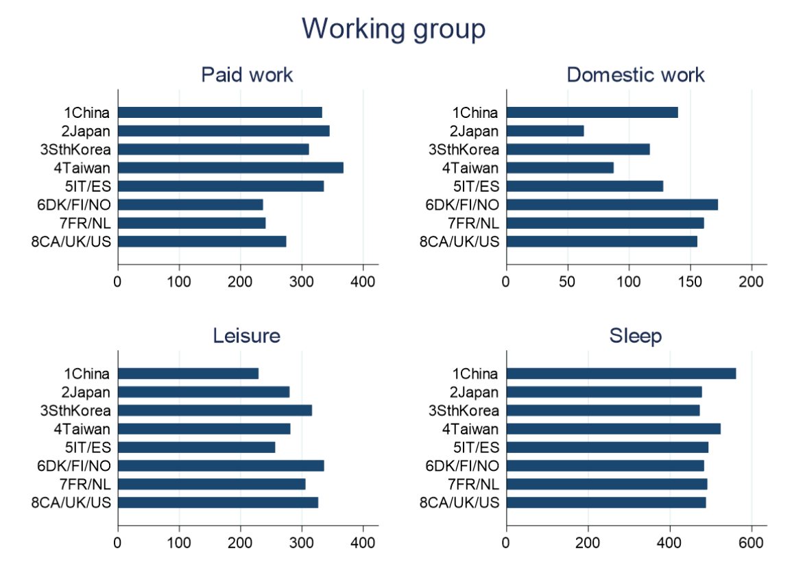
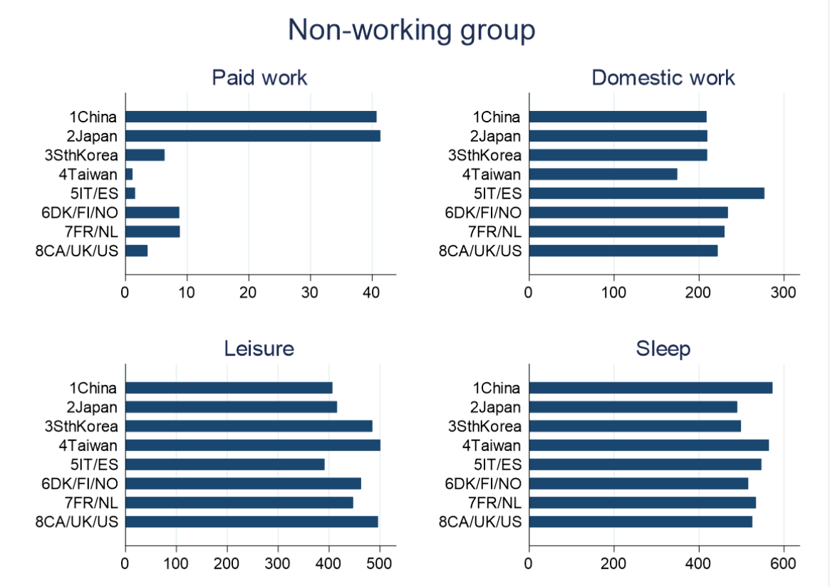

Figure A1. Mean Time (minutes/day) Spent in Major Daily Activities by Older Respondents by Employment Status, across Countries/Regions
Note: Results graph the average time spent in daily activities (in minutes/day) for older respondents, by employment status, across the 8 countries/regions included in this study. Working group= respondents were employed; Non-working group=respondents were not employed.

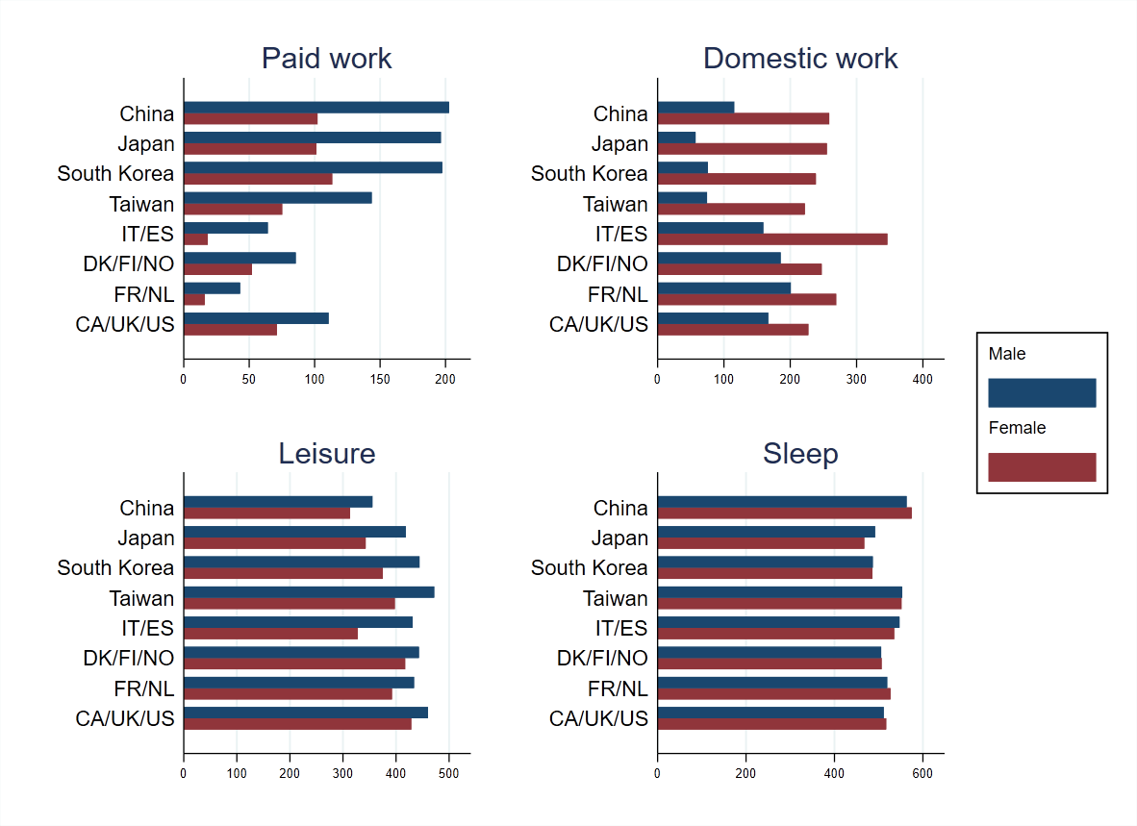
Figure A2. Mean Time (minutes/day) Spent in Major Daily Activities by Male and Female Older Respondents, across Countries/Regions
Note: Results graph the average time spent in daily activities (in minutes/day) for older respondents by gender, across the 8 countries/regions included in this study.

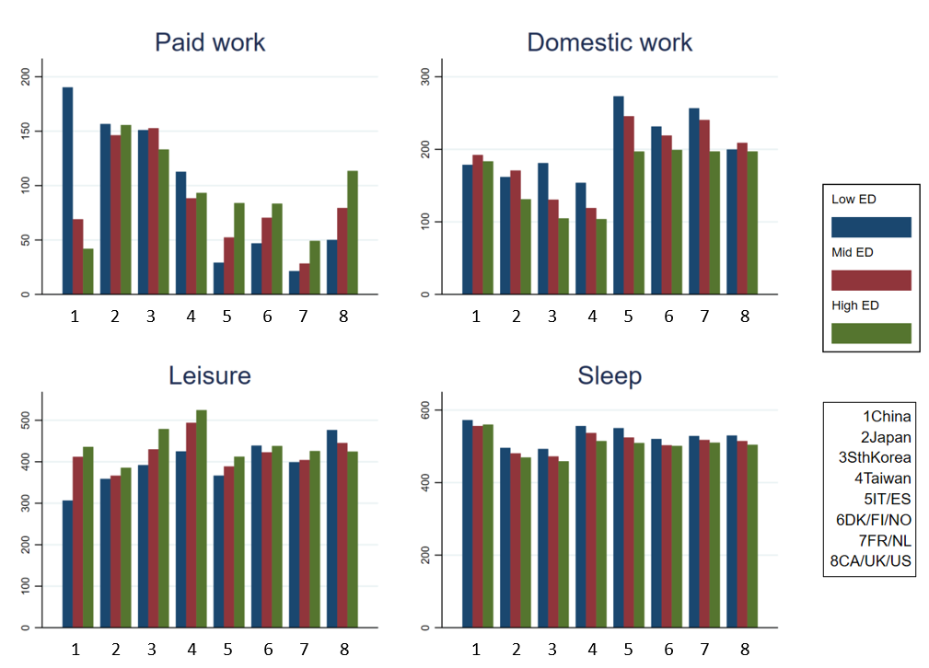

Figure A3. Mean Time (minutes/day) Spent in Major Daily Activities by Older Respondents, across Countries/Regions by Education Level
Note: Results graph the average time spent in daily activities (in minutes/day) for older respondents by education level, across the 8 countries/regions included in this study. Low ED= Less than Higher Secondary Education. Mid ED= Higher Secondary Education. High ED= More than Higher Secondary Education.

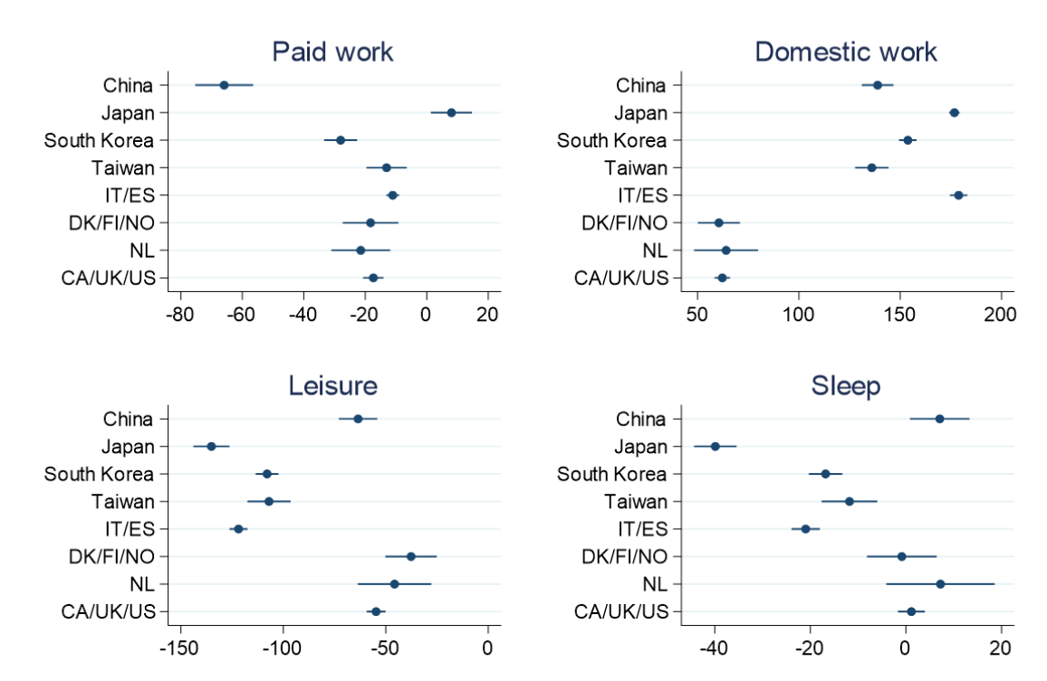

Figure A4. Gender Difference (Women vs. Men) in Time-use among Older People, across Countries/Regions. Point Estimates and 95% Confidence Interval from Regression Models Controlling for Employment Status.

Note: The X axis presents difference in time (minutes/day) between women and men, aged 60 to 75, for four separate daily activities. Negative values indicate that men do more of that activity; positive values indicate that women do more of that activity. Results from OLS models, estimated separately for each activity and including controls for individual level factors (gender, education level, partnership status, age, age squared, household size, urban area, if survey was conducted on a weekday and survey year) and employment status (1=employed, 0=not employed). Estimates for France (region 7) are missing because the indicator for employment status is missing from the France dataset. Coefficients and cell sizes are available in the Appendix, Tables A6-A9.

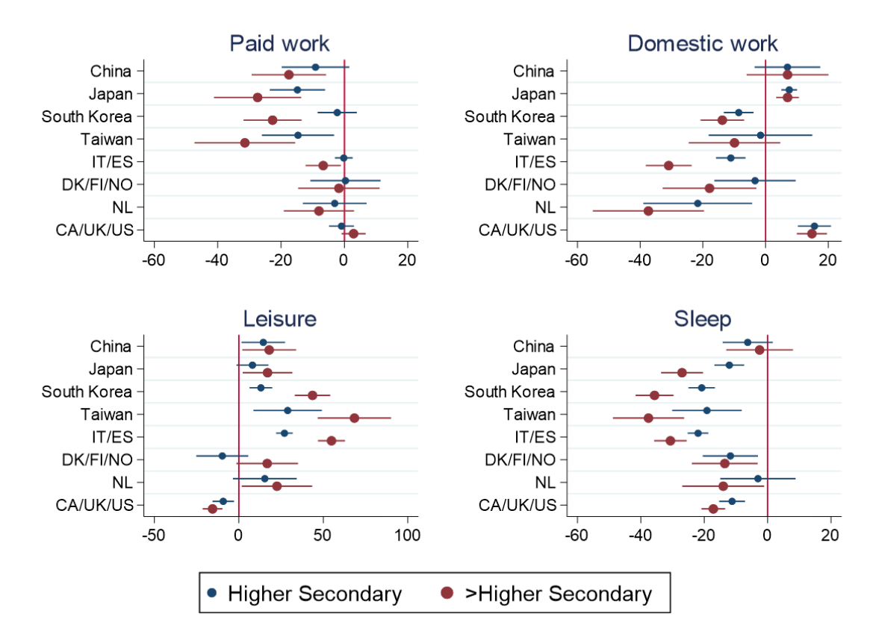

Figure A5. Time-use among Older People, by Educational Level (reference group: Less than higher secondary education). Point Estimated and 95% Confidence Interval from Regression Models Controlling for Employment Status.

Note: The X axis presents difference in time between respondents with Higher Secondary Education and those with Less than Higher Secondary Education (blue lines); and More than Higher Secondary Education and those with Less than Higher Secondary Education (read lines); aged 60 to 75, across daily activities. Negative values indicate that the reference group (Less than Higher Secondary Education) do more of that activity; the reverse for positive values. Results from OLS models, estimated separately for each activity and including controls for individual level factors (gender, education level, partnership status, age, age squared, household size, urban area, if survey was conducted on a weekday and survey year) and employment status (1=employed, 0=not employed). Estimates for France (region 7) are missing because the indicator for employment status is missing from the France dataset. Coefficients and cell sizes are available in the Appendix, Tables A6-A9.

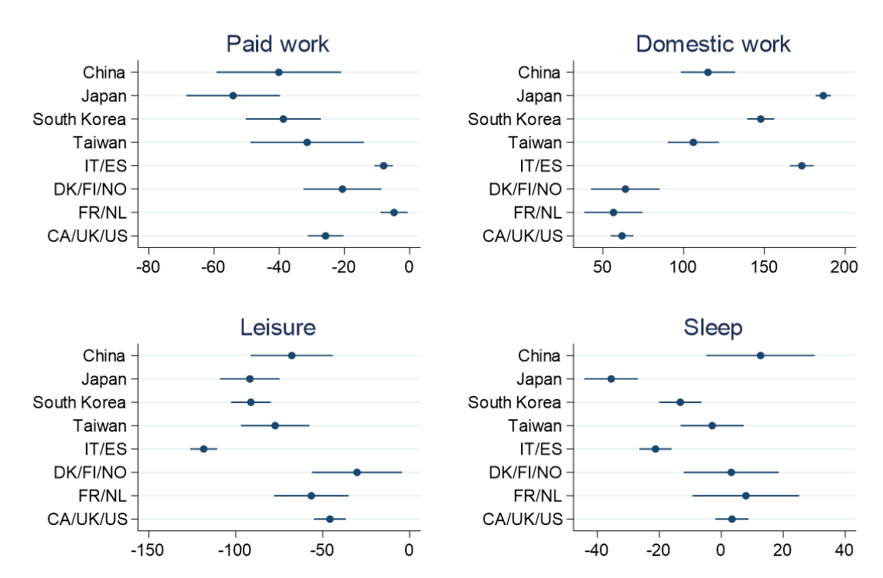

Figure A6. Point Estimates and 95% Confidence Interval of Gender Difference (Women vs. Men) in Time-use among Older People ages 70 to 75, across Countries/Regions

Note: The X axis presents difference in time (minutes/day) between women and men, aged 70 to 75, for four separate daily activities. Negative values indicate that men do more of that activity; positive values indicate that women do more of that activity. Results from OLS models, estimated separately for each activity and including controls for individual level factors (gender, education level, partnership status, age, age squared, household size, urban area, if survey was conducted on a weekday and survey year). Coefficients and cell sizes are available in the Appendix, Tables A10-A13.

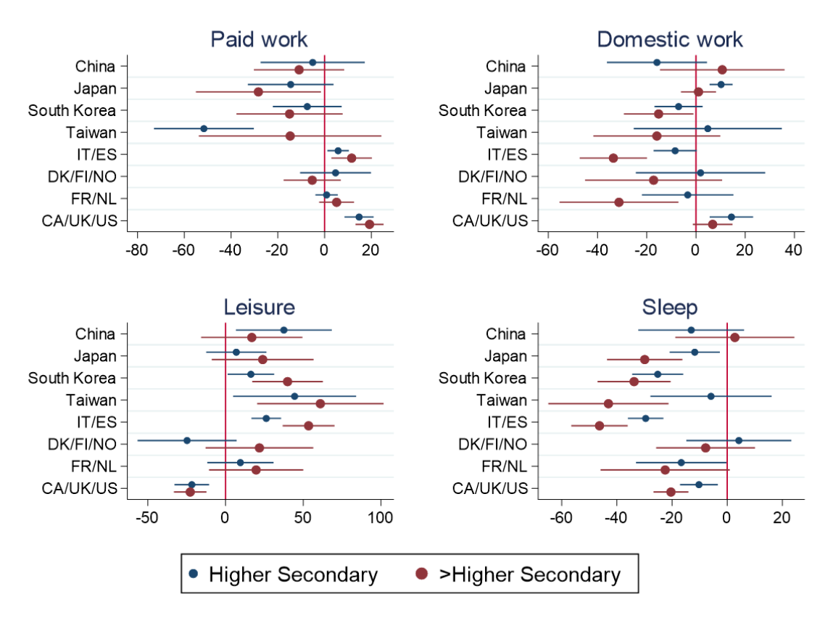

Figure A7. Point Estimated and 95% Confidence Interval of Time-use among Older People ages 70 to 75, by Educational Level (reference group: Less than higher secondary education)

Note: The X axis presents difference in time between respondents with Higher Secondary Education and those with Less than Higher Secondary Education (blue lines); and More than Higher Secondary Education and those with Less than Higher Secondary Education (read lines); aged 70 to 75, across daily activities. Negative values indicate that the reference group (Less than Higher Secondary Education) do more of that activity; the reverse for positive values. Results from OLS models, estimated separately for each activity and including controls for individual level factors (gender, education level, partnership status, age, age squared, household size, urban area, if survey was conducted on a weekday and survey year). Coefficients and cell sizes are available in the Appendix, Tables A10-A13.

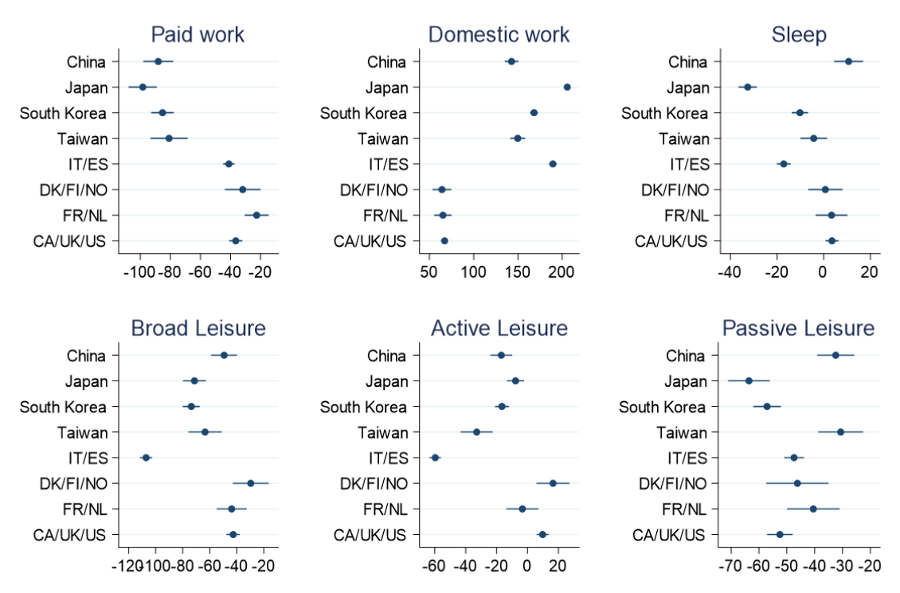

Figure A8. Point Estimates and 95% Confidence Interval of Gender Difference (Women vs. Men) in Time-use among Older People, across Countries/Regions

Note: The X axis presents difference in time (minutes/day) between women and men, aged 60 to 75, for four separate daily activities. Negative values indicate that men do more of that activity; positive values indicate that women do more of that activity. Results from OLS models, estimated separately for each activity and including controls for individual level factors (gender, education level, partnership status, age, age squared, household size, urban area, if survey was conducted on a weekday and survey year). Coefficients and cell sizes are available in the Appendix, Tables A14-A15.

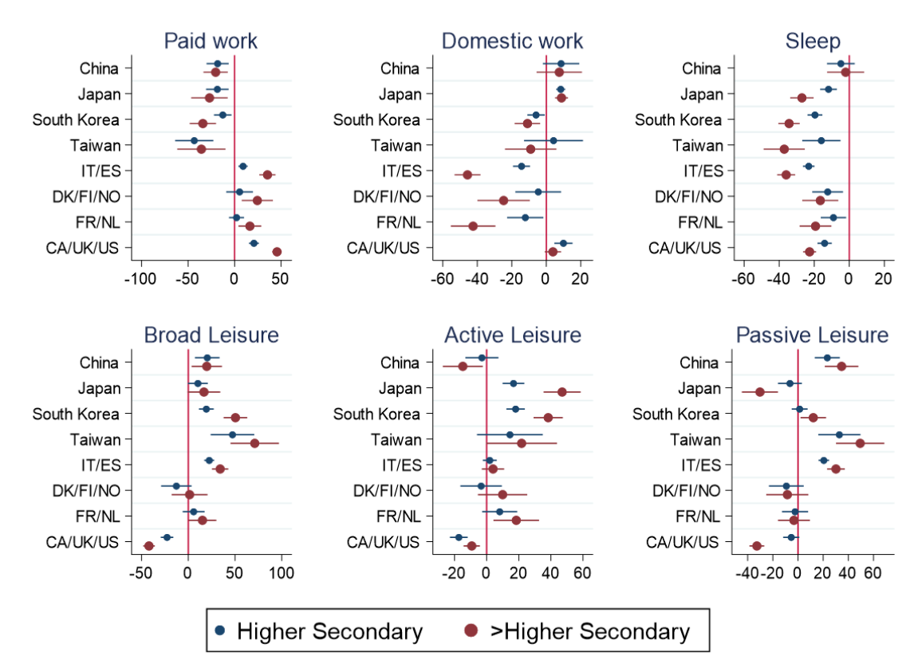

Figure A9. Point Estimated and 95% Confidence Interval of Time-use among Older People, by Educational Level (reference group: Less than higher secondary education)

Note: The X axis presents difference in time between respondents with Higher Secondary Education and those with Less than Higher Secondary Education (blue lines); and More than Higher Secondary Education and those with Less than Higher Secondary Education (read lines); aged 60 to 75, across daily activities. Negative values indicate that the reference group (Less than Higher Secondary Education) do more of that activity; the reverse for positive values. Results from OLS models, estimated separately for each activity and including controls for individual level factors (gender, education level, partnership status, age, age squared, household size, urban area, if survey was conducted on a weekday and survey year). Coefficients and cell sizes are available in the Appendix, Tables A14-A15.

