SUPPLEMENTARY INFORMATION:

Variation in multimorbidity between and within age groups

Table of Contents of Supplementary Information

Supplementary Tables
SI Table 1. Summary statistics of age and eCCI in people included in this study from four health systems.
SI Table 2. Least squares estimates and 95% confidence intervals of the coefficients a, b of Taylor’s law (1).
SI Table 3. Least squares estimates and 95% confidence intervals of the coefficients of the quadratic Taylor’s law (2).
SI Table 4. Statistics of Taylor’s law regressions (1) in SI Table 2 and quadratic Taylor’s law regressions (2) in SI Table 3

Supplementary Figures
SI Figure 1. Number of people of each age with at least 100 people, by health system. Source: NumberOfPeopleEachAge4HSagemin100_20250131-122802.png
SI Figure 2. Number of people in each 4-year age group in each health system. Source: NPeopleByAge16GroupsHealthSystem_20250115-184027.png
SI Figure 3. Estimates of the negative binomial parameters r, p as a function of age group for each health system. Source: NegativeBinomialParameters_20250115-185504.png

Supplementary Tables
SI Table 1. Summary statistics of age and eCCI in people included in this study from four health systems.
Health system →  Attribute ↓ | 1 NYC | 2 NYC | 3 CHI | 4 CHI
Number of people | 39018 | 41400 | 91568 | 66170
Minimum age years | 18 | 18 | 19 | 19
Median age years | 39 | 52 | 39 | 40
Maximum age years | 106 | 108 | 112 | 110
Mean age | 42.3493 | 51.3300 | 41.6381 | 43.4239
Standard dev. age | 15.8985 | 17.7623 | 15.5392 | 16.4802
Minimum eCCI | 0 | 0 | 0 | 0
Median eCCI | 1 | 2 | 0 | 0
Maximum eCCI | 24 | 22 | 23 | 21
Mean eCCI | 1.4322 | 2.4736 | 1.0860 | 0.8847
Standard dev. eCCI | 2.2007 | 2.3270 | 1.7543 | 1.6422
SI Table 2. Least squares estimates and 95% confidence intervals of the coefficients a, b of Taylor’s law (1). For example, in HS 1, the best approximating TL is
$\log_{10}{variance of eCCI at age x}≈0.4171+1.0729⋅\log_{10}{mean eCCI at age x}$.
The nominal 95% confidence intervals (C.I.) are approximate because they assume the mean eCCI is known without sampling error. The units of analysis here are one-year age groups with 100 or more individuals.
Health system | a | low C.I. | high C.I. | b | low C.I. | high C.I.
1 NYC | 0.4171 | 0.37991 | 0.45429 | 1.0729 | 0.95743 | 1.1884
2 NYC | 0.15558 | 0.096415 | 0.21475 | 1.2287 | 1.0861 | 1.3713
3 CHI | 0.35842 | 0.3422 | 0.37464 | 0.92951 | 0.87851 | 0.98052
4 CHI | 0.46305 | 0.45062 | 0.47548 | 1.108 | 1.0442 | 1.1718

SI Table 3. Least squares estimates and 95% confidence intervals of the coefficients of the quadratic Taylor’s law (2). The negative estimates of c for New York characterize a concave, non-linear variance function for eCCI. The units of analysis here are one-year age groups with 100 or more individuals.
Health system | a | low C.I. | high C.I. | b | low C.I. | high C.I. | c | low C.I. | high C.I.
1 NYC | 0.5176 | 0.48978 | 0.54542 | 1.4061 | 1.3173 | 1.495 | -1.5587 | -1.8352 | -1.2823
2 NYC | -0.03568 | -0.13277 | 0.061417 | 2.8083 | 2.1197 | 3.497 | -2.3272 | -3.3249 | -1.3296
3 CHI | 0.4169 | 0.39678 | 0.43702 | 1.0527 | 1.0018 | 1.1036 | -0.71316 | -0.9095 | -0.51683
4 CHI | 0.47221 | 0.45618 | 0.48824 | 1.061 | 0.97871 | 1.1433 | -0.29897 | -0.63715 | 0.039209

SI Table 4. Statistics of Taylor’s law regressions (1) in SI Table 2 and quadratic Taylor’s law regressions (2) in SI Table 3: coefficient of determination R²; probability p of the F-statistic of the null hypothesis of no relationship; residual sum of squares RSS. Fcompare is the F-statistic comparing the fit of the quadratic Taylor’s law with the fit of Taylor’s law; P is the probability of the null hypothesis of no improvement. The null hypothesis is rejected for all four health systems, even though for HS 4 the difference between TL and QTL is visually very small in Figure 2.
Taylor’s law regressions (1) in SI Table 2
Health system | R² | pFstat2 | MSE2 | RSS2
1 NYC | 0.84766 | 5.09E-27 | 0.014956 | 0.9273
2 NYC | 0.80843 | 8.02E-27 | 0.011681 | 0.81766
3 CHI | 0.95394 | 1.71E-44 | 0.003822 | 0.24463
4 CHI | 0.94877 | 1.16E-43 | 0.002446 | 0.15898

quadratic Taylor’s law regressions (2) in SI Table 3
Health system | R² | pFstat2 | MSE2 | RSS2 | Fcompare | P
1 NYC | 0.9506 | 1.44E-40 | 0.00493 | 0.30071 | 127.1 | 0
2 NYC | 0.85419 | 1.41E-29 | 0.009019 | 0.62233 | 21.656 | 0
3 CHI | 0.97492 | 3.80E-51 | 0.002115 | 0.13322 | 52.688 | 0
4 CHI | 0.95115 | 1.11E-42 | 0.002369 | 0.1516 | 3.1191 | 4.72E-06

Supplementary Figures
SI Figure 1. Number of people of each age with at least 100 people, by health system. Source: NumberOfPeopleEachAge4HSagemin100_20250131-122802.png
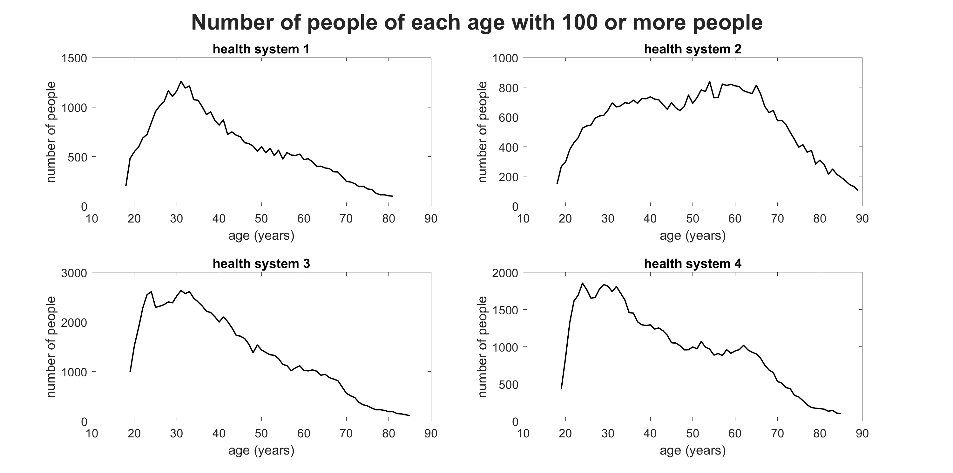
SI Figure 2. Number of people in each 4-year age group in each health system. Source: NPeopleByAge16GroupsHealthSystem_20250115-184027.png
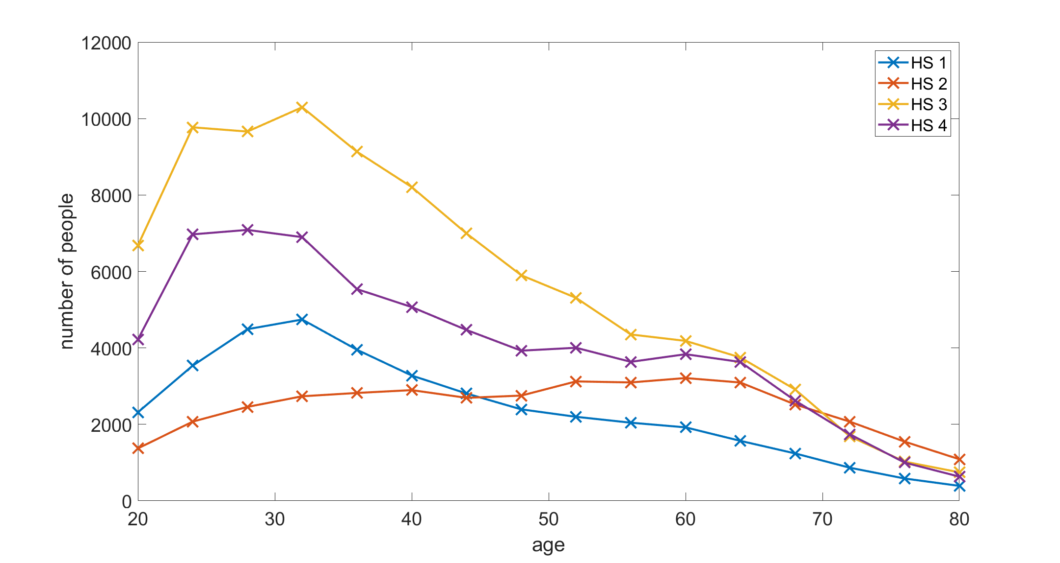

SI Figure 3. Estimates of the negative binomial parameters r, p as a function of age group for each health system. Source: NegativeBinomialParameters_20250115-185504.png
