Supplementary material:
Long-term efficacy and safety of tenofovir disoproxil fumarate in Chinese patients with chronic hepatitis B: 5-year results
Xieer Liang, Zhiliang Gao, Qing Xie, Jiming Zhang, Jifang Sheng, Jun Cheng, Chengwei Chen, Qing Mao, Wei Zhao, Hong Ren, Deming Tan, Junqi Niu, Shijun Chen, Chen Pan, Hong Tang, Hao Wang, Yimin Mao, Jidong Jia, Qin Ning, Min Xu, Shanming Wu, Jun Li, Xinxin Zhang, Wenyan Zhang, Cui Xiong, Jinlin Hou
Journal: Hepatology International

Corresponding author:
Jinlin Hou, MD
State Key Laboratory of Organ Failure Research, Guangdong Provincial Key Laboratory of Viral Hepatitis Research, Department of Hepatology Unit and Infectious Diseases, Nanfang Hospital, Southern Medical University, Guangzhou, China;
E-mail: jlhousmu@163.com; Phone: +86-13802727354

Table of content
Table | Table caption | Page number
Supplementary Table 1 | Comparison between patients with and without histological improvement | 3
Supplementary Table 2 | Summary of mutations (ITT population†) | 5
Supplementary Table 3 | Viraemic patients with changes in HBV pol/RT during open-label treatment (ITT Population) | 7
Supplementary Figure 1 | Changes from baseline to Week 240 in the (A) knodell necroinflammatory and (B) fibrosis scores (n=27 with histological assessment) | 8
Supplementary Figure 2 | Mean (A) creatinine, (B) creatinine clearance and (C) phosphorous in patients with impaired and normal renal function (safety population) | 9

Supplementary Table 1. Comparison between patients with and without histological improvement at week 240
Characteristics | Patients with histological improvement  n=19 | Patients without histological improvement  n=8 | P value
Age (years) | 36.2 (9.87) | 38.8 (12.45) | 0.5769
BMI (kg/m²) | 23.3 (3.29) | 21.9 (3.58) | 0.3394
Gender, n (%)  Male  Female | 15 (78.95)  4 (21.05) | 8 (100.0)  0 | 0.2855
ALT (U/L) | 158.7 (131.5) | 132.1 (96.39) | 0.6114
Albumin (g/dL) | 45.53 (2.55) | 48.13 (2.80) | 0.0268
Platelet (10^9/L) | 166.1 (44.58) | 175.6 (34.96) | 0.5944
Positive for HBV (months) | 92.19 (67.67) | 183.4 (122.3) | 0.0789
HBV genotype, n (%)  B  BC  C | 6 (31.58)  1 (5.26)  12 (63.16) | 5 (62.50)  0  3 (37.50) | 0.2998
HBV DNA (×${10}^{9}$ copies/mL) | 0.34(0.58) | 1.60 (3.39) | 0.3297
HBsAg value (IU/mL) | 6358.6 (8103.8) | 16293.0 (31327.5) | 0.4042
HBeAg, n (%)  Negative  Positive | 12 (63.16)  7 (36.84) | 5 (62.50)  3 (37.50) | 1.000
Knodell necroinflammatory score | 9.21 (2.32) | 4.75 (2.19) | <0.0001
Knodell fibrosis score | 3.11 (0.94) | 1.13 (0.83) | <0.0001
Previous LAM use, n (%) | 2 (10.53) | 0 | 1.000
HBV DNA <400 copies/mL at Week 240, n (%) | 18 (94.74) | 8 (100.0) | 1.000
ALT normalization at Week 240, n (%) | 16 (94.12)ª | 6 (85.71)^{b} | 0.5072
HBeAg loss up to Week 240, n (%) | 3 (42.86)^{c} | 0^{d} | 0.4750
Platelet change from baseline to Week 240, (10^9/L) | 35.39 (18.96)^{e} | 7.13 (22.87) | 0.0030
Albumin change from baseline to Week 240, (g/dL) | 1.42 (3.25) | -0.25 (2.87) | 0.2198
HBeAg change from baseline to Week 240 | -207.4 (374.5) | -448.1 (695.4) | 0.3801
HBsAg loss up to Week 240, n (%) | 0 | 0 | -
HBsAg change from baseline to Week 240 (IU/mL) | -3937.2 (8107.8) | -15043.2 (31489.0) | 0.3562
Data presented as mean (SD), unless otherwise specified. ALT, alanine transaminase; BMI, body mass index; HBV, hepatitis B virus; LAM, lamivudine.
ªn=17, ^{b}n=7, ^{c}n=7, ^{d}n=3, ^{e}n=18.
Reference values of biochemical parameters:
Alanine aminotransferase: 0-48 U/L; Albumin : 32-50 g/L; platelet: 130-400 10^9/L; Creatinine Clearance: males: 85-125 mL/min; females:75-115 mL/min; Phosphate: 0.7-1.45 mmol/L; Serum Creatinine: males: 59.2- 136.1 umol/L; females:42.4-104.3 umol/L

Supplementary Table 2. Summary of mutations (ITT population†)
 | HBV DNA  ≥69 IU/mL |  | Virological breakthrough |  | Discontinued treatment with viraemia‡ |  | Overall
 | TDF-TDF | ADV-TDF | TDF-TDF | ADV-TDF | TDF-TDF | ADV-TDF | TDF-TDF | ADV-TDF
N | 257 | 252 | 257 | 252 | 257 | 252 | 257 | 252
Double-blind phase | 25 (9.7) | 118 (46.8) | 0 | 6 (2.4) | 0 | 0 | 25 (9.7) | 118 (46.8)
Invalid sequence or DNA sequence undetectable | 14 (5.4) | 21 (8.3) | 0 | 0 | 0 | 0 | 14 (5.4) | 21 (8.3)
No changes from baseline | 9 (3.5) | 82 (32.5) | 0 | 6 (2.4) | 0 | 0 | 9 (3.5) | 82 (32.5)
Wild type§ at baseline | 9 (3.5) | 74 (29.4) | 0 | 6 (2.4) | 0 | 0 | 9 (3.5) | 74 (29.4)
Documented NA-related¶ mutation | 0 | 8 (3.2) | 0 | 0 | 0 | 0 | 0 | 8 (3.2)
Sequence changes from baseline | 2 (0.8) | 15 (6.0) | 0 | 0 | 0 | 0 | 2 (0.8) | 15 (6.0)
Sequence change at documented NA-related mutation | 2 (0.8) | 6 (2.4) | 0 | 0 | 0 | 0 | 2 (0.8) | 6 (2.4)
Sequence change at non-NA-related mutation | 0 | 9 (3.6) | 0 | 0 | 0 | 0 | 0 | 9 (3.6)
Open-label phase | 16 (6.2) | 17 (6.7) | 3 (1.2) | 6 (2.4) | 1 (0.4) | 2 (0.8) | 17 (6.6) | 21 (8.3)
Invalid sequence or DNA sequence undetectable | 5 (1.9) | 7 (2.8) | 0 | 2 (0.8) | 0 | 0 | 5 (1.9) | 9 (3.6)
No changes from baseline | 9 (3.5) | 6 (2.4) | 3 (1.2) | 1 (0.4) | 1 (0.4) | 1 (0.4) | 10 (3.9) | 6 (2.4)
Wild type§ at baseline | 9 (3.5) | 6 (2.4) | 3 (1.2) | 1 (0.4) | 1 (0.4) | 1 (0.4) | 10 (3.9) | 6 (2.4)
Documented NA-related¶ mutation | 0 | 0 | 0 | 0 | 0 | 0 | 0 | 0
Sequence changes from baseline | 2 (0.8) | 4 (1.6) | 0 | 3 (1.2) | 0 | 1 (0.4) | 2 (0.8) | 6 (2.4)
Sequence change at documented NA-related mutation | 1 (0.4) | 2 (0.8) | 0 | 1 (0.4) | 0 | 0 | 1 (0.4) | 2 (0.8)
Sequence change at non-NA-related mutation | 1 (0.4) | 2 (0.8) | 0 | 2 (0.8) | 0 | 1 (0.4) | 1 (0.4) | 4 (1.6)
Data are presented as n (%). ADV, adefovir dipivoxil; HBV, hepatitis B virus; NA, nucleic acid; TDF, tenofovir disoproxil fumarate.
Of the 25 HBeAg-positive patients qualified for genotypic analysis during the open-label phase, two patients had no resistance surveillance outcome that was recorded as protocol deviation. Of the 19 HBeAg-negative patients qualified for genotypic analysis during the open-label phase, two patients had no resistance surveillance outcome that was recorded as protocol deviation.
†Patients without baseline data for DNA were excluded.
‡Patients who temporarily stopped treatment were excluded.
§Includes patients without sequence changes from consensus and sequence changes from consensus at non-NA-related positions.
¶Includes all widely accepted or frequently reported NA-related mutation:
I. Primary mutations: rtM204I/V/S, rtA181V/T, rtN236T, rtI169T, rtT184S/A/G/I/L, rtS202G/C/I, rtM250V/I/L
II. Secondary compensatory mutations: rtV173L, rtL180M
III. Other reported positions: rtV207I/L, rtS213T, rtV214A/E, rtI233V, rtP237H, rtN238D/S/T

Supplementary Table 3. Viraemic patients with changes in HBV pol/RT during open-label treatment (ITT Population)
S. No | Treatment | HBeAg status at screening | Virological breakthrough (Yes/No) | Visit | HBV DNA (log₁₀ copies/mL) | Confirmed mutation | Non-confirmed mutation
1. | TDF-TDF | Negative |  | Baseline | 5.31 | S213T, V173L/V, M204V/M, L180M/L | -
1. | TDF-TDF | Negative | No | Week 96 | 2.62 | V173L, M204V, S213T | -
2. | TDF-TDF | Positive |  | Baseline | 9.2 | Wild type | -
2. | TDF-TDF | Positive | No | Week 144 | 2.83 | Wild type | N/H238Q/K
3. | ADV-TDF | Negative |  | Baseline | 7.21 | Wild type | -
3. | ADV-TDF | Negative | No | Week 96 | 3.2 | M204I | L229V
4. | ADV-TDF | Negative |  | Baseline | 9.31 | Wild type | -
4. | ADV-TDF | Negative | Yes | Week 144 | 2.95 | M250M/V, L180L/M, M204M/V, V173V/L | -
5. | ADV-TDF | Negative |  | Baseline | 7.09 | Wild type | A223A/S, V224V/I
5. | ADV-TDF | Negative | Yes | Week 204 | 3.54 | Wild type | -
6. | ADV-TDF | Negative |  | Baseline | 7.3 | Wild type | A223S/A
6. | ADV-TDF | Negative | Yes | Week 216 | 4.01 | Wild type | A223S/A, V224V/I
7. | ADV-TDF | Positive |  | Baseline | 8.01 | Wild type | A222T
7. | ADV-TDF | Positive | Yes | Week 240 | 3.22 | Wild type | A222A/T
8. | ADV-TDF | Negative |  | Baseline | 7.98 | Wild type | -
8. | ADV-TDF | Negative | Yes | Week 240 | 3.48 | Wild type | G255G/E
ADV, adefovir dipivoxil; HBV, hepatitis B virus; pol/RT, polymerase-reverse transcriptase; TDF, tenofovir disoproxil fumarate.

Supplementary Figure 1. Changes from baseline to Week 240 in the (A) knodell necroinflammatory and (B) fibrosis scores (n=27 with histological assessment)
- B)
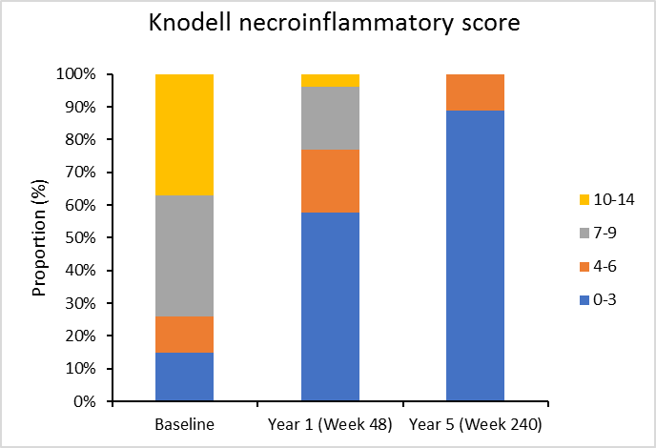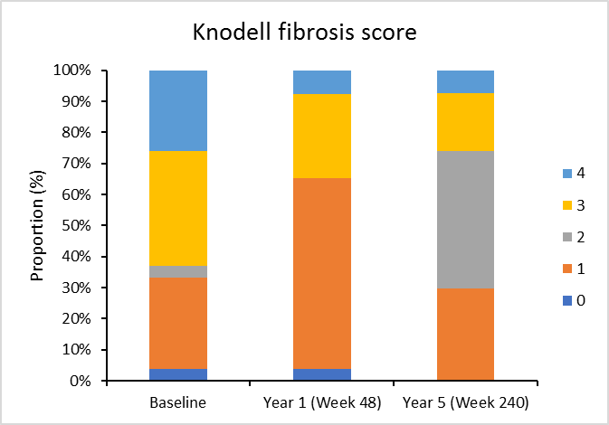

Supplementary Figure 2. Mean (A) creatinine, (B) creatinine clearance and (C) phosphorous in patients with impaired and normal renal function (safety population)
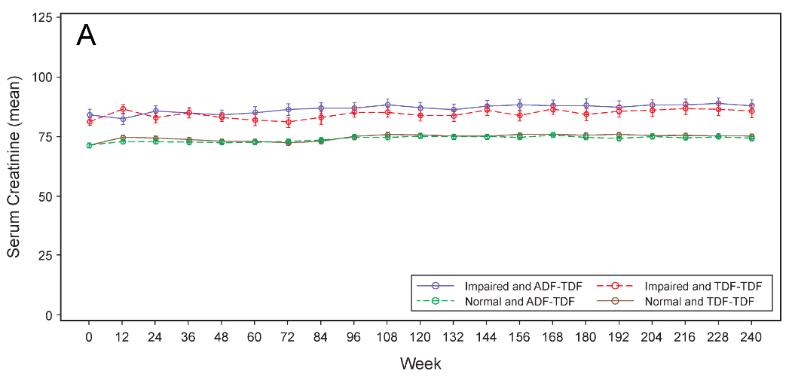

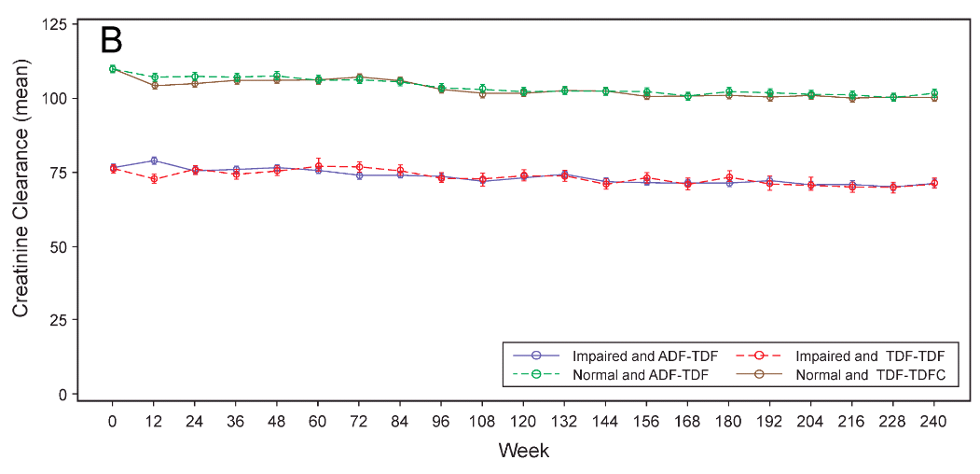
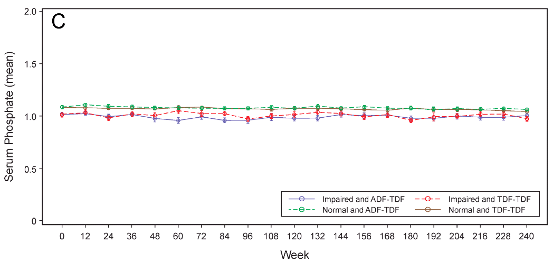
ADV, adefovir dipivoxil; TDF, tenofovir disoproxil fumarate.
 | TDF-TDF | ADV-TDF
serum creatinine change from baseline:
Normal renal function: | 3.62 ± 6.90 | 3.35 ± 7.34
impaired renal function: | 3.91 ± 8.49 | 3.76 ± 6.56
creatinine clearance change from baseline:
Normal renal function | -9.20 ± 10.75 | -8.60 ± 13.22
impaired renal function | -5.80 ± 8.42 | -5.60 ± 6.84

