Figure S1 UPLC-UV profiles Chemical structure of compounds in PNS. (1) Notoginsenoside R1(2) Ginsenoside Rg1(3) Ginsenoside Re (4) Ginsenoside Rf (5) Ginsenoside Rb1 (6) and Ginsenoside Rd contained in PNS sample.

Figure S2 The liver histology in ob/ob and HFD-fed mice treated with vehicle or PNS (400 mg/kg and 800 mg/kg)
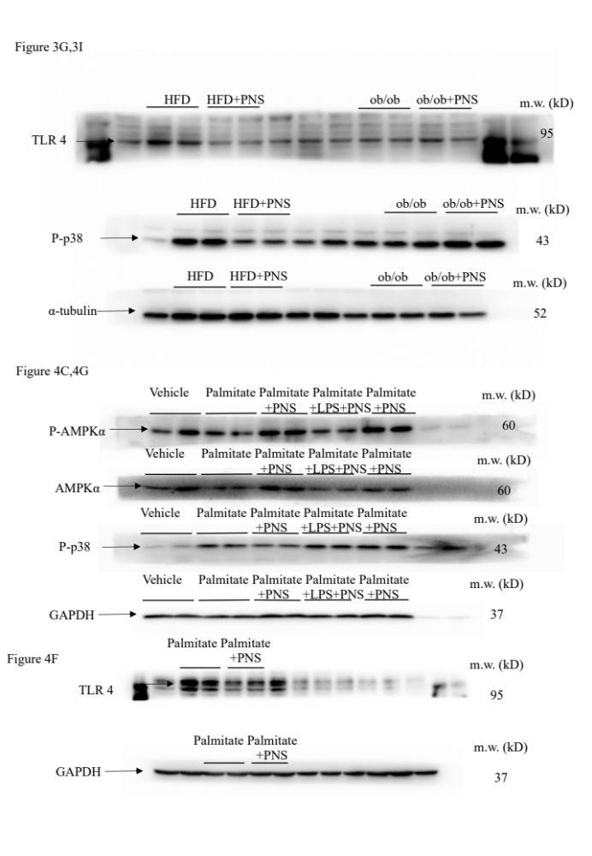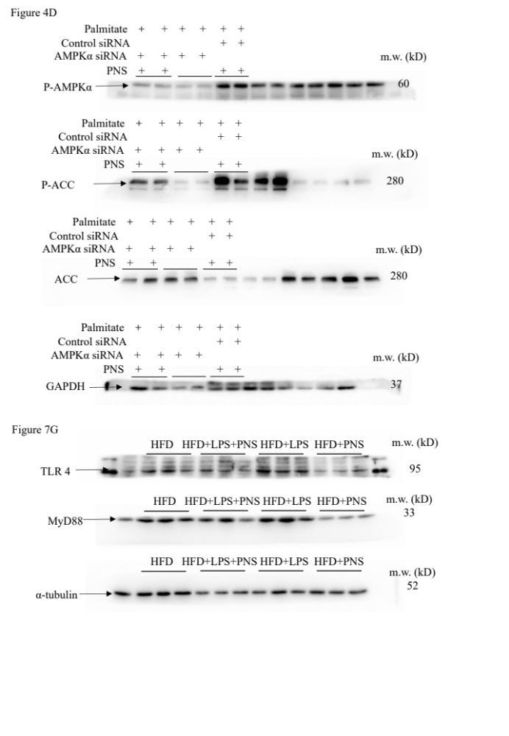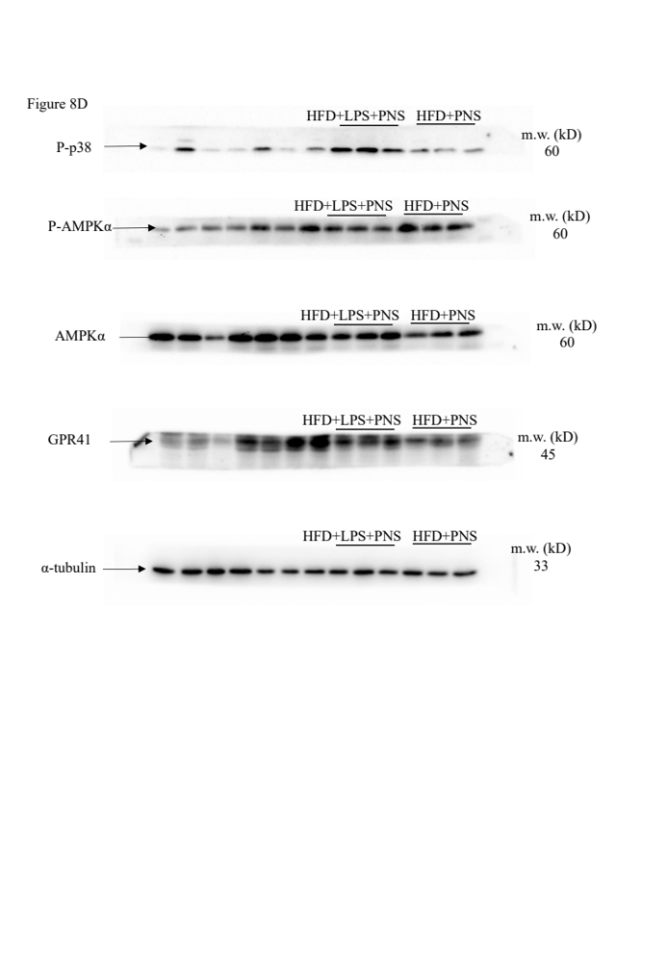

Table S1. Real-time PCR primer sequence

Gene | Sequence(5' to 3‘) | Sequence(5' to 3‘)
ACC | GTCCCCAGGGATGAACCAATA | GCCATGCTCAACCAAAGTAGC
FAS | GCGATGAAGAGCATGGTTTAG | GGCTCAAGGGTTCCATGTT
SREBP-1C | GAACAGACACTGGCCGAGAT | GAGGCCAGAGAAGCAGAAGAG
PPARα | TCGGCGAACTATTCGGCTG | GCACTTGTGAAAACGGCAGT
PPARγ | GTACTGTCGGTTTCAGAAGTGCC | ATCTCCGCCAACAGCTTCTCCT
CPT-1 | CAGAGGATGGACACTGTAAAGG | CGGCACTTCTTGATCAAGCC
CD36 | GAACCACTGCTTTCAAAAACTGG | TGCTGTTCTTTGCCACGTCA
ACOX-1 | CGGAAGATACATCCCGGAGACC | AAGTAGGACACCATACCACCC
ACAT1 | GCAGGGAAGTTTGCCAGTGAGA | GAACACGGTCTTGAGCTTTGGC
ACAT2 | GAGATTGTGCCAGTGCTGGTGT | GTGACAGTTCCTGTCCCATCAG
ECH1 | CGTGACCTCATCAGCAAGTACC | GCAGTAGCGAATGTCACAGGCA
Collagen I | CGGGCAGGACTTGGGTA | CGGAATCTGAATGGTCTGACT
Collagen IV | CAACACTAACCACAGACTGAAT | GAAGGAGGCTAACAAAGGC
α-SMA | TGGCACCACACCTTCTACAA | CGGAGGCATAGAGGGACA
TNFα | CTACCTTGTTGCCTCCTCTTT | GAGCAGAGGTTCAGTGATGTAG
IL-6 | AGGATACCACTCCCAACAGACCT | CAAGTGCATCATCGTTGTTCATAC
CD14 | GGCCGCGCGGATTCCTAGTC | ATCGGGTCCGGTGGCTTCCA
β-actin | ACGGCCAGGTCATCACTATTG | TGGAAAAGAGCCTCAGGGC

