Statistical Analysis

Continuous variables were reported as mean ± standard deviation (SD) or median (IQR), and categorical variables were reported as number (n) of patients with the certain characteristic (proportion of patients with the certain characteristics [%]). Student’s t-test was used for group comparisons of normally distributed data, while Mann-Whitney-U test was applied when data was not normally distributed. Pearson's chi-squared test or Fisher’s exact test were performed to conduct group comparisons of categorical variables. The prognostic value of the genetic risk factors additionally to routinely assessed patient variables that are clinically relevant and have previously been associated with increased risk (further referred to as “baseline variables”) was assessed using logistic regression models. For each of the three outcomes: advanced fibrosis (F3/4), significant fibrosis (≥F2) and NAS ≥5, we fitted a “baseline model” including only “baseline variables” (Variables: advanced fibrosis F3/4; significant fibrosis ≥F2: age, sex, BMI, diabetes; NAS ≥5: age, sex, BMI, diabetes, ALT) and subsequently included each of the genetic risk factors separately. Improved model fit was assessed using a likelihood-ratio test and genetic risk factors significantly improving the model fit compared to the “baseline model” were included in a final model. Model fit was visualized using receiver operating characteristics curves and the corresponding area-under the receiver operating characteristics curve, alongside p-values from the likelihood ratio test, which refer to improvement in model fit. Furthermore uni- and multivariable binary logistic regression models were conducted to evaluate factors independently associated with NAS≥5 or F≥3 respectively. Two-sided p values <0.05 were considered as statistically significant. Since p-values serve only descriptive purposes, no multiplicity correction was applied. The IBM SPSS 24.0 statistic software (SPSS Inc., Armonk, NY) and R 3.6.3[Package: ggplot2, pROC](19) were used for all statistical analyses. All analyzes were performed by Rafael Paternostro (clinical researcher and medical doctor, ≥5 year experience in the field of clinical research) and Elias L. Meyer (Professional Statistican, Medical University of Vienna).

Suppl. Table S1: Patient characteristics of the overall study population and patient characteristics stratified according to PNPLA3 status.
 | All patients (n=703) | C/C (n=358) | C/G (n=267) | G/G (n=78) | p-value
Sex, n(%)  Female  Male | 338 (54.7%)  318 (45.3%) | 194 (54.3%)  163 (45.7%) | 152 (56.9%)  115 (43.1%) | 38 (48.7%)  40 (51.3%) | 0.432
Age, mean±SD | 47±14 | 48±13 | 46±14 | 48±15 | 0.218
NAS, n(%)  1-2 Points  3-4 Points  ≥5 points | 328 (46.7%)  202 (28.7%)  173 (24.6%) | 192 (53.6%)  101 (28.2%)  65 (18.2%) | 112 (41.9%)  80 (30.0%)  75 (28.1%) | 24 (30.8%)  21 (26.9%)  33 (42.3%) | <0.001
NAS, n(%)  1-4 Points  ≥5 points | 530 (75.4%)  173 (24.6%) | 293 (81.8%)  65 (18.2%) | 192 (71.9%)  75 (28.1%) | 45 (57.7%)  33 (42.3%) | <0.001
NAS, median (IQR) | 3 (1-4) | 2 (1-4) | 3 (1-5) | 4 (2-5) | <0.001
Steatosis, %  Median (IQR) | 40 (15-70) | 30 (10-60) | 40 (20-70) | 50 (29-70) | <0.001
NAS Steatosis, n(%)  Grade 1  Grade 2-3 | 344 (48.9%)  359 (51.1%) | 206 (57.5%)  152 (42.5%) | 114 (42.7%)  153 (57.3%) | 24 (30.8%)  54 (69.2%) | <0.001
NAS Steatosis, n(%)  Grade 1-2  Grade 3 | 521 (74.1%)  182 (25.9%) | 294 (82.1%)  64 (17.9%) | 175 (65.5%)  92 (34.5%) | 52 (66.7%)  26 (33.3%) | <0.001
NAS Inflammation, n(%)  Grade 0-1  Grade 2-3 | 639 (90.9%)  64 (9.1%) | 327 (91.3%)  31 (8.7%) | 244 (91.4%)  33 (8.6%) | 68 (87.2%)  10 (12.8%) | 0.481
NAS Ballooning, n(%)  Grade 0-1  Grade 2 | 606 (86.2%)  97 (13.8%) | 321 (89.7%)  37 (10.3%) | 226 (84.6%)  41 (15.4%) | 59 (75.6%)  19 (24.4%) | 0.003
Fibrosis, n(%)  Grade 0-2  Grade 3/4 | 622 (88.5%)  81 (11.5%) | 327 (91.3%)  31 (8.7%) | 236 (88.4%)  31 (11.6%) | 59 (75.6%)  19 (24.4%) | <0.001
Cirrhosis, n(%)  No  Yes | 674 (95.9%)  29 (4.1%) | 347 (96.9%)  11 (3.1%) | 257 (96.3%)  10 (3.7%) | 70 (89.7%)  8 (10.3%) | 0.014
Diabetes, n(%)  No  Yes | 479 (68.1%)  224 (31.9%) | 241 (67.3%)  117 (32.7%) | 186 (69.7%)  81 (30.3%) | 52 (66.7%)  26 (33.3%) | 0.789
BMI, median (IQR) | 43.1 (30.6-50.4) | 43.5 (32.8-50.5) | 43.8 (31.2-51.0) | 32.0 (27.9-46.7) | 0.001
AST, median (IQR) | 30 (23-44) | 28 (22-41) | 32 (24-47) | 37 (26-57) | <0.001
ALT, median (IQR) | 40 (26-63) | 36 (24-55) | 42 (27-68) | 52 (34-82) | <0.001
GGT, median (IQR) | 44 (27-84) | 43 (26-69) | 43 (26-91) | 48 (32-105) | 0.187
Abbreviations: NAS – Non-Alcoholic Fatty Liver Disease (NAFLD) Activity Score, BMI – Body Mass Index, AST – Aspartate Aminotransferase, ALT – Alanine Aminotransferase, GGT – Gamma Glutamyl Transferase. Statistical Analysis within tables S1-S3: Student’s t-test was used for group comparisons of normally distributed data (mean±SD), while Mann-Whitney-U test was applied when data was not normally distributed (median[IQR]). Pearson's chi-squared test or Fisher’s exact test were performed to conduct group comparisons of categorical variables.

Suppl. Table S2: Patients stratified according to their TM6SF2 status. Since only n=8 patients were found with the T/T variant we have grouped all patients with at least one T-allele together to be able for perform adequate statistical analyses.
 | C/C (n=588) | C/T or T/T (n=115) | p-value
NAS, n(%)  1-2 Points  3-4 Points  >= 5 points | 286 (48.6%)  166 (28.2%)  136 (23.1%) | 42 (36.5%)  36 (31.3%)  37 (32.2%) | 0.038
NAS, n(%)  1-4 Points  ≥5 points | 452 (76.9%)  136 (23.1%) | 78 (67.8%)  37 (32.2%) | 0.039
NAS, median (IQR) | 3 (1-4) | 4 (2-5) | 0.005
Steatosis, %, Median (IQR) | 35 (10-70) | 50 (30-70) | <0.001
NAS Steatosis, n(%)  Grade 1  Grade 2-3 | 302 (51.4%)  286 (48.6%) | 42 (36.5%)  73 (63.5%) | 0.004
NAS Steatosis, n(%)  Grade 1-2  Grade 3 | 443 (75.3%)  145 (24.7%) | 78 (67.8%)  37 (32.2%) | 0.092
NAS Inflammation, n(%)  Grade 0-1  Grade 2-3 | 539 (91.7%)  49 (8.3%) | 100 (87.0%)  15 (13.0%) | 0.108
NAS Ballooning, n(%)  Grade 0-1  Grade 2 | 512 (87.1%)  76 (12.9%) | 94 (81.7%)  21 (18.3%) | 0.129
Fibrosis, n(%)  Grade 0-2  Grade 3/4 | 527 (89.6%)  61 (10.4%) | 95 (82.6%)  20 (17.4%) | 0.031
Cirrhosis, n(%)  No  Yes | 566 (96.3%)  22 (3.7%) | 108 (93.9%)  7 (6.1%) | 0.247
Diabetes, n(%)  No  Yes | 398 (67.7%)  190 (32.3%) | 81 (70.4%)  34 (29.6%) | 0.563
BMI, median (IQR) | 43.6 (31.2-50.6) | 39.6 (28.7-48.9) | 0.020
AST, median (IQR) | 30 (23-43) | 34 (25-48) | 0.040
ALT, median (IQR) | 39 (25-60) | 43 (28-71) | 0.034
GGT, median (IQR) | 43 (26-84) | 45 (28-85) | 0.585
Abbreviations: NAS – Non-Alcoholic Fatty Liver Disease (NAFLD) Activity Score, BMI – Body Mass Index, AST – Aspartate Aminotransferase, ALT – Alanine Aminotransferase, GGT – Gamma Glutamyl Transferase.

Suppl. Table S3: Patients stratified according to their HSD17B13 status.
 | T/T (n=398) | T/TA (n=250) | TA/TA (n=55) | p-value
NAS, n(%)  1-2 Points  3-4 Points  ≥ 5 points | 192 (48.2%)  93 (23.4%)  113 (28.4%) | 117 (46.8%)  81 (32.4%)  52 (20.8%) | 19 (34.5%)  28 (50.9%)  8 (14.5%) | <0.001
NAS, n(%)  1-4 Points  ≥5 points | 285 (71.6%)  113 (28.4%) | 198 (79.2%)  52 (20.8%) | 47 (85.5%)  8 (14.5%) | 0.018
NAS, median (IQR) | 3 (1-5) | 3 (1-4) | 3 (2-4) | 0.842
Steatosis, %  Median (IQR) | 38 (15-70) | 40 (11-70) | 45 (20-70) | 0.296
NAS Steatosis, n(%)  Grade 1  Grade 2-3 | 200 (50.3%)  198 (49.7%) | 122 (48.8%)  128 (51.2%) | 22 (40.0%)  33 (60.0%) | 0.362
NAS Steatosis, n(%)  Grade 1-2  Grade 3 | 301 (75.6%)  97 (24.4%) | 184 (73.6%)  66 (26.4%) | 36 (65.5%)  19 (34.5%) | 0.265
NAS Inflammation,n(%)  Grade 0-1  Grade 2-3 | 356 (89.4%)  42 (10.6%) | 231 (92.4%)  19 (7.6%) | 52 (94.5%)  3 (5.5%) | 0.276
NAS Ballooning, n(%)  Grade 0-1  Grade 2 | 334 (83.9%)  64 (16.1%) | 222 (88.8%)  28 (11.2%) | 50 (90.9%)  5 (9.1%) | 0.123
Fibrosis, n(%)  Grade 0-2  Grade 3/4 | 348 (87.4%)  50 (12.6%) | 224 (89.6%)  26 (10.4%) | 50 (90.9%)  5 (9.1%) | 0.591
Cirrhosis, n(%)  No  Yes | 379 (95.2%)  19 (4.8%) | 243 (97.2%)  7 (2.8%) | 52 (94.5%)  3 (5.5%) | 0.411
Diabetes, n(%)  No  Yes | 268 (67.3%)  130 (32.7%) | 177 (70.8%)  73 (29.2%) | 34 (61.8%)  21 (38.2%) | 0.378
BMI, median (IQR) | 41.8 (30.1-49.1) | 44.3 (31.2-50.6) | 43.8 (31.3-53.0) | 0.082
AST, median (IQR) | 32 (23-45) | 29 (23-41) | 32 (24-48) | 0.089
ALT, median (IQR) | 41 (26-65) | 38 (25-59) | 42 (27-61) | 0.313
GGT, median (IQR) | 44 (26-88) | 43 (27-74) | 39 (26-84) | 0.778
Abbreviations: NAS – Non-Alcoholic Fatty Liver Disease (NAFLD) Activity Score, BMI – Body Mass Index, AST – Aspartate Aminotransferase, ALT – Alanine Aminotransferase, GGT – Gamma Glutamyl Transferase.

Suppl. Figure S4: AUC for predicting significant fibrosis (≥F2) using (A) baseline model (BL; age, sex, BMI, and diabetes), (B) BL + PNPLA3, (C) BL + HSD17B13 (D) BL + TM6SF2;
P-values: (B), (C), and (D) vs. BL model

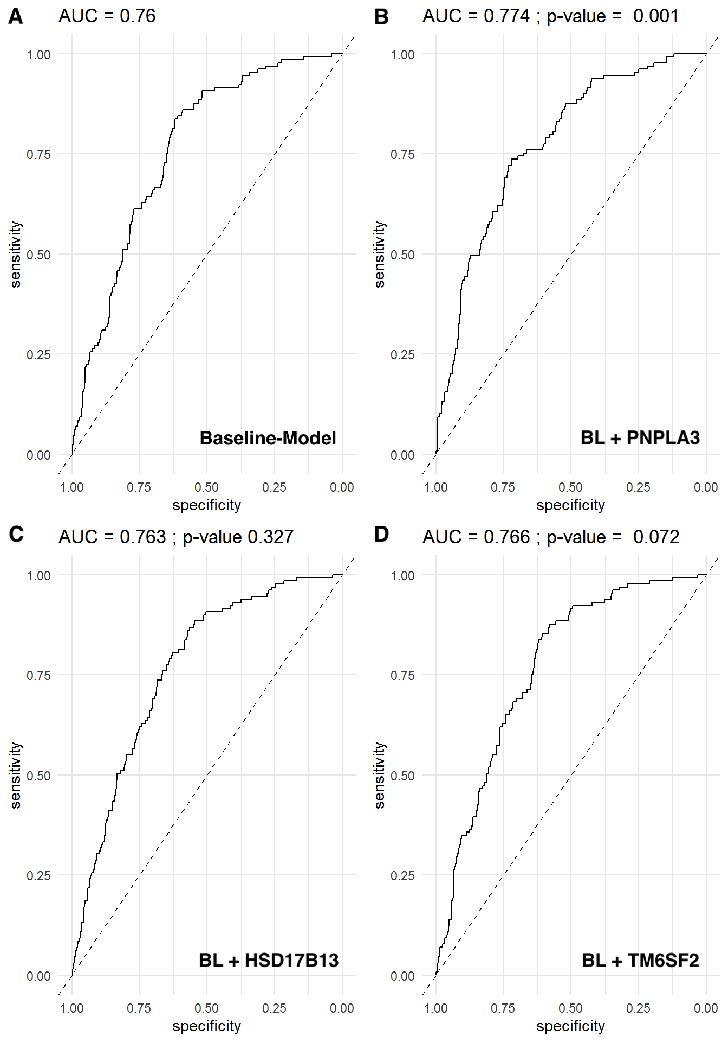

Suppl. Figure S5: AUC for predicting advanced fibrosis (≥F3) using (A) FIB-4 (B) FIB-4 + PNPLA3, (C) FIB-4 + HSD17B13 and (D) FIB-4 + TM6SF2;
P-values: (B), (C), and (D) vs. FIB-4 model).

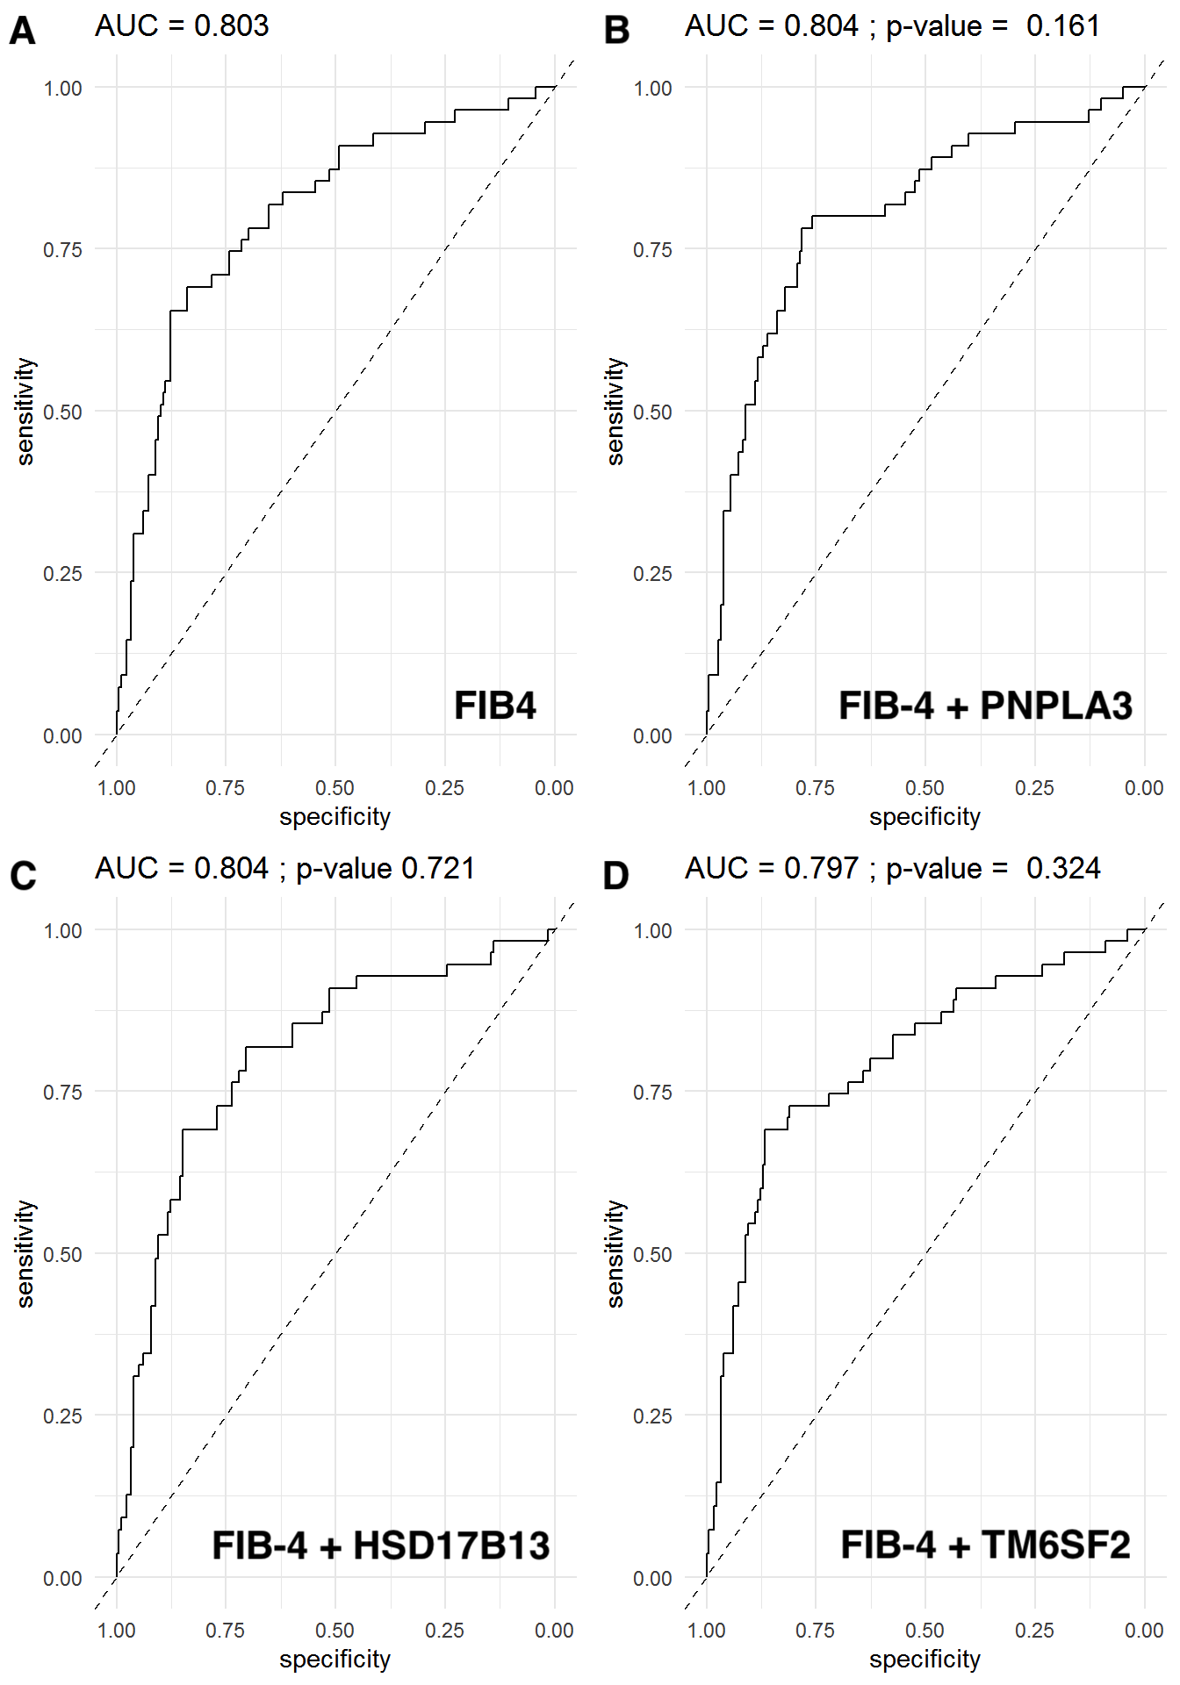

Suppl. Figure S6: AUC for predicting advanced fibrosis (≥F3) using (A) NAFLD-Fibrosis Score [NFS](B) NFS + PNPLA3, (C) NFS + HSD17B13 and (D) NFS + TM6SF2;
P-values: (B), (C), and (D) vs. NFS model).

