Supplementary table 1: Cumulative relative survival estimates with confidence intervals for the study population

Years after diagnosis | Age
Years after diagnosis | -30 | 30-45 | 45-49 | 60-
0.0 - 2.0 | 1.00 (1.00 -1.00) | 1.00 (1.00 -1.00) | 0.99 (0.93-1.00) | 1.00 (0.88-1.03)
2.0 - 4.0 | 1.00 (0.96-1.00) | 1.00 (1.00 -1.00) | 0.97 (0.91-1.00) | 0.89 (0.71-0.98)
4.0 - 6.0 | 0.98 (0.95-1.00) | 0.97 (0.90-1.00) | 0.97 (0.90-1.00) | 0.80 (0.58-0.94)
6.0 - 8.0 | 0.98 (0.93-0.99) | 0.95 (0.87-0.98) | 0.95 (0.87-0.99) | 0.71 (0.46-0.90)
8.0 - 10.0 | 0.98 (0.94-1.00) | 0.95 (0.87-0.99) | 0.93 (0.83-0.99) | 0.75 (0.48-0.95)
10.0 - 12.0 | 0.98 (0.94-1.00) | 0.92 (0.82-0.97) | 0.91 (0.79-0.97) | 0.49 (0.08-0.95)
12.0 - 14.0 | 0.95 (0.88-0.98) | 0.91 (0.80-0.96) | 0.85 (0.71-0.94)
14.0 - 16.0 | 0.94 (0.85-0.98) | 0.84 (0.71-0.92) | 0.84 (0.68-0.94)
16.0 - 18.0 | 0.89 (0.78-0.95) | 0.85 (0.71-0.93) | 0.78 (0.60-0.91)
18.0 - 20.0 | 0.87 (0.74-0.94) | 0.76 (0.59-0.87) | 0.80 (0.62-0.93)
20.0 - 22.0 | 0.87 (0.74-0.94) | 0.77 (0.60-0.88) | 0.67 (0.44-0.85)
22.0 - 24.0 | 0.83 (0.67-0.92) | 0.73 (0.55-0.86) | 0.63 (0.38-0.84)
24.0 - 26.0 | 0.84 (0.67-0.93) | 0.74 (0.56-0.87) | 0.47 (0.21-0.74)

Supplementary Table 2: Cox proportional hazards model for development of cholangiocarcinoma

 | Univariate |  |  | Multivariate
Predictor | HR | 95% CI | P-value | HR | 95% CI | P-value
Male | 1.27 | 0.526-3.07 | 0.60
Cirrhosis | 0.59 | 0.258-1.33 | 0.20
Dominant stricture | 4.31 | 1.84-10.1 | <0.001 | 3.33 | 1.40-7.88 |  | 0.006
Overlap (AIH) | 1.71 | 0.131-2.39 | 0.43
IBD | 3.19 | 0.747-13.6 | 0.12
UDCA | 1.47 | 0.583-3.71 | 0.41
Age at diagnosis | 1.03 | 1.01-1.06 | 0.009 | 1.03 | 1.00-1.05 |  | 0.031
ALP at diagnosis | 0.99 | 0.997-1 | 0.59
Bilirubin at diagnosis | 0.99 | 0.988-1.01 | 0.87
CA 19-9 at diagnosis | 0.99 | 0.937-1.04 | 0.62
Colectomy | 3.25 | 1.42-7.42 | 0.005 | 2.95 | 1.29-6.76 |  | 0.011
AIH; autoimmune hepatitis, ALP; alkaline phosphatase, CA 19-9; carbohydrate antigen 19-9, CI; confidence interval, HR; hazard ratio, IBD; inflammatory bowel disease, UDCA; ursodeoxycholic acid
Supplementary Table 3: Cox proportional hazards model for transplant-free survival

 | Univariate |  |  |  | Multivariate
Predictor | HR | 95% CI | p-value | HR |  | 95% CI |  | p-value
Male | 0.79 | 0.548-1.15 | 0.22
Cirrhosis | 5.72 | 3.50-9.34 | <0.0001 | 6.49 |  |  | 2.90-14.6 |  | <0.0001
Dominant stricture | 1.53 | 1.06-2.22 | 0.025 | 0.758 |  |  | 0.42-1.37 |  | 0.356
Small duct subtype | 0.46 | 0.188-1.12 | 0.088
Overlap (AIH) | 1.08 | 0.643-1.81 | 0.772
Cholangiocarcinoma | 2.56 | 1.58-4.14 | <0.0001 | 3.03 |  |  | 1.28-7.15 |  | 0.011
Hepatocellular carcinoma | 1.91 | 0.777-4.69 | 0.16
Colorectal carcinoma | 0.82 | 0.336-2.02 | 0.67
IBD | 0.64 | 0.435-0.938 | 0.022 | 0.747 |  |  | 0.445-1.25 |  | 0.270
IBD Type  Crohn’s  IBDU | 0.85  1.44 | 0.507-1.41  0.35-5.92 | 0.52  0.61
UDCA | 1.17 | 0.788-1.73 | 0.44
Age at diagnosis | 1.02 | 1.01-1.03 | <0.001 | 1.02 |  |  | 1.007-1.03 |  | 0.0028
ALP at diagnosis | 1.001 | 1.00-1.00 | 0.0075 | 1.000 |  |  | 1.00-1.00 |  | 0.0887
Bilirubin at diagnosis | 1.005 | 1-1.01 | <0.001 | 1.003 |  |  | 0.999-1.01 |  | 0.118
AIH; autoimmune hepatitis, ALP; alkaline phosphatase, CI; confidence interval, HR; hazard ratio, IBD; inflammatory bowel disease, IBDU; inflammatory bowel disease-unclassified, UDCA; ursodeoxycholic acid

Supplementary Figure 1

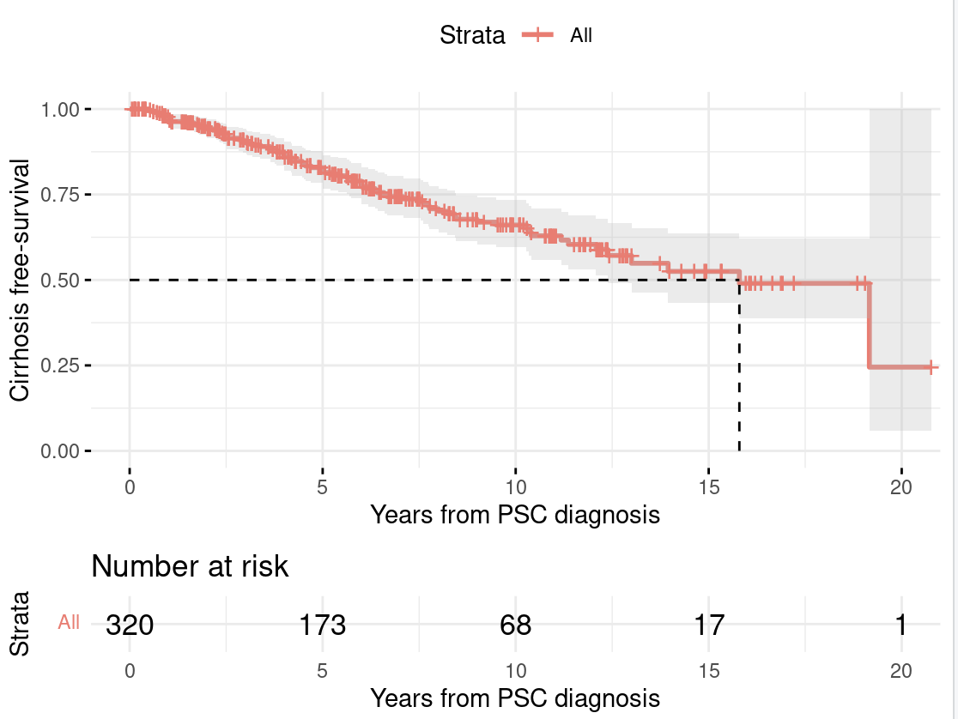

No. of Subject | Event | Censored | Median cirrhosis-free survival (95% CI) | 5 years cirrhosis-free survival | 10 years cirrhosis-free survival | 20 years cirrhosis-free survival
320 | 82 (25.6%) | 238 (74.4%) | 15.8 (12.4, NA) | 82.4% (77.9%, 87.3%) | 66.1% (59.4%, 73.4%) | 24.5% (6.0%, NA)

Supplementary Figure 2

Supplementary Figure 3
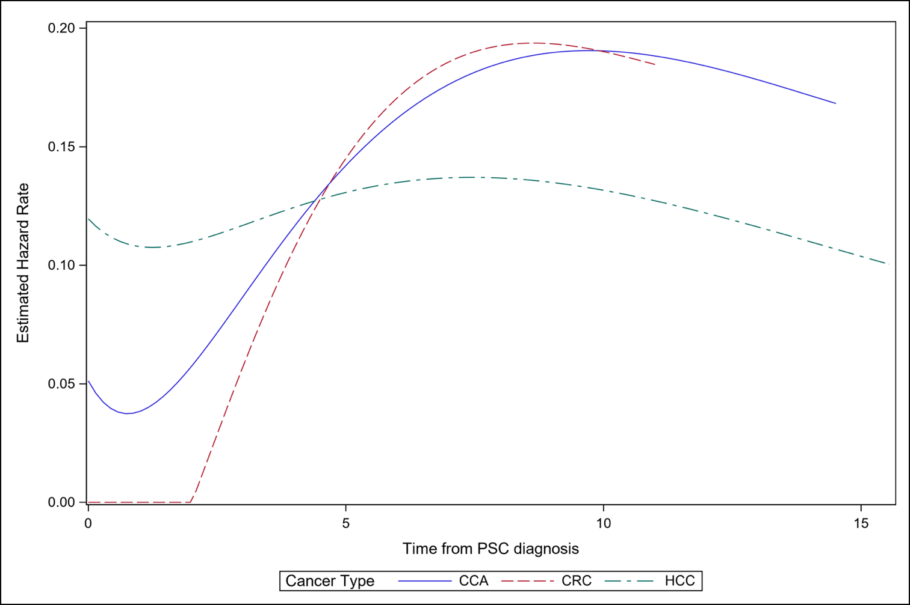
CCA; cholangiocarcinoma, CRC; colorectal carcinoma, HCC; hepatocellular carcinoma

Supplementary Figure 4

No. of Subject | Event | Censored | Median survival (95% CI)
24 | 18 (75%) | 6 (25%) | 0.6 (0.3, NA)
Supplementary Figure 5

No. of Subject | Event | Censored | Median Survival (95% CI) | 5 years Survival | 10 years Survival | 20 years Survival
413 | 49 (12%) | 364 (88%) | NA (18.4, NA) | 95.2% (92.9%, 97.5%) | 89.6% (86.0%, 93.4%) | 60.3% (48.3%, 75.2%)

Supplementary Figure 6
No. of Subject | Event | Censored | Median Survival (95% CI) | 5 years Survival | 10 years Survival | 20 years Survival
413 | 78 (18.9%) | 335 (81.1%) | NA (14.1, NA) | 93.1% (90.5%, 95.9%) | 77.7% (72.3%, 83.4%) | 50.1% (40.8%, 61.6%)

