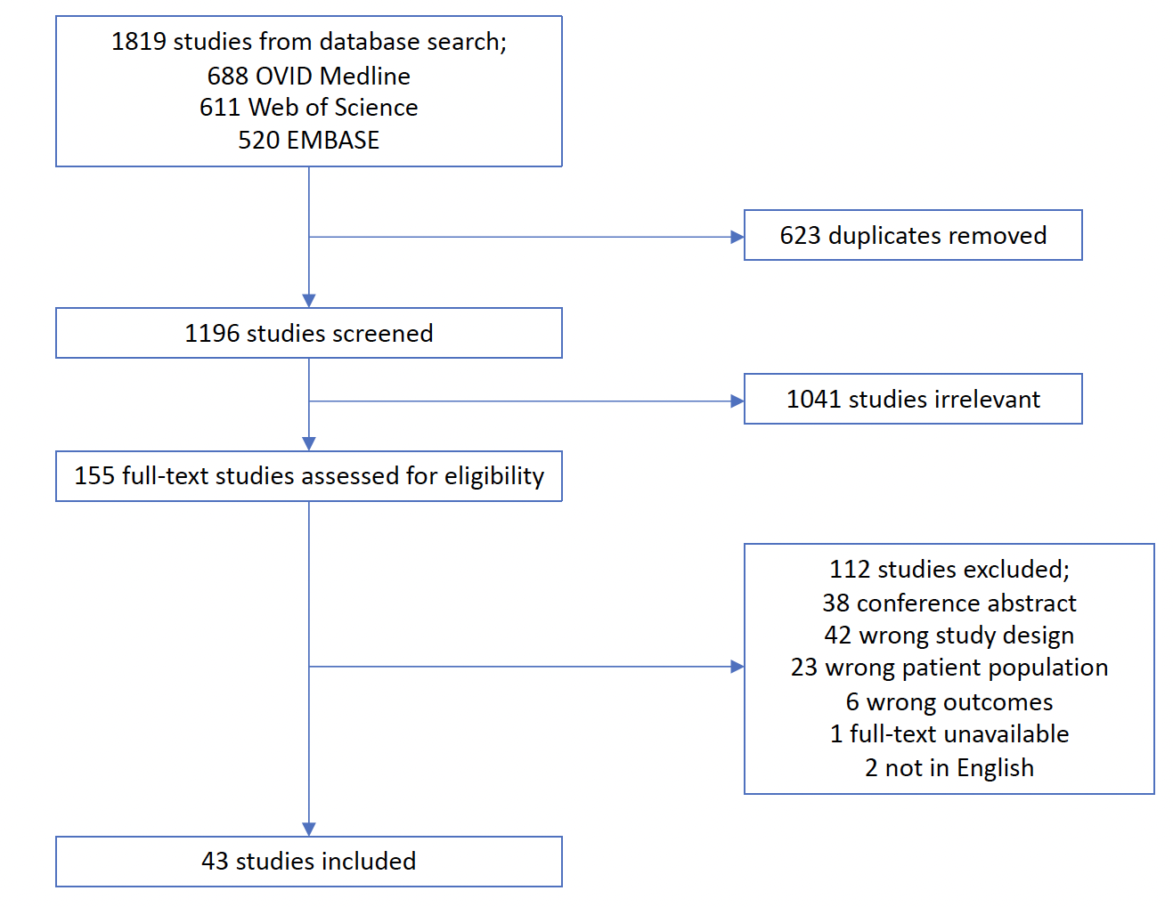

Supplementary Figure 1. PRISMA flowchart demonstrating the search and selection process of studies within systematic review

