
6th APASL- ACLF Consensus Meeting
14TH Annual Meeting of APASL- ACLF Research Consortium (A.A.R.C)
Theme: “Acute-On-Chronic Liver Failure (ACLF) towards a Global Consensus” `
Date -March 29 (Friday), 2024.
Time: 8:00 AM To 6:00 PM
Venue: - Room 558, 5F, Kyoto International Conference Center, Japan
Hybrid Event

SCIENTIFIC PROGRAM
Theme: “Acute-On-Chronic Liver Failure (ACLF): Towards a Global Consensus”
Section Sl. | Section Heading | Virtual Meeting Date | Virtual Meeting Time
Section-III | Infection and/or Sepsis in the Natural History of Chronic Liver Disease | 07-03-2024 (Thursday) | 04:30 PM (IST)
Section-IV & V | Organ Failure and its implication in patients with Liver Failure due to an Acute Insult  AND  Definition of ACLF | 09-03-2024 (Saturday) | 04:30 PM (IST)
Section-VI | Defining the Acute Insult in ACLF | 10-03-2024 (Sunday) | 10:30 AM (IST)
Section-VII-VIII | Defining the underlying chronic liver disease in ACLF  AND  ACLF and Acute Decompensation (AD) are Distinct: Differentiating AD and ACLF | 12-03-2024 (Tuesday) | 04:30 PM (IST)
Section-IX-X | Portal and Systemic hemodynamic in ACLF  AND  Role of Liver histology in ACLF | 14-03-2024 (Thursday) | 04:30 PM (IST)
Section-XI | Treatment of ACLF | 21-03-2024 (Thursday) | 04:30 PM (IST)
XII, XII & XIV | Liver Transplant in ACLF  AND  Prognostic Models in ACLF  AND  Prognostic Models and Global Convergence in ACLF | 24-03-2024 (Sunday) | 10:30 AM (IST)

Organized By
APASL ACLF Research Consortium (AARC)

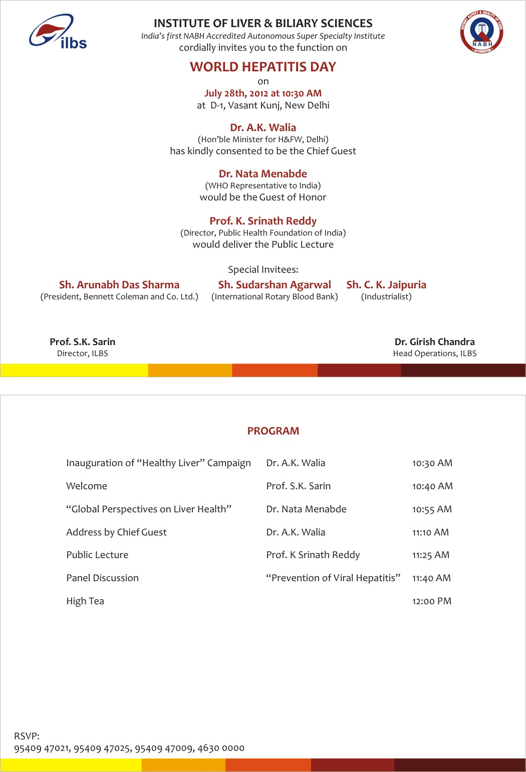
Page-1

Agenda
Section-I: Introduction.
1 | ACLF: towards a Global Consensus | C.E Eapen | Sagnik Biswas | Jin Mo Yang

Section-II: The Concept of Hepatic Reserve and the Liver Failure.
Drafting in-Charge: D J Kim, Wasim Jafri, Jia Ji Dong

2a | Natural history of Cirrhosis and Decompensation and causes of death | Gennaro D'Amico | Gupse Adali | Guan-Huei Lee
2b | Recompensation-The concept and implication for diagnosis of ACLF | Ashwani K. Singal | Nipun Verma | Hasmik Ghazinian
2c | Further decompensation in a decompensated cirrhosis- defining AD, ACLF, ESLD | Jonel Trebicka | Apichat Kaewdech | Vinod Arora
2d | Reversal of ACLF Syndrome- Timeline, predictor and Outcome | Zaigham Abbas | V Rajan | Soek Siam Tan
2e | Reversal of Cirrhosis- the aetiology, time frame and implication for ACLF | K. Rajender Reddy | Babu Lal Meena | Ruveena Bhavani
2f | Unified Prognostic Model for ACLF and Steps for Prioritization for LT in ACLF | Sumeet Asrani | Sargsyan Violeta | Sakkarin Chirapongsathorn
Repertoire- Omesh Goyal and Omkar
Section-III: Infection and/or Sepsis in the Natural History of Chronic Liver Disease
Drafting in-Charge: Ajay Duseja, A Kadir Dokmeci, Yoon Jun Kim

3a | Infection leading to Liver Failure in Cirrhosis | Qin Ning | Rahul Kumar | Shantan Venishetty
3b | Infection leading to other OF followed by Liver Failure | Debbie Shawcross | Kemal Fariz Kalista | Pravin Rathi
3c | Infection leading to other organ failure and death without liver failure. | Jasmohan Bajaj | Kessarin Thanapirom | Ameet Mandot
3d | Lab and clinical Diagnosis of infection in Cirrhosis with or without decompensation. | Do Seon Song | Mark Dhinesh Muthiah | Ajay Kumar Patwa
3e | Hepato tropic versus non-hepato tropic infections | Diana Alcantara-Payawal | Vinay Kumar B R | M Golam Azam
Repertoire-Sanjeev Sachdeva, Saurav Page-2

Section-IV: Organ Failure and its implication in patients with Liver Failure due to an Acute Insult
Drafting in-Charge: Saeed Hamid, George K Lau, Anand Kulkarni

4a | Defining the Organ Dysfunction and Organ Failure | V M Dayal | Anand Kulkarni | Chien Hao Huang
4b | Hepatic vs. Extrahepatic OD/OF in a Decompensated cirrhosis | Jennifer C. Lai | Lubna Kamani | Sachin Palnitkar
4c | Renal Dysfunction or Failure- the course and implication in cirrhosis with predominant liver failure | Rakhi Maiwall | Shahinul Alam | Sudhir Maharshi
4d | Renal Dysfunction or Failure- the course and implication in cirrhosis with acute decompensation with other extra-hepatic complications/OF | Paolo Angeli | H. Janaka De Silva | Shiran Shetty
4e | Circulatory and Respiratory failure are terminal events in ESLD rather than type of Organ Failure | Constantine J. Karvellas | Ananta Shrestha | Narendra Choudhary
Repertoire-Girish Kumar Pati, Ayush Jain
Section-V: Definition of ACLF
Drafting in-Charge: Sunil Dadhich, Gamal Shiha & Surender Singh

5a | APASL Definition of ACLF | Omesh Goyal | Bui Huu Hoang | Punit Puri
5b | Other Existing definition for ACLF | Ajay Mishra | Vandana Midha | PN Rao and Sunil Dadhich
5c | Similarities and differences in existing definitions. | Soe Thiha Maung | Karan Kumar | Hai Li
5d | Gaps to be bridged for a global definition | Amrish Sahney | Dharmesh Kapoor | Joy Varghese
Repertoire- Girish Kumar Pati, Ayush Jain

Page-3

Section-VI: Defining the Acute Insult in ACLF
Drafting in-Charge: Akash Shukla, Krishnadas Devdasa & Eugene Wong Yu Jun

6a | Alcoholic Hepatitis in ACLF and development of jaundice in decompensated Cirrhosis- Are they same? | Gyongyi Szabo | Sunil Taneja | Fazal Karim
6b | Hepatitis B Reactivation | Yu Shi | Jin Jun Chen | Chun Yen Lin
6c | Acute Viral Hepatitis -Hepatotropic and non-hepatotropic CD Virus | Dibya L Praharaj | Jidong Jia | Teerha Piratvisuth
6d | Drug Induced Liver Injury (Drugs, CAM & HDS) - with and without cirrhosis | Dhiraj Agrawal | Harshad Devarbhavi | Madunil A Niriella
6e | Autoimmune Liver Disease – distinction in resentation as ACLF and ALF | Manasa Alla | Atsushi Tanaka | Jose D Sollano
6f | Vascular diseases (PVT, HVOTO) | Pathik Parikh | Akash Shukla | Simone Strasser
6g | Infection and Sepsis | Rosmawati Binti Mohamed and Jaideep Behari | Arun Valsan | Amna Subhan Butt
6h | Variceal Bleed, post- TACE or post-hepatectomy liver failure | Aleksander Krag | Ashish Goel | Amar Mukund
6i | Timeline of acute injury and Liver failure with or without other OF- implication for definition (4 weeks versus 12 weeks) | Nadim Mahmud | Suprabhat Giri | Sanjiv Saigal
Repertoire- Phool Chand
Section-VII: Defining the underlying chronic liver disease in ACLF
Drafting in-Charge: Rino Gani, C Rinaldi Lesmana, Mohd Eslam

7a | CLD with or without Cirrhosis-implications in therapy and response | Tawesak Tanwandee | Tarana Gupta | Virendra Singh
7b | ‘Index’ presentation or ‘ACLF Again’ | Ashish Kumar | Manoj Sahu | Ashok Choudhury
7c | Impact of Comorbidities and Obesity | Rohit Loomba | Jacob George | Hong Ling Yu and Anand Kulkarni
7d | Changing trends for the aetiology of the acute insult and chronic injury | Jun Li | Tao Chen | Piyush Ranjan
Repertoire- Suguna Sree

Page-4

Section-VIII: ACLF and Acute Decompensation (AD) are Distinct: Differentiating AD and ACLF
Drafting in-Charge: Goeff Mcgauhan, James Fung, Mamun Al Mehtab, Tawesak Tanwandee

8a | Natural history and outcome ACLF | James Fung | Manoj Kumar Sharma | A. Kadir Dokmeci
8b | Natural history and outcome of Acute Decompensation | Abhijeet Choudhary | Kaushal Madan | Hemamala Ilango
8c | Acute Decompensation –differentiating from ACLF for clarity in definition | Khin Maung Win | Sombat Tressurepark | Irsan Hasan
8d | Hepatic encephalopathy -Prevention, therapy and implication in natural history of ACLF | Necati Ormeci | Sanjeev Sachdeva | A C Anand
Repertoire- Suguna Sree

Section-IX: Portal and Systemic hemodynamic in ACLF
Drafting in-Charge: Ankur Jindal, Harshvardhan Tevethia, Zaigham Abbas

9a | Acute Portal Hypertension in ACLF i.e. the Variceal bleed & Ascites | Xiaolong Qi | Akash Roy | Anil Arora
9b | Variceal progression in ACLF and role of preemptive BB therapy | Chitranshu Vasishtha | Mamun Al Mehtab | Ankur Jindal
9c | PICD-incidence, presentation, diagnosis and management | Vinod Arora | Hari Kumar Nair | Saurabh Mukewar
9d | Systemic, hepatic and pulmonary hemodynamics in ACLF | Jin Hua Hu | Madhumita P | Shobna Bhatia
Repertoire- Charles Panackel, Sudhir Verma

Section-X: Role of Liver histology in ACLF
Drafting in-Charge: Mukul Vij, Amit Goel, Y K Chawla

10a | Diagnostic Implication | Archana Rastogi | K C Sudhamshu
10b | Prognostic Implication | Chhagan Bihari | Chen Yu
10c | Safety, feasibility and cost | Puja Sakhuja | Venera Rakhmetova
Repertoire- Charles Panackel,

Page-5

Section-XI: Treatment of ACLF
Drafting in-Charge: Sombat T , A Tanaka , Shasthry S M, H C Lin

11a | Antiviral strategies in ACLF HBV Reactivation (2019) | Dr. Mohamed Elbasiony | M F Yuen | Cesar Yaghi
11b | Steroid in Alcoholic ACLF | Juan Pablo Arab | Mithun Sharma | Oidov Baatarkhuu  and  Subrat Acharya
11c | Steroid in DILI and AIH -ACLF | Mithra Prasad | V G Mohan Prasad | Shalimar
11d | Emerging therapies in ACLF-Anti-inflammatory, immune-modulators and others | Shyam Kotilil | Abraham Koshy | Ajay Kumar GB Pant
11e | Fecal Microbiota Transplant | Ki Tae Suk | C Abby Phillips | Apurva Pande  And  Guru Prasad  Dhakal
11f | Regenerative and cell-based Therapy | Ajit Sood | Anupam Kumar | Osamu Yokosuka
11g | Liver dialysis, Plasmapheresis and other artificial liver support system | Santhosh E Kumar | Kaiser Raja | Meenu Bajpai
Repertoire- Mukesh Sharma Paudel, Amanjot Kaur

Section-XII: Liver Transplant in ACLF
Drafting in-Charge: S G Lim, , Rohit Mehtani, Dong-Sik Kim, Mohd. Rela, Albert Chan

12a | Prediction of Liver Transplant-the need, Transplant window and optimization | Paul J Thuluvath | Chang Wook Kim and  Mettu Srinivas Reddy | Viniyendra Pamecha
12b | Unsuitability, contra-indications and futility of LT in ACLF | Kamal Kajal | Neeraj Saraf | Audrey Coilly
12c | Prioritization for LT in live and cadaveric transplant | Francoiz Durand | Navin Kumar Marannan | Md. Rela
12d | Right time for transplant in alcoholics with ACLF | D S Kim | Sanjiv Saigal | Sonal Asthana
12e | Innovations in technique and management for improved transplant outcomes in ACLF | Ravi Mohanka | Prashant Bhangui | Subhash Gupta and Shweta A Singh
12f | Immune-suppression and ACLF -are they same or different | Dinesh Jothimani | A S Soin | Satendra Pal Singh
12g | Nutritional assessment and interventions | Manav Wadhawan | Jaya Benjamin | Anoop Saraya
Repertoire- Rahul Pathakd, Ananthu

Page-6

Section-XIII: Prognostic Models in ACLF
Drafting in-Charge: Z Duan, Tao Chen, Manya Prasad

13a | ACLF patient in ICU- Prognostic score, AI MODELS | J Fernadez | Vivek Saraswat | Sargsyan Violeta
13b | Current Prognostic Models - Strength and Weaknesses | R K Dhiman | Samagra Agarwal | Amna Subhan Butt
Repertoire- Rahul Pathakd, Ananthu

Section-XIV: Prognostic Models and Global Convergence in ACLF
Drafting in-Charge: Vincet Wong, Van Huy Vo, Qin Ning

14a | ACLF in East and West are different patients than a different definition: Steps to convergence | Richard Moreau | Chetan R Kalal | Chandan K N
14b | Convergence 2024 for an ACLF unified Definition | S.K. Sarin | Vincent Wong | Van Huy Vo
Repertoire- Rahul Pathakd, Ananthu

Title: Acute-on-chronic liver failure: Consensus recommendations of the Asian Pacific Association for the Study of the Liver (APASL): An update and Steps Towards a Global Consensus
Keywords: Liver failure, ACLF, AARC, Chronic liver disease, Global Consensus.

Page-7

Outline of the Consensus meeting
Phase-1: Preparation of Draft
Formation of section with Team of 2 to 3 experts as Draft Incharge
Your role as an expert will involve presenting a Consensus Draft, comprising 1-2 paragraphs (approximately 300-500 words) with 5-6 references and 4-6 consensus statements following the GRADE system. The draft will be a focal point for discussion and approval by the panelists, as well as the speaker and moderator in a subsequent Hybrid presentation.
Data from AARC database is there, if you think of any analysis to be incorporated, our statistical team and AARC nodal Centre is happy to help.
Phase-2: Virtual meeting for approval of the Draft
Initial Section wise meeting of experts, Draft In charge as well as Invited faculties will be done virtually after the draft is received. This will make the first consensus draft. The draft in-charge for the section will lead the meeting and the final section draft will be shared to us.
Phase-3: Hybrid Meeting during APASL 2024 at Kyoto
The approved draft and selected topics which are needed to be discussed as per theme will be presented at the hybrid consensus meeting of AARC in Kyoto during APASL 2024 ON 29th March 2024.
Guideline for the Consensus Draft
· Draft within 500 words.
· 4 or 5 consensus statements (as per GRADE, attached below).
· Maximum of 5-6 references
· Any conceptualized figure/table is most welcome.

Page-8

Table 1 Level of Evidence and Grade of Recommendations (Adapted from Grading of Recommendations, Assessment, Development and Evaluations [GRADE] System with Minor Modificationsª).
 | Level of evidence^{b} | Confidence in the evidence
High | Information obtained from meta-analyses or systematic reviews, or from numerous randomized trials that have high quality data | It is improbable that additional research will significantly alter our level of confidence in the ssessment of potential benefits and risks
Moderate | Information obtained from either a singular randomized controlled trial (RCT) or various non-randomized studies | Additional research, if conducted, may potentially alter our estimation of the benefit and risk and have an impact on our level of confidence in the estimate.
Low | Studies of limited sample size, observational studies conducted retrospectively, and registries. | There is a degree of uncertainty associated with any estimate of the effect.
 | Recommendations – Grade^{c} | Wording associated with the grade of recommendation
Strong | The strength of the recommendation was influenced by several factors, such as the quality of the evidence, the presumed outcomes that are important for the patient, and the cost implications | “must”, “should”, or “we recommend
Weak | The recommendation may be made with less certainty and may result in higher costs or resource consumption due to variability in preferences and values, or increased uncertainty | “can”, “may”, or “we suggest
a-To make the GRADE system more objective, the type of studies from which the evidences are derived have been mentioned in the Level of Evidence
b-Level was graded down if there was a poor quality, strong bias or inconsistency between studies; level was graded up if there was a large effect size.
c-Recommendations reached by consensus of the members and included the quality of evidence, presumed patient-important outcomes and costs.
1. Atkins D, Best D, Briss PA, et al. Grading quality of evidence and strength of recommendations. BMJ. 2004; 328:1490. https://doi.org/10.1136/bmj.328.7454.1490.
2. Guyatt GH, Oxman AD, Vist GE, et al. GRADE: an emerging consensus on rating quality of evidence and strength of recommendations. BMJ. 2008; 336:924–926. https://doi.org/10.1136/bmj.39489.470347.AD.
Kindly Email in- aarc@aclf.in
In case of any confusion, can reach us by email or WhatsApp Call/message
Radhika- AARC Research Coordinator +91 9540947087
Dr Ashok Choudhury- Coordinator AARC. Email-doctor.ashokchoudhury@gmail.com
Dr Anand Kulkarni- Editorial Team. Email-anandvk90@gmail.com
Dr Vinod Arora-PI AARC. Email-vinod_ucms@yahoo.com
Page-9

