Supplementary Materials
Histomorphometry indicates distinct contributions of myofibroblast activation and sinusoidal capillarization to portal hypertension
Thomas SORZ-NECHAY, MD^{1,2,3,4}
Benedikt S. HOFER, MD^{1,2,3,4}
Philipp KÖNIGSHOFER, DVM^{1,2,3}
Alexis TREITLER^{1,2}
Georg SEMMLER, MD PhD^{1,4}
Benedikt SIMBRUNNER, MD, PhD^{1,2,4}
Vlad TARU, MD^{1,2}
Katharina BONITZ, MSc^{1,2,3}
Henriette HORSTMEIER, MD¹
Georg KRAMER, MD^{1,2,3,4}
Kerstin ZINOBER^{1,2,4}
Katharina REGNAT^{1,2,4}
Mattias MANDORFER, MD PhD^{1,4}
Barbara NEUDERT⁵
Christopher C. KALTENECKER⁵
Behrang MOZAYANI, MD⁵
Renate KAIN, MD⁵
Michael TRAUNER, MD^{1,4}
Philipp SCHWABL, MD PhD^{1,2,3,4}
Thomas REIBERGER, MD^{1,2,3,4*}

¹ Division of Gastroenterology and Hepatology, Department of Medicine III, Medical University of Vienna, Vienna, Austria.
² Christian Doppler Laboratory for Portal Hypertension and Liver Fibrosis, Medical University of Vienna, Vienna, Austria.
³ CeMM Research Center for Molecular Medicine of the Austrian Academy of Sciences, Vienna, Austria.
⁴ Clinical Research Group MOTION, Medical University of Vienna, Vienna, Austria
⁵ Department of Pathology, Medical University of Vienna, Vienna, Austria

*Corresponding author: Thomas REIBERGER, MD
Division of Gastroenterology and Hepatology
Department of Medicine III
Währinger Guertel 18-20
A-1090 Vienna, Austria
P: +4314040065890
F: +4314040047350
M: thomas.reiberger@meduniwien.ac.at

Supplementary Methods
Histological Staining
All liver biopsy specimens were formalin fixed (7.5% neutral buffered formaldehyde), paraffin-embedded and cut at 2μm thickness.
For picrosirius-red/fast-green staining, unstained tissue sections were deparaffinized in xylene and rehydrated in descending concentrations of ethanol (99%, 80%, 70%, 60%) for 5 minutes each. Following staining with “Weigerts Eisenhämatoxylin” (#HT1079, Sigma-Aldrich, Missouri, United States) according to the manufacturer’s instructions, the tissue was stained in 0.1% Fast Green (#16596, Morphisto, Offenbach am Main, Germany) for 4 minutes, briefly rinsed in acetic acid and deionized water and immersed in 0.1% picrosirius-red solution (#13425, Morphisto, Offenbach am Main, Germany) for 1 hour. Lastly, the tissue was dehydrated in ascending concentrations of ethanol, followed by immersion in xylene and covered in hydrophobic mounting medium.
Binding of antibodies to alpha alpha-smooth-muscle-actin (αSMA: mouse monoclonal antibody to Actin, Smooth Muscle [1A4], #760-2833 IVD, ready-to-use, CellMarque, California, USA; CD34: mouse monoclonal antibody to CD34 [QBEnd/10], #NCL-L-END, dilution 1:50, Leica Biosystems, Nussloch, Germany) after enzymatic antigen retrieval were visualized by automated immunohistochemistry using a NovolinkTM Polymer Detection system on an Immunostainer Benchmark Ultra (Ventana/Roche). Following dehydration in ascending concentrations of ethanol and immersion in xylene, samples were covered in hydrophobic mounting medium.

Histomorphometry Pipeline
All slides were digitized in high-resolution (40x objective, 0.137μm/pixel) using the Olympus SLIDEVIEW VS200 research slide-scanner (EVIDENT Europe GmbH, Hamburg, Germany). Digital histomorphometry was performed using customized computational pipelines. First, all images were converted to .tiff format at a downscaled resolution (20x, 0.274μm/pixel) using bfconvert (version 5.6.0). If multiple layers of the same section were available on a slide, the highest quality section was chosen and cropped from the image. Damaged tissue regions, artifacts and large areas of parenchyma-free connective tissue were marked using QuPath (version 0.5.1), exported as masks in portable network graphics (.png) format, and masks were used in Python for exclusion.
The pre-processed images were then analyzed with a customized pipeline. Briefly, images were converted to Hue-Saturation-Lightness (HSL) color space, denoised using Gaussian-Blur with a kernel-size of 75x75 pixels and tissue was detected via thresholding (Lightness-Channel pixel-value < 235). In samples with faint staining or strong background intensity, the lightness threshold was adjusted on a per-case basis. If no suitable lightness threshold could be found, the tissue was segmented manually in QuPath. The resulting tissue regions were filtered using area-based exclusion (<0.1mm²) to remove artifacts.
Following tissue segmentation, quantification of the histological biomarker was performed by converting the image to Hue-Saturation-Value color space, applying Gaussian-Blur with a kernel-size of 5x5 pixels and performing color segmentation based on empirically determined thresholds. For immunohistochemical stains, diaminobenzidine area was quantified using the following thresholds: 80-140 (Hue), 25-250 (Saturation), 5-200 (Value). For picrosirius-red stains, collagen proportionate area (CPA) was quantified using the following thresholds: 110-160 (Hue), 30-210 (S), 190-255 (V). The biomarker area was calculated as the number of positive pixels (color mask) divided by the total tissue pixels (tissue mask), expressed as percentage.

Supplementary Figures
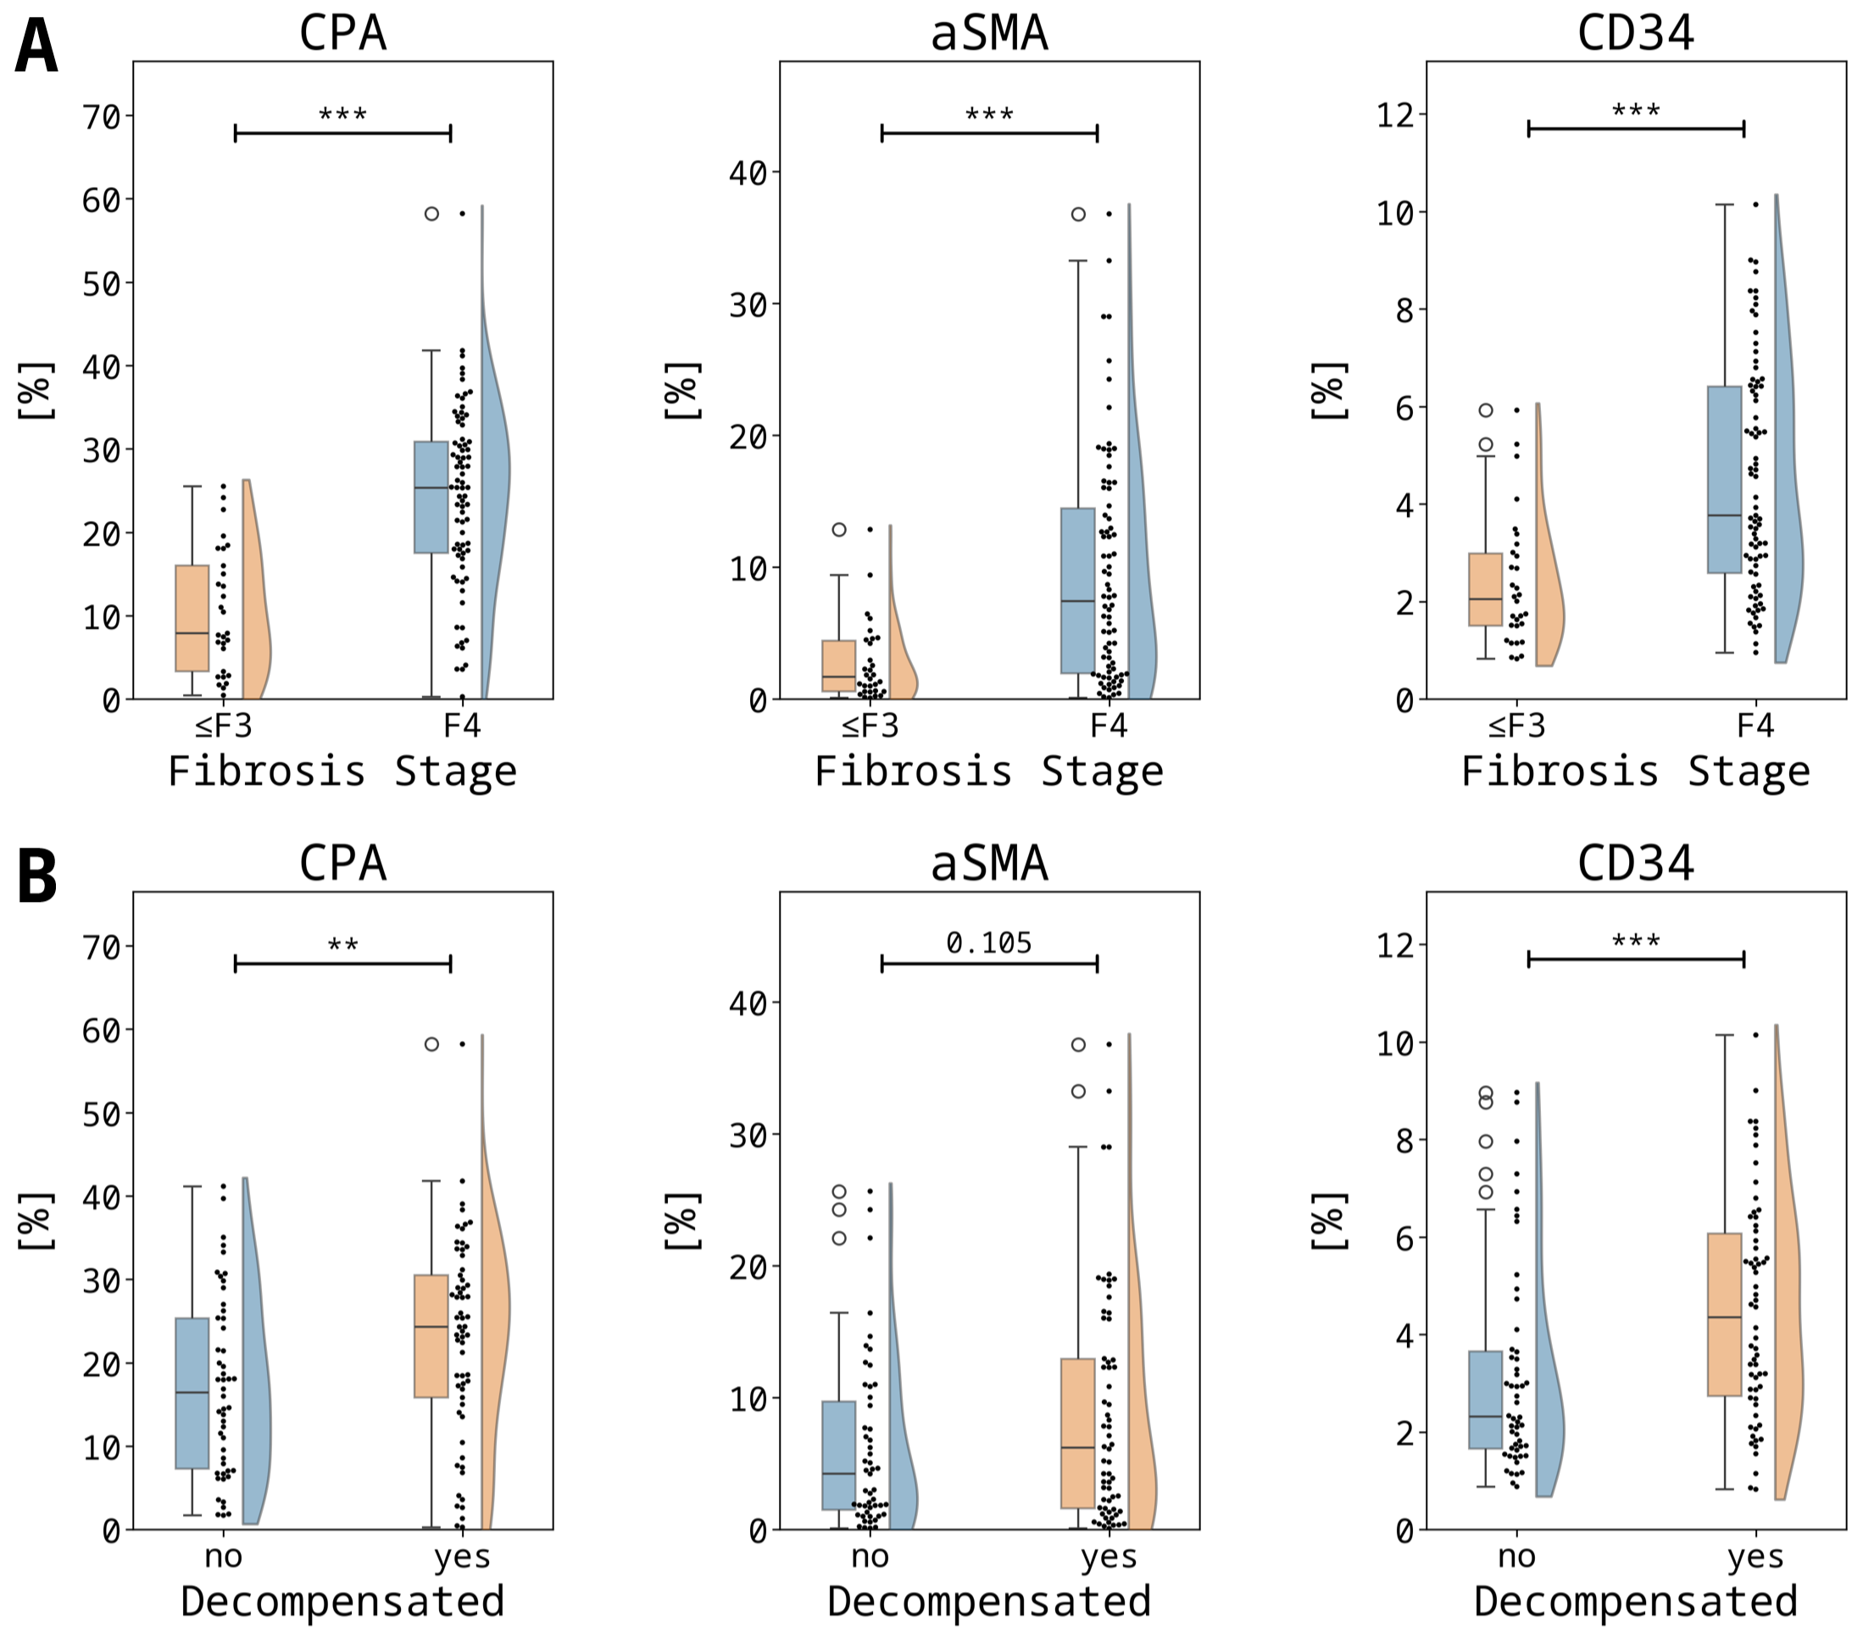
Supplementary Figure 1: Histological Biomarkers by Fibrosis Stage and Decompensation Status. Abbreviations: CPA - collagen proportionate area, αSMA - alpha smooth-muscle-actin.

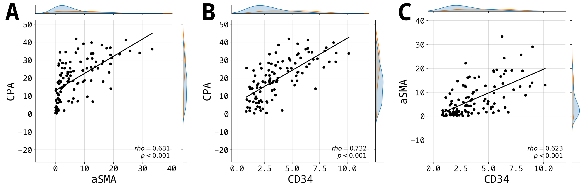
Supplementary Figure 2: Shared effects of Histological Biomarkers. Abbreviations: CPA - collagen proportionate area, αSMA - alpha smooth-muscle-actin.
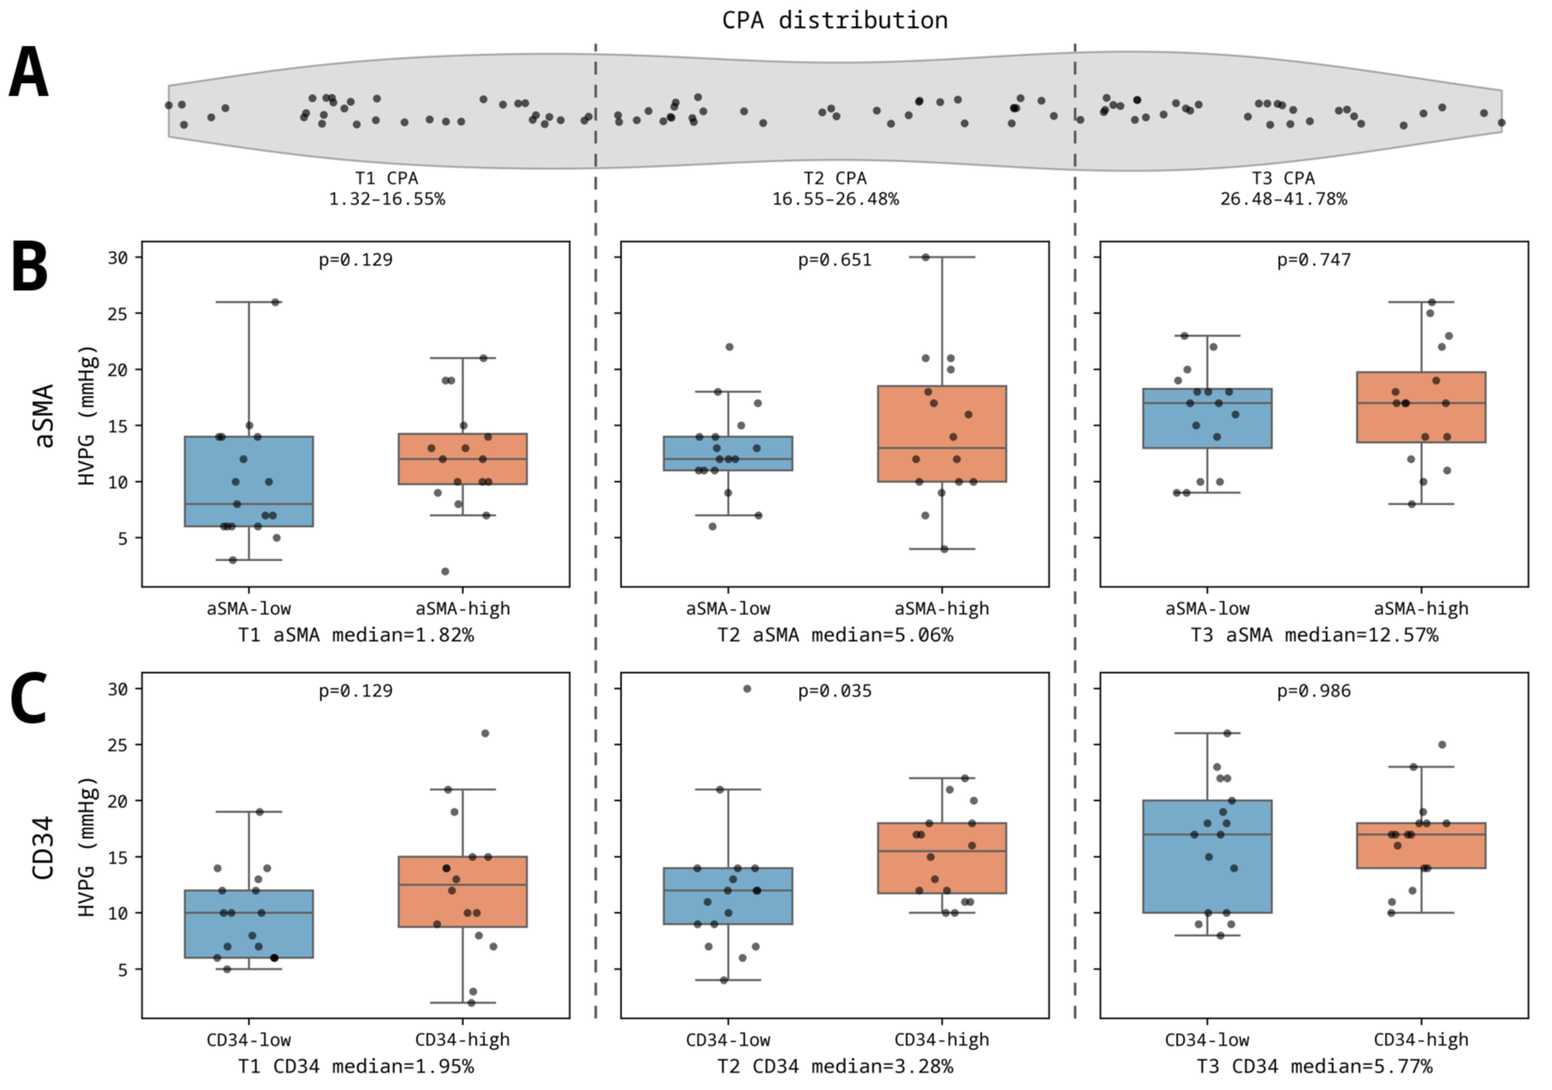
Supplementary Figure 3: Dynamic effects of αSMA and CD34 on HVPG after controlling for fibrosis severity. (A) Representative violinplot of CPA severity strata. The x-axis has been warped for visualization purposes. (B) HVPG values after sub-stratification based on within-tertile median αSMA. Patients in the T1 CPA tertile showed a trend for higher HVPG values if αSMA was higher. (C) HVPG values after sub-stratification based on within-tertile median CD34. Patients in the T1 CPA tertile showed a trend for higher HVPG values if CD34 was higher, in addition to a significant difference in the T2 CPA tertile. Abbreviations: CPA - collagen proportionate area, HVPG – hepatic venous pressure gradient, T – tertile, αSMA - alpha smooth-muscle-actin.

Supplementary Tables

Etiology | n | Histological Biomarker | Spearman's rho | p-value
ALD | 32 | CPA | 0.224 | 0.217
ALD | 32 | CD34 | 0.222 | 0.222
ALD | 32 | αSMA | 0.165 | 0.368
Cholestatic | 14 | CPA | 0.407 | 0.167
Cholestatic | 14 | CD34 | 0.248 | 0.393
Cholestatic | 14 | αSMA | 0.027 | 0.928
MASLD | 28 | CPA | 0.423 | 0.025
MASLD | 28 | CD34 | 0.611 | 0.001
MASLD | 28 | αSMA | 0.465 | 0.014
Viral | 11 | CPA | 0.416 | 0.204
Viral | 11 | CD34 | 0.201 | 0.554
Viral | 11 | αSMA | 0.105 | 0.759
Supplementary Table 1: Subgroup analysis of HVPG correlation to histological biomarkers by etiology. MetALD (n=7) patients were merged with MASLD. Abbreviations: ALD – alcohol-related liver disease, CPA – collagen proportionate area, MASLD – metabolic dysfunction-associated steatotic liver disease, αSMA - alpha smooth-muscle-actin.

Independent Variable | Dependent Variable | Spearman's rho | p-value
CPA | TIMP1 | 0.372 | p<0.001
CPA | P3NP | 0.299 | p=0.003
CPA | HA | 0.341 | p<0.001
αSMA | TIMP1 | 0.322 | p=0.001
αSMA | P3NP | 0.201 | p=0.054
αSMA | HA | 0.202 | p=0.052
CD34 | TIMP1 | 0.404 | p<0.001
CD34 | P3NP | 0.467 | p<0.001
CD34 | HA | 0.508 | p<0.001
Supplementary Table 2: Correlation of histological biomarkers to ELF score components. Abbreviations: HA – hyaluronic acid, P3NP – aminoterminal peptide of type III collagen, TIMP1 – tissue inhibitor of metalloproteinase 1.

