Supplementary

Supplementary Table 1. Real world outcomes stratified by modified ALBI grade
 | Before PS-matching |  |  |  |  | After PS-matching
 | Lenvatinib  (N=132) |  | Sorafenib  (N=163) |  |  | Lenvatinib  (N=117) |  | Sorafenib  (N=117)
 | Event no. | Median [95%CI] | Event no. | Median [95%CI] | p-value | Event no. | Median [95%CI] | Event no. | Median [95%CI] | p-value
Grade 1
rwOS | 13 | NE [7.10, NE] | 16 | NE [10.87, NE] | 0.740 | 11 | NE [7.10, NE] | 14 | NE [7.95, NE] | 0.894
rwTTD | 25 | 4.50 [2.96, 9.66] | 33 | 2.46 [1.91, 3.68] | <0.001 | 21 | 4.50 [3.22, 9.66] | 27 | 2.46 [1.84, 3.91] | 0.001
rwTTNT | 25 | 5.49 [3.25, 10.61] | 33 | 3.71 [2.96, 5.45] | 0.075 | 21 | 5.49 [3.55, 10.63] | 27 | 3.29 [2.80, 5.13] | 0.063
Grade 2a
rwOS | 6 | NE [NE, NE] | 10 | NE [6.41, NE] | 0.063 | 6 | NE [11.01, NE] | 8 | 10.09 [6.41, NE] | 0.105
rwTTD | 18 | 5.55 [4.04, NE] | 22 | 2.23 [1.84, 3.91] | <0.001 | 17 | 5.98 [3.91, NE] | 17 | 2.30 [1.84, 5.52] | 0.002
rwTTNT | 18 | 6.01 [4.17, NE] | 22 | 3.15 [2.43, 4.40] | <0.001 | 17 | 6.01 [4.07, NE] | 17 | 3.27 [2.56, NE] | 0.006
Grade 2b
rwOS | 18 | 10.91 [6.21, NE] | 39 | 4.60 [3.15, 6.01] | 0.005 | 16 | NE [6.21, NE] | 32 | 3.68 [2.83, NE] | 0.005
rwTTD | 29 | 3.75 [2.23, 6.31] | 48 | 1.48 [1.18, 1.97] | <0.001 | 27 | 3.81 [2.17, NE] | 40 | 1.22 [1.15, 1.84] | <0.001
rwTTNT | 29 | 5.72 [3.61, NE] | 48 | 2.99 [2.17, 3.71] | <0.001 | 27 | 4.01 [3.29, NE] | 40 | 2.33 [1.87, 3.45] | <0.001
Grade 3
rwOS | 1 | NE [NE, NE] | 13 | 1.94 [1.58, NE] | 0.130 | 1 | NE [NE, NE] | 6 | 1.71 [1.12, NE] | 0.096
rwTTD | 2 | 8.94 [NE, NE] | 15 | 1.31 [0.59, NE] | 0.006 | 2 | 8.94 [NE, NE] | 6 | 0.82 [0.46, NE] | 0.008
rwTTNT | 2 | 8.97 [NE, NE] | 15 | 1.91 [1.41, NE] | 0.068 | 2 | 8.98 [8.97, NE] | 6 | 1.74 [1.15, NE] | 0.096
The median values were estimated using the Kaplan-Meier method. In cases where the number of events was insufficient or the median was not reached during the study period, the median was not estimable (NE). Abbreviations: PS, propensity score; CI, confidence interval; ALBI, Albumin-Bilirubin; rwOS, Real-world Overall Survival; rwTTD, Real-world Time to Discontinuation; rwTTNT, Real-world Time to Next Treatment.

Supplementary Table 2. Subsequent treatment modalities after discontinuation of second line systemic anti-cancer therapy
 | Lenvatinib  (n=70) | Sorafenib  (n=75)
Systemic anti-cancer therapy | 52 (74.28%) | 60 (80.00)
Sorafenib | 49 (70.00) | 0 (0.00)
Nivolumab | 1 (1.43) | 8 (10.67)
Regorafenib | 1 (1.43) | 46 (61.33)
Doxorubicin | 0 (0.00) | 1 (1.33)
Ipilimumab + nivolumab | 0 (0.00) | 2 (2.67)
Atezolizumab + bevacizumab | 0 (0.00) | 1 (1.33)
Cabozantinib | 0 (0.00) | 1 (1.33)
Lenvatinib | 0 (0.00) | 1(1.33)
Others including clinical trial regimen | 1 (1.43) | 0 (0.00)
Hepatectomy | 0 (0.00) | 0 (0.00)
Liver transplantation | 0 (0.00) | 1 (1.33)
Local ablation therapy | 2 (2.86) | 0 (0.00)
Transarterial therapy | 5 (7.14) | 5 (6.67)
External beam radiation therapy | 11 (15.71) | 9 (12.00)
Note: Values are presented as number of patients (%).

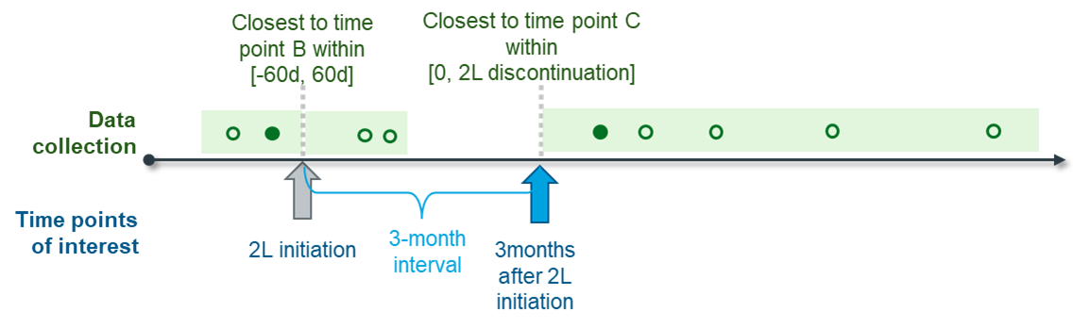
Supplementary Fig. 1. Examples of data collection for PIVKA-II and AFP laboratory values used in the exploratory analysis.

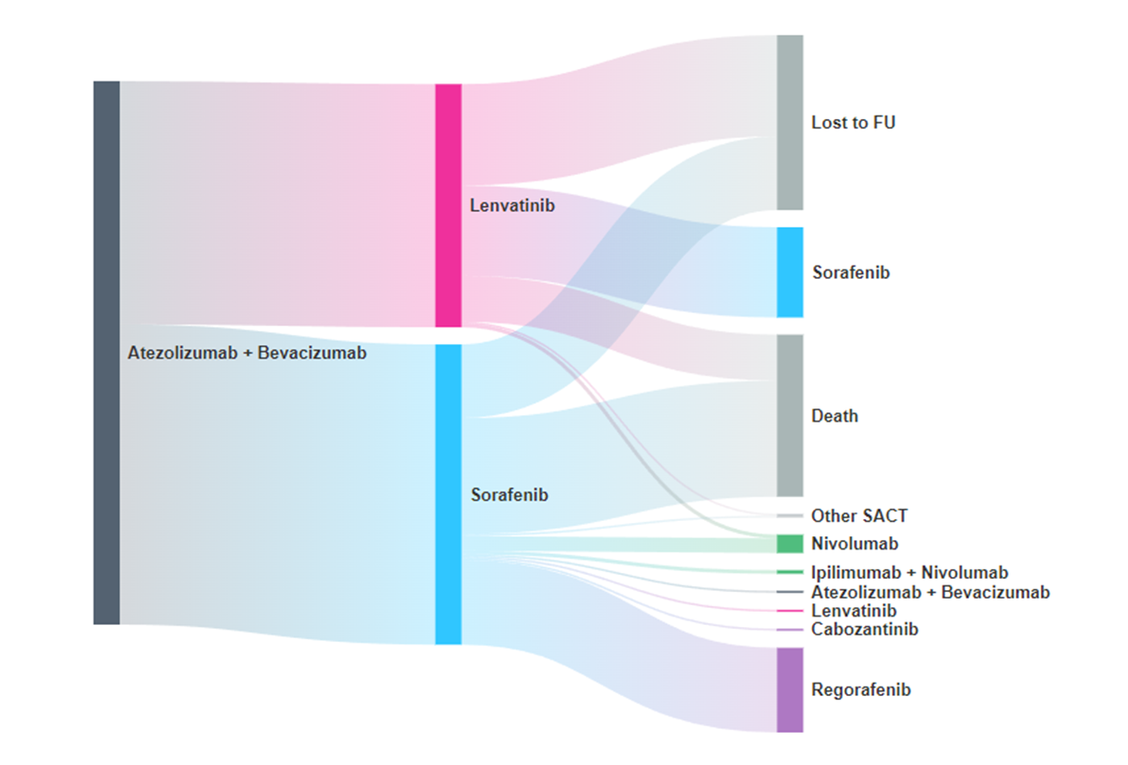
Supplementary Fig. 2. Sankey diagram showing subsequent patient pathways after first-line atezolizumab plus bevacizumab, stratified by second-line treatment with lenvatinib or sorafenib. Flow widths are proportional to the number of patients moving from second-line therapy to third-line systemic anticancer therapy (SACT), lost to follow-up, or death. Among patients who proceeded to third-line SACT, the regimen pattern differed by prior second-line treatment: sorafenib was most frequently used after lenvatinib, whereas regorafenib was predominant after sorafenib. Abbreviations: FU, follow-up; LEN, lenvatinib; SACT, systemic anticancer therapy; SOR, sorafenib.

