Appendix: Details on optimal escapement calculations
Our analysis involves solving for optimal escapements in three scenarios: sole owner, non-cooperative, and BMRA. Here we explain how the optimal escapements were derived.
Case 1: Sole Owner. Our problem is similar to the problem studied in Kaffine and Costello (2011) except that our problem has adult mobility and adult survival. The structure of our problem implies that the sole owner will choose an optimal escapement level for each country, and while those escapements are constant over time, they are different in each country. To derive those optimal escapements, we write the dynamic programming equation for the sole owner, which is:
$V(x_{At},x_{Bt})=\max_{e_{At}{,e}_{Bt}}\left[b_{A}\left(x_{At}-e_{At}\right){+ b}_{B}\left(x_{Bt}-e_{Bt}\right)+δ V(x_{At+1},x_{Bt+1}) \right]$ subject to:
$$x_{At+1}=μ_{A}M_{AA}e_{At}+μ_{B}M_{BA}e_{Bt}{+σ}_{A}(D_{AA}f_{A}{(e}_{At})+D_{BA}f_{B}(e_{Bt}))$$
$$x_{Bt+1} =μ_{B}M_{BB}e_{Bt}+μ_{A}M_{AB}e_{At}{+σ}_{B}{(D}_{BB}f_{B}{(e}_{Bt})+D_{AB}f_{A}(e_{At}))$$
We work backwards from the end of time (at which time the value function equals zero), which reveals that the sole owner will choose time-independent constant escapement levels. We then derive the first order conditions, which are:
$$f_{A}'(e_{At})=\frac{\frac{b_{A}}{δ}-b_{A}μ_{A}M_{AA}-b_{B}μ_{A}M_{AB}}{b_{A}σ_{A}D_{AA}+b_{B}σ_{B}D_{AB}}$$
$$f_{B}'(e_{Bt})=\frac{\frac{b_{B}}{δ}-b_{B}μ_{B}M_{BB}-b_{A}μ_{B}M_{BA}}{b_{B}σ_{B}D_{BB}+b_{A}σ_{A}D_{BA}}$$

Notice that the right hand side of each expression is a constant, which we denote $ϕ_{A}^{*}$ and $ϕ_{B}^{*}$ in the main text. Taking the derivative of the growth equation and solving explicitly for $e_{A}^{*}$ and $e_{B}^{*}$ gives the desired result from the main text.
Case 2: Non-cooperative. Again borrowing from Kaffine and Costello (2011), each country now has its own dynamic programming equation. Because its competitor chooses constant escapement, the stock in the competing country drops out as a state variable (because any extra stock is just harvested down to the constant escapement by the competitor). This simplifies the dynamic program. We follow exactly the same procedure as above, which gives rise to a different optimized value of $f_{A}'(e_{At})$ and $f_{B}'(e_{Bt})$, which we denote by ${\hat{ϕ}}_{A}$and ${\hat{ϕ}}_{B}$ in the main text.
3. BMRA. Under a bilateral marine reserve, country A pays country B to become a marine reserve, so B does not harvest. This immediately breaks the constant escapement property in country B and it turns out that in turn, it breaks the constant escapement property in country A. In this scenario, the value function for B is trivial (because they never harvest), so we only need to calculate the value function and policy function for country A, taking as given that escapement in B is equal to the stock in B in every period. This presents quite a complicated dynamic programming problem for A because optimal escapement depends both on the current stock in A and the current stock in B. We are unaware of an analytical solution to this problem, so we used numerical value function iteration to produce the optimal policy function in A. That function describes the optimal escapement in A for any stock levels in A and B.
We implement the BMRA policy function as follows. For any set of parameters, we conduct the value function iteration to derive the optimal policy function. Then in every period, we calculate the stocks in A and B, and use the policy function to determine optimal escapement in A, recalling that escapement in B is just the stock in B. This procedure allows us to simulate stocks and escapements over time in the BMRA scenario, as reported in the main text.

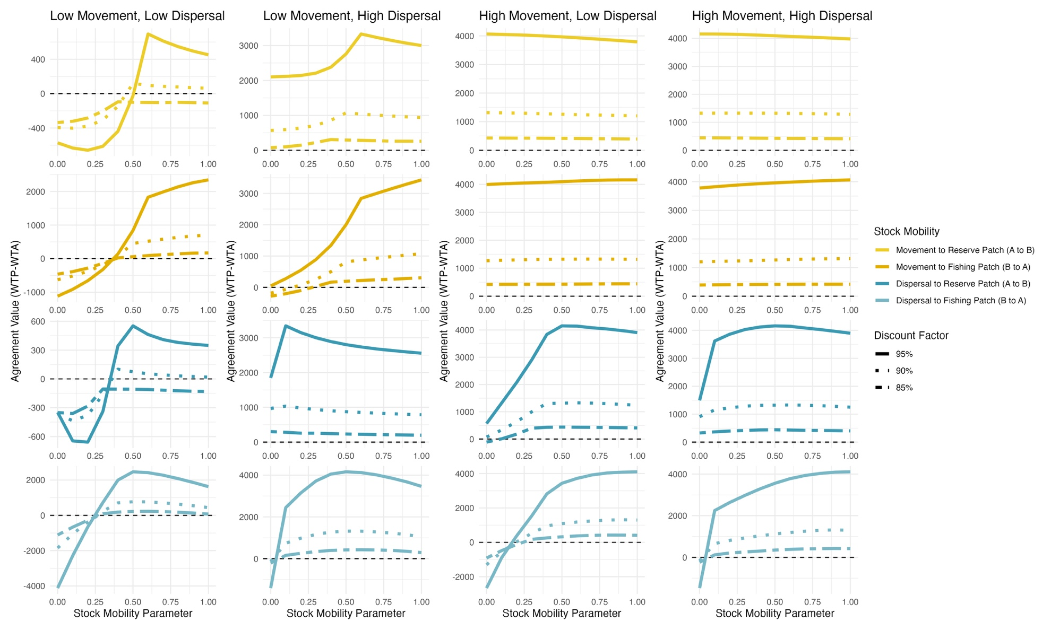
Supplemental Figure 1. Variation in the discount factor $δ$ , and its interaction with spatial movement parameters.

