Xylose metabolization by a Saccharomyces cerevisiae strain isolated in Colombia
Supplementary information

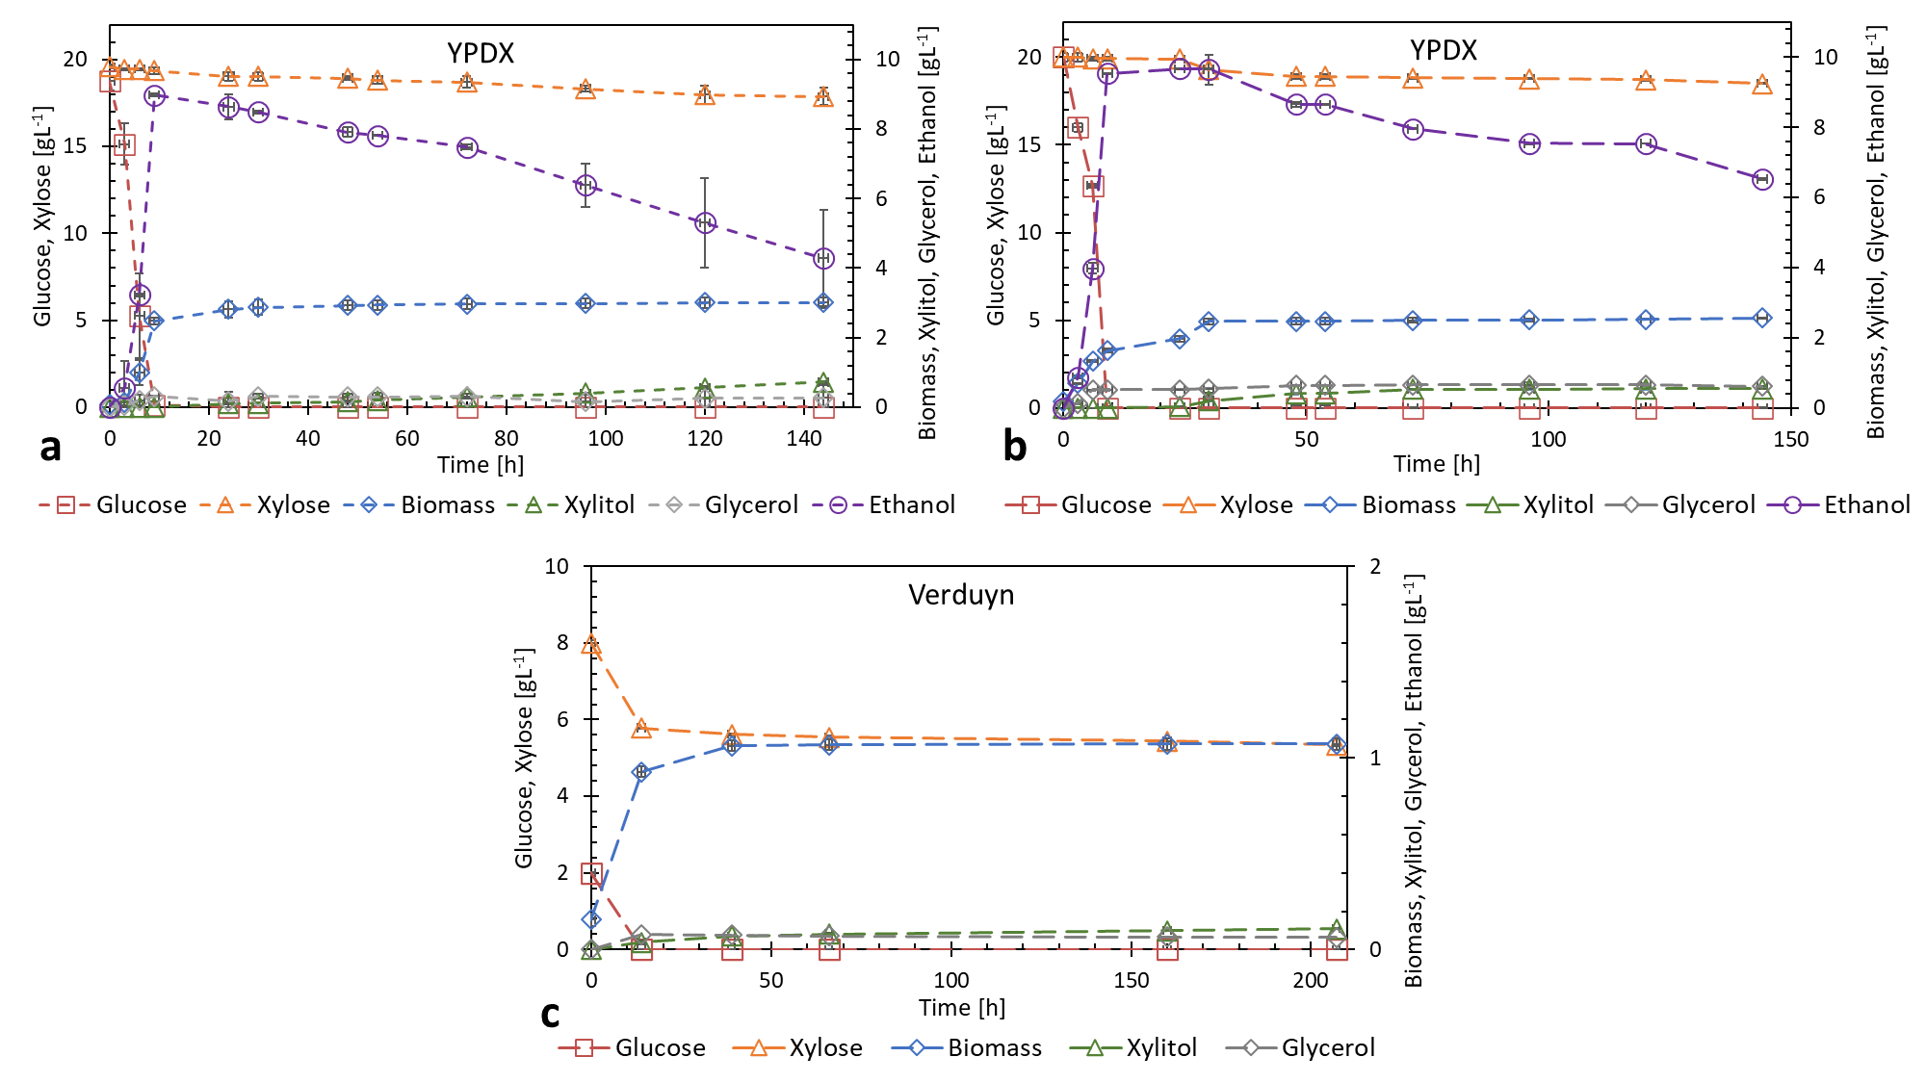
Figure S1. Glucose+xylose consumption by strain 202-3 in YPDX medium 20 gL⁻¹ glucose+20 gL⁻¹ xylose: (a) under microaerobic and (b) anaerobic conditions. (c) Growth in Verduyn medium (2 gL⁻¹ glucose+8 gL⁻¹ xylose).
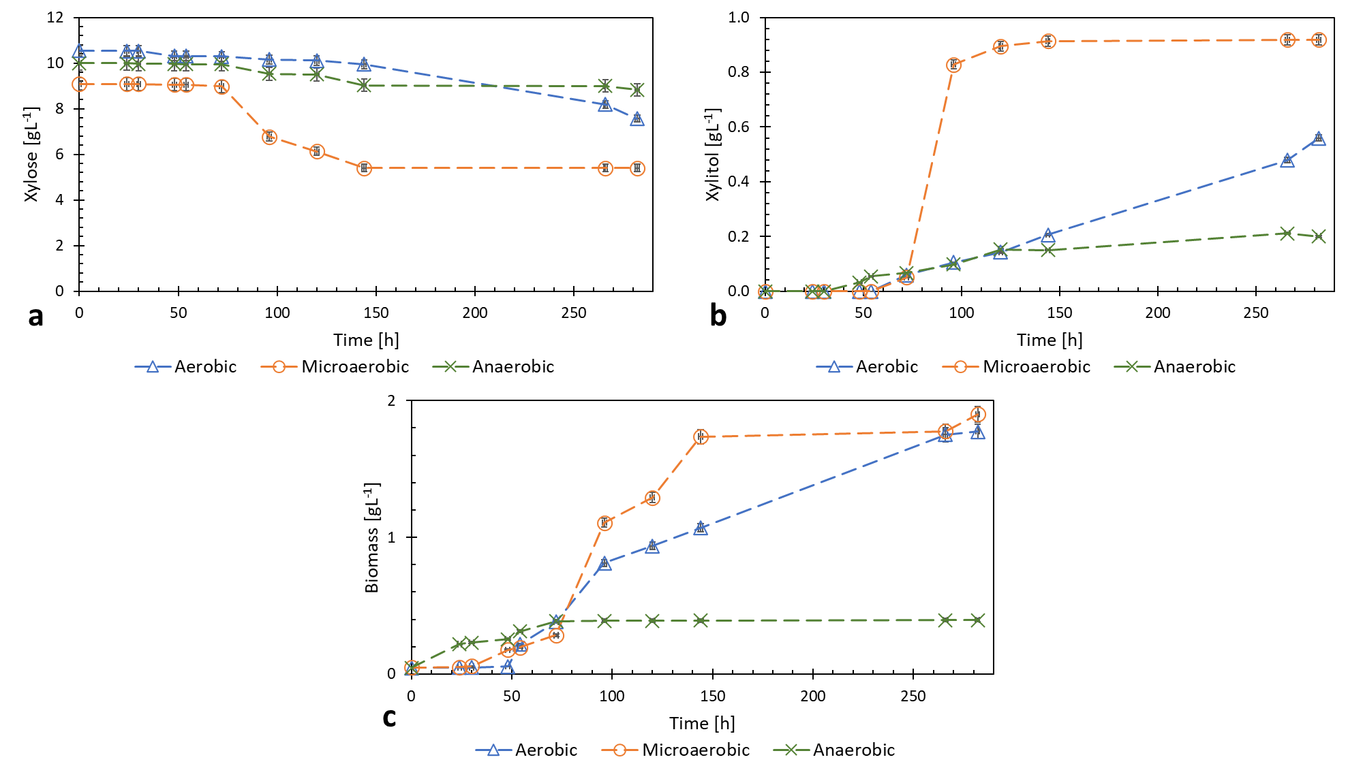
Figure S2. Growth of strain 202-3 in Verduyn medium of 10 gL⁻¹ of xylose, under aerobic, anaerobic and microaerobic conditions: comparison of (a) xylose consumption, (b) xylitol production and (c) biomass production.
Supplementary Table. Reported strains of Saccharomyces cerevisiae with xylose consumption or growth in that pentose.
S. cerevisiae strain | Conditions | Xylose consumption or growth [gL⁻¹] | Xylitol production | Reference
202-3 | Microaerobic conditions  (20 gL⁻¹ xylose) | 1.94 | 0.71 | This study
202-3 | Microaerobic conditions  (30 gL⁻¹ xylose) | 3.91 | 0.47 | This study
202-3 | Microaerobic conditions  (40 gL⁻¹ xylose) | 3.11 | 0.59 | This study
202-3 | Anaerobic conditions  (20 gL⁻¹ xylose) | 1.36 | 0.31 | This study
ATCC 4126 | Fermentative conditions  (50 gL⁻¹ xylose) | 0.59 | 0.16 | Gong et al., 1983 [5]
ATCC 4132 | Fermentative conditions  (50 gL⁻¹ xylose) | 0.36 | 0.08 | Gong et al., 1983 [5]
ATCC 9763 | Fermentative conditions  (50 gL⁻¹ xylose) | 0.42 | 0.10 | Gong et al., 1983 [5]
ATCC 24553 | Fermentative conditions  (50 gL⁻¹ xylose) | 0.44 | 0.13 | Gong et al., 1983 [5]
ATCC 24857 | Fermentative conditions  (50 gL⁻¹ xylose) | 0.68 | 0.26 | Gong et al., 1983 [5]
ATCC 24859 | Fermentative conditions  (50 gL⁻¹ xylose) | 0.66 | 0.42 | Gong et al., 1983 [5]
ATCC 26497 | Fermentative conditions  (50 gL⁻¹ xylose) | 0.66 | 0.26 | Gong et al., 1983 [5]
ATCC 26497 | Aerobic conditions  (50 gL⁻¹ xylose) | 1.63 | 0.34 | Gong et al., 1983 [5]
ATCC 26603 | Aerobic conditions  (50 gL⁻¹ xylose) | 0.52 | 0.09 | Gong et al., 1983 [5]
ATCC 26785 | Fermentative conditions  (50 gL⁻¹ xylose) | 0.64 | 0.29 | Gong et al., 1983 [5]
A364A | Aerobic conditions | Positive growth DO_{600 nm} | Unanalyzed | Batt et al., 1986  [25]
Montrachet | Aerobic conditions | Positive growth DO_{595 nm}* | Unanalyzed | Wenger et al., 2010 [14]
Premier Cuvee | Aerobic conditions | Positive growth DO_{595 nm}* | Unanalyzed | Wenger et al., 2010 [14]
UCD819 | Aerobic conditions | Positive growth DO_{595 nm}* | Unanalyzed | Wenger et al., 2010 [14]
G30 #2 | Aerobic conditions | Positive growth DO_{595 nm}* | Unanalyzed | Wenger et al., 2010 [14]
921 PRF21-2 | Aerobic conditions | Positive growth DO_{595 nm}* | Unanalyzed | Wenger et al., 2010 [14]
SIHA Activ-hefe 4 | Aerobic conditions | Positive growth DO_{595 nm}* | Unanalyzed | Wenger et al., 2010 [14]
Fermichamp | Aerobic conditions | Positive growth DO_{595 nm}* | Unanalyzed | Wenger et al., 2010 [14]
BP725 | Aerobic conditions | Positive growth DO_{595 nm}* | Unanalyzed | Wenger et al., 2010 [14]
Actiflore C (F33) | Aerobic conditions | Positive growth DO_{595 nm}* | Unanalyzed | Wenger et al., 2010 [14]
Lalvin AC | Aerobic conditions | Positive growth DO_{595 nm}* | Unanalyzed | Wenger et al., 2010 [14]
YJM270 | Aerobic conditions | Positive growth DO_{595 nm}* | Unanalyzed | Wenger et al., 2010 [14]
ATCC66283 | Aerobic conditions | Positive growth DO_{595 nm}* | Unanalyzed | Wenger et al., 2010 [14]
BDX | Aerobic conditions | Positive growth DO_{595 nm}* | Unanalyzed | Wenger et al., 2010 [14]
EC1118 | Aerobic conditions | Positive growth DO_{595 nm}* | Unanalyzed | Wenger et al., 2010 [14]
FA1 | Aerobic conditions | Positive growth DO_{595 nm}* | Unanalyzed | Wenger et al., 2010 [14]
French White | Aerobic conditions | Positive growth DO_{595 nm}* | Unanalyzed | Wenger et al., 2010 [14]
Premier Cuvee | Aerobic conditions | Positive growth DO_{595 nm}* | Unanalyzed | Wenger et al., 2010 [14]
Simi White | Aerobic conditions | Positive growth DO_{595 nm}* | Unanalyzed | Wenger et al., 2010 [14]
CS2 | Aerobic conditions | Positive growth DO_{595 nm}* | Unanalyzed | Wenger et al., 2010 [14]
SIHA Activ-hefe 3 | Aerobic conditions | Positive growth DO_{595 nm}* | Unanalyzed | Wenger et al., 2010 [14]
71B | Aerobic conditions | Positive growth DO_{595 nm}* | Unanalyzed | Wenger et al., 2010 [14]
PDM | Aerobic conditions | Positive growth DO_{595 nm}* | Unanalyzed | Wenger et al., 2010 [14]
Primeur | Aerobic conditions | Positive growth DO_{595 nm}* | Unanalyzed | Wenger et al., 2010 [14]
Enoferm M1 | Aerobic conditions | Positive growth DO_{595 nm}* | Unanalyzed | Wenger et al., 2010 [14]
Fermicru LVCB | Aerobic conditions | Positive growth DO_{595 nm}* | Unanalyzed | Wenger et al., 2010 [14]
WE14 | Aerobic conditions | Positive growth DO_{595 nm}* | Unanalyzed | Wenger et al., 2010 [14]
* Positive growth DO_{595 nm} TECAN Genios plate reader with orbital shaking.

