Supplementary Table 1 – Mesh and EMTREE terms
MEDLINE-PubMed

Line | Parameter | Terms | No hits
1 | Population | ("Adult"[Mesh]) AND "Carcinoma, Non-Small-Cell Lung"[Mesh] | 33.153
2 | Intervention | "High-Throughput Nucleotide Sequencing"[Mesh] OR “NGS” OR Next-generation sequencing | 102.120
3 | Outcome | (sensitiv*[Title/Abstract] OR sensitivity and specificity[MeSH Terms] OR diagnose[Title/Abstract] OR diagnosed[Title/Abstract] OR diagnoses[Title/Abstract] OR diagnosing[Title/Abstract] OR diagnosis[Title/Abstract] OR diagnostic[Title/Abstract] OR diagnosis[MeSH:noexp] OR (diagnostic equipment[MeSH:noexp] OR diagnostic errors[MeSH:noexp] OR diagnostic imaging[MeSH:noexp] OR diagnostic services[MeSH:noexp]) OR diagnosis, differential[MeSH:noexp] OR diagnosis[Subheading:noexp]) | 6.491.527

EMBASE

Line | Parameter | Terms | No hits
1 | Population | ('non small cell lung cancer'/exp OR 'bronchial non small cell cancer' OR 'bronchial non small cell carcinoma' OR 'carcinoma, non-small-cell lung' OR 'lung cancer, non small cell' OR 'lung non small cell cancer' OR 'lung non small cell carcinoma' OR 'non oat cell lung cancer' OR 'non small cell bronchial cancer' OR 'non small cell cancer, lung' OR 'non small cell lung cancer' OR 'non small cell lung carcinoma' OR 'non small cell pulmonary cancer' OR 'non small cell pulmonary carcinoma' OR 'non squamous nsclc' OR 'non-oat cell lung cancer' OR 'non-small-cell lung carcinoma' OR 'nonsmall cell carcinoma of the lung' OR 'nonsmall cell lung cancer' OR 'nonsmall cell lung carcinoma' OR 'pulmonary non small cell cancer' OR 'pulmonary non small cell carcinoma') | 226.450
3 | Intervention | ('high throughput sequencing'/exp OR 'ngs analysis (next generation sequence analysis)' OR 'high through-put nucleotide sequencing' OR 'high through-put sequence analysis' OR 'high through-put sequencing' OR 'high throughput nucleotide sequence analysis' OR 'high throughput nucleotide sequencing' OR 'high throughput sequence analysis' OR 'high throughput sequencing' OR 'high-throughput nucleotide sequencing' OR 'next generation sequence analysis' OR 'next generation sequencing' OR 'next generation sequencing technology' OR 'next-gen sequence analysis' OR 'next-gen sequencing') | 193.706
5 | Outcome | ('diagnostic procedure'/de OR diagnosis/de OR 'diagnostic accuracy'/de) | 1.834.813

Supplementary Table 2 – Actionable mutations included
Gene | Mutation
EGFR | Exon 19 deletion
EGFR | L858R exon 21
EGFR | T790M exon 20
EGFR | G719X exon 18
EGFR | L861Q exon 21
EGFR | S768I exon 20
EGFR | Exon 20 insertions
ALK | Rearrangements
ROS1 | Rearrangements
NTRK | Rearrangements
RET | Rearrangements
MET | Exon 14 skipping mutation
MET | Focal amplifications
BRAF | V600E Mutation
KRAS | G12C Mutation
HER2/ERBB2 | Exon 20 alterations

Anaplastic Lymphoma Kinase (ALK), B-Raf Proto-Oncogene (BRAF), Epidermal Growth Factor Receptor (EGFR), Human Epidermal Growth Factor Receptor 2 (HER2/ERBB2), Kirsten Rat Sarcoma Viral Oncogene Homolog (KRAS), MET Proto-Oncogene (MET), Neurotrophic Tyrosine Receptor Kinase (NTRK), Ret Proto-Oncogene (RET), C-Ros Proto-Oncogene 1 (ROS1).

Supplementary Table 3 – Clinical characteristics
Type of study | (n) | (%)
Prospective | 44 | 78.57%
Retrospective | 10 | 17.86%
Prospective and retrospective | 2 | 3.57%
Patients
Total population | 7143 | 100%
Men | 3712 | 51.97%
Women | 3104 | 43.46%
Smoking status
No smokers | 1767 | 24.74%
Smokers | 3449 | 48.29%
No record | 172 | 2.41%
Clinical Stage
Stage III | 668 | 9.35%
Stage IV | 4694 | 65.71%
No record | 37 | 0.52%
Histological Characteristics
Adenocarcinoma | 5373 | 75.22%
Squamous cell carcinoma | 542 | 7.59%
Other | 358 | 5.01%
No record | 22 | 0.31%

Characteristics of patients with advanced NSCLC for whom data were available.

Supplementary Table 4 - Performance of NGS in liquid biopsy Compared to SOC + NGS in Tissue
Gene | Eval. | Sen. (%) | CI - 95% | Spe. (%) |  | CI - 95%
KRAS G12C | NGS TT  NGS LB | 87% | 68-95% | 100% |  | 97-100%
EGFR | PCR TT  NGS LB | 86% | 79-91% | 97% |  | 84-99%
BRAF V600E | NGS TT  NGS LB | 78% | 53-91% | 100% |  | 99-100%
EGFR | NGS TT  NGS LB | 76% | 70-81% | 97% |  | 93-99%
ALK | IHC + FISH  NGS LB | 76% | 50% - 90% |  | 100% |  | 100%
ALK | NGS TT  NGS LB | 66% | 52-78% |  | 100% |  | 99-100%
MET | NGS TT  NGS LB | 57% | 42-70% |  | 100% |  | 98-100%
ROS1 | NGS TT  NGS LB | 30% | 12-56% |  | 100% |  | 98-100%

Anaplastic Lymphoma Kinase (ALK), B-Raf Proto-Oncogene, V600E mutation (BRAF V600E), Confidence Interval (CI), Epidermal Growth Factor Receptor (EGFR), Evaluation (Eval), Fluorescence In Situ Hybridization (FISH), Immunohistochemistry (IHC), Kirsten Rat Sarcoma Viral Oncogene Homolog, G12C mutation (KRAS G12C), Liquid biopsy (LB), MET Proto-Oncogene (MET), Next-Generation Sequencing (NGS), Polymerase Chain Reaction (PCR), C-Ros Proto-Oncogene 1 (ROS1), Sensitivity (Sen), Specificity (Spe), Standard of Care (SOC), Tumor Tissue (TT).

Supplementary Table 5 – Risk of Bias Assessment
Risk of bias
Id |  | PATIENT SELECTION | INDEX TEST | REFERENCE STANDARD | FLOW AND TIMING
1 | Leest_2023 | Low | Unclear | Low | Low
4 | Murakami_2022 | Low | Low | Low | High
5 | Sugimoto_2023 | Low | Low | Low | Low
7 | Cui_2022 | Low | Low | Unclear | Low
9 | Palmero_2021 | Low | Unclear | Unclear | Low
13 | Sepúlveda-Hermosilla_2021 | Low | Unclear | Unclear | High
14 | Zhang_2021 | High | Unclear | Unclear | Low
23 | Tran_2019 | Unclear | Unclear | Low | Low
29 | Dono_2019 | Unclear | Unclear | Unclear | Low
30 | Lin_2019 | Low | Unclear | Low | High
31 | Li_2019 | Low | Low | Low | Low
39 | Malapelle_2017 | Unclear | High | Low | Low
40 | Lambros_2017 | Low | High | Low | Low
48 | Mehta_2020 | Low | Low | Low | Low
50 | Sabari_2019 | Low | High | Low | High
58 | Tachon_2019 | Low | Low | Low | Low
62 | Lettig_2019 | Low | High | Low | Unclear
65 | Francaviglia_2019 | Unclear | Low | Low | High
70 | Müller_2017 | Low | Unclear | Unclear | High
91 | Reckamp_2016 | Low | Low | Low | Low
93 | Paweletz_2016 | Unclear | Low | Low | High
96 | Papadopoulou_2019 | Unclear | Unclear | Low | Unclear
97 | Rachiglio_2016 | Unclear | Unclear | Unclear | Low
98 | Wang_2016 | Unclear | High | Low | Low
102 | Couraud_2014 | Low | Unclear | Low | Low
104 | Leighl_2019 | Low | Unclear | Unclear | High
105 | Remon_2019 | Low | Low | Low | Low
106 | Pritchett_2019 | Low | Low | Low | Low
108 | Mehta_2021 | Low | Low | Low | Low
111 | Lam_2021 | Unclear | Low | Low | Unclear
112 | Bauml_2022 | Low | Low | Low | Low
113 | Cui_2017 | Low | Unclear | Unclear | Unclear
114 | Veldore_2018 | Unclear | Unclear | Unclear | Low
115 | Park_2021 | Unclear | Unclear | Unclear | Low
116 | Schwaederlé_2017 | Unclear | Unclear | Unclear | Low
117 | Xu_2016 | Unclear | Unclear | Unclear | Low
124 | Wang_2020 | Low | Low | Low | Low
127 | Jatkoe_2022 | Low | Low | Unclear | Unclear
130 | Prabhash_2022 | Low | Low | Unclear | Low
131 | Williamson_2022 | Unclear | Unclear | Unclear | Low
133 | McKeage_2020 | Low | High | Low | Unclear
137 | Iwama_2018 | Low | Unclear | Unclear | High
139 | De Luca_2018 | Low | Unclear | Unclear | Unclear
140 | Liu_2018 | Low | Low | Low | Unclear
147 | De Biase_2013 | Low | Unclear | Unclear | Unclear
161 | Mondelo-Macía_2023 | Unclear | Unclear | Unclear | High
163 | Sim_2018 | Unclear | Low | Low | Unclear
169 | Yao_2017 | Unclear | Low | Unclear | Low
172 | Fernandes_2021 | Low | Unclear | Unclear | Low
190 | Jiao_2021 | Low | Low | Low | Low
192 | Toor_2018 | Low | Unclear | Unclear | High
193 | Yang_2018 | Unclear | Unclear | Unclear | Low
194 | Jin_2018 | Unclear | Unclear | Unclear | Unclear
195 | Guo_2016 | Unclear | Low | Low | Low
201 | Horn_2019 | Unclear | Unclear | Low | High
174 | Chow_2022 | High | High | Low | High

Supplementary Table 6 – Applicability Assessment
Applicability
Id |  | PATIENT SELECTION | INDEX TEST | REFERENCE STANDARD
1 | Leest_2023 | Low | Low | Low
4 | Murakami_2022 | Low | Low | Low
5 | Sugimoto_2023 | Low | Low | Low
7 | Cui_2022 | Low | Low | Low
9 | Palmero_2021 | Low | Low | Low
13 | Sepúlveda-Hermosilla_2021 | Low | Low | Low
14 | Zhang_2021 | Low | Low | Low
23 | Tran_2019 | Low | Low | Low
29 | Dono_2019 | Low | Low | Low
30 | Lin_2019 | Low | Low | Low
31 | Li_2019 | Low | Low | Low
39 | Malapelle_2017 | Low | Low | Low
40 | Lambros_2017 | Low | Low | Low
48 | Mehta_2020 | Low | Low | Low
50 | Sabari_2019 | Low | Low | Low
58 | Tachon_2019 | Low | Low | Low
62 | Lettig_2019 | Low | Low | Low
65 | Francaviglia_2019 | Low | Low | Low
70 | Müller_2017 | Low | Low | Low
91 | Reckamp_2016 | Low | Low | Low
93 | Paweletz_2016 | Low | Low | Low
96 | Papadopoulou_2019 | Low | Low | Low
97 | Rachiglio_2016 | Low | Low | Low
98 | Wang_2016 | Low | Low | Low
102 | Couraud_2014 | Low | Low | Low
104 | Leighl_2019 | Low | Low | Low
105 | Remon_2019 | Low | Low | Low
106 | Pritchett_2019 | Low | Low | Low
108 | Mehta_2021 | Low | Low | Low
111 | Lam_2021 | Low | Low | Low
112 | Bauml_2022 | Low | Low | Low
113 | Cui_2017 | Low | Low | Low
114 | Veldore_2018 | Low | Low | Low
115 | Park_2021 | Low | Low | Low
116 | Schwaederlé_2017 | Low | Low | Low
117 | Xu_2016 | Low | Low | Low
124 | Wang_2020 | Low | Low | Low
127 | Jatkoe_2022 | Low | Low | Low
130 | Prabhash_2022 | Low | Low | Low
131 | Williamson_2022 | Low | Low | Low
133 | McKeage_2020 | Low | Low | Low
137 | Iwama_2018 | Low | Low | Low
139 | De Luca_2018 | Low | Low | Low
140 | Liu_2018 | Low | Low | Low
147 | De Biase_2013 | Low | Low | Low
161 | Mondelo-Macía_2023 | Low | Low | Low
163 | Sim_2018 | Low | Low | Low
169 | Yao_2017 | Low | Low | Low
172 | Fernandes_2021 | Low | Low | Low
190 | Jiao_2021 | Low | Low | Low
192 | Toor_2018 | Low | Low | Low
193 | Yang_2018 | Low | Low | Low
194 | Jin_2018 | Low | Low | Low
195 | Guo_2016 | Low | Low | Low
201 | Horn_2019 | Low | Low | Low
174 | Chow_2022 | Low | Low | Low

Supplementary Figure 1 – Comparison of Valid Results Between Non-NGS and NGS Tests in Tissue Samples

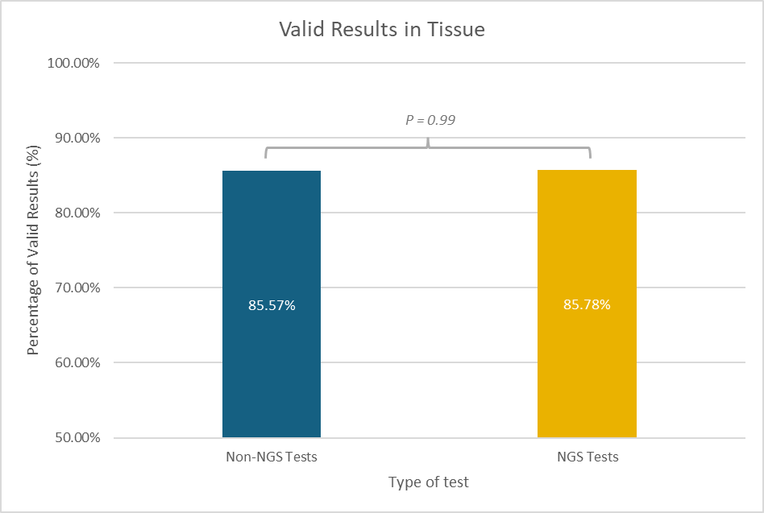
The number of valid results for standard tests in tissue averaged 85.57% (95% CI 59.54–111.60%). For NGS in tissue, the average was 85.78% (95% CI: 62.96–108.60%). No statistically significant difference was found between both methods (p = 0.99).
Supplementary Figure 2 – Comparison of Valid Results Between tissue and NGS liquid biopsy

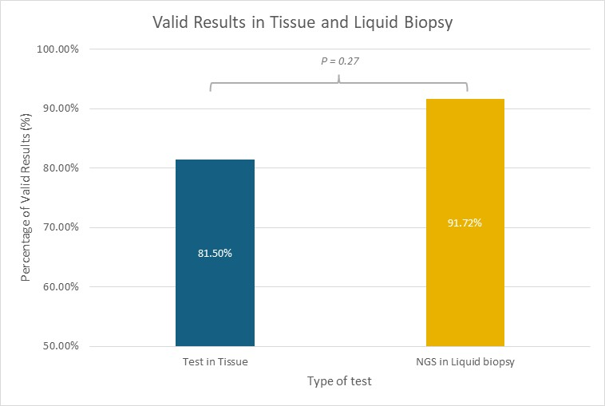
In tissue-based tests, including standard methods and NGS, the percentage of valid results averaged 81.5% (95% CI 65.27–97.73%). For NGS in liquid biopsy, the percentage was 91.72% (95% CI 81.70–101.75%). No statistically significant difference was found between both methods (p = 0.277).

Supplementary Figure 3 – Turnaround Between Tests Performed in Tissue Compared to NGS in Liquid Biopsy
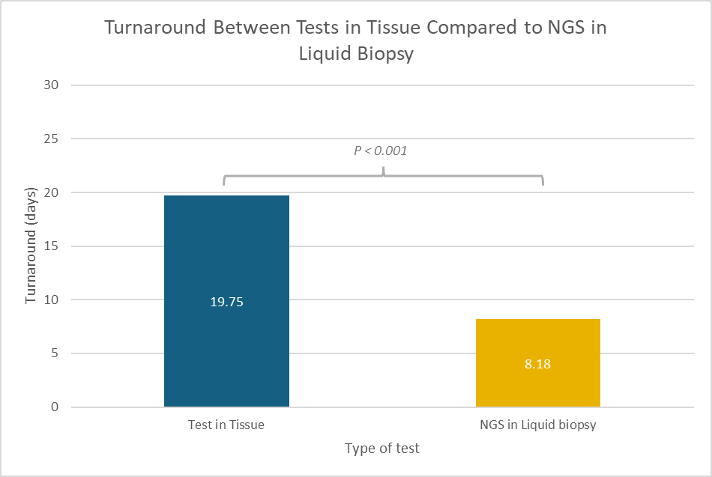
The turnaround time for tests performed in tissue averaged 19.75 days (95% CI 14.49–25 days). In liquid biopsy, the weighted average turnaround time was 8.18 days (95% CI 6.19–10.17 days). The mean difference between both methods was -11.57 days (95% CI -15.41 to -7.73 days), indicating that liquid biopsy provides significantly faster results than tissue testing (p < 0.001).

Supplementary Figure 4 – Comparison Between PCR in Tissue and NGS in Tissue for Detection of Mutations in EGFR
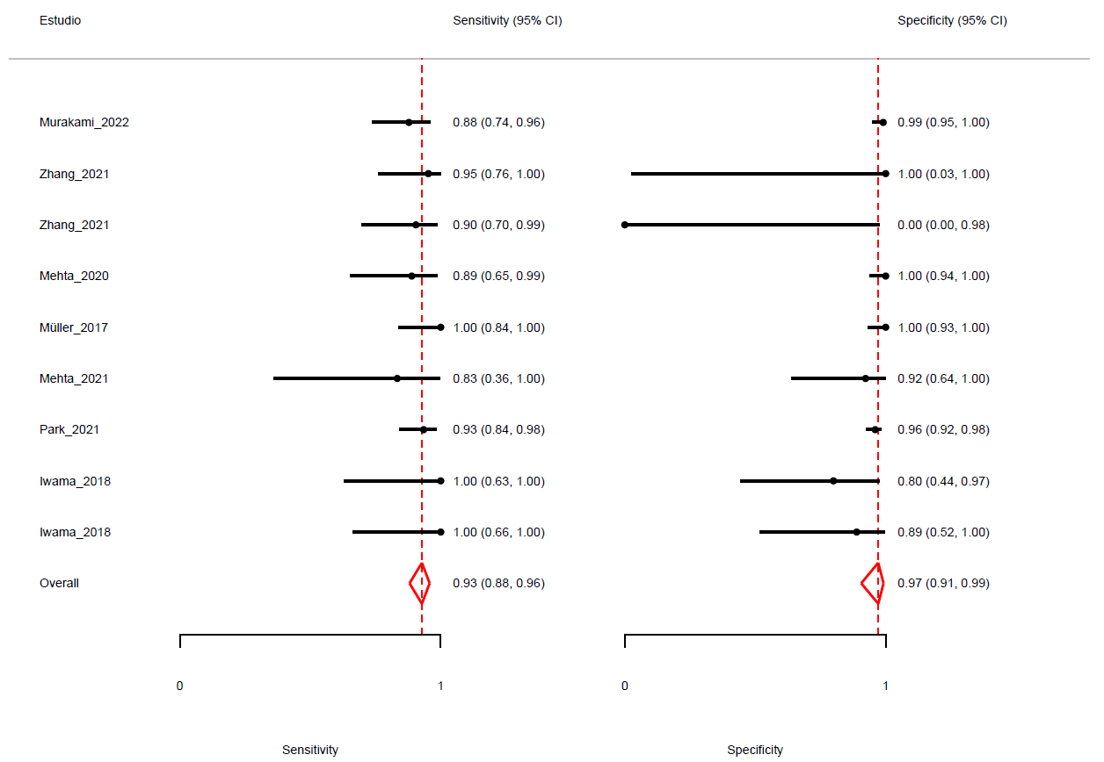
Epidermal Growth Factor Receptor (EGFR), Next-Generation Sequencing (NGS), Polymerase Chain Reaction (PCR).
Supplementary Figure 5 – Comparison Between PCR in Tissue and NGS in Tissue for Detection of rearrangements in ALK

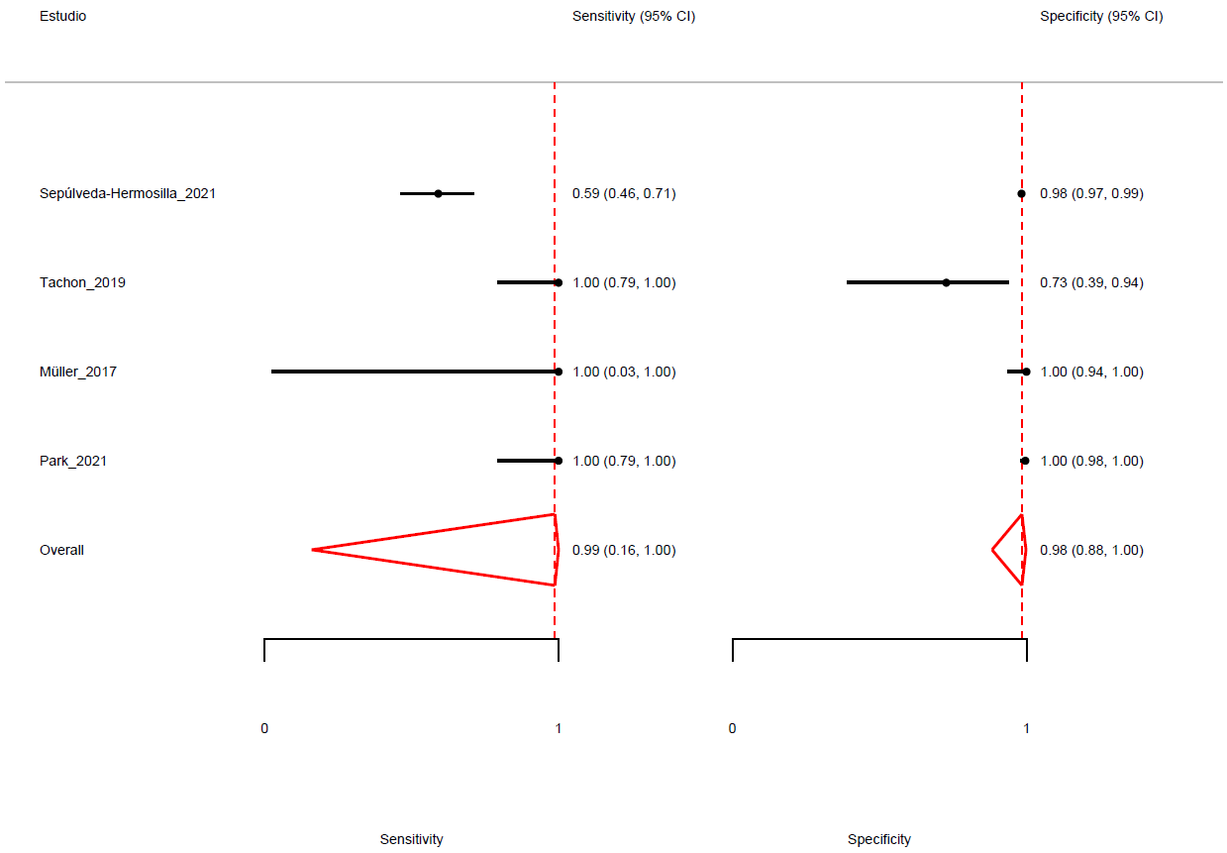
Anaplastic Lymphoma Kinase (ALK), Next-Generation Sequencing (NGS), Polymerase Chain Reaction (PCR).
Supplementary Figure 6 – Performance of NGS in Liquid Biopsy for Detecting alteration of EGFR, mutation KRASG12C, BRAFV600E and alterations of HER2
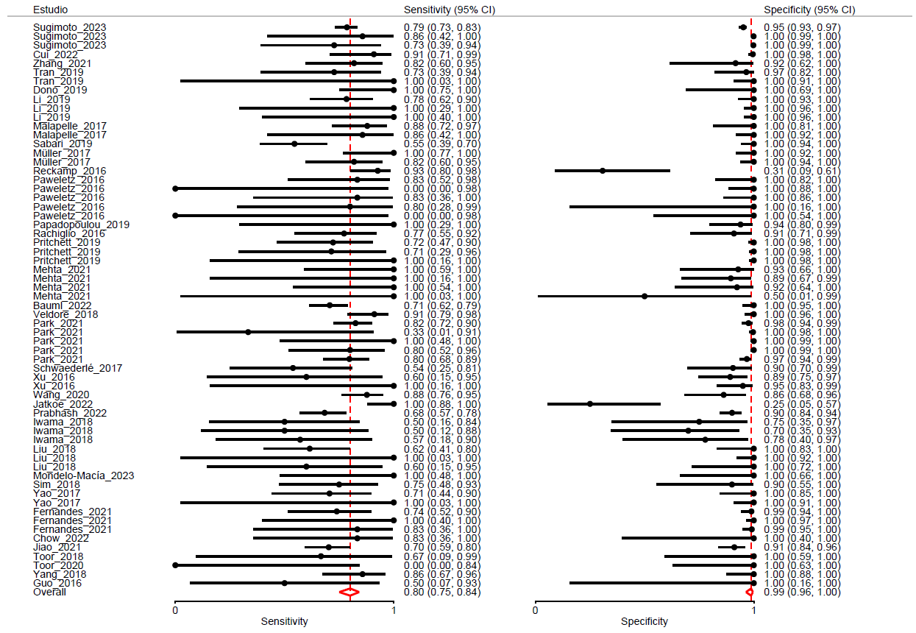
The forest plot displays the comparisons that evaluated the diagnostic performance of detecting mutations in EGFR, BRAF V600E, KRAS G12C, and HER2 exon 20 mutations. V600E mutation (BRAF V600E), Epidermal Growth Factor Receptor (EGFR), Human Epidermal Growth Factor Receptor 2 (HER2/ERBB2), Kirsten Rat Sarcoma Viral Oncogene Homolog, G12C mutation (KRAS).

Supplementary Figure 7 – Performance of NGS in Liquid Biopsy for Detecting Rearrangements of ALK, ROS1, RET and NTRK
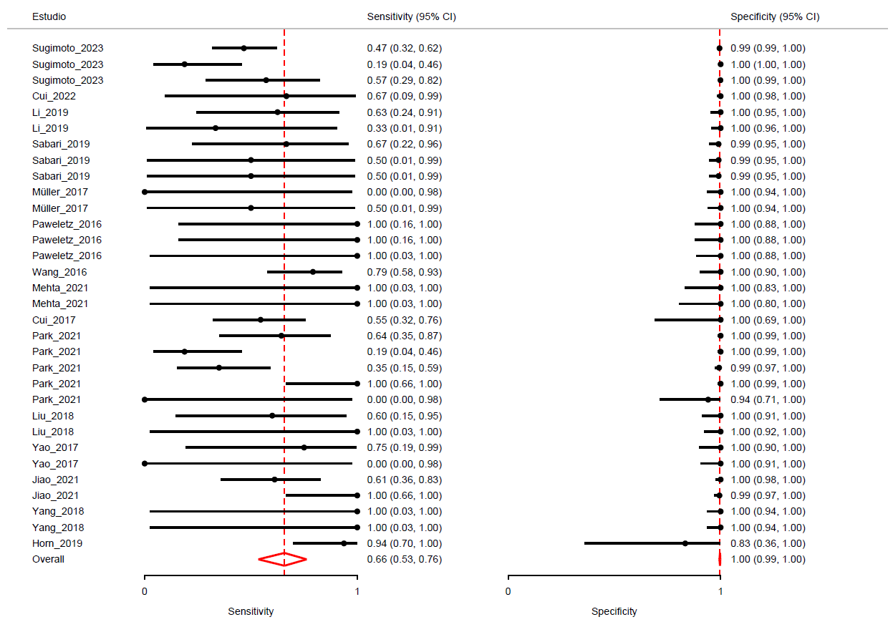
The forest plot shows the comparisons that evaluated the diagnostic performance of detecting rearrangements in ALK, ROS1, RET, and NTRK. Anaplastic Lymphoma Kinase (ALK), B-Raf Proto-Oncogene, Neurotrophic Tyrosine Receptor Kinase (NTRK), Ret Proto-Oncogene (RET), C-Ros Proto-Oncogene 1 (ROS1).
Supplementary Figure 8 – Comparison between SOC + NGS in tissue and NGS in liquid biopsy for detecting rearrangements in ALK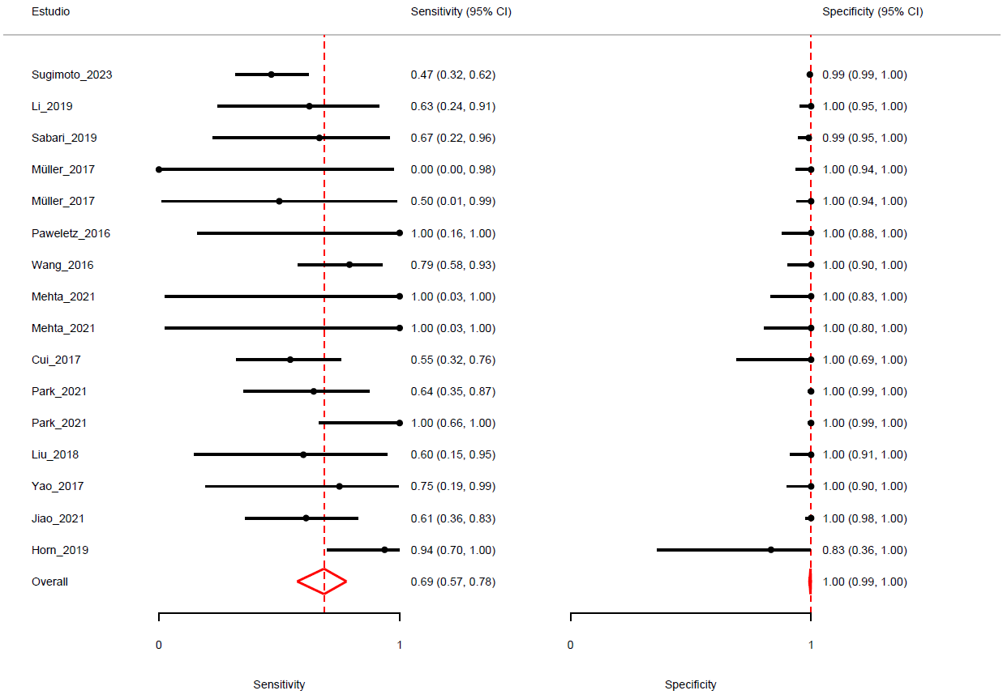
Anaplastic Lymphoma Kinase (ALK), Next-Generation Sequencing (NGS), Standard of Care (SOC).

Supplementary Figure 9 – Comparison between SOC + NGS in tissue and NGS in liquid biopsy for detecting BRAF V600E mutation
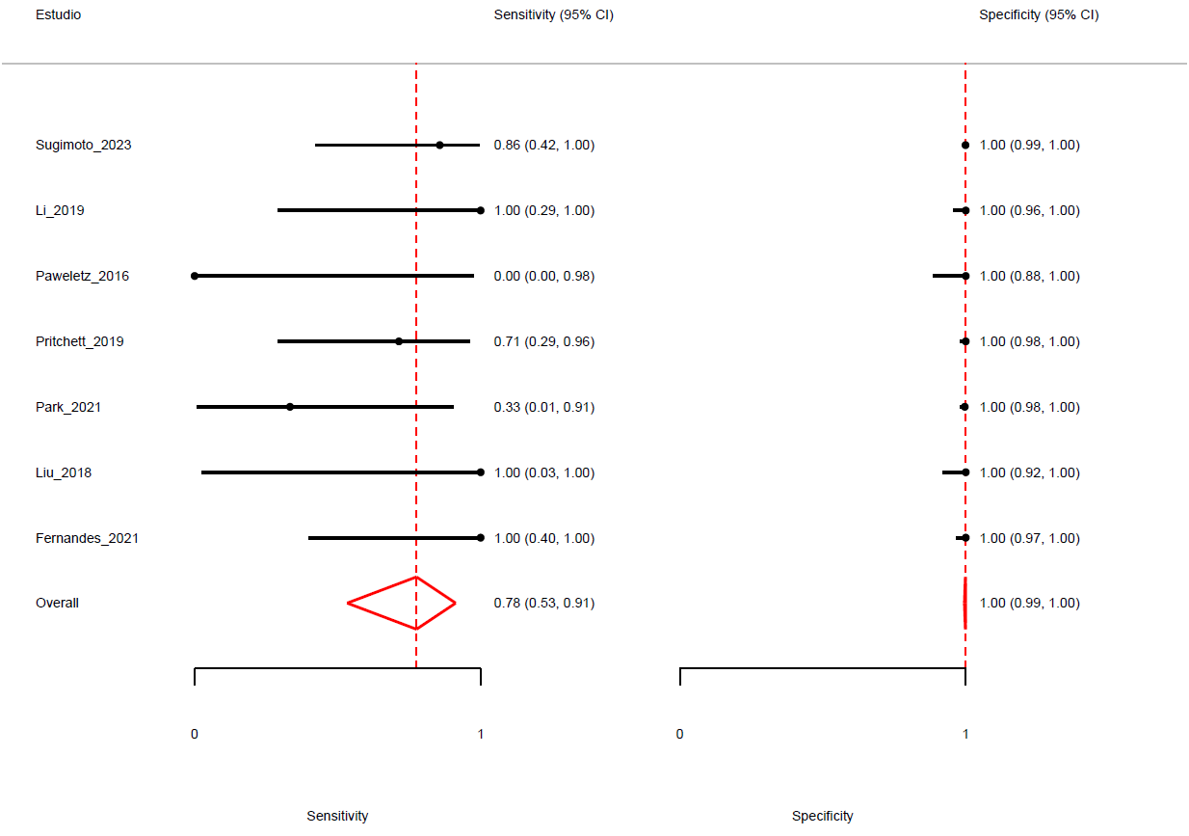
B-Raf Proto-Oncogene, V600E mutation (BRAF V600E), Next-Generation Sequencing (NGS), Standard of Care (SOC).
Supplementary Figure 10 – Comparison between SOC + NGS in tissue and NGS in liquid biopsy for detecting EGFR mutations
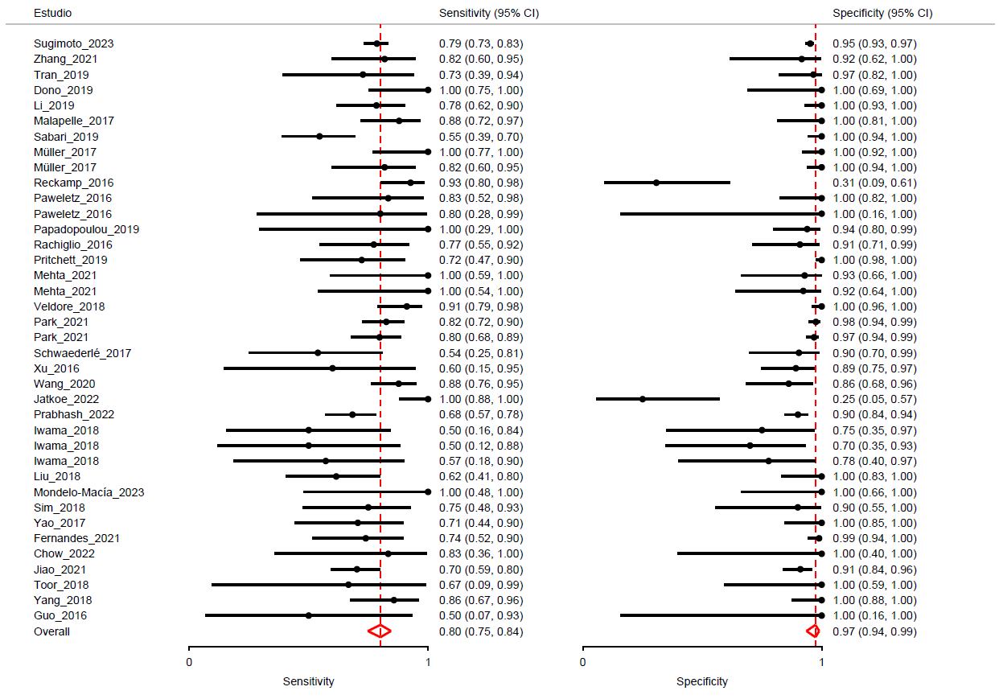
Epidermal Growth Factor Receptor (EGFR), Next-Generation Sequencing (NGS), Standard of Care (SOC).

Supplementary Figure 11 – Comparison between SOC + NGS in tissue and NGS in liquid biopsy for detecting KRAS G12C mutation
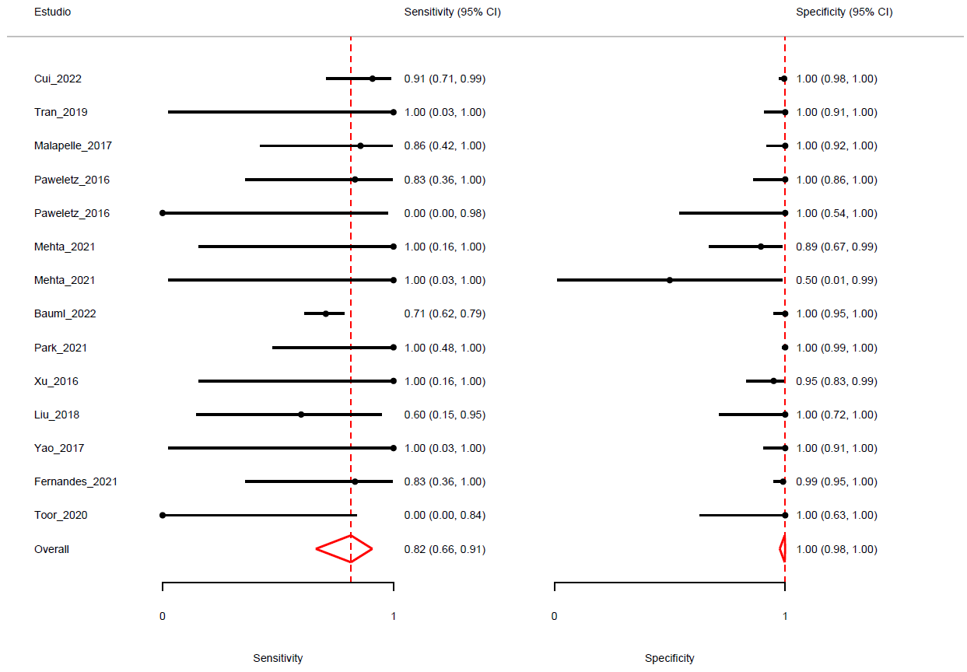
Kirsten Rat Sarcoma Viral Oncogene Homolog G12C mutation (KRAS G12C), Next-Generation Sequencing (NGS), Standard of Care (SOC).

Supplementary Figure 12 – Comparison between SOC + NGS in tissue and tissue NGS for detecting MET alterations
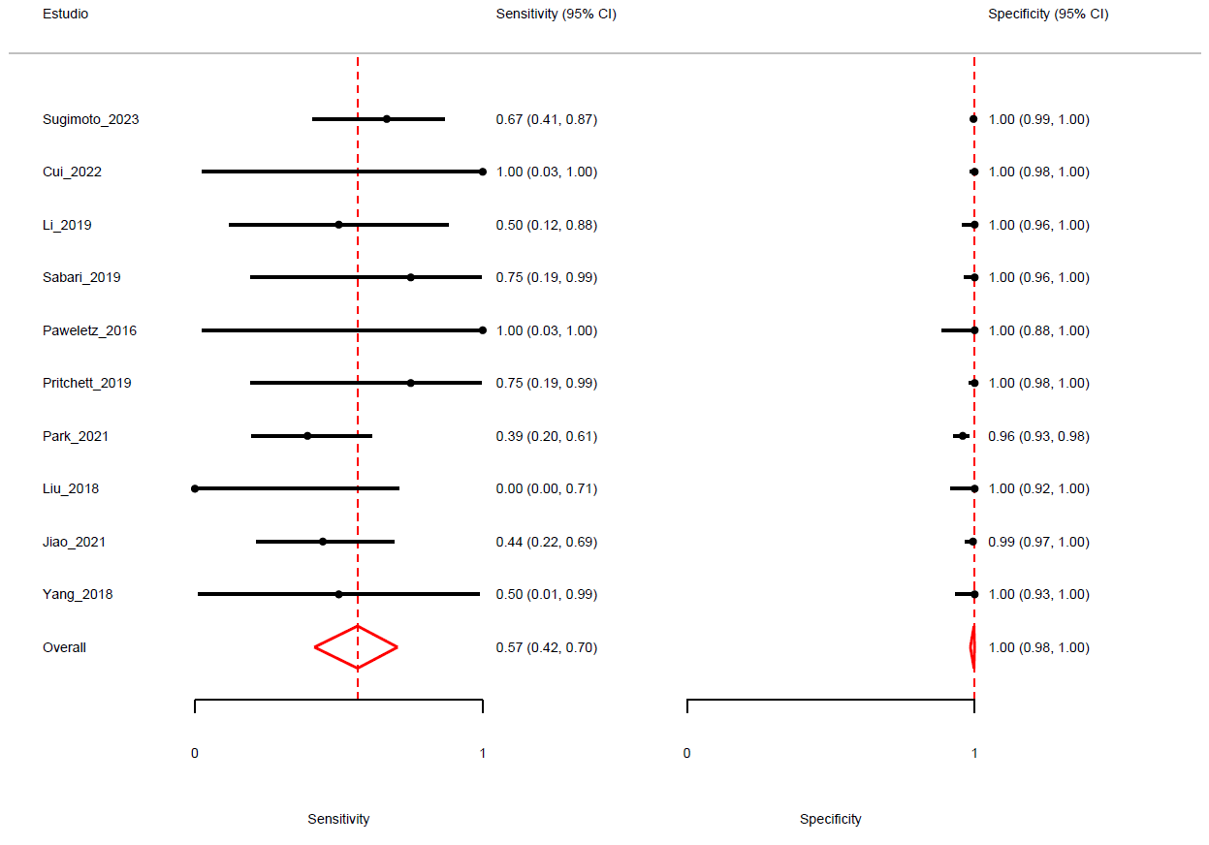
MET Proto-Oncogene (MET), Next-Generation Sequencing (NGS), Standard of Care (SOC).

Supplementary Figure 13 – Comparison between SOC + NGS in tissue and NGS in tissue for the detection of RET rearrangements
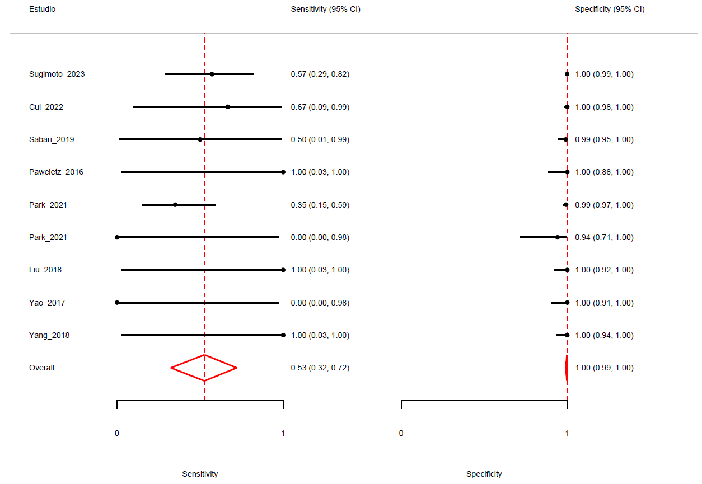
Next-Generation Sequencing (NGS), Ret Proto-Oncogene (RET), Standard of Care (SOC).
Supplementary Figure 14 – Comparison between SOC + NGS in tissue and tissue NGS for the detection of ROS1 rearrangements
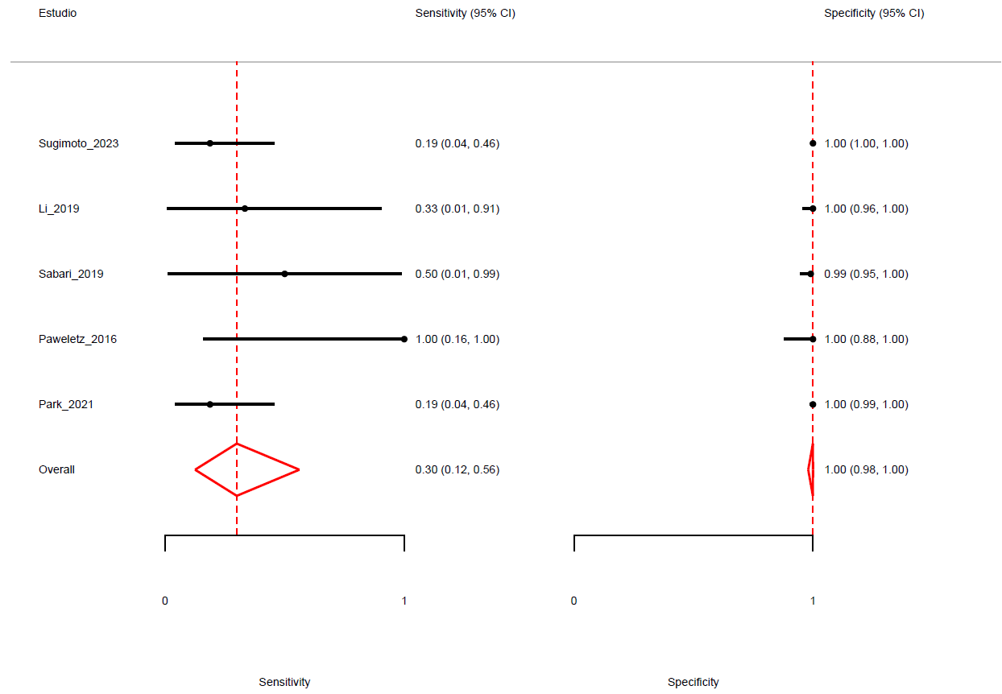
Next-Generation Sequencing (NGS), Standard of Care (SOC), Ret Proto-Oncogene (RET).

