Supplementary Tabler 1. Basic characteristics of the TCGA cohort

Clinical data |  | TCGA GDC BLCA, n(%)
Cases |  | 403
Median age |  | 68.5 (range 34-89)
Sex | Female | 106 (26.3%)
Sex | Male | 297 (73.7%)
Race | White | 330 (79.4%)
Race | Black or African-American | 23 (5.7%)
Race | Asian | 43 (10.7%)
Clinical stage | I | 9 (2.3%)
Clinical stage | II | 111 (27.3%)
Clinical stage | III | 30 (7.4%)
Clinical stage | IV | 11 (2.7%)
Tumor stage | T2 | 118 (29.3%)
Tumor stage | T3 | 194 (48.1%)
Tumor stage | T4 | 57 (14.1%)
Lymph nodes invasion | N0 | 235 (58.3%)
Lymph nodes invasion | N1-N3 | 11 (2.7%)
Metastasis | M0 | 192 (47.6%)
Metastasis | M1 | 128 (31.8%)
Follow-up time (median) |  | 17.3 months (range 0-166)
Survival status | Alive | 224 (55.6%)
Survival status | Dead | 179 (44.4%)
Due to missing data, no cases not always sum up to 403.
Supplementary Table 2. The correlation of clinicopathological features of bladder cancer and HSP90AB1 in the TCGA cohort
Variables | Total (N, %) | Median HSP90AB1 expression (FPKM) | Q1 | Q3 | P value
Gender
Females | 106 (26.3%) | 9.1 (range 7-10.3) | 8.7 | 9.4 | 0.76
Males | 297 (73.7%) | 9.1 (range 5.9-11.2) | 8.7 | 9.4 | 0.76
Race
White | 330 (79.4%) | 9.1 (range 7.6-11.1) | 8.7 | 9.4
Black or African American | 23 (5.7%) | 9.2 (range 7.8-10.3) | 8.6 | 9.4
Asian | 43 (10.7%) | 9.1 (range 5.9-11.2) | 8.7 | 9.3
pT status
T2 | 118 (29.3%) | 9.2 (range 7-11.2) | 8.8 | 9.4 | 0.92
T3 | 194 (48.1%) | 9.1 (range 5.9-10.7) | 8.7 | 9.4 | 0.92
T4 | 57 (14.1%) | 9 (range 7.6-11.1) | 8.7 | 9.3 | 0.92
pN status
N0 | 235 (58.3%) | 9.1 (range 5.9-10.7) | 8.7 | 9.4 | 0.74
N1 | 46 (11.4%) | 9.1 (range 8.5-10.7) | 8.9 | 9.4 | 0.74
N2 | 75 (18.6%) | 9.0 (range 7.6-11.1) | 8.7 | 9.4 | 0.74
N3 | 7 (1.7%) | 8.7 (range 8.3-10) | 8.5 | 9.8
Stage
I | 9 (2.3%) | 9.1 (range 5.9-11-2) | 8.5 | 9.3 | 0.34
II | 111 (27.3%) | 9.2 (range 7.7-10.7) | 8.8 | 9.5 | 0.34
III | 30 (7.4%) | 9.1 (range 7.8-10.3) | 8.8 | 9.3 | 0.34
IV | 11 (2.7%) | 8.7 (range 8.1-10.2) | 8.3 | 9.3 | 0.34

Supplementary Figure 1. HSP90AB1 expression in tumor and normal samples (TCGA)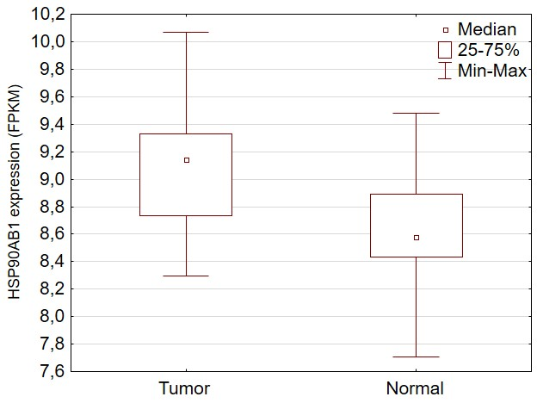

Supplementary Figure 2. Overall survival in the TCGA laryngeal cancer cohort based on HSP90AB1 expression
