Supplementary material
Supplementary Fig. 1 Study design
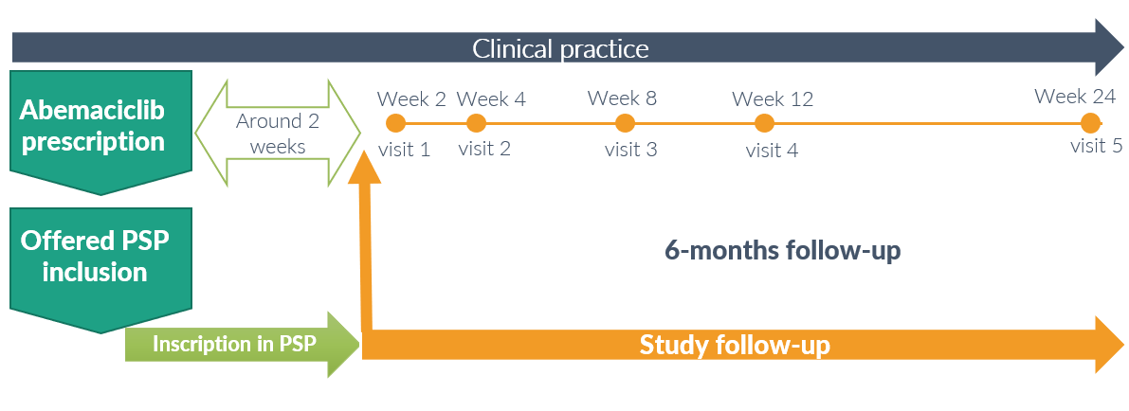

Supplementary Table 1: Self-care practices and self-management of diarrhea questionnaire
SELF-CARE PRACTICES AND SELF-MANAGEMENT OF DIARRHOEA
This questionnaire is composed by two sections where we will ask you about:
- Section A: In case you have had diarrhoea, how you have managed it.
- Section B: How do you feel about the treatment and management of diarrhoea.
It is very important that you answer all the questions. Mark your answers with an X. Make sure that the copy sheet (yellow sheet) is well marked.
- A) SELF-CARE AND SELF-MANAGEMENT DURING DIARRHOEAL EPISODES:
Answer the following table if you have had diarrhoea. Otherwise, skip to section B
If you presented diarrhoea from the last visit, how you managed it? Please, mark with an X the measures adopted |  |  | I received this advice from: |  |  |  | Did it help your diarrhoea?
 |  |  | Physician, nurse or pharmacist |  | PSP | None
☐ |  | Increase fluid intake | ☐ |  | ☐ | ☐ | ☐ Yes ☐ No
☐ |  | Change of diet (astringent diet) | ☐ |  | ☐ | ☐ | ☐ Yes ☐ No
☐ |  | Diet restrictions | ☐ |  | ☐ | ☐ | ☐ Yes ☐ No
☐ |  | Use of prescribed loperamide | ☐ |  | ☐ | ☐ | ☐ Yes ☐ No
☐ |  | Use of other prescribed drugs. Specify:___________ | ☐ |  | ☐ | ☐ | ☐ Yes ☐ No
 |  | Use of other prescribed drugs. Specify:__________ | ☐ |  | ☐ | ☐ | ☐ Yes ☐ No
 |  | Use of other prescribed drugs. Specify:___________ | ☐ |  | ☐ | ☐ | ☐ Yes ☐ No
☐ |  | Use of loperamide without medical prescription (OTC) | ☐ |  | ☐ | ☐ | ☐ Yes ☐ No
☐ |  | Use of dietary supplements | ☐ |  | ☐ | ☐ | ☐ Yes ☐ No
☐ |  | Use of herbal remedies | ☐ |  | ☐ | ☐ | ☐ Yes ☐ No
☐ |  | Rest and reduce normal activity | ☐ |  | ☐ | ☐ | ☐ Yes ☐ No
- B) CURRENTLY, YOU FEEL…
Please, mark with an X your answer to each one of the questions.
 | I am confident to manage diarrhoea episodes when they occur |  |  | ☐ Strongly disagree  ☐ Disagree  ☐ Neither agree nor disagree.  ☐ Agree  ☐ Strongly agree  ☐ Not applicable
 | I am confident to contact with physician/nurse responsible for my cancer treatment if I present diarrhoea episodes |  |  | ☐ Strongly disagree  ☐ Disagree  ☐ Neither agree nor disagree.  ☐ Agree  ☐ Strongly agree  ☐ Not applicable
 | I am confident to contact with PSP if I present diarrhoea episodes |  |  | ☐ Strongly disagree  ☐ Disagree  ☐ Neither agree nor disagree.  ☐ Agree  ☐ Strongly agree  ☐ Not applicable
 | I believe that, apart from medicines, there are other important measures (e.g. diet and lifestyle) in the management of diarrhoea. |  |  | ☐ Strongly disagree  ☐ Disagree  ☐ Neither agree nor disagree.  ☐ Agree  ☐ Strongly agree  ☐ Not applicable
 | I can recognise the intensity of diarrhoea episodes when I have it and I know when I should call for help |  |  | ☐ Strongly disagree  ☐ Disagree  ☐ Neither agree nor disagree.  ☐ Agree  ☐ Strongly agree  ☐ Not applicable
 | The PSP has helped me to manage diarrhoea episodes |  |  | ☐ Strongly disagree  ☐ Disagree  ☐ Neither agree nor disagree.  ☐ Agree  ☐ Strongly agree  ☐ Not applicable
 | Participating in the PSP helps me to take my medicine as I have been instructed. |  |  | ☐ Strongly disagree  ☐ Disagree  ☐ Neither agree nor disagree.  ☐ Agree  ☐ Strongly agree  ☐ Not applicable
 | Participating in the PSP makes me feel listened and supported regarding my disease |  |  | ☐ Strongly disagree  ☐ Disagree  ☐ Neither agree nor disagree.  ☐ Agree  ☐ Strongly agree  ☐ Not applicable

Supplementary Table 2 Patient satisfaction with PSP questionnaire
PATIENT SATISFACTION WITH PSP
How do you feel about…? Please, mark with an X the answer you consider appropriate.
Participation on the PSP:
☐ Totally unsatisfied ☐ Unsatisfied ☐ Indifferent ☐ Satisfied ☐ Totally satisfied
Information about the disease given by PSP:
☐ Totally unsatisfied ☐ Unsatisfied ☐ Indifferent ☐ Satisfied ☐ Totally satisfied
Information about adverse effects I may experiment during treatment
☐ Totally unsatisfied ☐ Unsatisfied ☐ Indifferent ☐ Satisfied ☐ Totally satisfied
Information about how to manage diarrhoea episodes while taking abemaciclib:
☐ Totally unsatisfied ☐ Unsatisfied ☐ Indifferent ☐ Satisfied ☐ Totally satisfied
Information about the severity of diarrhoea episodes:
☐ Totally unsatisfied ☐ Unsatisfied ☐ Indifferent ☐ Satisfied ☐ Totally satisfied
Information about dietary habits to help managing diarrhoea episodes:
☐ Totally unsatisfied ☐ Unsatisfied ☐ Indifferent ☐ Satisfied ☐ Totally satisfied
Information about where and when to call for help/health services while having diarrhoea:
☐ Totally unsatisfied ☐ Unsatisfied ☐ Indifferent ☐ Satisfied ☐ Totally satisfied
Emotional support provided by PSP professionals:
☐ Totally unsatisfied ☐ Unsatisfied ☐ Indifferent ☐ Satisfied ☐ Totally satisfied

Supplementary Figure 2 Treatment modifications due to diarrhea (swimmer plot)
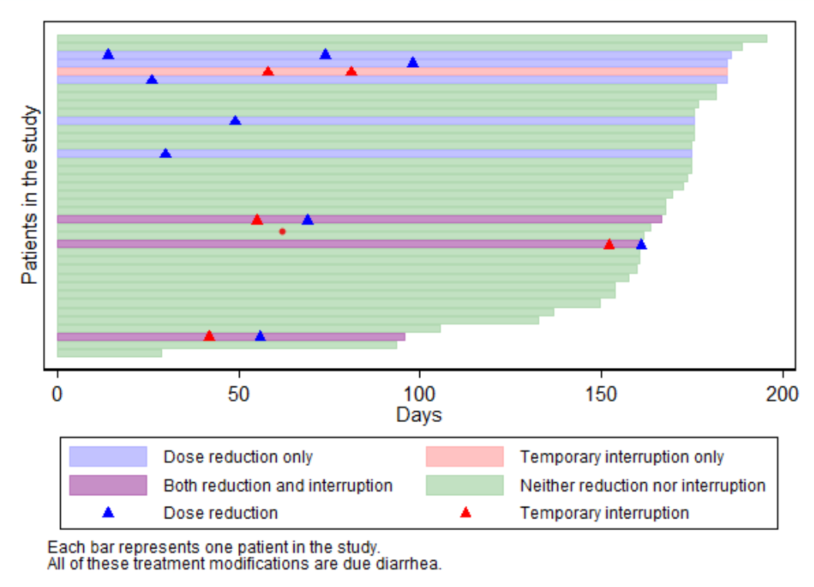

Supplementary Table 3 Patient´s self-care and diarrhea management ad-hoc questionnaire
Time in weeks (patients) | 2 weeks  (n = 21) |  | 4 weeks  (n = 25) |  | 8 weeks  (n = 23) |  | 12 weeks  (n = 20) |  | 24 weeks  (n = 17)
3 | n | % | n | % | n | % | n | % | n | %
Increase fluid intake | 14 | 66.67 | 17 | 68.00 | 16 | 69.57 | 13 | 65.00 | 12 | 70.59
Recommended by the HCP | 10 | 47.62 | 11 | 44.00 | 13 | 56.52 | 11 | 55.00 | 8 | 47.06
Recommended by the PSP | 9 | 42.86 | 11 | 44.00 | 12 | 52.17 | 7 | 35.00 | 7 | 41.18
Recommended by other sources | 4 | 19.05 | 2 | 8.00 | 0 | 0.00 | 2 | 10.00 | 2 | 11.76
Recommendation was helped | 11 | 78.57 | 16 | 94.12 | 12 | 75.00 | 11 | 84.62 | 7 | 58.33
Diet change (to an astringent diet) | 12 | 57.14 | 17 | 68.00 | 15 | 65.22 | 15 | 75.00 | 11 | 64.71
Recommended by the HCP | 7 | 33.33 | 9 | 36.00 | 9 | 39.13 | 12 | 60.00 | 4 | 23.53
Recommended by the PSP | 8 | 38.10 | 12 | 48.00 | 9 | 39.13 | 9 | 45.00 | 6 | 35.29
Recommended by other sources | 2 | 9.52 | 4 | 16.00 | 1 | 4.35 | 2 | 10.00 | 3 | 17.65
Recommendation was helped | 9 | 75.00 | 15 | 88.24 | 10 | 66.67 | 13 | 86.67 | 5 | 45.45
Diet restrictions | 12 | 57.14 | 13 | 52.00 | 8 | 34.78 | 12 | 60.00 | 7 | 41.18
Recommended by the HCP | 6 | 28.57 | 6 | 24.00 | 5 | 21.74 | 8 | 40.00 | 1 | 5.88
Recommended by the PSP | 6 | 28.57 | 10 | 40.00 | 5 | 21.74 | 5 | 25.00 | 3 | 17.65
Recommended by other sources | 2 | 9.52 | 3 | 12.00 | 1 | 4.35 | 4 | 20.00 | 2 | 11.76
Recommendation was helped | 10 | 83.33 | 11 | 84.62 | 5 | 62.50 | 11 | 91.67 | 4 | 57.14
Use of prescribed loperamide | 16 | 76.19 | 19 | 76.00 | 19 | 82.61 | 15 | 75.00 | 10 | 58.82
Recommended by the HCP | 13 | 61.90 | 17 | 68.00 | 17 | 73.91 | 14 | 70.00 | 7 | 41.18
Recommended by the PSP | 11 | 52.38 | 11 | 44.00 | 9 | 39.13 | 4 | 20.00 | 2 | 11.76
Recommended by other sources | 0 | 0.00 | 2 | 8.00 | 0 | 0.00 | 0 | 0.00 | 1 | 5.88
Recommendation was helped | 15 | 93.75 | 18 | 94.74 | 16 | 84.21 | 15 | 100.00 | 7 | 70.00
Use of another prescribed medication | 1 | 4.76 | 1 | 4.00 | 0 | 0.00 | 1 | 5.00 | 1 | 5.88
Recommended by the HCP | 1 | 4.76 | 1 | 4.00 | - | - | 0 | 0.00 | 1 | 5.88
Recommended by the PSP | 0 | 0.00 | 0 | 0.00 | - | - | 0 | 0.00 | 0 | 0.00
Recommended by other sources | 0 | 0.00 | 0 | 0.00 | - | - | 0 | 0.00 | 0 | 0.00
Recommendation was helped | 1 | 50.00 | 1 | 50.00 | - | - | 0 | 0.00 | 1 | 100.00
Use of non-prescribed loperamide | 4 | 19.05 | 4 | 16.00 | 4 | 17.39 | 5 | 25.00 | 4 | 23.53
Recommended by the HCP | 1 | 4.76 | 0 | 0.00 | 1 | 4.35 | 0 | 0.00 | 2 | 11.76
Recommended by the PSP | 0 | 0.00 | 0 | 0.00 | 1 | 4.35 | 0 | 0.00 | 1 | 5.88
Recommended by other sources | 2 | 9.52 | 3 | 12.00 | 3 | 13.04 | 3 | 15.00 | 1 | 5.88
Recommendation was helped | 3 | 75.00 | 1 | 25.00 | 0 | 0.00 | 3 | 60.00 | 2 | 50.00
Use of dietary supplements | 5 | 23.81 | 7 | 28.00 | 3 | 13.04 | 4 | 20.00 | 3 | 17.65
Recommended by the HCP | 2 | 9.52 | 1 | 4.00 | 0 | 0.00 | 0 | 0.00 | 0 | 0.00
Recommended by the PSP | 1 | 4.76 | 1 | 4.00 | 0 | 0.00 | 0 | 0.00 | 0 | 0.00
Recommended by other sources | 3 | 14.29 | 5 | 20.00 | 3 | 13.04 | 2 | 10.00 | 2 | 11.76
Recommendation was helped | 3 | 60.00 | 2 | 28.57 | 1 | 33.33 | 1 | 25.00 | 1 | 33.33
Use of medicinal herbs/plants | 6 | 28.57 | 5 | 20.00 | 3 | 13.04 | 6 | 30.00 | 3 | 17.65
Recommended by the HCP | 2 | 9.52 | 1 | 4.00 | 0 | 0.00 | 2 | 10.00 | 0 | 0.00
Recommended by the PSP | 1 | 4.76 | 2 | 8.00 | 0 | 0.00 | 0 | 0.00 | 0 | 0.00
Recommended by other sources | 2 | 9.52 | 3 | 12.00 | 3 | 13.04 | 2 | 10.00 | 1 | 5.88
Recommendation was helped | 4 | 66.67 | 2 | 40.00 | 1 | 33.33 | 2 | 33.33 | 1 | 33.33
Rest and reduction of daily activities | 6 | 28.57 | 10 | 40.00 | 10 | 43.48 | 6 | 30.00 | 4 | 23.53
Recommended by the HCP | 3 | 14.29 | 7 | 28.00 | 3 | 13.04 | 2 | 10.00 | 0 | 0.00
Recommended by the PSP | 3 | 14.29 | 6 | 24.00 | 4 | 17.39 | 1 | 5.00 | 0 | 0.00
Recommended by other sources | 3 | 14.29 | 3 | 12.00 | 5 | 21.74 | 3 | 15.00 | 1 | 5.88
Recommendation was helped | 4 | 66.67 | 8 | 80.00 | 7 | 70.00 | 3 | 50.00 | 2 | 50.00
HCP health care provider, PSP patient support program

Supplementary Fig. 3 How patient feels related to treatment and diarrhea management
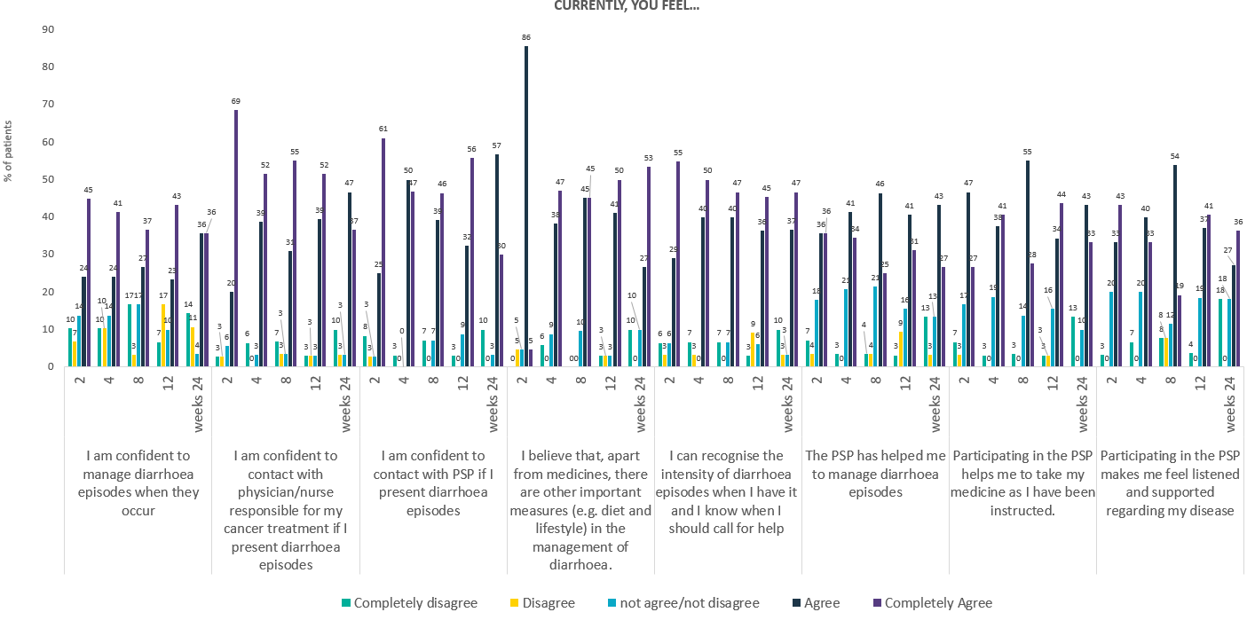

Supplementary Fig. 4 Number of calls (a) and topics discussed (B) during follow-up times

A
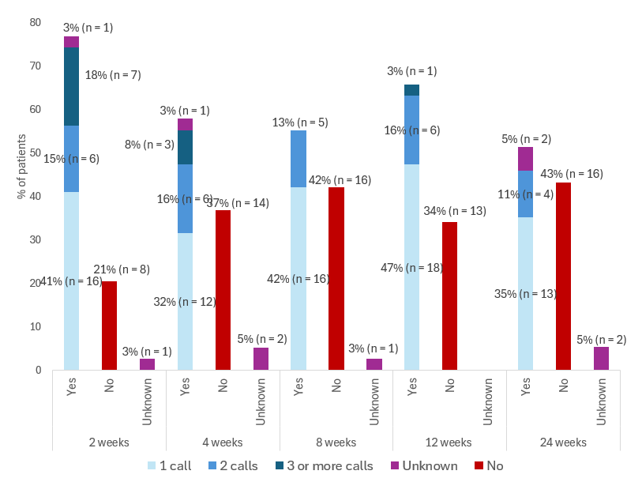
B
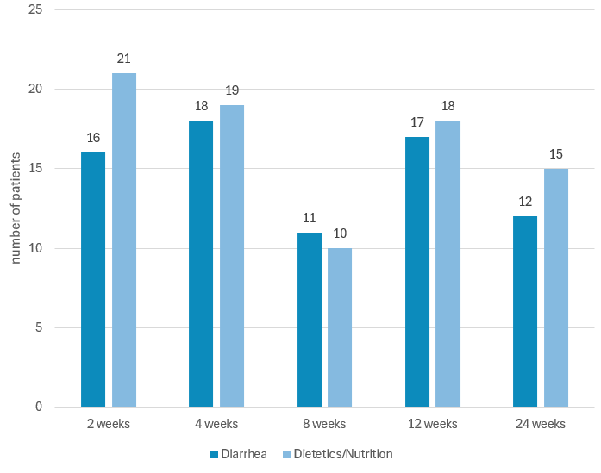

Supplementary Fig. 5 Patient´s satisfaction level regarding several PSP-related statements at week 24

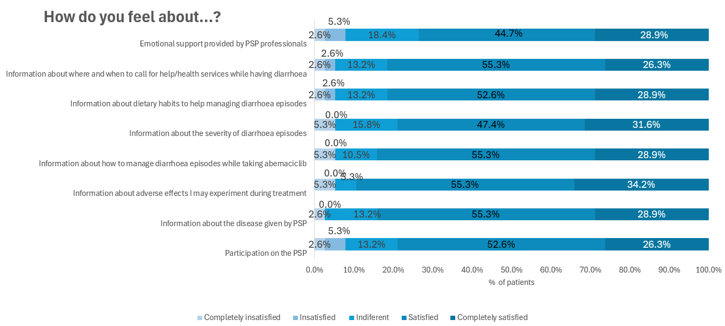

Supplementary Table 4 Patients’ satisfaction with PSP during study treatment: How do you feel about…?
 |  | Completely disagree | Disagree | not agree/not disagree | Agree | Completely Agree
Participation on the PSP | 2 weeks | 0.0 | 5.6 | 8.3 | 47.2 | 38.9
Participation on the PSP | 4 weeks | 5.6 | 0.0 | 13.9 | 55.6 | 25.0
Participation on the PSP | 8 weeks | 0.0 | 5.6 | 16.7 | 50.0 | 27.8
Participation on the PSP | 12 weeks | 2.7 | 5.4 | 8.1 | 62.2 | 21.6
Participation on the PSP | 24 weeks | 2.9 | 5.7 | 14.3 | 48.6 | 28.6
Information about the disease given by PSP | 2 weeks | 0.0 | 8.3 | 5.6 | 47.2 | 38.9
Information about the disease given by PSP | 4 weeks | 0.0 | 0.0 | 8.3 | 66.7 | 25.0
Information about the disease given by PSP | 8 weeks | 0.0 | 5.6 | 5.6 | 61.1 | 27.8
Information about the disease given by PSP | 12 weeks | 2.7 | 5.4 | 2.7 | 64.9 | 24.3
Information about the disease given by PSP | 24 weeks | 2.8 | 2.8 | 13.9 | 50.0 | 30.6
Information about adverse effects I may experiment during treatment | 2 weeks | 0.0 | 5.6 | 8.3 | 38.9 | 47.2
 | 4 weeks | 0.0 | 5.6 | 8.3 | 66.7 | 19.4
 | 8 weeks | 2.8 | 5.6 | 8.3 | 55.6 | 27.8
 | 12 weeks | 2.7 | 5.4 | 5.4 | 59.5 | 27.0
 | 24 weeks | 5.7 | 0.0 | 5.7 | 51.4 | 37.1
Information about how to manage diarrhoea episodes while taking abemaciclib | 2 weeks | 0.0 | 5.6 | 5.6 | 55.6 | 33.3
 | 4 weeks | 0.0 | 2.8 | 5.6 | 66.7 | 25.0
 | 8 weeks | 0.0 | 0.0 | 16.7 | 50.0 | 33.3
 | 12 weeks | 0.0 | 5.4 | 10.8 | 59.5 | 24.3
 | 24 weeks | 5.7 | 0.0 | 11.4 | 51.4 | 31.4
Information about the severity of diarrhoea episodes | 2 weeks | 2.8 | 5.6 | 11.1 | 50.0 | 30.6
Information about the severity of diarrhoea episodes | 4 weeks | 0.0 | 5.6 | 11.1 | 63.9 | 19.4
Information about the severity of diarrhoea episodes | 8 weeks | 2.9 | 0.0 | 14.3 | 60.0 | 22.9
Information about the severity of diarrhoea episodes | 12 weeks | 0.0 | 5.4 | 10.8 | 54.1 | 29.7
Information about the severity of diarrhoea episodes | 24 weeks | 5.7 | 0.0 | 17.1 | 42.9 | 34.3
Information about dietary habits to help managing diarrhoea episodes | 2 weeks | 5.6 | 5.6 | 11.1 | 47.2 | 30.6
 | 4 weeks | 0.0 | 2.8 | 11.1 | 61.1 | 25.0
 | 8 weeks | 2.8 | 0.0 | 16.7 | 58.3 | 22.2
 | 12 weeks | 0.0 | 5.4 | 5.4 | 67.6 | 21.6
 | 24 weeks | 2.9 | 2.9 | 14.3 | 48.6 | 31.4
Information about where and when to call for help/health services while having diarrhoea | 2 weeks | 2.8 | 2.8 | 11.1 | 50.0 | 33.3
 | 4 weeks | 0.0 | 8.3 | 2.8 | 66.7 | 22.2
 | 8 weeks | 0.0 | 0.0 | 13.9 | 63.9 | 22.2
 | 12 weeks | 0.0 | 5.4 | 8.1 | 67.6 | 18.9
 | 24 weeks | 2.9 | 2.9 | 14.3 | 51.4 | 28.6
Emotional support provided by PSP professionals | 2 weeks | 2.8 | 5.6 | 19.4 | 44.4 | 27.8
Emotional support provided by PSP professionals | 4 weeks | 0.0 | 5.6 | 13.9 | 61.1 | 19.4
Emotional support provided by PSP professionals | 8 weeks | 0.0 | 2.8 | 16.7 | 55.6 | 25.0
Emotional support provided by PSP professionals | 12 weeks | 0.0 | 7.9 | 13.2 | 55.3 | 23.7
Emotional support provided by PSP professionals | 24 weeks | 2.9 | 5.7 | 20.0 | 40.0 | 31.4

